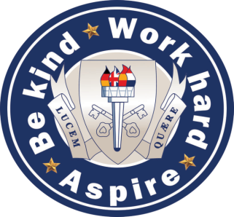

**History at The South Wolds Academy and Sixth Form**

The South Wolds History Department is committed to teaching students in a relevant and creative way to promote resilience and a thorough understanding of the past. We are a friendly, tight knit and enthusiastic team of three teachers who continually look to develop new ideas and incorporate them into our teaching. We have enjoyed much success over recent years, including strong exam results at GCSE and A level.

Our Key Stage 3 schemes of work have been designed to allow students to study a wide range of topics in a variety of ways. The time period covered over the three years goes from 1066 to 1989 and students demonstrate their knowledge and understanding through extended writing, project work, model-making, presentations and drama. We are unique in that we also offer Fristory as an option in Years 7 and 8 which is essentially History taught in French .

At Key Stage 4 we follow the Edexcel specification. The topics covered in Year 10 are Medicine Through Time and Weimar and Nazi Germany. In Year 11, we cover the Cold War and Elizabethan England.

History is a popular A Level subject. We follow the AQA syllabus; the topics covered are Russia 1917 to 1953 and Tudor England, 1485 to 1603. The coursework option is Civil Rights in the USA, 1865-1965.

We have high expectations of pupils and look to support them with a positive and caring attitude. Standards are consistently outstanding within History.