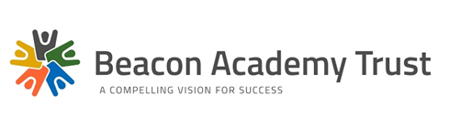

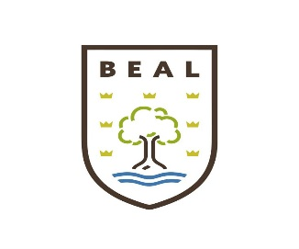

Education, training, skills and employment services on one campus to raise standards in education for ALL

**Beal High School**

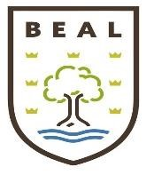

**Based at the Beacon Campus**

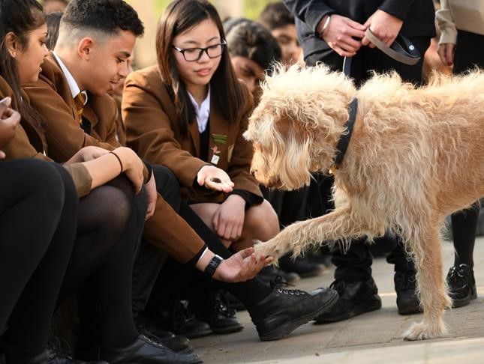

# COMPELLING VISION FOR SUCCESS

**Beal High School (part of Beacon Multi-Academy Trust)**

**Beacon Campus**

**Teaching Assistant – SEN and Autism**

**Salary: LBR Grade 3 – points 14 to 17 – £21,591 - £21,981 FTE**

**£15,273 - £18,140 at pro rata value**

**(Depending on experience and working pattern)**

**Required: ASAP**

We have a very successful provision for secondary aged students with Autistic Spectrum Disorders. Our students work within the purpose-built provision on the main school site and where appropriate in the mainstream school. Students are also involved in a range of social and extra-curricular activities with their mainstream peers.

We are seeking to recruit a passionate and empathetic teaching assistant. You will need to be flexible, possess a variety of skills and be willing to undertake a variety of activities with our students.

The successful candidates will have:

• Experience of students with special needs

• The ability to support our students in their mainstream lessons

• Provide in class support in the provision

• Knowledge of Autism and communication difficulties or a commitment to training

The Trust is committed to safeguarding and promoting the welfare of young people and expects all members of staff to share this commitment. The below documents must be read prior to applying for this role and will be factored into interviews:

[Keeping Children Safe in Education](https://www.gov.uk/government/uploads/system/uploads/attachment_data/file/550511/Keeping_children_safe_in_education.pdf)

[BMAT – Safeguarding and Child Protection Policy](http://beaconacademytrust.co.uk/wp-content/uploads/2018/05/SAFEGUARDING-CP-POLICY-Jan2018-USE-THIS-VERSION-1.pdf)

An Enhanced DBS (with list checks) is required for this post.

Further information and an application form can be found at [www.beaconacademytrust.co.uk](http://www.beaconacademytrust.co.uk/)

Please forward your electronic applications to beasuccess@beaconademytrust.co.uk

**Please note we reserve the right to close or extend this position depending on application numbers, therefore we would urge candidates to submit an application as soon as possible.**

**‘A specialist secondary provision for students with Autism and Asperger Syndrome’**

**Our Aims**

* Provide an Autism friendly environment where our students are happy and stimulated.
* Enable students to access mainstream opportunities appropriate to their educational and emotional needs.
* Establish awareness in the wider school community about diversity, so that our students are valued.
* Offer a broad, balanced curriculum that is Autism friendly and emphasises communication, social skills, autonomy and self-advocacy to prepare our students for the opportunities, responsibilities and experiences of adult life.

**Key Stage 3 Curriculum**

Classes are small and usually have between 6 and 8 students. The class does most of their learning in their class base with their teacher and Teaching assistant.

Our Key Stage 3 curriculum consists of:

* English
* Maths
* Science
* ICT
* History, Geography and RE
* Music, Art and Drama
* Modern foreign language experiences
* Social Skills
* PSHE
* PE

All students are linked to a mainstream tutor group and will be timetabled to access some appropriate subjects in mainstream.

**Key Stage 4 Curriculum**

Our Key Stage 4 curriculum has an emphasis on preparing students for moving onto college and becoming adults. We do this through nationally recognised accreditation, work experience opportunities, local college link courses and curriculum enrichment opportunities.

In Key Stage 4 students will work towards the ‘Entry level’ and Level 1 qualifications in English, maths and science.

In addition students study:

* ICT
* History, Geography and RE
* Music, Art and Drama
* Modern foreign language experiences
* Social Skills and life skills
* PSHE
* PE

**Higher Level Qualifications**

Some students may also access the mainstream school for GCSE and BTEC level 2 qualifications.

**6th Form**

**Programme of study:**

* Life skills course: ASDAN Personal and Social Development at Entry level 1, 2 or 3.
* Functional Skills ICT
* Music, drama and art
* Cooking
* Leisure PE

**Other activities:**

* Speech and language therapy
* Attend a local college one day a week
* Practise independent travel skills
* Take part in a residential
* Access work experience opportunities, usually one day a week.
* Provide support through the application, interview and orientation process for moving to college.

**Speech Therapy**

Our Speech and Language Therapists are integral members of our staff team and focus on developing the students’ social communication and language skills.

**Other External Agencies**

We regularly work with agencies:

* Connexions
* CAMHS
* Social Services
* Education Psychology Service
* Health Professionals

Plus any other agencies or professionals involved with our students.

**Extra-Curricular and Enrichment Activities**

We are able to offer students a wide and varied programme of extra-curricular and enrichment activities throughout Key stages 3, 4 and 5 and an after school Youth Club and Holiday Club.

**Teaching Assistant: Job Description**

**Line Management:** TAs may receive direction from any of the following people - The Senior TA, BCS Class Teachers, the Head or Deputy of BCS and SENCo’s.

**Purpose of the job**

* To work with and support individuals and small groups of students on activities as directed by teachers both within school or the local community.
* To assist in the support and integration of children within BCS classes and other departments of the main school.

**Supporting the student**

* To actively seek to develop an understanding of the specific needs and targets of the students.
* To establish a supportive relationship with the students.
* To encourage acceptance of the student within the context of integration.
* To develop methods of promoting and reinforcing student’s confidence and self-esteem.
* To promote the independent learning of students as much as possible and diminish adult reliance
* Supervising students at break and lunch times on a rota basis.

**Supporting Teachers and other professionals**

* To assist the teacher in the development of a suitable programme of education and support for the students either within BCS or other departments.
* To show initiative in preparation of appropriate lesson materials and resources.
* To contribute to annual reviews in writing and attend the meeting if requested.
* Assist mainstream teachers on understanding a pupil’s needs and the appropriate differentiation.
* Assist teachers in the preparation and maintenance of classroom and corridor displays.

**Supporting the Department**

* To develop and foster a positive relationship between the student’s home and school.
* To liaise, advise and consult with other members of the BCS team, mainstream teachers and outside professionals in support of the students.
* To attend relevant in-service training, BCS team meetings, departmental meetings and whole school staff meetings as required.
* To be aware of and follow BCS and whole school procedures / policies.

The above mentioned duties are neither exclusive nor exhaustive and the post holder may be called upon to carry out such other duties as may be required by the Line Manager that are broadly within the level of the post.

**Teaching Assistant: Person Specification**

|  |  |  |
| --- | --- | --- |
|  | **Essential (E)**  **Desirable (D)** | **Application (A)**  **Interview (I)**  **Reference (R)** |
| **Qualifications** | | |
| 1. NVQ 3 or equivalent qualification | **D** | **A/I/R** |
| 2. Qualification at Level 2 (Grade C or above) in English, Maths and Science | **E** | **A/I/R** |
|  | | |
| 3. ICT skills and knowledge of other specialist equipment/resources. | **E** | **A/I/R** |
| 4. Relevant knowledge and demonstrable experience of young people with special educational needs or autism | **E** | **A/I** |
| 5. Able to work effectively in a team and contribute to its success | **E** | **A/I/R** |
| 6. Good written English and effective communication skills | **E** | **A/I** |
| 7. Knowledge or experience of Autism and Asperger Syndrome | **D** | **A/I** |
|  | | |
| 8. Reliable, respectful, responsible & conscientious approach | **E** | **A/I/R** |
| 9. Flexibility to deal with diverse needs of the post | **E** | **A/I** |
| 10. Establish and maintain appropriate relationships | **E** | **A/I/R** |
| 11. High level of initiative and ability to work independently | **E** | **A/I/R** |

**The school is committed to safeguarding and promoting the welfare of young people and expects all members of staff to share this commitment. Enhanced DBS Disclosure is required for this post.**