

Assistant Curriculum Leader / Second in Charge for English
MPS/UPS + TLR 2b (£4396) / Additional Allowance
Full time – Permanent – January 2018 start
Are you a Teacher of English interested in becoming the Second in Department?
Do you have experience raising attainment in English at KS3 and KS4?
Would you like to work in a vibrant Academy where you are recognised for your hard work?

If you have answered yes to these questions, The Chalk Hills Academy would love to hear from you!

The Chalk Hills Academy have a great opportunity for a self-motivated Teacher of English to join our wonderful Department as Second in Charge. We are seeking a teacher who has the drive and determination to see all children succeed regardless of where they may start. In particular, the successful candidate will be the Pupil Champion for Achievement at KS4 with a focus on the progress of learner groups and daily cover in KS4. We are really looking to recruit an exceptional candidate to join our team and are willing to pay an additional recruitment and retention allowance for the right person who will drive attainment in English forward.
The successful candidate will:
- Hold Qualified Teaching Status
- Have an established and evidenced practice as an outstanding teacher over a prolonged period
- Have a proven ability to raise standards in classrooms other than their own
- Have experience of leading teaching and learning initiatives beyond their own classroom
- Have excellent understanding of the components which comprise outstanding teaching and learning
- Have experience of conducting lesson observations, giving effective feedback to colleagues about professional performance and mentoring colleagues
- Be able to use assessment and attainment information to improve practice and raise standards
- Have a vision for the development of teaching and learning and have strategies to enhance this
Why work for Chalk Hills Academy?
- £30 million state of the art building with well-equipped classrooms in an Ofsted rated ‘Good’ school
- You’ll be working alongside a collaborative, forward thinking Principal and Senior Leadership Team who are here to support and develop you
- Unparalleled CPD opportunities with free courses every Thursday catered to your developmental needs
- We recruit for attitude and train for skills with excellent opportunities for career progression in a successful and expanding Academy
- All teaching staff receive a laptop to use whilst in employment
- Freshly brewed coffee for staff on arrival to the academy every morning
- Employee of the month scheme winning shopping vouchers
- Fantastic staff benefits that make a difference to your work life balance

Here’s what Ofsted have to say: “The purposeful and caring leadership of the Principal and SLT have created a strong academy identity and a positive ethos shared by all members of the community. The strength of leadership is recognised without exception by the academy’s staff. Students’ behaviour is good, the atmosphere in lessons is calm and studious and attitudes to learning are routinely positive as students want to learn. Students are hugely proud of their academy, they wear their blazers and ties smartly, do not drop litter and look after the modern, purpose-built site impeccably. They stand without instruction when any adult enters a classroom.”
Teacher Testimonial: “Having worked in London schools for over 12 years and overseas for a couple of years, I hadn’t really considered a move to Luton. There is something about the diversity of London schools, both culturally and socially that I love and I genuinely didn’t think that this would be replicated unless I working in another big city. The opportunity to work at Chalk Hills Academy came up and after looking at the website and Ofsted report, I decided to apply and have been here since January 2017. Chalk Hills Academy and The Shared Learning Trust (this is my first time working in a small academy trust) has certainly exceeded my expectations. Everything that I loved about working in London - diversity, atmosphere, forward thinking and generally wanting the best for all students is at Chalk Hills. In addition, working in a school that is part of a small multi-academy trust means that there are regular opportunities for collaborative working and partnerships. As well as the working environment, salary is always a consideration and I have been pleasantly surprised to find that there isn’t a great deal of difference between The Shared Learning Trust and an Inner London salary. I would unreservedly recommend Chalk Hills Academy, The Shared Learning Trust and Luton; have a look I am sure you will too will be pleasantly surprised!”

Meet the lovely English Department:


Visits to the Academy are warmly welcomed, please contact Gayle Elliott, PA to the Principal on 01582 601 221.
‘We believe in the safeguarding and welfare of children and expect all staff to share this view’.
The Academy is committed to safeguarding and promoting the welfare of children and expects all staff to share this commitment. Applicants must be willing to undergo child protection screening appropriate to the post including checks with past employers and the Disclosure and Barring Service. We are an equal opportunities employer.

HOW TO APPLY

Closing Date: Thursday 26th October at 12pm Interviews: Monday 30th October 2017
Please read the information in this pack. If you decide to apply, please apply online via our career site on www.thesharedlearningtrust.careers.eteach.com or email this application to Hannah Chandler, Recruitment Officer at The Shared Learning Trust on academyrecruitment@thesharedlearningtrust.org.uk with the subject line English Second in Charge. To ensure the safe delivery of your application, please do not post applications without first speaking with Hannah on 01582 211 226.



INFORMATION FOR APPLICANTS:
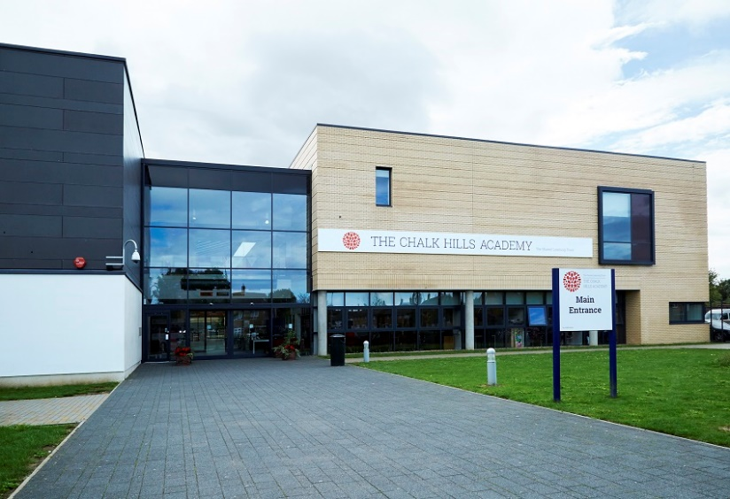
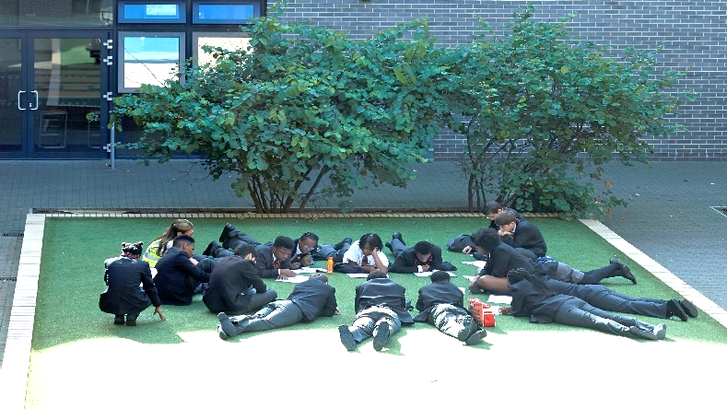

Assistant Curriculum Leader / Second in Charge for English

WELCOME TO THE SHARED LEARNING TRUST FROM THE CHIEF EXECUTIVE, CATHY BARR
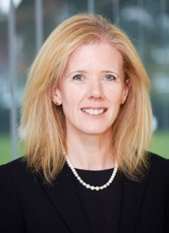
The Shared Learning Trust has appointed Cathy Barr as its new Chief Executive Officer. Cathy is already part of the Shared Learning Trust's family of schools, having been Principal of the Stockwood Park Academy in Luton for the last five years. The Shared Learning Trust is a stand-alone multi academy trust, which runs a family of four schools based in Bedfordshire: Stockwood Park Academy, the Chalk Hills Academy, the Linden Academy and the Vale Academy. Cathy grew up locally, in Harpenden, and went to school in St Albans. She has almost 25 years' teaching experience under her belt, qualifying in 1993 and joining the team at Stockwood Park (then the Barnfield South Academy) in 2009.
Cathy said of her appointment: "I am thrilled to have been appointed CEO of the Shared Learning Trust. I care passionately about the students we teach and will do all I can to ensure each and every child, from the age of two to 18, gets the best possible care and education in our academies."
I am conscious that this may be your first contact with our Academy Trust and first impressions are very important. I hope what you read; coupled with anything else you discover about us, inspires you to apply for this post.
- We recruit people for attitude and train for skills
We aim to recruit outstanding people who have the right attitude. If you have a love for teaching and are passionate about seeing children succeed, we would love to hear from you!
Recruiting the right teachers and staff help us to achieve the goals we set for our children. We are always keen to hear from educators who are passionate about working for the schools and communities we serve. We would rather make no appointment than appoint someone who does not share the same positive ethos that runs through our Academies. For this reason, we try to articulate clearly our vision, values and expectations when putting together information for applicants.
We aim to recruit staff who:
- are excited by their role and by the prospect of working with young people, even those who are less well motivated;
- love the processes of learning and teaching and are keen to continually develop their own skills;
- recognise that teaching can be a demanding job but react positively to those demands rather than complaining;
- will subscribe to the ethos of the Trust and ‘go the extra mile’ in terms of time and commitment to get the very best from our young people;
- see break duty as an opportunity to talk to children;
- are quick to praise and slow to criticise; and are not afraid to admit to seeing themselves as potential leaders of the future.

WELCOME TO THE CHALK HILLS ACADEMY FROM THE PRINCIPAL, LOUISE LEE
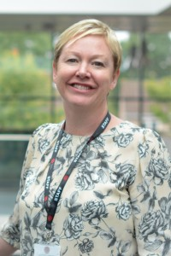
Dear Applicant,
It is a privilege and an honour to lead Chalk Hills Academy.
Our students are extremely motivated, and have an exceptional desire to achieve and behave impeccably.
Our staff are highly qualified and work tirelessly in the pursuit of world class progress for all of our students.
The facilities at Chalk Hills Academy are state of the art, providing students with the opportunity to develop their interests and skills in a wide range of areas.
In 2016 our students achieved 60% A*-C English & mathematics, which was a fantastic achievement for our young people.

As an Academy within the Shared Learning Trust, we believe our key aim is to give every child the best possible opportunity to flourish and develop into decent, disciplined, well-educated and employable adults.
Learning is clearly at the heart of all we do.
‘It is the supreme art of the teacher to awaken joy in creative expression and knowledge.’ - Albert Einstein
I am delighted to extend a warm welcome to you.
Best wishes,
Louise Lee

THE TRUST

The Shared Learning Trust is a stand-alone multi academy trust, which runs a family of four schools based in Bedfordshire:

- The Chalk Hills Academy, Luton, age 11-18, judged 'Good' by Ofsted
- The Stockwood Park Academy, Luton, ages 11-18, judged 'Good' by Ofsted
- The Sixth Form, Luton, age 16-19, judged 'Good' by Ofsted (A part of both Chalk Hills and Stockwood)
- The Linden Academy, Luton, age 4-11, judged 'Good' by Ofsted
- The Vale Academy, Dunstable, age 4-13, judged 'Good' by Ofsted

Our Academies are supported in their work by our Teaching School, based at The Chalk Hills Academy. The structure of our family of schools means that we can be with a child every step of the way, from teaching them to tie their shoe laces right through to congratulating them on their university place or their first job.

Our Trust is vibrant and friendly, supported by 3 state-of-the-art buildings. It is a learning environment where all students have the opportunity to be high achievers, make good friends, contribute to their community and take part in a wide range of extra-curricular activities.

VISION & VALUES – ‘Strive, Achieve, Believe’

At The Shared Learning Trust, we provide opportunities for all our students and adults to be aspirational and develop a passion and excitement for learning. Working with our communities, we ensure all students are able to achieve beyond their targets to reach the success they deserve. Our students develop a strong self-belief so that they flourish and develop into well-rounded, self-respecting young people.
Our commitment to our vision can be seen through:
- Our academies working together to provide more opportunities for all students and staff
- A focus on the development of our staff with opportunities for clear and dynamic career progression and high quality recruitment and retention.
- Strong Trust approaches to our key issues, for example; teaching, assessment, attendance and curriculum development.
- Partnerships with schools outside of our Trust to maximise opportunities for all.
- Close working and communication with our families and local community.
- Care for our families beyond the school day.
- Excellent lessons and learning incorporating effective use of new technologies.
- An interesting yet challenging curriculum.
- 16-19 provision, which ensures progression, routes for all.
- A Cross-Trust focus on high achievement and high standards.
- Ensuring that every child in our Trust reaches their full potential by providing exciting opportunities both inside and outside of the classroom.
- Exemplary behaviour and conduct at all times.
- A can-do attitude across the Trust that fosters belief and high expectation.
- Ensuring no opportunities are missed.

ABOUT THE CHALK HILLS ACADEMY

Providing the very best education for all our students is the simple goal for The Chalk Hills Academy. Whilst firmly rooted in traditional values, we have made our Academy a vibrant and exciting place with a positive ethos that runs throughout the Academy. We want our children to flourish and develop into decent, disciplined, well-educated and employable adults.

We have an innovative curriculum, which makes the transition from primary to secondary education an enriching and enjoyable experience and enables students to follow a personalised route to success. Our students are achieving the highest standards in the classroom, on the sports field and among the community.

Our state of the art building which we moved into in February 2011 offers cutting edge facilities that are benefiting students even further. Our hardworking and motivated staff are providing outstanding lessons and are given the best possible support. We work closely with parents and carers, encouraging their children to achieve and ensuring that excellent progress is made.

With the rigorous use of data, constant assessment of student progress and quality assurance methods, together, we are achieving more than we ever thought possible. We instantly respond if students experience difficulties. Dialogue with teachers is encouraged as a framework for students to develop ideas, ask questions think about their learning.





OFSTED at The Chalk Hills Academy


Leadership and Management: ‘GOOD’
- The purposeful and caring leadership of the Principal and the senior team have created a strong academy identity and a positive ethos shared by all members of the community. The strength of leadership is recognised without exception by the academy’s staff. The atmosphere created allows teachers to teach effectively and students to learn well.

Behaviour and Safety of Students: ‘GOOD’
- The behaviour of the students is good. Students are calm and orderly when moving between lessons and at breaks and lunchtimes. They are unfailingly polite and courteous to staff and each other. The atmosphere in lessons is calm and studious, attitude to learning are routinely positive as students want to learn and these characteristics have a strong impact on their progress.

Quality of Teaching: ‘GOOD’
- Teachers help create positive learning environments in their classrooms. Constructive, trusting relationships have been developed throughout the academy and teachers and students share an expectation that learning will begin as soon as each lesson starts. Students are confident to engage actively in lessons and feel safe to venture answers to questions and make mistakes. Teachers are committed to improving their own skills and they regularly take advantage of the high quality professional development opportunities available at the academy. This has enabled continuous improvement in the quality of teaching.

Achievement of Pupils: ‘GOOD’
- The proportion of students that attain five or more good GCSE passes including English and mathematics is higher than the national level. When compared to other schools nationally the progress made between Key Stage 2 and Key Stage 4 at the academy overall is extremely high. Most ability groups make very strong progress and finish Key Stage 4 with standards of attainment which are above average.

CPD and Training: Our Teaching Trust (We invest in you!)

All four Academies at The Shared Learning Trust are a part of our Teaching Trust, which is held at The Chalk Hills Academy. We aim to offer exceptional teacher training and high quality professional development programmes to new and experienced staff to support them in excelling in their career.

Our programmes are facilitated by experienced school leaders, who have exemplary records in leadership and improving outcomes for their students. We are able to cater for specific requests and can offer custom-made support packages that focus on the quality of teaching and learning, curriculum development and aspects of Leadership and Management.

We currently offer 'The National Award for Middle Leaders', 'The Outstanding Teacher Programme', 'The Improving Teacher Programme' and 'The National Professional Qualification for Senior Leadership'. As Chalk Hills Academy is part of a Multi-Academy Trust, there are fantastic opportunities to climb the career ladder. The Shared Learning Trust are a firm believer in helping all staff reach their full potential and developing their career within our Academies. If you are willing and wanting, we will do all we can to put you on the relevant courses and give you the right opportunities so you can keep achieving more in your career. If there isn't a current opportunity at The Chalk Hills Academy for promotion, there will be opportunities to move to one of our partner Academies.

Teacher Testimonial

“Moving from Industry to Teaching was a daunting yet exciting experience; I joined Stockwood Park Academy (known as South Luton High School at the time) as an instructor to see if teaching was for me, and have never looked back! The seamless transition into education was exciting, demanding, and the best decision I made.
Like many teachers, my role has evolved and I have been fortunate enough to work across the Trust in different positions. The Trust has provided me with multiple opportunities to grow and develop. I now work as an Assistant Principal at The Chalk Hills Academy, with a focus on The Teaching Trust, Admissions and Science.
I feel extremely privileged to be working for an organisation that inspires learning, growth, confidence and creativity, and challenges students to rise to their full potential in a warm and caring environment.”

RECRUITMENT TIMETABLE

Wednesday 18th October 2017 | Advertisement appears on the Trust Website, Indeed, TES, The Guardian
Thursday 26th October at 12pm | Closing date for applications  References will be requested at this stage
Monday 30th October 2017 | Interviews commence

Job Description

Job Title: Assistant Curriculum Leader / Second in English
Accountable to: Principal through Curriculum Leader
Accountable for: Strategic development of Key Stage
Salary: MPS/UPS + TLR: 2b
Core Purpose of Post: (Curriculum)
In addition to the generic responsibilities of teaching staff, to support their Curriculum Leader in taking responsibility for raising the standards of attainment for all students through a high standard of learning and teaching in their particular subject area. It is also expected that the post holder contribute to whole-school improvement at a strategic level.
Core Accountabilities for faculty area
- Responsibility for standards of attainment
- Responsibility for strategic development
- Responsibility for staff and staffing
- Responsibility for student achievement and welfare
- Responsibility for resources

Key Tasks
- Responsibility for standards of attainment in KS4 faculty area
- To raise standards of attainment in an agreed area of the faculty.
- To support the Curriculum Leader in that faculty to:
  - Develop and embed whole-school CPD and outputs from various working groups
  - Ensure targets for student attainment are met or exceeded and devising intervention strategies, as appropriate, to accelerate progress in areas of underperformance
  - Maintain accurate and comprehensive records of student progress
  - Evaluate standards being achieved against local and national data
  - Implement intervention strategies to ensure all students make progress
  - Ensure recording and reporting of student attainment including the preparation of data for examination entries is completed in good time

- Responsibility for strategic development of KS4 faculty area
- Meet with the Curriculum Leader as agreed to plan and develop the faculty area
- To plan and develop an agreed area of the faculty
- To support the Curriculum Leader in that faculty to:
  - Conduct an annual review of the curriculum
  - Update and publish annually, Schemes of Learning for specific years incorporating G & T and differentiated material for SEND.
  - Integrate school policies into SoL as appropriate
  - Evaluate and report the impact of all improvement activities on teaching and learning
  - Support the CL to produce an annual faculty plan
  - Ensure all students have access to an appropriately challenging and supportive enrichment programme.

- Responsibility for strategic development of KS4 faculty area
- Maintain personal expertise in your subject and share it with others
- Act as a role model of good classroom practice for other teachers by being effective and pro-active in implementing high quality teaching and learning
- To support the CL to:
  - Plan the effective deployment of staff expertise
  - Support the development needs of staff and induct new staff as agreed
  - Have full consideration for staff well-being and developing morale

- Responsibility for students in KS4 faculty area
- To support the CL to:
  - Ensure the subject area is stimulating and engaging to all students
  - Provide for the learning needs of all students, including liaising with the SENDCO, as appropriate
  - Maintain a safe and productive learning environment for all students, dealing with discipline issues following the school’s behaviour code to avoid disruption to learning. Co-ordinate faculty detention and develop the behaviour management skills of the staff
  - Instill a sense of pride, worth and achievement

- Responsibility for KS4 resources in faculty area
- Take responsibility for the resources and teaching and learning in an agreed area of the faculty
- To support the CL in:
  - Using accommodation available to create an effective and stimulating environment for the teaching and learning of the subject with available resources. Plan future development.
  - Monitor use of faculty teaching areas to ensure a high standard of condition is maintained reporting defects as appropriate
  - Organise capitation bids
  - Audit of all equipment and ensure equipment register is up-to-date
  - Contribute to the school health and safety file as appropriate
This job description will be reviewed annually and may be subject to amendment or modification at any time after consultation with the post holder. It is not a comprehensive statement of procedures and tasks but sets out the main expectations of the school in relation to the post holder’s professional responsibilities and duties.

Person Specification – Second in Department for English

The successful candidate will be experienced professional who is energetic, innovative and influential, reliable and committed to working as part of a team. More specifically candidates should be able to demonstrate the following minimum requirements:

Essential | Desirable
Qualifications and Experience:  - Qualified Teacher Status  - A good honours degree or equivalent  - Established and evidenced practice as an outstanding teacher over a prolonged period | - Evidence of further subject-based professional development.  - Accreditation as an Advanced Skills Teacher
Teaching:
- Evidence of a commitment to own professional development
- Outstanding classroom practitioner
- Proven ability to raise standards in classrooms other than their own
- Experience of leading teaching and learning initiatives beyond their own classroom
- Excellent understanding of the components which comprise outstanding teaching and learning
- Experience of giving effective feedback to colleagues about professional performance
- Experience of mentoring colleagues
- Experience of conducting lesson observations

Assessment:
- Use of assessment and attainment information to improver practice and raise standards
- Use of strategies to promote good learning relationships and high attainment in an inclusive environment
- Vision for the developments of teaching and learning
- Strategies to enhance teaching and learning
- Use of Intervention strategies to address identified issues for development
- Awareness of the latest developments and initiatives in education

Planning:  - The ability to lead and foster positive professional relationships and work effectively with teaching staff of varying experience  - Developing high quality learning strategies and monitoring learner progress to raise attainment  - Evidence of high achievement in teaching across the key stages  - The ability to prioritise | - Working effectively as a middle manager or currently leading a key responsibility/ development within a team  - Working effectively as a personal tutor
Professional Attributes:  - Highly motivated  - Respond well to a challenge  - Maintain high professional standards  - Outstanding communication skills with parents, students and colleagues | - Experience of contribution to the professional development /mentoring of colleagues
Skills and experience:
- Effective use of Assessment for Learning to engage learners as partners in their learning
- Ability to plan and resource effective interventions to meet curricular objectives
- Development of partnerships with other schools , business and the community

‘The School is committed to safeguarding and promoting the welfare of children and expects all staff to share this commitment. Applicants must be willing to undergo child protection screening appropriate to the post, including checks with past employers and the Disclosure and Barring Service.

We will consider any reasonable adjustments under the terms of the Disability Discrimination Act (1995), to enable an applicant with a disability (as defined under the Act) to meet the requirements of the post.

The postholder will ensure that school policies are reflected in all aspects of his/her work, in particular those relating to; Equal Opportunities, Health and Safety, Data Protection Act (1984 & 1998) and Code of Conduct.



Vacancy title: |  | Application Form  The Shared Learning Trust is committed to protecting and safeguarding children.  We apply stringent safer recruitment practices.
Closing date:

Academy/
Establishment:

Please ensure that all sections are completed (using black ink or type), otherwise your application will not be considered. All information that you provide will be treated as confidential. The Declaration of Criminal Offences form must be completed. If you require any reasonable adjustments as part of the application or selection process please contact us.

1. About you
Title:
First names:
Previous names:
Surname:
Previous surnames:
National Insurance No.
DFE Number (if applicable)
Address Details
Address:
Town:
Postcode:
Email: |  |  | Daytime telephone number
Mobile: |  |  | Evening telephone number
Do you currently work for the Trust? |  |  | Yes No
Where did you see this vacancy advertised? (publication/website)

Are you applying with a job share partner? | Yes No
If yes, Please specify hour/day arrangement
Do you have a full current driving licence valid in the UK? |  | Yes No

2. Employment history
Please list your current and all previous employers. Any gaps in employment must be explained and a continuation sheet used, if required. If you have been dismissed from any previous employment, please specify below.

Employers’ names, addresses and type of business | Job title, Key responsibilities | Dates of employment |  | Salary/  Grade | Reason for leaving
Employers’ names, addresses and type of business | Job title, Key responsibilities | From | To | Salary/  Grade | Reason for leaving

3. Education, qualifications and training – any gaps must be explained and a continuation sheet used if required.

Name of school, college, university etc. | Name of course | Dates |  | Qualification/grade achieved
Name of school, college, university etc. | Name of course | From | To | Qualification/grade achieved

4. Professional association membership

Name of professional association | Year of membership | Grade/level

5. Personal statement

Relevant abilities, skills, knowledge and experience

Tell us how your abilities, skills, knowledge and experience meet the Person Specification, drawing on all aspects of your education and experience, including paid employment and unpaid work.

6. Right to work in the UK
Are you required to have a UK work visa/permit? | Yes No
If yes, do you have a valid visa/permit? |  | Yes No
If yes, when does it expire? |  | dd/mm/yyyy
If yes, Please specify the type of Visa (Example: Tier 2)
7. References
Please give details of two referees from whom confidential enquiries may be made. Your referees should be from your current or most recent employer or your current educational establishment. Please note references will be taken up prior to interview for all shortlisted candidates. Educational referees should only be given where this will be your first employment following qualification. If you are applying for a post which involves working with children or vulnerable adults, you will be required to supply references which go back 5 years. Please attach these on a separate sheet.

Name of referee: |  |  | Name of referee:
Job title: |  |  | Job title:
Organisation: |  |  | Organisation:
Address: |  |  | Address:
Telephone: |  |  | Telephone:
Email: |  |  | Email:
Capacity in which known to you: |  |  | Capacity in which known to you:

8. Declaration
All applicants are required to declare personal relationships with existing employees/ those affiliated with The Shared Learning Trust.

Are you related to, or a close friend of, any member affiliated with The Share Learning Trust?
Yes No

If yes, please provide the following details:

Name:

Relationship:

Address:

Any financial interests that applicants may have in contracts with the Trust or pending tenders must be declared.

Are you or any of your relative’s party to an existing contract or involved in any competitive tendering process?
Yes No

If yes, specify the contract details:

Teaching Disqualifications

Have you ever been disqualified from Teaching? Yes No

If yes, please specify and confirm if the sanction is spent:

9. Declaration of Criminal Offences

The job for which you are applying involves substantial opportunity for access to children. It is therefore exempt from the Rehabilitation of Offenders Act 1974. You are required to declare any convictions or cautions you may have, even if they would otherwise be regarded as "spent" under this Act. The information you give will be treated in confidence and will only be taken into account in relation to an application where the exemption applies. As the occupant of the post will have substantial access to children, a disclosure request will be made to the Disclosure and Barring Service (DBS) to ascertain whether their records reveal any criminal convictions (including spent ones) relating to the successful applicant. All information given will be treated in the strictest confidence and will be used for this job application only. The disclosure of a criminal record will not debar you from appointment unless the selection panel considers that the conviction renders you unsuitable for appointment. In making this decision the panel will consider the nature of the offence, how long ago and what age you were when it was committed and any other factors which may be relevant.

Your application will not be considered without completion of this section.
Nature of offence(s) | Details of offence(s) | Place and date of judgement(s) |  | Sentence(s)
All information given will be treated in the strictest confidence and will be used for this job application only.

I certify that, to the best of my knowledge, the information on this form is true and accurate. I understand that if the information I have supplied is false or misleading in any way, it will automatically disqualify me from appointment or may render me liable to instant dismissal without notice.

Signed - Applicant: |  |  | Date (dd/mm/yyyy):
Name (please print)

Diversity Monitoring Form

The Shared Learning Trust aims to have a workforce that reflects the diversity of talent, experiences and skills of our learners.

We monitor the composition of our workforce to ensure that is representative and that all staff are treated fairly. In addition, we are committed to promoting race equality, under the Race Relations (Amendment) Act 2000, which applies to everything the trust does. The information you give on this form will remain strictly confidential, in accordance with the Data Protection Act 1998, and will not affect any decision to employ you.

Date of Birth:

Age: Under 20 20-29 30-39 40-49 50-59 60 and over

Disability

The Disability Discrimination Act 1995 defines a disability as ‘A physical or mental impairment that has a substantial and long-term adverse effect on his or her ability to carry out normal day-to-day activities’. In this definition, long term is taken to mean more than 12 months.

Do you consider that you have a disability under the Disability Discrimination Act definition?

Yes No

If you have answered ‘Yes’, please select the definition/s from the list below that best describes your disability/disabilities:

Hearing (such as deaf, partially deaf or hard of hearing) | Reduced physical capacity (such as inability to lift, carry or otherwise move everyday objects, debilitating pain and lack of strength, breath, energy or stamina, asthma, angina or diabetes)
Vision (such as blind or fractional/partial sight. Does not include people whose visual problems can be corrected by glasses/contact lenses) | Severe disfigurement
Speech (such as impairments that can cause communication problems) | Learning difficulties (such as dyslexia)
Mobility (such as wheelchair user, artificial lower limb(s), walking aids, rheumatism or arthritis) | Mental illness (substantial and lasting more than a year, such as severe depression or psychoses)
Physical co-ordination (such as manual dexterity, muscular control, cerebral palsy) | Other disability (please specify)

Ethnicity

Asian or Asian British | Black or Black British | Mixed | Other | White
Bangladeshi | African | White and Asian | Chinese | British
Indian | Caribbean | White and Black African | Other | Irish
Pakistani | Black British | White and Black Caribbean |  | Other
Other | Other | Other

If you selected any of the ‘other’ categories, please tell us how you would further describe yourself:

Faith

Agnostic | Atheist | Buddhist | Christian | Muslim
Hindu | Humanist | Jain | Jewish | Sikh
No religion | Prefer not to say | Other faith (please specify)

Gender

Female | Male

Sexuality (Optional information)

Bisexual | Gay | Heterosexual | Lesbian

In addition, if you prefer to define your sexuality in terms other than those used above, please let us know.

I certify that, to the best of my knowledge, the information I have provided on this application form, and on my completed declaration of criminal offences form, is true and accurate. I understand that if the information I have supplied is false or misleading in any way, it will automatically disqualify me from appointment or may render me liable to dismissal without notice. I give explicit consent that the information provided by me on this form may be processed in accordance with the Trusts registration under the 1998 Data Protection Act and authorise the disclosure of personal data when references are taken up.

Signed – Applicant: | Date: dd/mm/yyyy
Please return your completed application form to: The Human Resources Team, The Shared Learning Trust, Dunstable, Bedfordshire LU5 4QP or by email to: academyrecruitment@thesharedlearningtrust.org.uk. If you have not heard from us within four weeks of the closing date you may conclude that you have not been shortlisted.

For office use only
Application withdrawn | Post withdrawn | Shortlisted Yes No
 |  | Appointed Yes No

