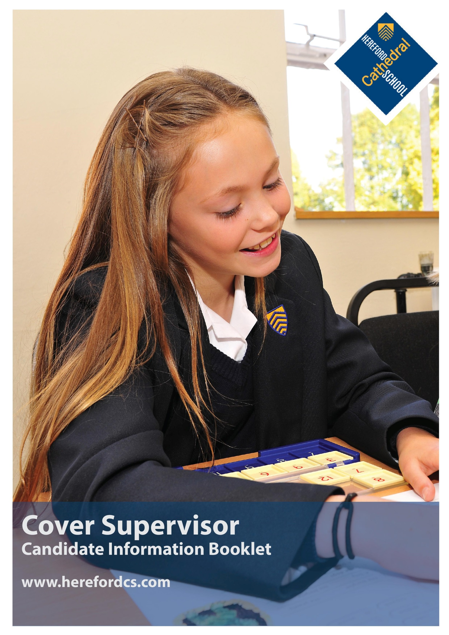

Welcome
Thank you for your interest in the position of Cover Supervisor at Hereford Cathedral School. I hope that this information booklet will help provide you with some insight into our School, Hereford city, and the outstanding county in which we are privileged to be located.

From our three year-olds in Nursery to our 18 year-olds in the Sixth Form, we seek to meet the specific needs of every pupil – providing stretch and challenge in the classroom and a wide variety of opportunities to develop individual interests, skills and self-esteem.

Alongside our small class sizes, excellent results and the outstanding range of opportunities on offer, we feel that our greatest strength lies in our friendly, family, inclusive ethos, encouraged by excellent staff pupil relations and a highly supportive parent body. It is this ethos, widely recognised as a special characteristic of the school, which enables pupils, young and old, to excel both in and out of the classroom.

The school is one of the UK’s leading independent co-educational day schools. We also benefit from the finest of settings, adjacent to a beautiful Cathedral and within a stone’s throw of the thriving city centre.

The Cover Supervisor will work with classes across the curriculum in the absence of teaching staff to ensure that work set by teaching staff is completed, behaviour is appropriate and to ensure the health and safety of all students.

I hope that the information provided in this pack gives you a sense of what to expect at Hereford Cathedral School and helps you to decide whether this is the right post for you. Please feel free to contact me directly if you have any further questions.

Paul Smith,
Headmaster

---

“Justifiably growing more self-assured, a school with a great deal to offer and an ethos of careful, thoughtful, nurture. Much to impress, with truly outstanding arts and music, a wide curriculum, a great sense of community service and genuine commitment to developing courage, confidence and a sense of adventure in even the quietest child.”

The Good Schools Guide Review 2013 of Hereford Cathedral School

Aims, Ethos & Vision

We provide boys and girls aged three to 18 with an excellent standard of teaching and individual care, offering them a broad range of opportunities to develop every aspect of their potential. The Hereford Cathedral School culture produces well-balanced, confident and considerate young adults ready for the wider world.

We seek:
- To meet pupils’ academic and personal needs and to promote the acquisition of moral values.
- To provide an environment in which pupils feel valued and learn to work co-operatively in a community.
- To provide a balanced, appropriate and challenging curriculum and a wide range of extra-curricular opportunities.
- To encourage pupils to achieve their academic potential and to foster a climate in which teaching and learning of high quality are given central priority.
- To ensure a high degree, within and outside the formal pastoral structure, of personal care, support and guidance.
- To respond to pupils’ aspirations and to be attentive to those of parents, and to their views.

As part of an ancient Cathedral foundation, and as a Choir School, which has the privilege of a Cathedral as its chapel, we are a Christian School in the Anglican tradition, although we welcome and value those of other denominations and faiths. Each pupil is encouraged to consider seriously and openly the Christian tradition within which the School is founded.

We place great value on maintaining close, constructive communication with parents and seek to establish the education of each pupil as a joint endeavour. While the academic development of each pupil is a central objective of both the school and the parent body, we seek, through example and ethos, to prepare our pupils for life beyond school by developing certain qualities and values. These include: self-discipline, diligence, acceptance of responsibility and challenge, regard for proper authority, honesty, courtesy, fairness, trustworthiness, loyalty, sensitivity to the needs and views of others, courage, and the capacity to look to the future.

Our aim is to fulfil our charitable status through service to the local community by support for Cathedral choristers, charitable fundraising, the loan of buildings and other services to the community. Through competitive fee levels and the award of choristerships, scholarships, and bursaries, the pupil body reflects a wide cross-section of the local population.

A Brief History

Hereford Cathedral School is amongst the oldest schools in the United Kingdom and is thought to have been founded as a song school attached to Hereford Cathedral in Anglo-Saxon times. The first written reference of the School dates back to Bishop Gilbert’s letter of 26th December 1384 appointing Richard of Cornwall as Headmaster.

The Junior School (formerly Hereford Cathedral Preparatory School) is also equally rich in history and was founded in 1898, moving to its current location in 1925.
“Parents are overwhelmingly positive and supportive of the School, and are very happy with the education their children receive.”

ISI Integrated Inspection 2014 of Hereford Cathedral Junior School

Life at the School

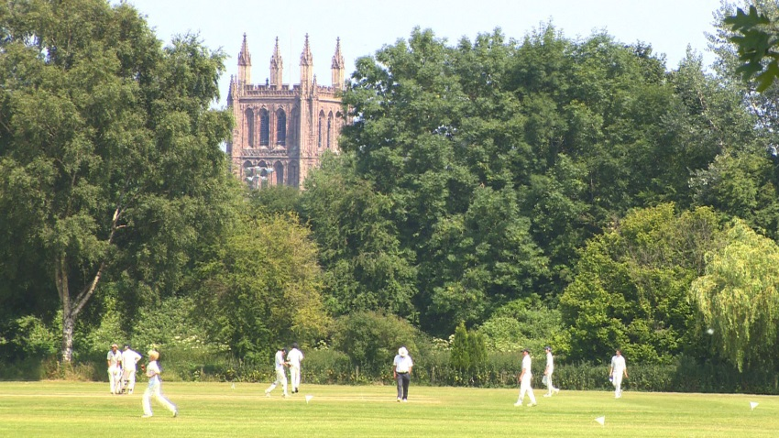
We are very much a family school, catering for pupils from age three to 18. Many of our pupils have siblings at the school, and in some cases their parents were here too. Pupils and parents are very loyal and supportive of ‘their’ school. We have a reputation for outstanding pastoral care and as a result pupils are remarkably tolerant and understanding of one another. It is important to us that every child is valued within our community. Good academic results are not enough: we seek to provide young people with the necessary skills and self-confidence to become well rounded, balanced adults who will make a positive contribution to those around them.

As a Cathedral School we expect pupils and staff to be sympathetic to our Christian ethos, although we welcome and value those of other faiths too.
“The children, from the nursery class eagerly talking about their book choices in the school library, to the reception children, busy with puzzles and problem solving, to year 4s enthusiastically reciting poetry, are the best possible advertisement for the school. Each child we spent time with was friendly, relaxed, happy and engaged. Bouncing about full of things to talk about. You can pretty much hear their little brains fizzing. A delightful place to start exploring life’s possibilities.”

The Good Schools Guide Review 2013 of Hereford Cathedral Junior School

Sport at the School

We love sport at Hereford Cathedral School and are proud of what our pupils and expert coaches achieve on and off the pitch, the court, the field and the river.

However, sport to us is about more than just exercise and physical well-being. We believe it is a key learning environment which contributes enormously to a child’s overall development, both psychologically and socially. From teamwork, friendship and leadership to self-esteem and self-worth, sport plays a pivotal role. As such, sport plays a major role in school life here and we encourage everybody, whatever their ability, to take part and have a go.

We play rugby and netball in the Autumn; football, hockey, rowing and 7s rugby in the Spring; and cricket, indoor cricket, rounders and athletics in the Summer. We also offer swimming, cross-country, badminton, equestrian competitions and tennis. Pupils have the opportunity to represent the school in an extensive fixture list and also during tours against local, regional, national and international schools, and we have had great success at local, county and regional levels.
Several of our students have also gone on to represent their counties, as well as England and Wales at under age-group levels.

Extra-Curricular Activities

We understand that a well-rounded education is about more than what happens in the classroom or on the sports field, and that’s why we offer and encourage our pupils to participate in a wide variety of outstanding extra-curricular opportunities. As a choir school, music forms a pivotal role in all that we do, and the school has a national reputation for choral music. Other opportunities include CCF, Debating, Drama, Duke of Edinburgh’s Award Scheme, Young Enterprise and a host of clubs and societies. There are also plenty of opportunities for pupils to participate in trips and tours - from trekking in Nepal, and skiing in Austria to Conservation Biology in Mexico.

We believe that providing such opportunities helps to develop self-esteem, and encourages important life skills such as leadership, teamwork, commitment and determination, as well as cultivating a sense of duty, and understanding of others. What happens outside the classroom also has a positive spin-off in lesson time, helping to engender an ethos of mutual respect between teachers and pupils.

“Extracurricular clubs in just about everything. Definitely a school where all interests are catered for.”

The Good Schools Guide Review 2013 of Hereford Cathedral School

The Curriculum

Our curriculum is well planned, wide ranging and enriching. Its balance and focus on individual development, helps us to stimulate an enquiring mind, establishing key skills and a wealth of experience in our pupils that will be of great benefit to them for the future.

Whole School A Level Results: (of all grades)

 | % A* grade | % A*/A grades | % A*-B grades | % A*-C grades
2016 | 16 | 45 | 73 | 87
2015 | 23 | 55 | 80 | 93
2014 | 19 | 48 | 76 | 93
2013 | 16 | 52 | 76 | 91
2012 | 25 | 56 | 79 | 93

Whole School GCSE Results: (of all grades)

 | % A* grade | % A*/A grades | % A*-B grades | % A*-C grades
2016 | 28.2 | 56.7 | 81 | 95
2015 | 35.3 | 58.3 | 77.3 | 87.2
2014 | 32 | 59 | 82 | 94
2013 | 35 | 63 | 84 | 97
2012 | 39 | 63 | 84 | 95
“Pupils’ success is the result of teaching of high quality within a broad and interesting curriculum, which includes many trips and talks from visitors, as well as the provision of a wide range of extra-curricular activities.”

ISI Integrated Inspection 2014 of Hereford Cathedral Junior School

ISI Integrated Inspection 2014

Main Findings | ISI Grading: HCS | ISI Grading: HCJS
The quality of academic and other achievements and learning:
- The quality of the pupils’ achievements and learning | Excellent | Excellent
- The contribution of curricular and extra-curricular provision | Excellent | Excellent
- The contribution of teaching | Excellent | Excellent
The quality of the pupils’ personal development:
- The spiritual, moral, social and cultural development of the pupils | Excellent | Excellent
- The contribution of arrangements for pastoral care | Excellent | Excellent
- The contribution of arrangements for welfare, health and safety | Excellent | Excellent
The effectiveness of governance, leadership and management:
- The quality of governance | Excellent | Excellent
- The quality of leadership and management, including links with parents, carers. | Excellent | Excellent
HCS: Hereford Cathedral School / HCJS: Hereford Cathedral Junior School
ISI use a four point grading scale when making judgements of quality, these are ‘Excellent’, ‘Good’, ‘Sound’ or ‘Unsatisfactory’.

“Staff know the pupils well and create a happy, friendly atmosphere, in which the pupils feel safe, secure and supported. They provide a high standard of help, guidance and monitoring, valued by the pupils and parents.”

ISI Integrated Inspection 2014 of Hereford Cathedral School

A cosmopolitan city, culture and a taste of tranquil countryside
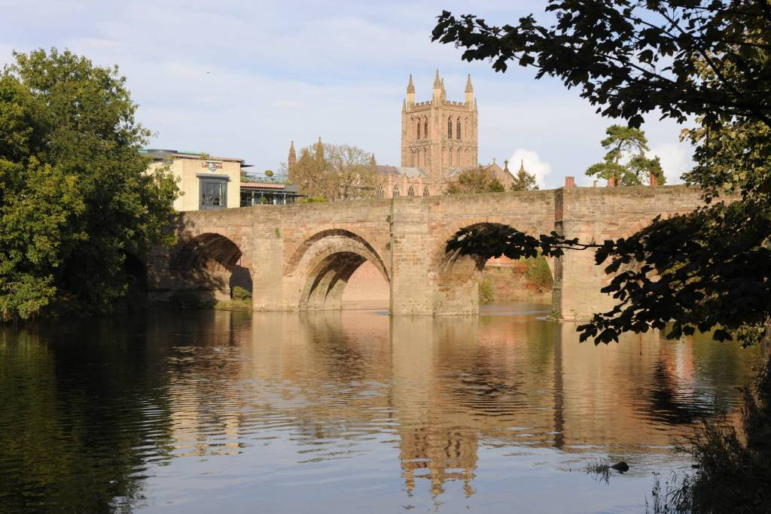
As a school we are fortunate to enjoy a position at the very heart of a fine cathedral city, at the centre of one of England’s least spoiled counties.
Hereford and the county beyond - with a range of housing to suit all tastes and price brackets, and ready access to beautiful countryside - affords an enviable quality of life. The River Wye flows past our doorstep through the city down to the Forest of Dean, while the Brecon Beacons, the Malvern Hills, Hay-on-Wye, with its internationally-acclaimed literary festival, and Ludlow, famous for its food festival, are all within easy commuting distance.
Hereford itself also offers a wide-range of independent eateries, great places to eat and drink; a new Odeon and a great shopping centre. Commuting is easy with great transport links to London, Birmingham and Cardiff.
A city renowned for its wonderful music, Hereford was also home to the composer Elgar for a significant period in his life. The cathedral and school play host to the Three Choirs Festival every three years, and everyday choral music of the very highest standard can be enjoyed at Evensong. For those with a more eclectic taste, the county is home to a host of talented musicians who regularly perform at venues and festivals across the region. It is little wonder that many people who have visited Hereford on holiday choose to settle in the area permanently.
www.visitherefordshire.co.uk

House Prices in Hereford (taken from www.rightmove.co.uk, 07/06/2017)

Last year most property sales in Hereford involved terraced properties which sold for on average £156,345. Semi-detached properties sold for an average price of £197,852, while detached properties fetched £281,277.
Hereford, with an overall average price of £197,808, was similar in terms of sold prices to nearby Credenhill (£200,861), but was cheaper than Lugwardine (£322,071) and Fownhope (£307,700).

During the last year, sold prices in Hereford were 3% up on the previous year and 11% up on 2007 when the average house price was £177,906.

“Pupils are an absolute delight – very supportive of one another, articulate and appreciative. Comfortable in their own skin, but not full of themselves. Extremely positive about the School and proud of their achievements, but no trace of entitlement or arrogance – if they are a little on the quiet side one gets the impression that this is the result of not having to shout in order to be heard.”

The Good Schools Guide Review 2013 of Hereford Cathedral School.

Quick Facts:

Hereford Cathedral Junior School (Head of Junior School: Mr Chris Wright)
28 Castle Street, Hereford HR1 2NW
Tel: 01432 363511, Email: enquiry@herefordcs.com, Website: www.herefordcs.com

Type: Day/Co-Education
Age Range: 3 to 11 years
Roll: 226 pupils
Fees: £2,624 to £3,307 per term
Inspection: ISI – Excellent in all areas (2014)
Affiliation: IAPS

Hereford Cathedral School (Headmaster: Mr Paul Smith)
Old Deanery, The Cathedral Close, Hereford HR1 2NG
Tel: 01432 363522, Email: schoolsec@herefordcs.com, Website: www.herefordcs.com

Type: Day/Co-Education
Age Range: 11 to 18 years
Roll: 486 pupils
Fees: £4,447 per term
Inspection: ISI – Excellent in all areas (2014)
Affiliation: HMC

COVER SUPERVISOR

Hereford Cathedral School is looking to appoint a Cover Supervisor to supervise the learning of whole classes in the event of the absence (planned or unplanned) of the teacher as they undertake the work set; to invigilate tests and examinations, provide administrative support to departments and to accompany staff and pupils on educational visits.
Work may be carried out in the classroom or outside the main teaching areas.
When not required for cover, to undertake pastoral duties and/or Teaching Assistant duties as part of the Learning Support department and supervise pupils as part of the duty rota and after school rota.
Work pattern: 35 hours per week, 5 days per week for 36 weeks per year (Term-time only).

Starting Salary: £21,332 FTE. This equates to £16,360 for the work pattern detailed above.

Start date: September 2017

You will have:
- experience of working with children and young people.
- excellent communication skills.
- Good levels of numeracy and literacy.
- the ability to be flexible with working arrangements.

We offer:
- an opportunity to be part of an enthusiastic and creative team.
- a working environment focused on teaching and learning.
- bright, friendly pupils.

An application form and information pack may be downloaded from the school website www.herefordcs.com/job-vacancies.
Completed applications should be accompanied by a covering letter and sent to
Mrs Cath Knowles, Hereford Cathedral School, Old Deanery, The Cathedral Close, Hereford HR1 2NG or to c.knowles@herefordcs.com

The closing date for applications is 28th June 2017.

The School is committed to safeguarding and promoting the welfare of children and young people and expects all members of staff and volunteers to share this commitment. Appointments are subject to enhanced DBS clearance and satisfactory pre-employment checks

Registered charity number 518889

Job Description: Cover Supervisor
Post Title | Cover Supervisor  Based at The Old Deanery, Cathedral Close, Hereford HR1 2NG
Salary Point(s) | 18-22
Hours/Weeks | 35 hours per week, 5 days per week for 36 weeks per year (Term-time only).

Purpose of this Job Description:
Hereford Cathedral School considers this document as a “snapshot” of the job and the tasks listed are not an exhaustive list. It aims to provide a clear guide at the time of writing to all that is involved about the requirements of the job. It will also be used to communicate expectations about performance and will be used to monitor effective performance.

The Organisation
Hereford Cathedral School is one of the UK’s leading independent co-educational day schools. providing boys and girls aged 3 to 18 with an excellent standard of teaching and individual care, offering them a broad range of opportunities to develop every aspect of their potential. The Hereford Cathedral School culture produces well-balanced, confident and considerate young adults ready for the wider world. We also benefit from one of the finest settings, adjacent to the beautiful Cathedral. We enjoy an air of tranquillity within a stone’s throw of the thriving city centre.

The School is committed to safeguarding and promoting the welfare of children and young people and expects all staff and volunteers to share this commitment.

Further information from http://www.herefordcs.com

Reporting Lines:
The post holder reports to the Academic Deputy Head.

Accountabilities:
To supervise the learning of whole classes in the event of the absence (planned or unplanned) of the teacher as they undertake the work set; to invigilate tests and examinations, provide administrative support to departments and to accompany staff and pupils on educational visits.

To ensure that work set by teaching staff is completed, behaviour is appropriate and to ensure the health and safety of all students.

Responsibilities:
- To receive the daily timetable and instructions from the Director of Studies.
- To liaise with Teachers and Heads of Departments to provide suitable cover for lessons for absent teachers
- To support students to engage with the work provided, including providing support where necessary with literacy, numeracy and organisational skills
- To feedback to the class teacher on pupil engagement and also on any issues that may have arisen during the covered lesson(s).
- Collect any completed work after the lesson and returning it to the appropriate teacher.
- To invigilate examinations as required.
- To be part of the duty team as required including lunchtime supervision of students
- To undertake pupil registration of a class, as required.
- To promote positive behaviour and relationships, using effective strategies in a timely manner in accordance with school policy
- To undertake pupil registration of a class, as required.
- To undertake Teaching Assistant duties as part of the Learning Support department and supervise pupils as part of the duty rota, after school rota and support elsewhere within the School.
- Attend meetings and training sessions as required.
- Abiding by and work towards all the policies within the school e.g. Safeguarding, behaviour management, Health & Safety, Equal Opportunities

Safeguarding and Protection of Children and Young Persons
In accordance with the Children’s Act 1989, on appointment post holders will be required to commit to their responsibilities with regards to safeguarding. In addition offers of appointment will be subject to an Enhanced criminal record check from the Disclosure and Barring Service (DBS).

These checks will highlight cautions, reprimands and final warnings as well as any convictions. The post holder must not have any spent or unspent convictions that would prevent working with children.

Health and Safety:
As an employee you are expected to:
- to take reasonable care of your own health and safety
- to take reasonable care not to put other people - fellow employees and members of the public - at risk by what you do or don't do in the course of your work
- to co-operate with your employer, making sure you get proper training and you understand and follow the company's health and safety policies
- not to interfere with or misuse anything that's been provided for your health, safety or welfare
- to report any injuries, strains or illnesses you suffer as a result of doing your job
- to tell your employer if something happens that might affect your ability to work (e.g. becoming pregnant or suffering an injury)
- if you drive or operate machinery, to tell your employer if you take medication that makes you drowsy

Particular H&S issues for this post are:
Occasional D.S.E

 | Person Specification
 | Essential Criteria | Desirable Criteria
Qualification | 5 A* - C GCSEs (including English and Maths) or equivalent | 2 A levels, NVQ level 3 or equivalent experience  Additional qualifications relating to practical skills, education, health/ social services  First Aid qualification
Experience and Knowledge | Knowledge, understanding and commitment to safeguarding and promoting the welfare of students  Experience of working within an educational setting  Sound understanding of equality of opportunity issues and how they can be effectively addressed in schools  Understanding of equality and diversity particularly within a school  Awareness of Safeguarding procedures and Health and Safety procedures
Skills/Abilities | Build effective relationships with young people, providing support for their learning  Ability to take responsibility and work with autonomy within set boundaries and expectations  Ability to work constructively as part of a team, understanding classroom roles and develop strong working relationships with colleagues.  An ability to respect sensitive and confidential work  Ability to work successfully with students and good understanding of effective procedures for managing and promoting positive behaviour among pupils  Ability to use ICT inside and outside of the classroom
Aptitude | Naturally demonstrates a ‘can do’ helpful attitude  Excellent attendance and punctuality  The confidence to manage and supervise effectively whole classes  Act as a role model, setting high expectations of conduct and behaviour  Strong interpersonal skills and ability to communicate effectively with young people and adults  Good organisation and personal management skills  High level of motivation and commitment
Circumstances | Able to work flexibly, some earlier starts, evenings and weekends will be occasionally required in support of wider school functions
Safeguarding Children, Young People and Vulnerable Adults | Understands their role in the context of safeguarding children, young people and vulnerable adults  Ability to form and maintain appropriate relationships and personal boundaries with children and young people
Equal Opportunities | Understanding of the requirements of Equality and Diversity

