



Walthamstow School
For Girls

“Neglect not the gift that is in thee”

Policy Document

Safeguarding and Promoting the Welfare of Children
Policy

Author(s): K Pratt

Ratification Date: December 2017

Next Review Date: December 2018

Reference: SG_POLICY_V1.0

CONTENTS | PAGE
Overview | 3
1 Introduction | 5
2 School Commitment | 5
3 Providing a Safe and Supportive Environment | 6
4 School Training and Staff Induction | 8
5 Related School Policies | 9
6 Roles and Responsibilities | 11
7 Identifying Children and Young People who may be Suffering Significant Harm | 12
8 Child Protection Procedures | 13
9 Female Genital Mutilation | 14
10 Anti-radicalisation / PREVENT and Channel | 16
11 Honour-based Violence | 17
12 Private Fostering Arrangements | 19
13 Domestic Abuse | 19
14 Child Sexual Exploitation | 20
15 Taking Action to Ensure that Children are Safe at School and at Home | 21
16 Allegations Regarding Person(s) Working in or on Behalf of the School (Including Volunteers) | 25
17 Children who Harm Others | 26
APPENDICES

A Waltham Forest VAWG Referral Pathways | 28
B Key Contacts for Child Protection in Waltham Forest | 29
C WSFG Safety and Welfare Concern Form | 30
D Action When a Child has Suffered or is Likely to Suffer Harm | 31
E Request for Help and Support or Protection | 32
F How to Escalate Professional Concerns About a Child | 42
G Allegations/Concerns Against Staff | 51

Safeguarding Policy for WSFG 2017/18

School - Walthamstow School for Girls

Headteacher - Meryl Davies

Named personnel with designated responsibility for Safeguarding

Academic Year | Designated Safeguarding Lead | Deputy Designated Safeguarding Lead | Nominated Safeguarding Governor | Chair of Governors
2017/18 | Kristine Pratt | Jonathan Gunzi Marianna Philippou | Daniel Phelps | Gillian Barker

Named personnel with designated responsibility regarding allegations against staff

Academic Year | Designated Senior Manager (this would normally be the Headteacher) | Deputy Designated Senior Manager | Chair of Governors | Nominated Governor
2017/18 | Meryl Davies | Kristine Pratt | Gillian Barker | Daniel Phelps

Dates the Safeguarding Policy is reviewed and dates of any safeguarding audits

Review Date | Changes made/Details of action plan | Due Date | By Whom
January 2016 | Safeguarding Audit | Completed | KPR / Forum Training
January 2017 | Safeguarding Audit | Completed | KPR / JGI
September 2017 | Review Policy | September 2017 | KPR / JGI
Spring 2018 | Safeguarding Audit (Borough) | Spring 2018 | KPR / JGI

Dates of Staff training and details of course title and training provider

Whole school | Designated Safeguarding Lead | Deputy Designated Safeguarding Lead
Reading part 1 of KCSIE guidance. Sign to show understanding. All staff  Sep- Nov 2016  All staff to complete in Spring 2018. | KPR | JGI / MPH
Briefing update on new guidance and notes out to all staff Sept 2016  Same update to Governors Oct 2016 | KPR | JGI / MPH
Further training on Child Protection, FGM, Forced Marriage, Honour-Based Violence, Prevent / Channel Nov 2016  Level 3 Safeguarding training update / KPR  Dec 2016 | KPR | JGI / MPH
On-line safety training Scheduled 2017 | KPR | JGI / DSH / RJA
Level 3 Safeguarding training update / MDA  Oct 2016 | KPR | JGI / MPH
Level 3 Safeguarding training update / KPR  Dec 2016 | KPR | JGI / MPH
Level 3 Safeguarding training extension / JKI  Dec 2016 | KPR | JGI / MPH
Level 3 Safeguarding training / MPU  Feb 2017 | KPR | JGI / MPH

Additional training for staff on local Safeguarding issues that may face our student population in Autumn 2017
Child Sexual Exploitation, Domestic Abuse, Children Missing Education / Gang Affiliation / County Lines.
1. INTRODUCTION

This policy has been developed in accordance with the principles established by the Children Acts 1989 and 2004; the Education Act 2002, and in line with government publications [Section 175 of the Education Act 2002 requires local education authorities and the governors of maintained schools and further education (FE) colleges to make arrangements to ensure that their functions are carried out with a view to safeguarding and promoting the welfare of children].

Section 157 of the same act and the Education (Independent Schools Standards) (England) Regulations 2003 require proprietors of independent schools (including academies and city technology colleges) to have arrangements to safeguard and promote the welfare of children who are pupils at the school.

This policy is in line with statutory guidance for schools and colleges; Keeping Child Safe in Education (update 2016), Working Together to Safeguard Children (2015), London Child Protection Procedures (5th Edition), ‘What to do if You are Worried a Child is Being Abused’ 2015 and WF Early Help and Threshold Criteria for Intervention

The Teacher Standards 2012 state that teachers, including Headteachers should safeguard children’s wellbeing and maintain public trust in the teaching profession as part of their professional duties.

- The statutory guidance Keeping Children Safe in Education update 2016 is issued under Section 175 of the Education Act 2002, the Education (Independent School Standards) Regulations 2014 and the Education (Non-Maintained Special Schools) (England) Regulations 2011. Schools and colleges must have regard to this guidance when carrying out their duties to safeguard and promote the welfare of children. Unless otherwise stated, ‘school’ in this guidance means all schools, whether maintained, non-maintained or independent, including academies and free schools, alternative provision academies and pupil referral units. ‘School’ includes maintained nursery schools. ‘College’ means further education colleges and sixth form colleges as established under the Further and Higher Education Act 1992 and relates to their responsibilities to children under the age of 18 (but excludes 16-19 academies and free schools, which are required to comply with relevant safeguarding legislation by virtue of their funding agreement).

- All staff must read Part One of this guidance and staff will be provided with a personal copy by the school (September 2016 on SCR).

Everyone working in or for our school service shares an objective to help keep children and young people safe by contributing to:

- Providing a safe environment for children and young people to learn and develop in our school setting.
- Identifying children and young people who are suffering or likely to suffer significant harm, and taking appropriate action with the aim of making sure they are kept safe both at home and in our school setting.
2. SCHOOL COMMITMENT

Walthamstow School for Girls is committed to safeguarding and promoting the welfare of all of its pupils. Each students’ welfare is of paramount importance.

We recognise that:

- Some children may be especially vulnerable to abuse.
- Children who are abused or neglected may find it difficult to develop a sense of self worth and to view the world in a positive way. Whilst at school, their behaviour may be challenging.
- Children can be victims and perpetrators of abuse.
- Children who harm others may have been abused themselves.
- Allegations can be made against staff, however careful and safe our recruitment practices.
- Early identification of issues promotes the welfare and care of children

This policy will be updated annually and known to everyone working in the school and the Governing Body. The Governing Body takes seriously its responsibility under Section 175 of the Education Act 2002 to safeguard and promote the welfare of children and to work together with other agencies to ensure adequate arrangements within our school to identify, assess, and support those children who are suffering harm.

The school’s safeguarding arrangements are inspected by Ofsted under the judgements for Behaviour & Safety, and Leadership & Management.

This policy is available on the school website and is included in the Staff Handbook.

It will also be available to parents / carers on request.

There will be an annual Safeguarding Audit Questionnaire of Safeguarding Policy and Practice (carried out under section 175 of the Education Act 2002). This will be shared in preparation for the Section 11 Audit due in December 2016.

3. PROVIDING A SAFE AND SUPPORTIVE ENVIRONMENT

3.1 Safer Recruitment and Selection

- The school pays full regard to the statutory guidance for schools and colleges; Keeping Children Safe in Education (2015). We ensure that all appropriate measures are applied in relation to everyone who works in the school and who is therefore likely to be perceived by the children as a safe and trustworthy adult. This includes volunteers, supervised volunteers and staff employed by contractors. Safer recruitment practice includes scrutinising applicants, verifying identity and academic or vocational qualifications, obtaining professional references, checking previous employment history and ensuring that a candidate has the health and physical capacity for the job. It also includes undertaking interviews and checks with the Disclosure and Barring Service (DBS).
Our school endeavours to ensure that we do our utmost to employ safe staff by following the guidance in Keeping Children Safe in Education (2015) together with the LSCB and the school’s Staff Recruitment policy and procedures.

Safer recruitment means that applicants will:

- Complete an application form which includes their employment history and explains any gaps in that history.
- Provide two referees, including at least one who can comment on the applicant’s suitability to work with children.
- Provide evidence of identity and qualifications.
- If offered employment, be checked in accordance with the Disclosure and Barring Service (DBS) regulations as appropriate to their role. This will include an enhanced DBS check and a Barred List Check for those engaged in regulated activity.
- If offered employment, provide evidence of their right to work in the UK.
- Be interviewed, if shortlisted.

The school will also:

- Verify the preferred candidate’s mental and physical fitness to carry out their work responsibilities.
- Obtain references for all shortlisted candidates, including internal candidates.
- Carry out additional or alternative checks for applicants who have lived or worked outside the UK.
- Ensure that applicants for teaching posts are not subject to a prohibition order issued by the Secretary of State.

At least one member of each recruitment panel will have attended safer recruitment training.

All new members of staff will undergo an induction that includes familiarisation with the school’s Child Protection Policy and Code of Conduct Policy & Procedures and identification of their Child Protection training needs.

All staff are required to sign to confirm they have received a copy of the Child Protection Policy and Code of Conduct Policy & Procedures Autumn Term 2016. All staff to read and sign Spring Term 2018.
All relevant staff are made aware of the Disqualification and Disqualification by Association legislation and their obligations to disclose relevant information to the school.

The school maintains a Single Central Record of recruitment checks undertaken.

3.2 Regulated Activity
Schools are ‘specified places’ which means that the majority of staff and volunteers will be engaged in regulated activity. A fuller explanation of regulated activity can be found in Keeping Children Safe in Education (2015) Part 3.

3.3 Volunteers
Volunteers, including governors will undergo checks commensurate with their work in the school and contact with pupils. Under no circumstances will a volunteer who has not been appropriately checked be left unsupervised or be allowed to engage in regulated activity.

3.4 Supervised Volunteers

Volunteers who work only in a supervised capacity and are not in regulated activity will undergo the safe recruitment checks appropriate to their role, in accordance with the school’s risk assessment process and statutory guidance.

3.5 Contractors

The school checks the identity of all contractors working on site and requests DBS checks and Barred List checks where required by statutory guidance. Contractors who have not undergone checks will not be allowed to work unsupervised or engage in regulated activity.

This school is committed to keeping an up to date Single Central Record detailing a range of checks carried out on our staff.
Meryl Davies (Headteacher)
Daniel Phelps (Designated School Governor)
Gillian Barker (Chair of Governors)

3.6 Safe Practice

Our school will comply with the current Guidance for Safer Working Practice for Adults who Work with Children and Young People and ensure that information in this guidance regarding conduct, is known to all staff, visitors and volunteers who come into the school.

Safe working practice ensures that pupils are safe and that all staff

- Are responsible for their own actions and behaviour and should avoid any conduct which would lead any reasonable person to question their motivation and intentions.
- Work in an open and transparent way.
- Work with other colleagues where possible in situations that could be open to question.
- Discuss and/or take advice from school management over any incident which may give rise for concern.
- Record any incidents or decisions made.
- Apply the same professional standards regardless of diversity issues.
- Be aware of information-sharing and confidentiality policies.
- Are aware that breaches of the law and other professional guidelines could result in criminal or disciplinary action being taken against them.

3.7 Helping Children to Keep Themselves Safe

Students are taught to understand and manage risk through our personal, social, health and economic (PSHE) education and Sex & Relationships lessons and through all aspects of school life. Our approach is designed to help students to think about risks they may encounter and with the support of staff work out how those risks might be reduced or managed. Discussions about risk are empowering and enabling for all children and promote sensible behaviour rather than fear or anxiety. Students are taught how to conduct themselves and how to behave in a responsible manner. They are also reminded regularly about e-safety, the risks of sharing content and images online and tackling bullying, including cyber bullying procedures. The school continually promotes an ethos of respect for young people and students are encouraged to speak to a member of staff of their choosing about any worries they may have.

All students know there is Designated Safeguarding Lead responsible for safeguarding and who this is and that they have a right to speak to this member of staff in confidence. They are reminded that confidentiality cannot be guaranteed, but that they will be listened to, heard and informed of what steps can be taken to protect them from harm and that feedback will be sought, so that their views about actions taken are known.

3.8 Partnership with Parents

The school shares a purpose with parents to educate and keep children safe from harm and to have their welfare promoted. We are committed to working with parents positively, openly and honestly. We ensure that all parents are treated with respect, dignity and courtesy. We respect parents’ rights to privacy and confidentiality and will not share sensitive information unless we have permission or it is necessary to do so in order to protect a child.

The school will, in most circumstances, endeavour to discuss all concerns with parents about their children. However, there may be exceptional circumstances when the school will discuss concerns with Social Care and/or the Police without parental knowledge (in accordance with the London Child Protection Procedures). The school will, of course, always aim to maintain a positive relationship with all parents. The school’s Safeguarding Policy is available on request.

3.9 Partnerships with Others

Our school recognises that it is essential to establish positive and effective working relationships with other agencies that are partners of the Waltham Forest Safeguarding Children Board. There is a joint responsibility on all these agencies to share information to ensure the safeguarding of all children.

4. SCHOOL TRAINING AND STAFF INDUCTION

4.1 Training

The school’s Designated Safeguarding Lead and Governor with Designated Responsibility for Safeguarding will undertake Child Protection training for Designated Safeguarding Leads and refresher training at two yearly intervals.

All other school staff, including non-teaching staff, will undertake appropriate induction training and Safeguarding/Child Protection training to enable them to carry out their responsibilities for safeguarding effectively, which will be updated regularly.

All staff (including temporary staff, volunteers, supervised volunteers and staff employed by contractors) are provided with the school’s Safeguarding Policy and informed of the school’s safeguarding arrangements on induction.

4.2 Support, Advice and Guidance for Staff

Staff will be supported by Kristine Pratt DSL, Jonathan Gunzi and Marianna Philippou Deputy DSLs.
The DSL will be supported by Meryl Davies, Headteacher and Daniel Phelps, Governor with Designated Responsibility for Safeguarding.

The DSL will know how to access the on-line London Child Protection Procedures.

If unsure whether or not to make a referral to Children’s Social Care, contact the Waltham Forest Multi Agency Safeguarding Hub (MASH) Team/Children’s Referral and Advice Team based at Juniper House.

See Appendix B – Key Contacts for Child Protection Issues in Waltham Forest.

5. RELATED SCHOOL POLICIES

Safeguarding covers more than the contribution made to Child Protection in relation to individual children. It also encompasses issues such as pupil health and safety, bullying and a range of other issues, for example, arrangements for meeting the medical needs of children, providing first aid, school security, drugs & substance misuse, positive behaviour etc. There may also be other safeguarding issues that are specific to the local area or population.

5.1 Anti-Bullying Policy (2016)

While bullying between children is not a separate category of abuse and neglect, it is a very serious issue that can cause considerable anxiety and distress. At its most serious level, bullying can have a disastrous effect on a child’s wellbeing and in very rare cases has been a feature in the suicide of some young people. WSFG promotes positive student behaviour.

All incidences of bullying, including cyber-bullying and prejudice-based bullying should be reported and will be managed through our tackling-bullying procedures. All pupils and parents receive a copy of the procedures on joining the school and the subject of bullying is addressed at regular intervals in PSHE education. If the bullying is particularly serious, or the tackling bullying procedures are deemed to be ineffective, the Headteacher and the DSL will consider implementing Child Protection procedures.

5.2 E-Safety Policy (2016)

The school recognises that its students will use mobile phones and computers at some time. They are a source of fun, entertainment, communication and education.

Our students increasingly use electronic equipment on a daily basis to access the Internet and share content and images via social networking sites such as Facebook, Twitter, MSN, tumblr, Snapchat and Instagram.

Unfortunately some adults and young people will use these technologies to harm children. The harm might range from sending hurtful or abusive texts and emails, to grooming and enticing children to engage in sexually harmful conversations, webcam photography or face-to-face meetings. Pupils may also be distressed or harmed by accessing inappropriate websites that promote unhealthy lifestyles, extremist behaviour and criminal activity.

The school’s E-Safety Policy explains how we try to keep students and adults safe in school and protect and educate pupils in the safe use of technology. Cyberbullying and sexting by pupils will be treated as seriously as any other type of bullying and will be managed through our anti-bullying procedures. Serious incidents may be managed in line with our sexual exploitation policy or child protection procedures.

Many students own or have access to hand held devices and parents are encouraged to consider measures to keep their children safe when using the internet and social media at home and in the community. All students and parents/carers are made aware of and sign the Acceptable Use of ICT Policy which details the regulations for using ICT facilities on the school site.

All staff will receive e-safety training and the school’s E-Safety Coordinator is Dave Shackson.

Chatrooms and social networking sites are the most obvious sources of inappropriate and/or harmful behaviour and students are not allowed to access these in school. Some students will undoubtedly ‘chat’ on mobiles or social networking sites at home and parents are encouraged to consider measures to keep their children safe when using social media.

The school has an E-Safety Policy that is known to all staff and students.

5.3 Photography and Images

The vast majority of people who take or view photographs or videos of children do so for entirely innocent, understandable and acceptable reasons. Sadly, some people abuse children through taking or using images, so we must ensure that we have safeguards in place.

To protect students we will:

- Seek their consent for photographs to be taken or published (e.g. on our website or in newspapers or publications).
- Seek parental consent.
- Ensure students are appropriately dressed.
- Encourage students to tell us if they are worried about any photographs that are taken of them.

5.4 Children Missing Education (CME) and Children Missing from Education (CMfE)

Attendance, absence and exclusions are closely monitored. A child going missing from education is a potential indicator of abuse and neglect, including sexual abuse and sexual exploitation. The DSL will monitor unauthorised absence and take appropriate action including notifying the Local Authority, particularly where children go missing on repeated occasions and/or are missing for periods during the school day. Staff must be alert to signs of children at risk of travelling to conflict zones, Female Genital Mutilation and forced marriage.

The school follows the Safeguarding Children Practice Guidance; Children Missing from School, from the London Child Protection Procedures and will refer all cases of concern to their Attendance Lead, the Borough EWO and Children’s Social Care.

Where parents inform our school that they wish to 'home educate' their child, our school will inform the Local Authority’s Behaviour, Attendance, Children Missing Education (BACME) Service and the School Admissions Service who will implement the ‘Elective Home Education’ procedure.

In Waltham Forest, the BACME Service within Early Help is responsible for the delivery of CME (Children Missing Education) duties defined by the Education Act Amendments.

In Waltham Forest, the BACME Service within Early Help is responsible for agreeing and monitoring CMfE (Children Missing from Education) with the Procedures for Once a School Place has Been Offered.

5.5 Extended School and Off-Site Arrangements

Where extended school activities are provided by and managed by the school, our own Safeguarding Policy and procedures apply. If other organisations provide services or activities on our site we will check that they have appropriate procedures in place, including safer recruitment procedures.

When our students attend off-site activities, including day and residential visits and work related activities, we will check that effective safeguarding arrangements are in place.

5.6 Confidentiality

The school will operate with regard to Information Sharing: Guidance for practitioners and managers (2015), and have a clear and explicit confidentiality policy.

“Where there is a concern that the child may be suffering or is at risk of suffering significant harm, the child’s safety and welfare must be the overriding consideration.“

The school policy should indicate:

- When information must be shared with police and social care where the child/young person is / may be at risk of significant harm.
- When the student’s and/or parent’s confidentiality must not be breached.
- That information is shared on a “need to know” basis.

5.7 Student Information

The School’s record-keeping policy for child welfare and child protection is consistent with DfE guidance, which is known to all staff.

In order to keep children safe and provide appropriate care for them, our school requires accurate and up to date information regarding:

- Names and contact details of persons with whom the child normally lives.
- Names and contact details of all persons with parental responsibility (if different from above).
- Emergency contact details (if different from above).
- Details of any persons authorised to collect the child from school (if different from above).
- Any relevant court orders in place including those, which affect any person’s access to the child (e.g. Residence order, contact order, care order, injunctions etc.).
- If the child is or has been subject to a Child Protection Plan or Care Plan.
- Name and contact detail of GP.
- Any other factors which may impact on the safety and welfare of the child.

The school will collate, store and agree access to this information.

All Child Protection documents will be retained in a Child Protection File, separate from the child’s main file. The main file will clearly show an alert that a Child Protection File exists and the location of this. This Child Protection File will be locked away and only accessible to the Headteacher and the Designated Safeguarding Lead. These records will be copied and transferred to any school or setting the child moves to, clearly marked ‘Child Protection, Confidential, FAO Designated Person Child Protection’. Original copies will be retained according to the school policy on retention of records.
The school has purchased “Safeguard” programme that will begin to be used for record keeping Spring Term 2018.

6. ROLES AND RESPONSIBILITIES

Our Governing Body will ensure that:

- The school has a Safeguarding Policy and procedures in place that are in accordance with Local Authority guidance and locally agreed inter-agency procedures, and the policy is made available to parents on request.
- The school operates safer recruitment procedures and makes sure that all appropriate checks are carried out on staff and volunteers who work with children.
- The school follows the London Child Protection Procedures for dealing with allegations of abuse against staff and volunteers.
- A senior member of the school’s Leadership Team is designated to take lead responsibility for safeguarding (and deputy).
- They have a named Governor with Designated Responsibility for Safeguarding.
- Staff undertake appropriate Safeguarding/Child Protection training, at regular intervals.
- They remedy, without delay, any deficiencies or weaknesses regarding safeguarding arrangements.
- A Governor is nominated to be responsible for liaising with the Local Authority and /or partner agencies in the event of allegations of abuse being made against the Headteacher.
- Where services or activities are provided on the school premises by another body, the body concerned has appropriate policies and procedures in place in regard to safeguarding children and liaises with the school on these matters where appropriate.
- They review their policies and procedures annually and provide information to the Local Authority about them and about how the above duties have been discharged.

The Headteacher Will Ensure That:

- The policies and procedures adopted by the Governing Body or Proprietor are fully implemented, and followed by all staff, to promote the best outcomes for the welfare of children.
- Sufficient resources and time are allocated to enable the DSL and the Deputy DSL to carry out their roles effectively including the assessment of pupils and attendance of strategy discussions and other necessary meetings e.g. Child Protection conferences and core group meetings.
- All staff and volunteers feel able to raise concerns about poor or unsafe practice in regard to children, and such concerns are addressed sensitively and effectively in a timely manner in accordance with the agreed Whistle Blowing Policy (Appendix C).
- All pupils are provided with opportunities throughout the curriculum to learn about safeguarding, including keeping themselves safe online.
- The school has completed the on-line Safer Recruitment training.
- The procedure for managing allegations against staff is known to staff and displayed in staff rooms.
- Operate the procedure for managing allegations effectively and refer relevant concerns to the Local Authority Designated Officer (LADO).
- That anyone who has harmed or may pose a risk to a child is referred to the DBS.
- A Deputy Headteacher is appointed to deal with allegations against staff in the absence of the Headteacher.

Senior Member of Staff with Designated Responsibility for Child Protection will:

Referrals

- Refer cases of suspected abuse or allegations to Children’s Social Care or appropriate services and maintain a record of all referrals.
- Act as a source of support, advice and expertise within the educational establishment and have access to the online London Child Protection Procedures.
- Liaise with the Headteacher to inform them of any issues and ongoing investigations and ensure there is always cover for this role.

Training

- Recognise how to identify signs of abuse and know when it is appropriate to make a referral.
- Have knowledge of the escalation policy, the Local Authority Designated Officer (LADO) role, conduct of a Child Protection Case Conference and be able to attend and contribute to these.
- Ensure that all staff have access to and understand the school’s Safeguarding Policy.
- Ensure that all staff have induction training.
- Keep detailed, accurate and secure written records.
- Obtain access to resources and attend any relevant or refresher training courses every two years.

Raising Awareness

- Ensure the Safeguarding Policy is updated and reviewed annually and work with the Governing Body regarding this
- Ensure parents are made aware of the Safeguarding Policy which alerts them to the fact that referrals may be made and the role of the establishment in this to avoid conflict later.
- Where a child leaves the establishment, ensure the Child Protection File is copied for the new establishment as soon as possible and transferred to the new school separately from the main student file, as well as ensure the student’s social worker is informed.

All staff and volunteers will:

Fully comply with the school’s policies and procedures, attend appropriate training and inform the designated safeguarding lead of any concerns.

7. IDENTIFYING CHILDREN AND YOUNG PEOPLE WHO MAY BE SUFFERING SIGNIFICANT HARM

Teachers and other adults in school are well placed to observe any physical, emotional or behavioural signs, which indicate that a child may be suffering significant harm. The relationships between staff, pupils, parents and the public which foster respect, confidence and trust can lead to disclosures of abuse, and/or school staff being alerted to concerns.

As in the Children Acts 1989 and 2004, a child is anyone who has not yet reached his/her 18th birthday.

Harm means ill-treatment or impairment of health and development, including, for example, impairment suffered from seeing or hearing the ill-treatment of another; Development means physical, intellectual, emotional, social or behavioural development; Health includes physical and mental health; Ill-treatment includes sexual abuse and other forms of ill-treatment which are not physical.

Abuse and Neglect are forms of maltreatment. Somebody may abuse or neglect a child by inflicting harm or failing to act to prevent harm. Children may be abused in a family or in an institutional or community setting, by those known to them, or, more rarely, by a stranger. They may be abused by an adult or adults, another child, children or young people. There are four categories of abuse; physical abuse, emotional abuse, sexual abuse and neglect.

8. CHILD PROTECTION PROCEDURES

8.1 Recognising abuse

To ensure that our pupils are protected from harm, we need to understand what types of behaviour constitute abuse and neglect.

Abuse and neglect are forms of maltreatment. Somebody may abuse or neglect a child by inflicting harm, for example by hitting them, or by failing to act to prevent harm, for example by leaving a small child home alone, or leaving knives or matches within reach of an unattended toddler.

Abuse may be committed by adult men or women and by other children and young people.

There are four categories of abuse.

8.2 Physical Abuse
Physical abuse is a form of abuse which may involve hitting, shaking, throwing, poisoning, burning or scalding, drowning, suffocating or otherwise causing physical harm to a child. Physical harm may also be caused when a parent or carer fabricates the symptoms of, or deliberately induces, illness in a child (this used to be called Munchausen’s Syndrome by Proxy, but is now more usually referred to as Fabricated or Induced Illness).

8.3 Emotional Abuse
Emotional abuse is the persistent emotional maltreatment of a child such as to cause severe and persistent adverse effects on the child’s emotional development. It may involve conveying to a child that they are worthless or unloved, inadequate, or valued only insofar as they meet the needs of another person. It may include not giving the child opportunities to express their views, deliberately silencing them or making fun of what they say or how they communicate. It may feature age or developmentally inappropriate expectations being imposed on children. These may include interactions that are beyond a child’s developmental capability, as well as overprotection and limitation of exploration and learning, or preventing the child participating in normal social interaction. It may involve seeing or hearing the ill-treatment of another. It may involve serious bullying (including cyber bullying), causing children frequently to feel frightened or in danger, or the exploitation or corruption of children. Some level of emotional abuse is involved in all types of maltreatment of a child, although it may occur alone.

8.4 Sexual Abuse
Sexual abuse involves forcing or enticing a child or young person to take part in sexual activities, not necessarily involving a high level of violence, whether or not the child is aware of what is happening. The activities may involve physical contact, including assault by penetration (for example, rape or oral sex) or non-penetrative acts such as masturbation, kissing, rubbing and touching outside of clothing. They may also include non-contact activities, such as involving children in looking at, or in the production of, sexual images, watching sexual activities, encouraging children to behave in sexually inappropriate ways, or grooming a child in preparation for abuse (including via the internet). Sexual abuse is not solely perpetrated by adult males. Women can also commit acts of sexual abuse, as can other children.

8.5 Neglect
Neglect is the persistent failure to meet a child’s basic physical and/or psychological needs, likely to result in the serious impairment of the child’s health or development. Neglect may occur during pregnancy as a result of maternal substance abuse. Once a child is born, neglect may involve a parent or carer failing to

- Provide adequate food, clothing and shelter (including exclusion from home or abandonment).
- Protect a child from physical and emotional harm or danger.
- Ensure adequate supervision (including the use of inadequate care-givers).
- Ensure access to appropriate medical care or treatment. It may also include neglect of, or unresponsiveness to, a child’s basic emotional needs.

Definitions taken from Keeping Children Safe in Education 2015.

8.6 Children who may be Particularly Vulnerable

Some children may have an increased risk of abuse. Many factors can contribute to an increase in risk, including prejudice and discrimination, isolation, social exclusion, communication issues and a reluctance on the part of some adults to accept that abuse can occur.

To ensure that all of our students receive equal protection, we will give special consideration to children who are:

- Disabled or have special educational needs.
- Young carers.
- Affected by parental substance misuse, domestic violence or parental mental heath needs.
- Asylum seekers.
- Living away from home.
- Vulnerable to being bullied, or engaging in bullying.
- Living in temporary accommodation.
- Live transient lifestyles.
- Living in chaotic and unsupportive home situations.
- Vulnerable to discrimination and maltreatment on the grounds of race, ethnicity, religion, disability or sexuality.
- At risk of sexual exploitation.
- Do not have English as a first language.
- At risk of Female Genital Mutilation (FGM).
- At risk of forced marriage.
- At risk of being drawn into extremism.

This list provides examples of additionally vulnerable groups and is not exhaustive. Special consideration includes the provision of safeguarding information and resources in community languages and accessible formats for children with communication needs.

9. FEMALE GENITAL MUTILATION (FGM)

FGM is illegal in the UK and a form of child abuse with long-lasting harmful consequences. Professionals in all agencies, and individuals and groups in relevant communities, need to be alert to the possibility of a girl being at risk of FGM, or already having suffered FGM.

FGM refers to procedures of any alteration involving partial or total removal of the external female genital organs. The procedure may lead to short term and long-lasting harmful consequences such as death, trauma, infections, flashbacks, infertility, kidney problems, sexual dysfunctions, incontinence, post-traumatic stress disorder etc. It is known to be practised in the North African countries, the Middle-East, Indonesia, Malaysia, India and Pakistan. However, with migration worldwide it is also practised in the UK, the USA, Canada, Australia etc.

One of the prominent reasons for the practice is to suppress women’s sexual desire. There is a social pressure on women to undergo the procedure otherwise they may be segregated by their peers, or labelled “unclean”. Furthermore, FGM is often a requirement for getting married in practicing communities. FGM is not a religious practice.

9.1 Indicators

There is a range of potential indicators that a girl may be at risk of FGM.
FGM often takes place in the summer holidays, as the recovery period after FGM can be 6 to 9 weeks. Professionals should be mindful of at risk times when children go on long holidays and/or are getting a visit by female elder from their country of origin. Additionally, girls are considered at risk where their mother or sisters have undergone FGM, and girls are talking about a ‘special’ event or procedure to ‘become a woman.’

The post FGM symptoms include, but are not limited to, difficulty in walking, sitting or standing, spending longer than normal in the bathroom or toilet, unusual behaviour after a lengthy absence, reluctance to undergo normal medical examinations, and asking for help but not being explicit about the problem due to embarrassment or fear. They can sometimes ask about their friend’s problem rather than their problem. Professionals should raise an alert to Child Social Care via the MASH if they have any FGM concerns.

Further information on warning signs that FGM may be about to take place, or may have already taken place, can be found on pages 16-17 of the Multi-Agency Practice Guidelines, and Chapter 9 of those Guidelines (pages 42-44), which focuses on the role of schools and colleges.

9.2 Actions

The United Nations addresses FGM as violation of human rights. In the UK FGM is a criminal offence and a harmful form of child abuse. It is illegal to practice in the UK and/or anyone involved in taking girl outside of the UK to have FGM carried out will be punished under the FGM act 2003 and Serious Crime Act 2015. LBWF follows a comprehensive approach comprising prevention, punishment, enforcement, support and protection measures to safeguard young girls from FGM.

If staff have a concern they should activate local safeguarding procedures via the MASH, using existing national and local protocols for multi-agency liaison with the police and Children’s Social Care. When mandatory reporting commences in October 2015 (see below) these procedures will remain when dealing with concerns regarding the potential for FGM to take place. Where a teacher discovers that an act of FGM appears to have been carried out on a girl who is aged under 18, there will be a statutory duty upon that individual to report it to the police.

9.3 Mandatory Reporting Duty

Section 5C of the Female Genital Mutilation Act 2003 (as inserted by Section 75 of the Serious Crime Act 2015) gives the Government powers to issue statutory guidance on FGM to relevant persons. Once the Government issues any statutory multi-agency guidance this will apply to schools and colleges.

Section 5B of the Female Genital Mutilation Act 2003 (as inserted by Section 74 of the Serious Crime Act 2015) will place a statutory duty upon teachers, along with social workers and healthcare professionals, to report to the police where they discover (either through disclosure by the victim or visual evidence) that FGM appears to have been carried out on a girl under 18. Those failing to report such cases will face disciplinary sanctions. It will be rare for teachers to see visual evidence, and they should not be examining pupils – it is likely that discovery will be made by disclosure by the student, parent or otherwise. These cases must be referred to police (via the local CAIT team or by calling 101). Immediate reporting is required if FGM has been performed recently, and in non-recent cases, reporting must take place as soon as possible and in exceptional cases within one month.

Mandatory reporting duty will commence in October 2015. Unless the teacher has a good reason not to, they should still consider and discuss any such case with the school’s Designated Safeguarding Lead and involve Children’s Social Care as appropriate.
WSFG will also:

- Circulate and display materials about FGM.
- Display relevant information (for example, details of the NSPCC’s Helpline and appropriate black and minority ethnic women’s groups).
- Inform colleagues/raise awareness of the issues around FGM – as well as including appropriate training in continuing professional development.
- Introduce FGM into the school curriculum in relevant classes, such as personal, social and health education (PSHE) and/or citizenship.

9.4 Reference and further information

- Keeping children safe in education, DfE (see pages 14-15), Multi-agency practice guidelines: FGM, Home Office, DfE (see pages 8, 16, 17 and 42)
- http://www.londonscb.gov.uk/fgm/

For support around training around FGM for teachers and students, please contact:

Waltham Forest Multi Agency Safeguarding Hub

221 Hoe Street
Walthamstow
London
E17 9PH
Phone: 020 8496 2310 (Monday - Thursday 09.00-17.15 and Friday 09.00-17.00)
Mobile: 020 8496 3000 (Out of Hours)
Fax: 020 8496 2313
Email: MASHrequests@walthamforest.gov.uk

10. ANTI-RADICALISATION / PREVENT AND CHANNEL

At WSFG we are fully aware of and committed to the on-going protection and safety of our pupils, staff and wider community in accordance with DfE guidance ‘Working together to Safeguard Children’ (2015) and ‘Keeping Children Safe in Education’ (2015). An integral part of that work relates to the Government’s PREVENT strategy and the duties it places on academic institutions.

Our school is committed to providing a secure environment for students, where children feel safe and are kept safe. All adults in our school recognise that safeguarding is everyone’s responsibility irrespective of the role they undertake or whether their role has direct contact or responsibility for children or not. Staff will be alert to issues including

- Disclosures by students of their exposure to the extremist actions, views or materials of others outside of school, such as in their homes or community groups.
- Graffiti symbols, writing or art work promoting extremist messages or images.
- Students accessing extremist material online, including through social networking sites.
- Parental reports of changes in behaviour, friendship or actions and requests for assistance.
- Use of extremist or ‘hate’ terms to exclude others or incite violence.
- Intolerance of difference, whether secular or religious or, in line with our equalities policy, views based on, but not exclusive to, gender, disability, homophobia, race, colour or culture.

By continually developing our leadership and accountability practices, staff training opportunities (primarily the Home Office developed WRAP Training), referral systems and management of those referrals, we strive to demonstrate a pro-active and diligent approach to this aspect of our responsibilities as educators and safe-guarders.

Aligned with a consistent delivery of a broad and balanced curriculum and use of the Local Authority-sanctioned
Self-Assessment framework, we strive to protect our students and the wider community against the threats of extremism, through the promotion of both fundamental values and cohesion amongst our communities.

We also recognise that further information and support is available from the Multi-Agency Safeguarding Hub (0208 496 2310) and the Local Authority’s Community Safety Team (0208 496 3000).

11. HONOUR-BASED VIOLENCE

The terms “honour crime” or “honour-based violence” or “izzat” embrace a variety of crimes of violence (mainly but not exclusively against women and girls), including assault, imprisonment and murder where the person is being punished by their family or their community. They are being punished for actually, or allegedly, undermining what the family or community believes to be the correct code of behaviour.

In transgressing this correct code of behaviour, the person shows that they have not been properly controlled to conform by their family and this is to the “shame” or “dishonour” of the family. It can be distinguished from other forms of abuse, as it is often committed with some degree of approval and/or collusion from family and/ community members. Victims will have multiple perpetrators not only in the UK; HBV can be a trigger for a forced marriage.

11.1 Forced Marriage

A forced marriage is where one or both people do not (or in cases of people with learning disabilities, cannot) consent to the marriage and pressure or abuse is used. It is recognised in the UK as a form of violence against women and men, domestic/child abuse and a serious abuse of human rights.

The pressure put on people to marry against their will can be physical (including threats, actual physical violence and sexual violence) or emotional and psychological (for example, when someone is made to feel like they’re bringing shame on their family). Financial abuse (taking your wages or not giving you any money) can also be a factor.

The Anti-social Behaviour, Crime and Policing Act 2014 makes it a criminal offence to force someone to marry. This includes

- Taking someone overseas to force them to marry (whether or not the forced marriage takes place).
- Marrying someone who lacks the mental capacity to consent to the marriage (whether they’re pressured to or not).
- Breaching a Forced Marriage Protection Order is also a criminal offence.
- The civil remedy of obtaining a Forced Marriage Protection Order through the family courts will continue to exist alongside the new criminal offence, so victims can choose how they wish to be assisted.
- Details of the new law can be found on the Legislation website.

Young people and adults with support needs are particularly vulnerable to forced marriage because they are often reliant on their families for care, they may have communication difficulties and they may have fewer opportunities to tell anyone outside the family about what is happening to them.

Safeguards for young people and adults with support needs from forced marriage are essentially the same as those without support needs, however agencies do have a role to play in ensuring they are safeguarded, via the MASH. In cases of forced marriage, involving the family and the community may increase the risk of significant harm to the child or young person. The family may deny that the child or young person is being forced to marry and they may expedite any travel arrangements and bring forward the marriage.

Any discussion and agreement-seeking between the family and the Local Authority Children’s Social Care should only be done where it will not place a child at increased risk of significant harm. In cases of forced marriage, discussion with the family or any type of family involvement will often place the child or young person at greater risk of harm.

https://www.gov.uk/government/uploads/system/uploads/attachment_data/file/322310/HMG_Statutory_Guidance_publication_180614_Final.pdf

11.2 What is Child Abuse Linked to Faith and Belief?

There is no agreed definition of or consensus about the concept of 'child abuse linked to faith or belief'. Child abuse linked to faith or belief can be separated into four areas as follows;

- Abuse that occurs as a result of a child being accused of witchcraft or of being a witch.
- Abuse that occurs as a result of a child being accused of being 'possessed by spirits' that is, 'spirit possession'.
- Ritualistic abuse.
- Satanic abuse.
The forms the abuse can take include;

- Physical abuse: beating, burning, cutting, stabbing, semi-strangulating, tying up the child, or rubbing chilli peppers or other substances on the child's genitals or eyes.
- Emotional abuse: in the form of isolation e.g. not allowing a child to eat or share a room with family members or threatening to abandon them. The child may also be persuaded that they are possessed.
- Neglect: failure to ensure appropriate medical care, supervision, school attendance, good hygiene, nourishment, clothing or warmth.
- Sexual abuse; within the family or community, children abused in this way may be particularly vulnerable to sexual exploitation.

11.2.1 Where does it take place?

Child Abuse linked to faith and/or belief is not confined to one faith, nationality or ethnic community. Examples have been recorded worldwide among Europeans, Africans, Asians and elsewhere as well as in Christian, Muslim, Hindu and pagan faiths among others.

Not all those who believe in witchcraft or spirit possession harm children. Data on numbers of known cases suggests that only a small minority of people with such beliefs go on to abuse children.

11.2.2 Common factors that put a child at risk of harm include

- Belief in evil spirits: this is commonly accompanied by a belief that the child could 'infect' others with such 'evil'. The explanation for how a child becomes possessed varies widely, but includes through food that they have been given or through spirits that have flown around them.
- Scapegoating because of a difference: it may be that the child is being looked after by adults who are not their parents (i.e. privately fostered), and who do not have the same affection for the child as their own children.
- Rationalising misfortune by attributing it to spiritual forces and when a carer views a child as being 'different' because of disobedience, rebelliousness, over-independence, bedwetting, nightmares, illness or because they have a perceived or physical abnormality or a disability; Disabilities involved in documented cases included learning disabilities, mental ill health, epilepsy, autism, a stammer and deafness.
- Changes and/or complexity in family structure or dynamics: there is research evidence (see Stobart: Child Abuse linked to Accusations of Spirit Possession) that children become more vulnerable to accusations of spirit possession following a change in family structure e.g. a parent or carer having a new partner or transient or several partners. The family structure also tends to be complex so that exact relationships to the child are not immediately apparent. This may mean the child is living with extended family or in a private fostering arrangement (see Children Living Away from Home Procedure and Section 12 - Private Fostering). In some cases, this may even take on a form of servitude
- Change of family circumstances for the worse: a spiritual explanation is sought in order to rationalise misfortune and the child is identified as the source of the problem because they have become possessed by evil spirits. Research evidence is that the family's disillusionment very often had its roots in negative experiences of migration.
- In the vast majority of identified cases in the UK to date, the families were first or second generation migrants suffering from isolation from extended family, a sense of not belonging or feeling threatened or misunderstood. These families can also have significantly unfulfilled expectations of quality of life in the UK.
- Parental difficulties: a parent's mental ill health appears to be attributed to a child being possessed in a significant minority of cases. Illnesses typically involved include post-traumatic stress disorder, depression and schizophrenia.
11.3 The Law in relation to child abuse linked to faith and belief

There are sufficient existing laws within the UK with which to prosecute those responsible for child abuse linked to faith and/or belief thereby negating any need for further more specific offences.

11.4 What to do if you suspect a child is at risk from abuse linked to faith and/or belief

Concerns about a child’s welfare can vary greatly in terms of their nature and seriousness. If you have concerns about a child, you should ask for help. You should discuss your concerns with your manager, a named or designated professional or a designated member of staff.

For example

- For school staff (both teaching and non-teaching), concerns should be reported via the schools’ or colleges’ Designated Safeguarding Lead. The Designated Safeguarding Lead will usually decide whether to make a referral to Children’s Social Care.

12. PRIVATE FOSTERING ARRANGEMENTS

A private fostering arrangement occurs when someone other than a parent or a close relative cares for a child for a period of 28 days or more, with the agreement of the child’s parents. It applies to children under the age of 16, or aged under 18 if the child is disabled. Children looked after by the Local Authority or who are placed in a residential school, children’s home or hospital are not considered to be privately fostered.

Private fostering occurs in all cultures, including British culture and children may be privately fostered at any age.

Most privately fostered children remain safe and well but safeguarding concerns have been raised in some cases so it is important that schools are alert to possible safeguarding issues, including the possibility that a child has been trafficked into the country.

By law, a parent, private foster carer or other persons involved in making a private fostering arrangement must notify children’s services as soon as possible (see LSCB guidance for further information).

Where a member of staff becomes aware that a student may be in a private fostering arrangement they will raise this with the DSL and the school will notify the Local Authority of the circumstances.

13. DOMESTIC ABUSE

Domestic abuse is any type of controlling, bullying, threatening or violent behaviour between people in a relationship. But it isn’t just physical violence – domestic abuse includes any emotional, physical, sexual, financial or psychological abuse. It can happen in any relationship, and even after the relationship has ended. Both men and women can be abused or abusers.

Witnessing domestic abuse is really distressing and scary for a child, and has the potential to cause serious harm. Children living in a home where domestic abuse is happening are at risk of other types of abuse too. Children can experience domestic abuse or violence in lots of different ways. They might:

- See the abuse.
- Hear it from another room.
- See a parent's injuries or distress afterwards.
- Be hurt by being nearby or trying to stop the abuse.

Domestic abuse can happen in any relationship, and it affects young people too. They may not realise that what is happening is abuse. Even if they do, they might not tell anyone about it because they're scared of what will happen, or ashamed about what people will think.

The school is a member of the local Operation Encompass initiative that ensures school have information of any DA involving a student by 9.00am the following day. KPR trained in Encompass use Autumn 2017. This will enable the student to be supported and ensure they are made to feel safe.

14. CHILD SEXUAL EXPLOITATION

“Child sexual exploitation (CSE) is a form of sexual abuse. It occurs where an individual or group takes advantage of an imbalance of power to coerce, manipulate or deceive a child or young person under the age of 18 into sexual activity (a) in exchange for something the victim needs or wants, and/or (b) for the financial advantage or increased status of the perpetrator or facilitator. The victim may have been sexually exploited even if the sexual activity appears consensual. Child sexual exploitation does not always involve physical contact; it can occur through the use of technology.” CSE / DfE Feb 2017
What marks out exploitation is an imbalance of power in the relationship. Sexual exploitation involves varying degrees of coercion, intimidation or enticement, including unwanted pressure from peers to have sex, sexual bullying including cyberbullying and grooming. However, it also important to recognise that some young people who are being sexually exploited do not exhibit any external signs of this abuse.

The school includes the risks of sexual exploitation in the PSHCE and RSE curriculum. A common feature of sexual exploitation is that the child often doesn’t recognise the coercive nature of the relationship and doesn’t see themselves as a victim. The child may initially resent what they perceive as interference by staff, but staff must act on their concerns, as they would for any other type of abuse.

All staff are made aware of the indicators of sexual exploitation and all concerns are reported immediately to the DSL.

The MASE is the Multi-Agency Sexual Exploitation meeting, which is held on a monthly basis and is co-chaired by Children's Social Care and the Metropolitan Police. The MASE has two purposes:

1. For professionals to refer young people who are at risk of or are experiencing sexual exploitation: who are subject to a plan (Child Protection, Multi-agency or Child in Need) but for whom the risks are not decreasing and specialist advice or support is required.

2. To refer information/intelligence about possible venues/people involved in sexual exploitation. This information will then contribute to developing a strategic overview and understanding of sexual exploitation in Waltham Forest.

Please see relevant documents below:

- MAP (multi-agency planning) and MASE (multi-agency sexual exploitation) meetings - local guidance document.
- WFSCB CSC referral letter.
- WFSCB MASE referral form.
- Pan-London Child Sexual Exploitation Operating Protocol (February 2014).

15. TAKING ACTION TO ENSURE THAT CHILDREN ARE SAFE AT SCHOOL AND AT HOME

All staff should follow the statutory guidance for schools and colleges; Keeping Children Safe in Education (2015) – Part One: Safeguarding information for all staff.

It is not the responsibility of school staff to investigate welfare concerns or determine the truth of any disclosure or allegation. All staff however, have a duty to recognise concerns and maintain an open mind. Accordingly all concerns regarding the welfare of pupils will be recorded and discussed with the Designated Safeguarding Lead (or the Deputy Designated Safeguarding Lead in the absence of the designated person) prior to any discussion with parents.

15.1 Staff must immediately report

- Any suspicion that a child is injured, marked, or bruised in a way which is not readily attributable to the normal knocks or scrapes received in play.
- Any explanation given which appears inconsistent or suspicious.
- Any behaviours which give rise to suspicions that a child may have suffered harm.
- Any concerns that a child may be suffering from inadequate care, ill treatment, or emotional maltreatment.
- Any concerns that a child is presenting signs or symptoms of abuse or neglect.
- Any significant changes in a child’s presentation, including non-attendance.
- Any hint or disclosure of abuse about or by a child / young person.
- Any concerns regarding person(s) who may pose a risk to children e.g. living in a household with children present.
- Information which indicates that the child is living with someone who does not have parental responsibility for them (private fostering).

15.2 If you are concerned about a student’s welfare

There will be occasions when staff may suspect that a student may be at risk, but have no real evidence. The student’s behaviour may have changed, their artwork could be bizarre, they may write stories or poetry that reveal confusion or distress, or physical but inconclusive signs may have been noticed. In these circumstances, staff will try to give the pupil the opportunity to talk. The signs they have noticed may be due to a variety of factors, for example, a parent has moved out, a pet has died, a grandparent is very ill or an accident has occurred. It is acceptable for staff to ask the student if they are alright or if they can help in any way.

Staff should use the referral form to record these early concerns. If the student does begin to reveal that they are being harmed, staff should follow the advice below. Following an initial conversation with the student, if the member of staff remains concerned, they should discuss their concerns with the DSL.

Concerns which do not meet the threshold for Child Protection intervention will be managed through the Early Help process. Discussion of such cases will be held formally at the half termly Interventions Meeting and Early Help referrals will be made by the team accordingly.

15.3 Responding to Disclosure

Disclosures or information may be received from students, parents or other members of the public. The school recognises that those who disclose such information may do so with difficulty, having chosen carefully to whom they will speak. Accordingly all staff will handle disclosures with sensitivity. Such information cannot remain confidential and staff will immediately communicate what they have been told to the Designated Safeguarding Lead and make a contemporaneous record.

15.4 Principles

Staff will not investigate but will, wherever possible, listen, record and pass on information to the Designated Safeguarding Lead in order that s/he can make an informed decision of what to do next.

Staff will

- Listen to and take seriously any disclosure or information that a child may be at risk of harm.
- Clarify the information.
- Make a written record of what the student has said using the Record Form (Appendix D).
- Try to keep questions to a minimum and of an ‘open’ nature e.g. ‘Can you tell me what happened?’ rather than ‘Did x hit you?’
- Try not to show signs of shock, horror or surprise.
- Not express feelings or judgements regarding any person alleged to have harmed the child.
- Explain sensitively to the person that they have a responsibility to refer the information to the Designated Safeguarding Lead.
- Reassure and support the person as far as possible.
- Explain that only those who ‘need to know’ will be told.
- Explain what will happen next and that another person will be involved as appropriate.

15.5 Action by the Designated Safeguarding Lead (or the Deputy Designated Safeguarding Lead in their absence)

Key points for staff to remember for taking action are

- In an emergency take the action necessary to help the child, if necessary call 999.
- Report your concern as soon as possible to the DSL, definitely by the end of the day.
- Do not start your own investigation.
- Share information on a need-to-know basis only – do not discuss the issue with colleagues, friends or family.
- Complete a record of concern.
- Seek support for yourself if you are distressed.

In June 2015 the local authority launched A Single Request for Help, Support and Protection, an integral part of this development was a single referral point into Children’s Social Care and Early Help within MASH. This process helps to ensure that there is

- Timeliness of screening decisions.
- Consistency of threshold decisions.
- Outcomes from the single request.
- Responses to referrers.
- Timeliness of allocations following screening decisions.

Following any information raising concern, the Designated Safeguarding Lead will:

- Consider the child‘s wishes and feelings, but not promise confidentiality.
- Consider any urgent medical needs of the child.
- Make an immediate Request for Help, Support and Protection to Waltham Forest MASH Team if there has been a disclosure and/or allegation of abuse or there are clear grounds for concerns about the child’s safety and well-being.
- Review Action When a Child Has Suffered or Is Likely to Suffer Harm (Appendix E) and Early Help and threshold criteria for intervention.
- Consult with a member of Waltham Forest MASH Team at Juniper House if they are uncertain whether or not a referral is required.

In consultation with Waltham Forest MASH Team at Juniper House, decide:

- Wherever possible, to talk to parents, unless to do so may place a child at risk of significant harm, impede any police investigation and/or place the member of staff or others at risk.
- Whether to make a Child Protection Referral to Children’s Social Care because a child is suffering or is likely to suffer significant harm and whether this needs to be undertaken immediately.
- Whether to contact the Designated Officer for Safeguarding in another agency, if that agency is working with the family.
OR
- Not to make a referral at this stage, but retain the information in written notes on the child’s school file.
- If further monitoring is necessary and agree who by and how this will be undertaken.
- If it would be appropriate to undertake an Early Help Assessment and/or make a referral for other services.

All information and actions taken, including the reasons for any decisions made, will be fully documented. All referrals to Children’s Social Care for children living in Waltham Forest need to be completed using the Request for Help and Support or Protection.

15.6 Action Following a Child Protection Referral

The Designated Safeguarding Lead or other appropriate member of staff will

- Maintain contact with the allocated Social Worker.
- Contribute to the Strategy Discussion and Strategy Meeting.
- Provide a report for, attend and contribute to any initial and review Child Protection Conference.
- Share the content of this report with the parent, prior to the meeting.
- Attend Core Group Meetings for any child subject to a Child Protection Plan or Child in Need Meeting for any child subject to a Child in Need Plan.
- Where a child on a Child Protection Plan moves from the school or goes missing, immediately inform the key worker in Children’s Social Care.

15.7 Dealing with Disagreement and Escalation of Concerns

The Designated Safeguarding Lead or other appropriate member of staff will

- Contact the line manager in Children’s Social Care if they consider that the social care response to a referral has not led to the child being adequately safeguarded and follow this up in writing.
- Contact the line manager in Children’s Social Care if they consider that the child is not being adequately safeguarded by the Child Protection Plan and follow this up in writing.
- Follow instructions in Appendix G “How to escalate professional concerns about a child” if this does not resolve the concern.

15.8 Supporting the Child and Working in Partnership with Parents

- We will provide a secure, caring, supportive and protective relationship for the child.
- The school recognises that the student’s welfare is paramount. Good Child Protection practice and a good outcome for the student relies on a positive, open and honest working partnership with parents.
- Whilst we may, on occasion, need to make referrals without consultation with parents, we will make every effort to maintain a positive working relationship with them whilst fulfilling our duties to protect any student.
- Children will be given a proper explanation (appropriate to age & understanding) of what action is being taken on their behalf and why.
- We will endeavour always to preserve the privacy, dignity and right to confidentiality of the child and parents. The Designated Safeguarding Lead will determine which members of staff need to know personal information and what they need to know for the purpose of supporting and protecting the child.

15.9 Early Help

Early Help is everyone’s business, and practitioners working in universal and targeted services need to be aware of their role in delivering Early Help so that children and families receive the right help, at the right time, by the right people, for the right reasons, where they can access it best.

School practitioners should assess need using the Early Help Assessment Form and ensure that assessed need is recorded. Assessments carried out with the family provide a better analysis and plans can be developed with families to help them achieve better outcomes. It is the school responsibility to identify, record and refer for EH Support.

Practitioners need to use the process of assessment as a way of engaging with other practitioners who may already be working with the child and their family, or to bring on board new practitioners who would be able to provide support and advice to the family. This work should be coordinated via the Team around the Family meeting, chaired by the lead professional.

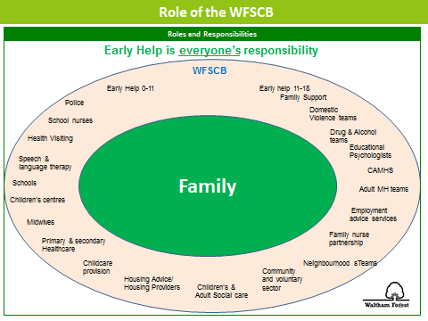

Practitioners can assess further advice and information from the website (http://www.walthamforest.gov.uk/earlyhelp) where a copy of the Early Help Assessment Form can be found. All the information for Early Help is on The Hub and on the website.

Assessed need is recorded on the actual Early Help Assessment Form and will be stored centrally by the Early Help Service when submitted to the inbox: EarlyHelp@walthamforest.gov.uk

The Early Help Co-ordinators will assist you with your EHA and convening initial Team around the Family Meetings (TAFs) where a case is complex. In most cases, this will allow for the co-ordination of all appropriate services with an identified Lead Professional for the family.

If you are uncertain who your Early Help Co-ordinator is, please send an e-mail to the above address and someone from the team will be in touch.

It is recognised that for some families to receive the right help at the right time, additional support may be needed from the LA’s Early Help service or from Children’s Social Care before an Early Help Assessment has been concluded by using the Request for Help and Support or Protection Form (Appendix F). The request for Help, Support and Protection Form also acts as the first part of the Early Help Assessment and dovetails with it so that the assessment can be continued by the school practitioner if appropriate, in the future.

There will be varying degrees of consent in some cases i.e. consent to do the EHA but only to share with certain people. Consent should always be discussed with parents and their wishes respected. Communication and engagement with parents is critical to informed consent. It is hoped in the majority of cases parents will see the EHA as something supportive and helpful.

The Request for Help and Support or Protection is available from the following web addresses

http://www.walthamforest.gov.uk/earlyhelp
https://www.walthamforest.gov.uk/pages/servicechild/mash-professionals.aspx#ReferralstoMASH

Waltham Forest Multi Agency Safeguarding Hub

221 Hoe Street
Walthamstow
London
E17 9PH
Phone: 020 8496 2310 (Monday - Thursday 09.00-17.15 and Friday 09.00-17.00)
Mobile: 020 8496 3000 (Out of Hours)
Fax: 020 8496 2313
Email: MASHrequests@walthamforest.gov.uk

16. ALLEGATIONS REGARDING PERSON(S) WORKING IN OR ON BEHALF OF THE SCHOOL (INCLUDING VOLUNTEERS)

When an allegation is made against a member of staff, set procedures must be followed. It is rare for a child to make an entirely false or malicious allegation, although misunderstandings and misinterpretations of events do happen.

A child may also make an allegation against an innocent party because they are too afraid to name the real perpetrator. Even so, we must accept that some professionals do pose a serious risk to students and we must act on every allegation.

Staff who are the subject of an allegation have the right to have their case dealt with fairly, quickly and consistently and to be kept informed of its progress. Suspension is not the default option and alternatives to suspension will always be considered. In some cases, staff may be suspended where this is deemed to be the best way to ensure that children are protected. In the event of suspension the school will provide support and a named contact for the member of staff.

The full procedures for dealing with allegations against staff can be found in Keeping Children Safe in Education (DfE, 2015).

Staff, parents and Governors are reminded that publication of material that may lead to the identification of a teacher who is the subject of an allegation is prohibited by law. Publication includes verbal conversations or writing, including content placed on social media sites.

Allegations concerning staff who no longer work at the school, or historical allegations will be reported to the police.
Where an allegation is made against any person working in or on behalf of the school that he or she has:
- Behaved in a way that has harmed a child or may have harmed a child.
- Possibly committed a criminal offence against or related to a child.
- Behaved towards a child or children in a way that indicates he or she would pose a risk of harm if they work regularly or closely with children (refer to statutory guidance for schools and colleges; keeping children safe in education (update 2016).

we will apply the same principles as in the rest of this document, as well as always follow the procedures outlined in the above-mentioned document. This includes allegations against staff in their personal lives.
Whilst we acknowledge such allegations, (as all others), may be false, malicious or misplaced, we also acknowledge they may be founded. It is, therefore, essential that all allegations are investigated properly, in line with agreed procedures and outcomes recorded.
16.1 Initial Action by Person Receiving or Identifying an Allegation or Concern
- Treat the matter seriously and keep an open mind.
- Make a written record of the information using the WSFG Safety and Welfare Concern Form (Appendix D), including the time, date and place of incident/s, persons present and what was said, and sign and date this.
- Immediately report the matter to the most DSL.

16.2 Initial Action Following an Allegation or Concern by the Designated Safeguarding Lead

The DSL will normally be the Headteacher. If the DSL is the subject of the allegation, then the Chair of Governors will take the following action.

- Obtain written details of the concern or allegation, but do not investigate or interview child, adult or witnesses.
- Contact the LADO within 1 working day.
- Discuss with the LADO next steps using the London Child Protection Procedures Flow Charts Allegations/Concerns against Staff Process (Appendix H).
- Inform the Chair of Governors of the allegation.

16.3 Subsequent Action Following an Allegation or Concern by the Designated Safeguarding Lead

  - Conduct a disciplinary investigation, if an allegation indicates the need for this.
  - Contribute to the child protection process by attending professional strategy meetings.
  - Maintain contact with the LADO.
  - Ensure clear and comprehensive records regarding the allegation, action taken and outcome are retained on the staff member’s personnel file.
  - Consider along with Human Resources and the LADO whether a referral to the DBS should be made.

17. CHILDREN WHO HARM OTHERS
Our school recognises that the harm caused to children by the harmful and bullying behaviour of other children can be significant.
Children who harm others should be held responsible for their harmful behaviour and the school staff alerted to the fact that they are likely to pose a risk to other children in the school, home and community.
Where this harm involves sexual abuse, serious physical or serious emotional abuse, the safeguarding procedures set out in this policy will be applied.
This school recognises that children who harm others are likely to have considerable needs themselves and may have experienced or be experiencing significant harm themselves.
17.1 Harmful Sexual Behaviour in Education Settings
If a school or education setting has concerns about a child or young person exhibiting sexualised or harmful sexual behaviour they should first screen the incident(s) using the ‘AIM for Education Settings’ tool (unless the incident warrants immediate police intervention). The outcome of this assessment will guide the school with regard to subsequent referrals, internal risk management, strategies and intervention.

Unless the outcome of the assessment is ‘Healthy’, the school should then compile a chronology of relevant incidents to support pattern mapping. This will then inform the school’s Safety and Support Plan both for the child that has harmed and the child that has been harmed. Throughout the process it is desirable that parents are engaged and informed. The local authority HSB lead are available to provide support, which is supplemented by detailed guidance and support in the AIM for Education Settings manual.

17.2 Harmful Sexual Behaviour (HSB): Local Authority Support for Schools

Much of the assessment guidance and resources derive from the AIM Project, who provide a range of training in this area. Most schools will have a member of staff trained in the AIM Education Guidelines and have an AIM Manual.

Key Contacts
Krishna Ridley - Harmful Sexual Behaviour Lead
krishna.ridley@walthamforest.gov.uk
Referrals
Where a child has caused significant harm to another child, through sexual abuse or serious physical or emotional abuse, the school will make a request for help, support and protection for both the victim and perpetrator.
Our school will be mindful of the sections in the London Child Protection Procedures concerning “Harming Others” and “Sexually Active Children” and work closely with Children’s Social Care, the police and other agencies following the investigation of a referral.

Appendix A
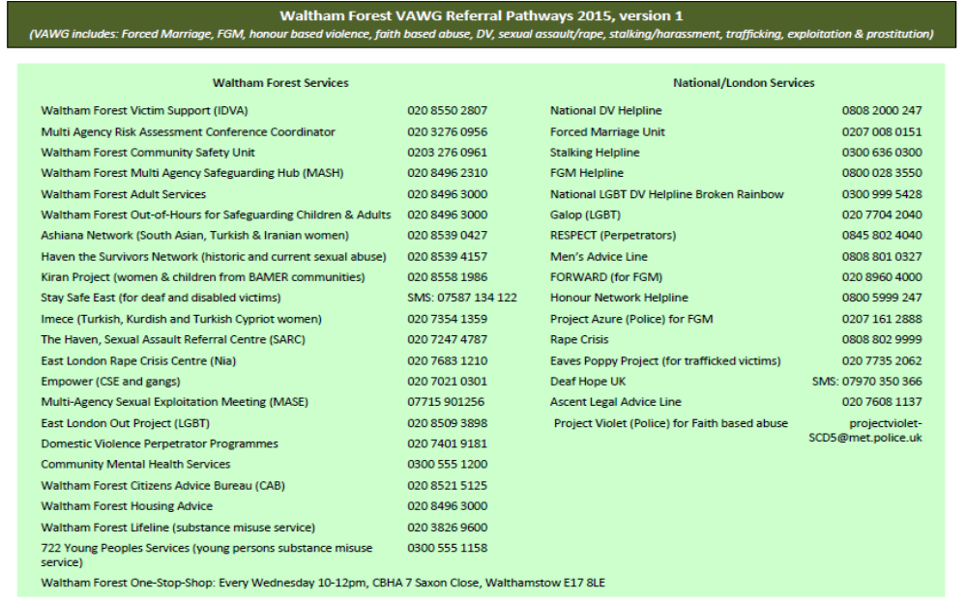
APPENDIX B

Key contacts for Child Protection Issues in Waltham Forest
The following details relate to key personnel in Child Protection who can be contacted should any child protection issues arise.

Name |  | Agency |  | Contact details
Designated Doctor for Child Protection |  | North East London Foundation Trust (NELFT) |  | 020 8430 7893  07795 548987
Named Nurse for Safeguarding – Community Health Services, School Nursing, Health Visitors and Child & Adolescent Mental Health Services (CAHMS) |  | North East London Foundation Trust (NELFT) |  | 020 8430 7827/7822  07568 130143  Fax: 020 8430 7981
Named Nurse for Safeguarding |  | Barts Health at Whipps Cross University Hospital Paediatric A&E |  | 020 8535 6855 bleep 514  Pager: 08700555500 ask for 850122  Secretary: Ext 5072
Police Referral Desk |  | Metropolitan Police Child Abuse & Investigation Team (CAIT) |  | 020 8345 3633  020 8345 3693
Designated Nurse for Safeguarding Children – GP Services |  | Clinical Commissioning Group (CCG) |  | 020 3688 2638
Divisional Director for Children & Families Services |  | Waltham Forest Children & Families Services |  | 020 8496 3206
Head of Service – Quality Assurance (QA)Service |  | Waltham Forest Children & Families Services |  | 020 8496 3685
Deputy Head of Service – Quality Assurance (QA) Service |  | Waltham Forest Children & Families Services |  | 020 8496 3250
Duty Child Protection Co-ordinators – Quality Assurance (QA) Service |  | Waltham Forest Children & Families Services |  | 020 8496 8279
Local Authority Designated Officer (LADO) – Quality Assurance (QA) Service |  | Waltham Forest Children & Families Services |  | 020 8496 3646
Safeguarding in Education Service |  | Waltham Forest Children & Families Services |  | 020 8496 4368  07974 186705
Head of Service – Children’s Safeguarding & Family Support Service |  | Waltham Forest Children & Families Services |  | 020 8496 8393
Deputy Heads of Service – Children’s Safeguarding & Family Support Service |  | Waltham Forest Children & Families Services |  | 020 8496 1375  020 8496 2338
Waltham Forest Multi Agency Safeguarding Hub (MASH) Team/Children’s Referral & Advice Team  Team Manager – Waltham Forest Multi Agency Safeguarding Hub (MASH) Team/Children’s Referral & Advice Team  Team Manager – Children’s Emergency Duty |  | Waltham Forest Children & Families Services  Waltham Forest Children & Families Services |  | cscreferrals@walthamforest.gov.uk  020 8496 2313 (Fax)  020 8496 2307/10/11/16/17  020 8496 2317  020 8496 3000

APPENDIX C

WSFG SAFETY AND WELFARE CONCERN FORM

Date: ________

Safety and Welfare Concern Form (to be written ASAP after not during your conversation with the child)

Child’s Name: | Class: | DOB: | Gender:

Date: | Time: | Place: | Name of person completing this form (please print):

Nature of Concern/Conversation (continue on a separate sheet if necessary)

Describe any marks you may have seen – noting size and position (refer to body map)

Name of person you reported your concerns to

Action to be taken / recommendations from the designated member of staff
Signed: Position:
Return the completed form to the Designated Safeguarding Lead / Deputy ASAP

APPENDIX D
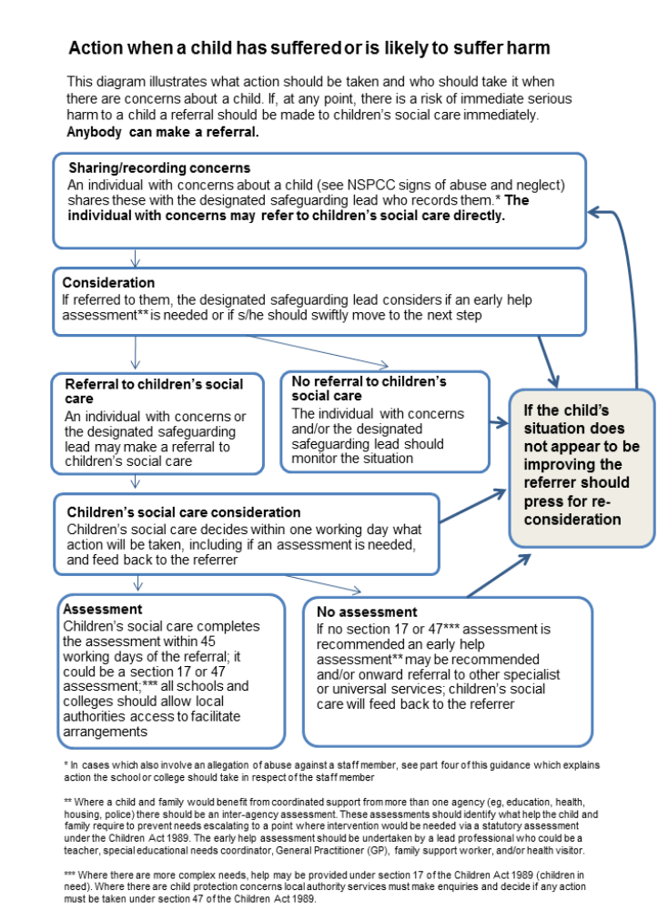
APPENDIX E


Request for Help and Support or Protection

Guidance

If you do not have direct access to Waltham Forest Families Information system then this form should be completed and emailed, to the MASH team:

Tel: 0208 496 2310 | Email: MASHrequests@walthamforest.gov.uk

(for NHS.net accounts please can you send to MASHrequests@walthamforest.gov.uk.cjsm.net )

Requests for Help and Support and or Protection must be made via this form and all relevant sections MUST be completed in order to support a good referral.
For guidance please refer to the Threshold Document http://www.walthamforest.gov.uk/pages/servicechild/mash-profession- als.aspx

You can make a ‘Request for Help and Support’ if you think a child or family has additional needs which require a multi-agency intervention, for example, persistent truanting, chronic/ recurring health problems, or behaviour is harmful to self and others. Before making this request you should gain consent of the child/young person or family concerned.

However, if you are worried that a child is at risk of significant harm i.e. through abuse or neglect you should make a ‘Request for Protection’. In this case you should inform the parents unless this will endanger the child’s safety.

FEED BACK TO REFERRERS

- We will ensure that your referral reaches the correct team and that you receive a written response to your referral within 48 hours of receipt of a fully completed form (24 hours if there are Protection concerns). This is automatically generated by the Families Information System.

- If you do not hear back from us regarding the outcome and/or progress of your referral, please contact the MASH Administrator on 0208 496 2310 who will inform you of your referral.

- If you encounter any difficulties in relation to your referral that you wish to bring to the attention of a Senior Manager, please contact the Head of Service for Safeguarding and Family Support on 0208 496 2310

Contact Details

Details of person making contact
Name:
Agency / Team:
Role / Job title:
Address
Contact Number(s):
Date of this request:

Consent / Information sharing:
Note: Consent must always be sought unless it puts a child at further risk to do so.

Has the parent or child / young person consented to the requested being made | Yes |  | No

The child / young person knows about the referral: | Yes |  | No
If no, please state the reason(s):

The parent / carer knows why the referral is being made: | Yes |  | No
If no, please state the reason(s):

The parent / carer understands and agrees to agencies sharing information: |  | Yes |  | No
If no, please state the reason(s):
Request Type
Please state what your primary request is for:
Request for help and support (Complete section A & B)
Request for protection (Complete section A & C)
Section A - Information about the child/ren and family

Parents/carers details of subject child / young person:

 | Mother |  | Father
Full name of parent:
Address of parent:
occupation:
Address:
Contact Number(s):
Add details of all subject(s)  Child/ren Young Person |  | - UPN - Unique Pupil Number  - Other Name(s) – Aliases/ Also Known As/ Previous Name(s)  - DOB – Date of Birth  - EDD – Expected Date of Delivery  - EHC – Education, Health & Care plan  Note: A statement of special Educational Needs, has been replaced by an EHC plan as of 1st Sep 2014

NHS ID | UPN ID | First name | Surname | DOB / EDD | Age | Gender | Address | Ethnicity | Religion | Has EHC plan

Does the child/children have any known disabilities

Details of family / household members:

First Name | Surname | DOB / EDD | Age | Gender | Address | Relationship with subject(s) | Parental Responsibility | Ethnicity | Religion

Details of other significant people not living in the household:

First Name | Surname | DOB / EDD | Age | Gender | Address | Relationship with subject(s) | Parental Responsibility | Ethnicity | Religion

Communication needs (including language) regarding any of the people named above

Legal status / Immigration status regarding any of the people names above:

Presenting issues

Please select all presenting issues that apply

Child / Young Person:
Abuse / Neglect Emotional Abuse |  | Abuse/ Neglect – Neglect |  | Abuse / Neglect – Physical Abuse
Abuse / Neglect Sexual Abuse |  | Alcohol Misuse |  | Anti-social Behaviour
Beyond Parental Control |  | Challenging Behaviour |  | Emotional Neglect
Child Missing Education |  | Domestic Abuse |  | Drugs Misuse
Elective Home Education |  | Female Genital Mutilation |  | Intentionally homeless
Gangs |  | Honour Based Violence |  | Forced marriage
Learning Disability |  | Mental Health |  | Missing from Education
Missing from Home |  | No Recourse to Public Funds |  | Physical Disability or illness
Privately Fostered |  | Protection / At Risk |  | Self-Harm
Sexual Harmful Behaviour |  | Sexual Exploitation |  | Socially Unacceptable Behaviour
Trafficking |  | Unaccompanied Asylum Seeking Children |  | Under 16 Year Old Pregnancy
Violent Extremism/Radicalisation |  | Young Carer |  | Child / Young Person In Need
School Attendance

Parent / Carer
Alcohol Misuse |  | Domestic Abuse |  | Drug Misuse
Intentionally Homeless |  | Learning Disability
No Recourse to Public Funds |  | Physical Disability or illness

General:
Alcohol Misuse |  | Domestic Abuse |  | Drug Misuse
Family Breakdown |  | Family Dispute |  | Financial Support
Learning Disability |  | Mental Health |  | Physical Disability or illness

Key agencies involved:
Add name, agency and contact details of all professional involved.
Name |  | Address
Role |  | Contact number(s)
Agency |  | Email address

Details of lead professional:

Name:
Agency / Team
Role / Job title
Address
Contact Number(s):
E-mail Address

The purpose of this section is to assist the inter-agency assessment. Where you do not know on this area please record ‘Not Known.’ (NK) Record the strengths as well as areas of need or risk so that resources can be directed appropriately.

Information supporting this referral:

Child/Young Person’s developmental needs/risk factors

 | Y | N | N/K | Y | N | N/K
 | NEED/RISK |  |  | STRENGTHS
Health
Emotional
Behavioural Development
Education
Identity
Family
Social Relationships
Social Presentation
Self-care

Parents/carers capacity to respond to child / young person:

 | Y | N | N/K | Y | N | N/K
 | NEED/RISK |  |  | STRENGTHS
Basic Care
Ensuring safety
Emotional Warmth
Stimulation
Provision of guidance
Boundaries
Stability

Please add any additional details here:
Section B – Request for Help and Support

What led to this referral:
What support has been provided to date to the child / young person or family:
Has this supported any positive changes for the child / young person:
What further support do you think is needed:
What are the outcomes you would like to see as a result:

Has an Early Help Assessment been completed:
Yes |  | No |  | If Yes, please attach the Early Help Assessment to this referral.
Have you discussed this case with a WF Early help Co-ordinator? |  |  |  |  | Yes |  | No
Who else has provided information to inform this request

Please attach or send any other assessments that have been completed.

Section C – Request for Protection

Please state why you think the child / young person has met the threshold for a social care assessment:
Section D – Information to referrer ( to be completed by Local Authority)

Once you have submitted this form the information will be collated and our Multi Agency Team will make a decision about the next step. This decision will be made within 48 hours of receipt of a fully completed form (24 hours if there are Protection concerns) and you will be notified accordingly.

Response to referrer form completed: |  |  |  |  |  |  |  | Date sent to referrer
Yes |  |  | No
Completed
Outcomes
Early Help Services |  |  |  |  |  |  | Children’s Social Care
Contact Name
Contact Number(s):

Thank you for your request for Help and Support or Protection

APPENDIX F

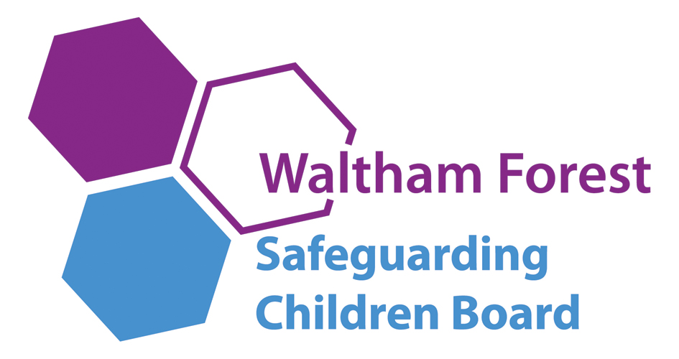
BUSINESS MANAGER: Suzanne Elwick
Tel: 020 8496 3683
suzanne.elwick@walthamforest.gov.uk
www.walthamforest.gov.uk/lscb

June 2015
Dear Colleague,

Re: How to escalate professional concerns about a child

I would like to advise you and staff in your organisation who have a child protection responsibility how to take action using the appropriate channels when you believe that your professional opinions have not been acted on appropriately. Please disseminate this advice widely to appropriate staff.

For example, if you have concerns regarding the lack of response to professional opinions and judgements expressed by your staff about safeguarding matters including concerns that social care services are not taking appropriate actions regarding the well-being of a child, or are not responding in a timely fashion to your concerns.

In the first instance please raise any concerns directly with the manager of the allocated social worker. If there is no allocated social worker please speak to the manager of referral and advice as below:

Children Social Care and Education

Team Manager MASH/Referral and Advice | 020 8496 2317

If you feel your concerns have still not been acted on appropriately then please escalate your concerns to the relevant head of service:

Head of Safeguarding and Family Support | 020 8496 1907
Deputy Head of Safeguarding and Family Support | 020 8496 1375
Head of Children in Care | 020 8496 8388
Deputy Head of Children in Care | 020 8496 2184
Head of Placement and Resources | 020 8496 2136
Deputy Head of Placement and Resources | 020 8496 2478
Head of Quality Assurance | 020 8496 3685
Deputy Head of Quality Assurance | 020 8496 8250

Where you remain concerned following your discussion with the head of service, a senior member of staff in your organisation should then speak to:

Divisional Director of Children and Families | 020 8496 3206

If you remain concerned, the most senior manager in your organisation should speak to the Deputy Chief Executive, Families Directorate:

Deputy Chief Executive, Families Directorate | 020 8496 3501

In the event that your concerns involve children social care in another local authority area, the above staff will contact the relevant staff in that organisation.

It is important that concerns are speedily escalated within the management structure for children’s social care until a satisfactory resolution of the concern is secured.

If you have any concerns related to the safeguarding practice of any other agencies, in the first instance please speak to the team manager of the practitioner, and if you remain concerned please contact the following. If you do not receive a satisfactory response please ask for the next appropriate manager to speak to.

Schools

Divisional Director Educational Improvement | 020 8496 3221

Barts Health at Whipps Cross Hospital

Named Nurse for Safeguarding | 020 8535 6855

Police

Detective Inspector, Sexual Offences, Exploitation and Child Abuse Command or next stage Detective Chief Inspector | 020 8217 6411/6471

Community health services, school nursing, health visitors, child and adolescent mental health services

Named Nurse for Safeguarding, NELFT | 020 8430 7827  M: 07738 803104

Community health Child Protection Doctor

Designated Doctor for Child Protection, NELFT | 0208 430 7883  M:07795 548987

Waltham Forest Clinical Commissioning Group (WFCCG)

Designated Nurse for Safeguarding, WFCCG | 020 3688 2681  M:07538798129
Designated Nurse for Looked After Children, WFCCG | 020 3688 2670  M:07930195306

If you have any general enquiries about the contents of this letter, please contact Suzanne Elwick, Waltham Forest Safeguarding Children Board, Business Manager, 020 8496 3683, suzanne.elwick@walthamforest.gov.uk.

Please bring this letter to the attention of all staff.

Yours sincerely

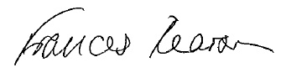
Fran Pearson WFSCB Independent Chair
APPENDIX G
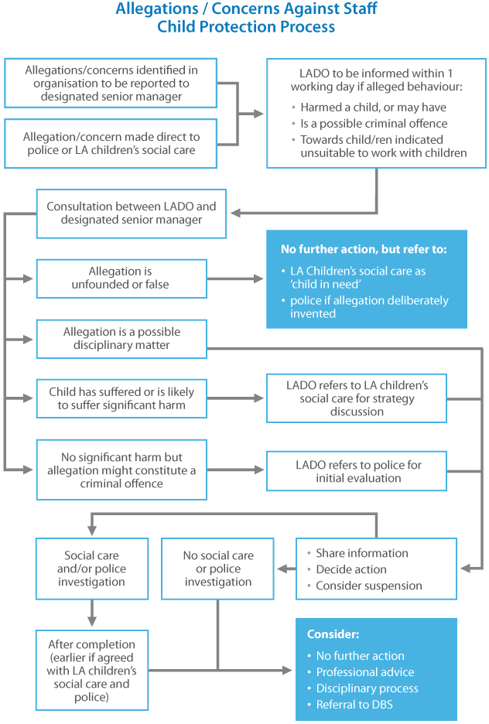
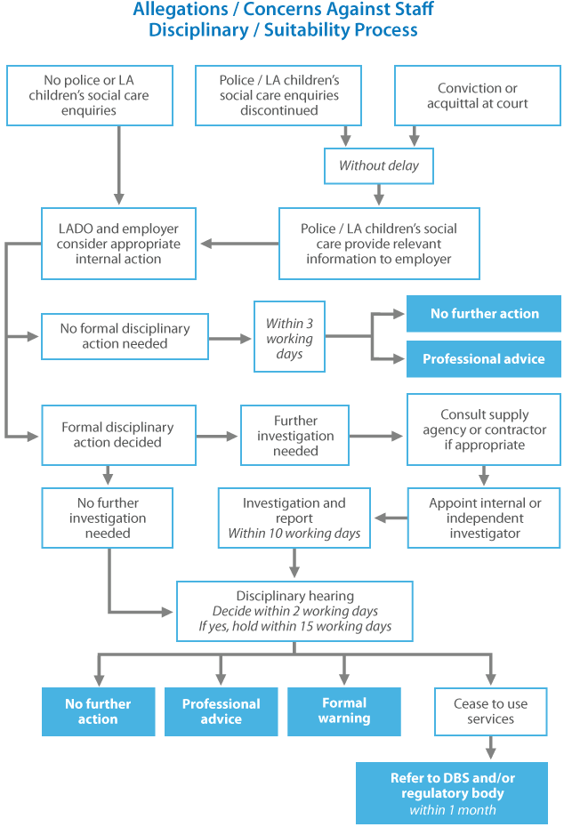

This website has been designed and is powered by tri.x and is the copyright of the London Safeguarding Children Board

“teacher” means— (a) in relation to England, a person within section 141A(1) of the Education Act 2002 (persons employed or engaged to carry out teaching work at schools and other institutions in England); (b) in relation to Wales, a person who falls within a category listed in the table in paragraph 1 of Schedule 2 to the Education (Wales) Act 2014 (anaw 5) (categories of registration for purposes of Part 2 of that Act) or any other person employed or engaged as a teacher at a school (within the meaning of the Education Act 1996) in Wales.

