

**WALTHAMSTOW SCHOOL FOR GIRLS**

***“NEGLECT NOT THE GIFT THAT IS IN THEE”***

**Deputy Head of Faculty Performing Arts /**

**Head of PE**

**(Maternity Cover)**

Candidate Information Pack

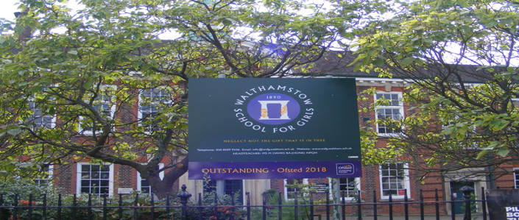

**Required for February 2021**

# 

Welcome letter from Meryl Davies, Headteacher

# October 2020

# Dear Applicant

Thank you for requesting an application pack for the post of Deputy Head of Faculty Performing Arts / Head of PE.

Walthamstow School for Girls is a high achieving, oversubscribed, diverse school which is regularly in the top 10% nationally for progress, significantly above the national average in all key indicators, and is at the centre of the vibrant local community of Waltham Forest (the first London Borough of Culture). We have an ambition to become ‘world class’ and a commitment to work with other professionals both locally, nationally and internationally, through our Erasmus links. We won the national High Aspiration Award for the progress made by disadvantaged students and have won SSAT Achievement and Progress awards annually since 2014. We have been awarded the SSAT Exceptional Education standard twice; in 2017, for *Leadership through Moral Purpose*, and, in 2018, for *Systems: use of assessment, data, policies* *and monitoring to support teaching and learning.* We were awarded Teaching School and National Support School Status in September 2017. In June 2018, following a Section 8 inspection, we were awarded an ‘outstanding’ judgement in all categories.

Our students are ambitious and hard-working; they embrace the range of opportunities offered to them both during and beyond the school day. This is highlighted not only by our exceptional examination results but also by the maturity of the girls, their sense of responsibility, community and fun. They are a delight to work with.

We offer excellent facilities to both staff and students. Our acclaimed architect designed site is an oasis of green and a pleasure to work in. It is well served by transport connections, being just ten minutes’ walk away from Walthamstow Central tube and overground station and five minutes’ walk from the popular Walthamstow ‘village’, and creative and restaurant quarter. We pride ourselves on working hard to retain our role as an important part of the local community. Examples of this commitment can be seen in our weekly *Greensheets*. Our staff are inclusive and friendly, with regular social and wellbeing events as well as charity fundraising.

We are committed to Safer Recruitment practices and procedures and shortlisted applicants will be questioned about their commitment to the safeguarding of young people. The successful candidate will be subject to an enhanced DBS clearance.

Thank you for taking an interest in this position. I do hope that having read more about the school you will decide to apply for the post. I look forward to receiving your application. Please note that it will not be possible to give feedback to unsuccessful applicants, other than those called for interview. Thank you for your understanding and good luck with your career in education.

Ms Meryl Davies

Headteacher, NPQH, NLE

About Walthamstow School for Girls

**History**

In January 1890, a circular stated that a “school for girls” was to be opened in Walthamstow. Miss Hewett was appointed as the first Headmistress and remained until she retired in 1924. There were 49 girls, whose ages ranged from 7-16 years. At this time there were only five teachers, two of whom were graduates.

Our original building was in West Avenue Road and when student numbers grew the school moved to Church Hill House, where a church now stands. It was in September 1913 that 243 girls came to the present building with the Greek Amphitheatre being added in the 1920s. In January 2010 our most recent refurbishment and rebuilding work was completed as part of the Building Schools for the Future Programme. This work has given us the unique blend of traditional and state of the art facilities that we currently enjoy at our school.

**Our school in 2020**

Walthamstow School for Girls is a high achieving, oversubscribed, diverse school which is regularly in the top 10% nationally for progress, significantly above the national average in all key indicators at Key Stage 4, and is at the centre of the vibrant local community of Waltham Forest (the 2019 and first London Borough of Culture). Our most recent results can be found on our website.

We have an ambition to become ‘world class’ and a commitment to work with other professionals both locally, nationally and internationally, through our Erasmus links. We won the national High Aspiration Award for the progress made by disadvantaged students in 2015 and have won SSAT Achievement and Progress awards annually since 2014.

We have been awarded the SSAT Exceptional Education standard twice; in 2017, for *Leadership through Moral Purpose*, and, in 2018, for *Systems: use of assessment, data, policies* *and monitoring to support teaching and learning.* We were awarded Teaching School and National Support School Status in July 2017. In June 2018, following a Section 8 inspection, we were awarded an ‘outstanding’ judgement in all categories.

*“Middle Leaders are exceptional and collaborate well to share best practice. They drive their teams with energy and enthusiasm. They share the strong moral purpose of the Headteacher to ensure that no pupil is left behind. As a result, outcomes for pupils are outstanding, giving them essential life chances.” Ofsted 2018.*

**Students and staff**

Every one of our 900 students is valued equally as an individual with different gifts and talents, reflecting our commitment to the school motto “Neglect not the gift that is in thee”. We offer strong pastoral support and regular monitoring, target setting and dialogue with students and parents/carers.

Our students are encouraged to express themselves, to be creative, to have high aspirations and to challenge stereotypes. There is a strongly ethos of equality at this school.

Our students are also ambitious and hard-working; they embrace the range of opportunities offered to them both during and beyond the school day. This is highlighted not only by our exceptional examination results but also by the maturity of the girls, their sense of responsibility, community and fun. They are a delight to work with.

One of the school’s strengths is the quality of the staff we are able to attract and keep. Our teachers ensure lessons are stimulating and challenging. Students work with enthusiasm and interest in classrooms where there is a calm atmosphere suitable for learning. The broad and balanced curriculum ensures that all students are extremely well equipped to continue their education.

**Our environment**

We offer excellent facilities to both staff and students. Our acclaimed architect designed buildings and facilities make a stunning learning and working environment. Our £18 million rebuild project, completed in 2010, dramatically extended and enhanced our accommodation. We have state-of-the-art facilities in science, technology and performing arts, as well as a fantastic dining hall, two assembly halls and social areas.

Situated in beautiful landscaped grounds, the school’s outside space encourages play and creativity as well as quiet reflection and study. Unusually for a London school, our buildings are surrounded by mature trees and lawns, a pond area and our Greek amphitheatre. We have an allotment area which invites students to learn how to grow fruit and vegetables, some of which are then used by our chef.

Our site is an oasis of green and a pleasure to work in. It is well served by transport connections, being just ten minutes’ walk away from Walthamstow Central tube and rail station and five minutes’ walk from the popular Walthamstow ‘village’, creative and restaurant quarter. We pride ourselves on working hard to retain our role as an important part of the local community. Examples of this commitment can be seen in our weekly *Greensheets*. Our staff are inclusive and friendly, with regular social and wellbeing events as well as charity fundraising.

**Educating and empowering young women**

Our role is to educate tomorrow’s women to be confident, articulate and able to discuss and debate intelligently. Through a range of activities and opportunities, students are helped to develop their leadership qualities, their sense of community and global responsibility as citizens of the world in line with our G.R.E.E.N. values.



Our G.R.E.E.N. Vision

**The G.R.E.E.N. values**

| https://www.wsfg.waltham.sch.uk/_site/data/files/images/values/C52FA90503F596A26EE2DC7FE1E19642.png | The value **GROWTH**is based on the work by Carol Dweck on growth mindset.  Having a growth mindset encourages the belief that we can all improve at whatever we put our minds to with practice and perseverance.  It encourages learning, effort and stickability.  It also promotes the importance of reflection and criticism as tools to move us forward. |
| --- | --- |
| https://www.wsfg.waltham.sch.uk/_site/data/files/images/values/3FEE02382FB6B8CCE94E0DF659218767.png | The value **RESILIENCE** represents the notion that, on any learning journey, there will be obstacles.  With **RESILIENCE**and perseverance, these obstacles can be overcome and the final goal more rewarding.  The key is not to be fearful of these obstacles and to accept that mistakes and challenges are an important part of learning.  The learning line is an effective symbol for resilience and for assessment for learning. |
| https://www.wsfg.waltham.sch.uk/_site/data/files/images/values/38C6CD54B28E286D9A8410BF39911E01.png | The value **ENERGY**is the centre of our vision.  It encourages focus and enthusiasm from everyone.  This **ENERGY** could be represented in the attitude of students as well as in staff morale, parent and governor involvement.  It promotes positivity and supports all of the other G.R.E.E.N. values. |
| https://www.wsfg.waltham.sch.uk/_site/data/files/images/values/BC7D9BD0A310876A7B76D38599477A89.png | The value **EMPATHY**promotes community spirit in many dimensions.  It signifies self-awareness as well as respect for each other despite our differences.  In addition to this, it illustrates that none of us are alone on our learning journey and that, through collaboration, success can be greater. |
| https://www.wsfg.waltham.sch.uk/_site/data/files/images/values/AABBE9BC30E8511FD418D7E3A2E90E56.png | The value **NEWNESS** is vital in an ever changing world.  This encourages us to be open to new ideas, techniques, technologies and challenges.  It encourages us all to step out of our comfort zones as this is where the deepest learning and the greatest success can be achieved. |

*“The school’s values of Growth, Resilience, Energy, Empathy and Newness (GREEN) are lived by staff and pupils in all aspects of the school’s work.” Ofsted 2018.*

What staff value about the school

* This school feels safe, kind and caring. We are not driven by results – we seem to be driven to produce fabulous young women
* Ethos of the school, supportive colleagues and strong management with compassion

*“There are very strong working relationships between staff and pupils based on mutual trust and respect.” Ofsted 2018*

* I value the ethos of hard work in the students and how the school promotes kindness, tolerance and maturity amongst the students
* Atmosphere of diversity, respect and inclusion
* Freedom to teach in a range of styles

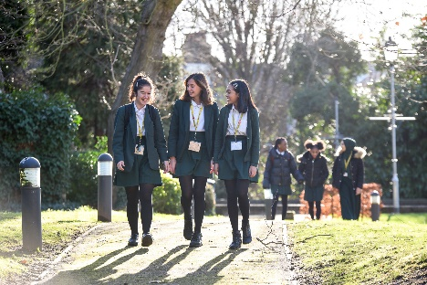

Job Description

**The Governing Body and the Local Authority are committed to safeguarding and promoting the welfare of children and young people. The Headteacher must ensure that the highest priority is given to following the latest national guidance and regulations on safeguarding and child protection. This role is subject to an enhanced DBS check.**

**Job title: Deputy Head of Faculty** (non-core) (DHOF)

**Reporting to:** Head of Faculty (HOF)

**Responsible for:** Communication to the Head of Faculty the interests and needs of those he/she line manages

**Line management of:** Named members of the faculty, this may include support staff if appropriate

**Liaising with:** HOF, teaching and support staff in their faculty, relevant teaching and support staff with cross-school responsibilities, LEA personnel, governors and parents/carers

**Working time:** 195 days per year – full time. Attendance at identified calendared events during the school year

**Salary/TLR Allowance:** Classroom Teachers’ Pay Scale + TLR 2b

**Disclosure:** Enhanced

|  |  |
| --- | --- |
| **Core Purpose** | * To lead and manage a subject area * To be accountable for student progress and attainment in that subject area * To deputise for the HOF in his/her absence (along with the other DHOF, in line with written faculty policy) * To make appropriate cover arrangements for classes when staff are absent (in line with written faculty policy) |
| **Curriculum** | * To lead, manage and develop student attainment across one subject area in the faculty * To be accountable for the planning, delivery and assessment of the subject at that subject area including the development of syllabi, differentiated resources, Schemes of Work (SOW) and assessment strategies * To keep up to date with national, regional and local developments in the subject area and to actively monitor and respond to them, disseminating the knowledge to the relevant members of staff |
| **Strategic Leadership** | * To lead on the implementation and evaluation of one of the three faculty development plan targets |
| **Quality Assurance** | * To support the HOF in carrying out the twice-yearly self-evaluation activity as a means of informing faculty practice and identifying areas of development * To monitor student standards and attainment in the subject area against annual targets * To support the HOF in setting annual targets for the subject area * To quality control subject reports |
| **Resources** | * To support the HOF in overseeing an evaluating the subject budget allocation to ensure it is spent in line with faculty and SIP priorities and best value principals |
| **Staffing** | * To be Performance Manager for a small number of faculty members, carrying out performance management reviews in line with school policy and setting challenging objectives * To lead, develop and enhance the teaching practice of the staff delivering the subject * To participate in the recruitment and interview process for members of the faculty |
| **Management Information** | * To use data appropriately to set targets and expectations and to ensure effectively differentiated teaching of the subject |
| **Cross Faculty Responsibilities** | * To be faculty rep for Challenge, ICT or SEN |
| **Teaching** | * To undertake an appropriate programme of teaching on a ratio of 40/50 |
| **School Ethos** | * To contribute to the development of whole school policy * To represent the faculty at HOF meetings in the HOFs absence * To attend Forum meetings * To support the school ethos, aims and policies |
| **Whole School Contribution** | * To play a full part in the life of the school community, to support is distinctive aims and ethos and to encourage staff and students to follow this example * To continue professional development * To comply with the schools Health and Safety policy * To engage actively in the performance review process * To undertake any other duty as specified by STPCB not mentioned above |

This job description is carried out in accordance with provisions of the School Teachers’ Pay and Conditions document and within the range of teachers’ duties set out in that document.

The school will endeavour to make any necessary reasonable adjustments to the job and the working environment to enable access to employment opportunity for disabled job applicants or continued employment for any employee who develops a disabling condition.

Each DHOF may have specific duties on top of these generic ones.

This job description is current at the date shown but, in consultation with you, may be changed by the Headteacher to reflect or anticipate changes in the job commensurate with the grade and job title.

March 2020

*This school is committed to safeguarding and promoting the welfare of children and young people and expects all staff and volunteers to share this commitment.*

Person Specification

|  |  |  |  |  |  |  |
| --- | --- | --- | --- | --- | --- | --- |
|  | **Criteria** | Essential | Desirable |  | Assessed by application | Assessed by selection process |
|  | **Qualifications** | | | | | |
| 1 | A good honours degree or equivalent | / |  |  | / |  |
| 2 | Qualified Teacher Status (QTS) | / |  |  | / |  |
|  | **Professional experience and knowledge** | | | | | |
| 3 | Proven experience as an outstanding classroom practitioner teaching the full ability range 11-16 | / |  |  | / | / |
| 4 | Successful management experience | / |  |  | / | / |
| 5 | Evidence of recent relevant professional development activities | / |  |  | / |  |
| 6 | Considerable experience of curriculum development | / |  |  | / | / |
|  | **Knowledge and Understanding** | | | | | |
| 7 | An in-depth understanding of the nature of the PE curriculum and its relationship to the curriculum as a whole | / |  |  | / |  |
| 8 | Secure knowledge of the statutory requirements for PE and assessment, recording and reporting requirements in the subject | / |  |  | / | / |
| 9 | Good knowledge and understanding of the characteristics of high-quality teaching in PE and the main strategies for improving and sustaining high standards of teaching, learning and achievement for all students | / |  |  | / | / |
| 10 | A full appreciation of the contribution the subject can make to furthering the school’s aims and to its central priority of further raising achievement | / |  |  |  | / |
| 11 | A full knowledge and understanding of the contribution the subject can make to the school’s Equal Opportunities Policy and practice | / |  |  | / | / |
| 12 | Knowledge and understanding of how evidence from a variety of sources can be used to inform expectations, targets and teaching approaches in the faculty | / |  |  |  | / |
| 13 | Knowledge and understanding of the current use and future potential of information technology to aid teaching and learning of the subject and to assist with subject management | / |  |  | / | / |
|  | **Skills and Personal Qualities** | / |  |  |  |  |
| 14 | Ability to set high standards and provide a professional role model for staff in the teaching and learning of the subject | / |  |  | / | / |
| 15 | Ability to set clear aims, direction and purpose for the subject and to lead a team to achieve identified aims | / |  |  | / | / |
|  |  |  |  |  |  |  |
| 16 | First class communication skills (written and oral) for working with a variety of audiences | / |  |  | / |  |
| 17 | Energy and enthusiasm for all aspects of the post | / |  |  | / | / |
| 18 | Creative approach to curriculum development and school development | / |  |  | / | / |
| 19 | Strong commitment to maintaining and improving still further the quality of teaching and learning and standards achieved in the faculty | / |  |  |  | / |
| 20 | Ability to evaluate the quality of classroom experience | / |  |  |  | / |
| 21 | Ability to support, guide and motivate others | / |  |  |  | / |
| 22 | Ability to provide strong leadership and to work as a member of a team and to understand when these roles are appropriate | / |  |  |  | / |
| 23 | Ability to work under pressure, to meet challenging deadlines and to be adaptable | / |  |  |  | / |
| 24 | Good organisation and proven administrative abilities | / |  |  | / | / |
| 25 | Ability to devolve responsibilities and delegate tasks, as appropriate | / |  |  |  | / |
| 26 | Ability to identify professional development needs and encourage continuing professional development, plan and organise INSET | / |  |  |  | / |
| 27 | Ability to develop successful relationships with students and to employ a variety of strategies for behaviour management | / |  |  | / | / |

March 2020

*This school is committed to safeguarding and promoting the welfare of children and young people and expects all staff and volunteers to share this commitment.*

Performing Arts Faculty Information

The Performing Arts Faculty is made up of a committed, passionate and energetic team of teachers. Music, Drama and Physical Education are taught as discrete subjects at KS3, but we adopt a unified approach and a shared philosophy across the three curriculum areas. At KS4 the academic results are very good and many students go on to study the subjects at ‘A’ level and beyond.

The Faculty enjoys a high profile within the school and the local community, and the extra-curricular programme on offer is a permanent and regular feature of school life, with a high percentage of the student body participating at a number of different levels. Every two years, in addition to the individual departmental activities, we work together on a fully staged Musical. The last few years have seen highly successful productions of ‘Bugsy Malone’, ‘The Wizard of Oz’, ‘Annie’ and ‘Mary Poppins’.

In Music at Key Stage Three all students follow a Scheme of Work designed to develop and extend their skills in the key areas of Performing, Composing and Listening and Appraising. This includes whole class vocal work, performing as part of a steel band and composing using Garageband.

At KS4 students follow the AQA GCSE Music Specification, further developing their Performing and Composing skills and deepening their understanding of music through the study of set works by Haydn, Copland, Santana and The Beatles.

The work of the Music Department is supported by 11 peripatetic instrumental teachers. They are an integral and indispensable part of the team. The department runs a choir, Glee Club, wind band, flute group, five steel bands and an orchestra, performing at numerous annual events throughout the school year. We are regular participants in the Festival of Music for Youth, having performed in the National Festival for the last two years running. In 2019 our Year 11 Steel Band was invited to perform as part of the Music for Youth Prom at the Royal Albert Hall. Our Glee Club was selected for the regional finals of the Jack Petchey Glee Club Challenge in 2019, and in 2020 progressed to the A Cappella Grand Final at Cadogan Hall.

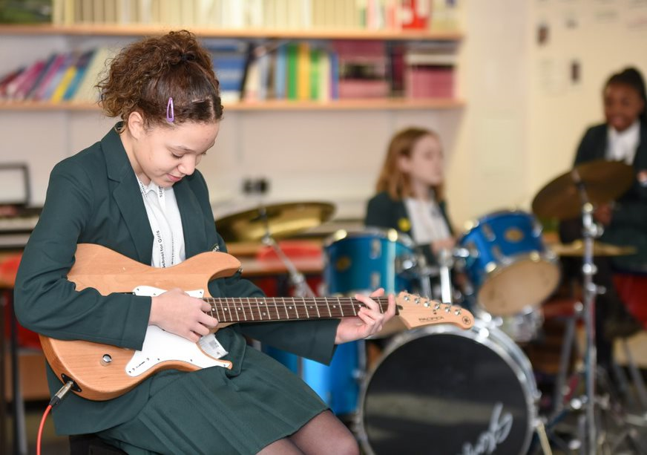

In Drama lessons at KS3, pupils explore the development of theatre, from ancient Greece to Commedia dell’arte, Shakespeare and Melodrama. Students develop drama skills through the study of practitioners and genres, including Boal, Stanislavski and physical theatre and use these skills to explore topics such as the transition from primary to secondary school. Students are given the opportunity to devise their own drama and work on text throughout Key Stage 3, and log books are used to record and support their learning. Within lessons, there is also a strong emphasis on the development of oracy.

At KS4, students follow the Eduqas GCSE Drama course. This involves the in-depth study of practitioners and genres, including Berkoff, Complicite and Frantic Assembly. Devising and text-work are given equal weighting, and experiencing live theatre is an important element of the course.

The provision of cultural enrichment through extra-curricular opportunities is a key element of the Drama Department’s philosophy. In recent years, we have forged partnerships with the Unicorn, Almeida and Old Vic theatres, giving students in Key Stages 3 and 4 numerous opportunities to experience live performance. Our students have participated in the Donmar’s Take the Stage project, Barbican Box, National Theatre Connections and Shakespeare Schools Festival, performing at the Donmar Warehouse, Barbican, Soho Theatre and Stratford Circus.

The P.E. Department aims to emphasise the importance of leading a healthy lifestyle and encourages participation in all forms of sporting activities. To this end, the core curriculum at KS4 has a more recreational basis and we offer activities such as boxing, badminton, trampolining and self-defence; many Year 11 students opt into offsite activities such as swimming and use of a local gym.

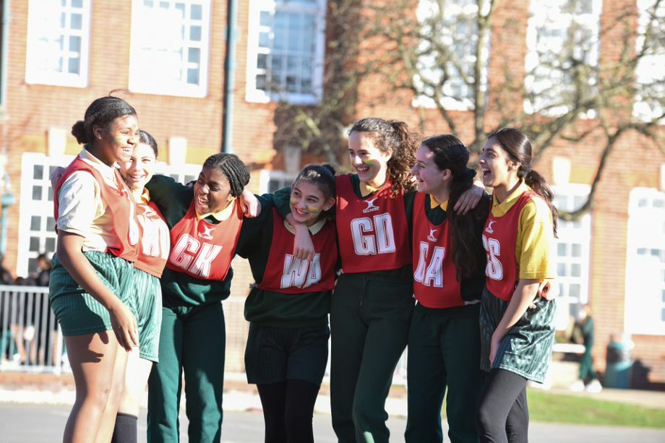

At KS3, the students follow a broad curriculum which includes dance, gymnastics, netball, football, basketball, trampolining, handball, tag rugby, fitness and athletics and are assessed at the end of each activity.

In addition to the 3 members of the P.E. department, the school is fortunate in having a number of specialist coaches, who come into the school to offer extra-curricular activities. The department organises an annual Sports Day in the summer term and Inter-Form competitions spread throughout the year, where every student in the school participates in a sporting activity. A range of extra-curricular clubs and events are run throughout the year, and the school has a reputation for high levels of participation in borough fixtures.

The Faculty firmly believes that education through aesthetic and physical subjects is of vital importance to the development of each individual and that cultural capital is a key element in academic and personal fulfilment. We strive to promote our work as a microcosm of the wider artistic and sporting world.

March 2020

Staff Benefits

Outlined below are some of the additional benefits available to staff working at Walthamstow School for Girls.

**Cycle 2 work scheme**

This benefit offers staff the opportunity to make tax and national insurance savings whilst keeping fit at the same time.

**Commitment to CPD**

We actively encourage CPD to all staff. We regularly provide whole school CPD as part of the school calendar, as well as opportunities for individual CPD requests.

“*I have been given some fantastic CPD opportunities with an amazing amount of training. My personal knowledge and confidence has increased immensely.”*

**Eye Tests**

All staff using computer equipment should have eye and eyesight checks at regular intervals. Eyesight testing should also happen where staff experience visual difficulties, which may reasonably be considered to be caused by computer work. Staff working within schools in the London Borough of

Waltham Forest may be entitled to reimbursement of some costs associated with vision testing and the frames and lenses needed to enable them to work safely on display screen equipment.

**Staff Wellbeing**

As part of our CPD for staff we include session related to staff wellbeing. There are also opportunities for staff to participate in various activities as individuals.

At Walthamstow School for Girls we also offer a staff running club, Badminton club, Boxfit exercise sessions, yoga and the London Club (historical walks around London).

“Since joining WSFG *I have felt totally reinvigorated and I am excited to teach again. This is undoubtedly because the atmosphere in school is a very positive one.”*

**Workplace Options - Employee Assistance Provider**

A confidential counselling, help and information service is provided for all those employed by Waltham Forest and is available free of charge 24 hours a day, every day of the year. This service can help with a range of problems from practical everyday matters to sensitive and emotional issues. For further information please call 0800 328 1437 or contact: [**www**.**employeeassistance.org.uk**](http://www.employeeassistance.org.uk)





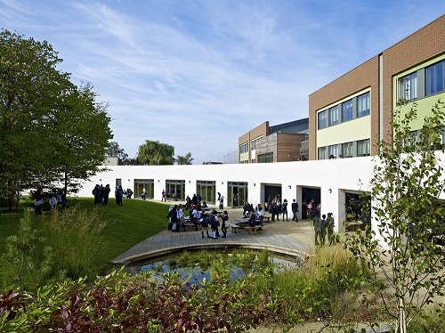

For further information about our school please visit our website: [**www.wsfg.waltham.sch.uk**](http://www.wsfg.waltham.sch.uk)