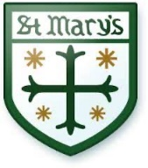

St Mary’s Catholic Primary School
Catholic Primary School for girls and boys aged 3-11 years in Chiswick, West London

Key Stage 2 Teacher
required for Maternity Cover from September 2024
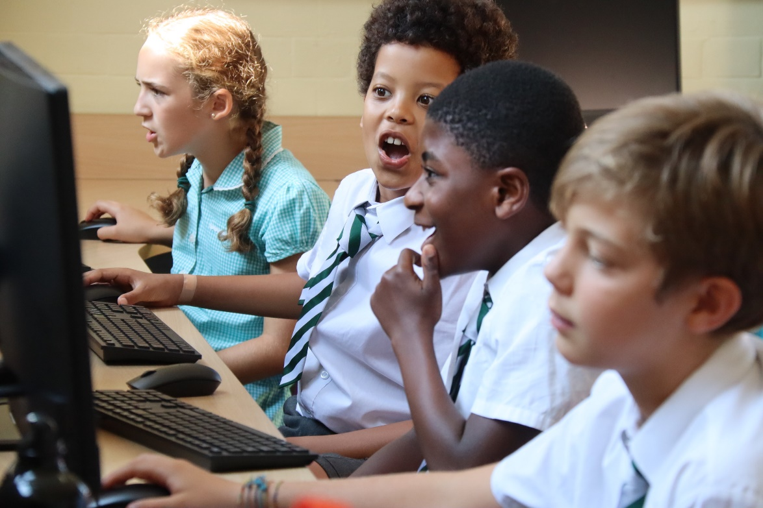

St Mary’s is a Catholic Primary school set in the heart of Chiswick for girls and boys aged 3-11 years. If you are passionate about Primary education and have a proven record of excellence in supporting children’s learning and development, this is the post for you. Our children are motivated and love learning. Our parents and School Community are extremely supportive.

The successful candidate will be:
- A qualified, experienced teacher with Key Stage 2 experience
- An enthusiastic, highly motivated and caring professional with a proven track record of excellence in teaching and learning
- Highly knowledgeable in the delivery of the Primary Curriculum
- Joining a team of dedicated, dynamic and caring staff
- Pay Scale
Closing date: mid-day Monday 1st July with interviews on Monday 8th July 2024
Please email sbm@stmarys.hounslow.sch.uk for an application pack
or you can telephone the school on 0208 994 5606 to arrange a visit or for information.

We are committed to safeguarding and promoting the welfare of children and young people, and expect all who work here to share this commitment. The successful applicant will be subject to an enhanced DBS disclosure and other relevant checks.
St Mary’s Catholic Primary School, Duke Road, Chiswick, London W4 2DF
www.stmarys.chiswick.org.uk

