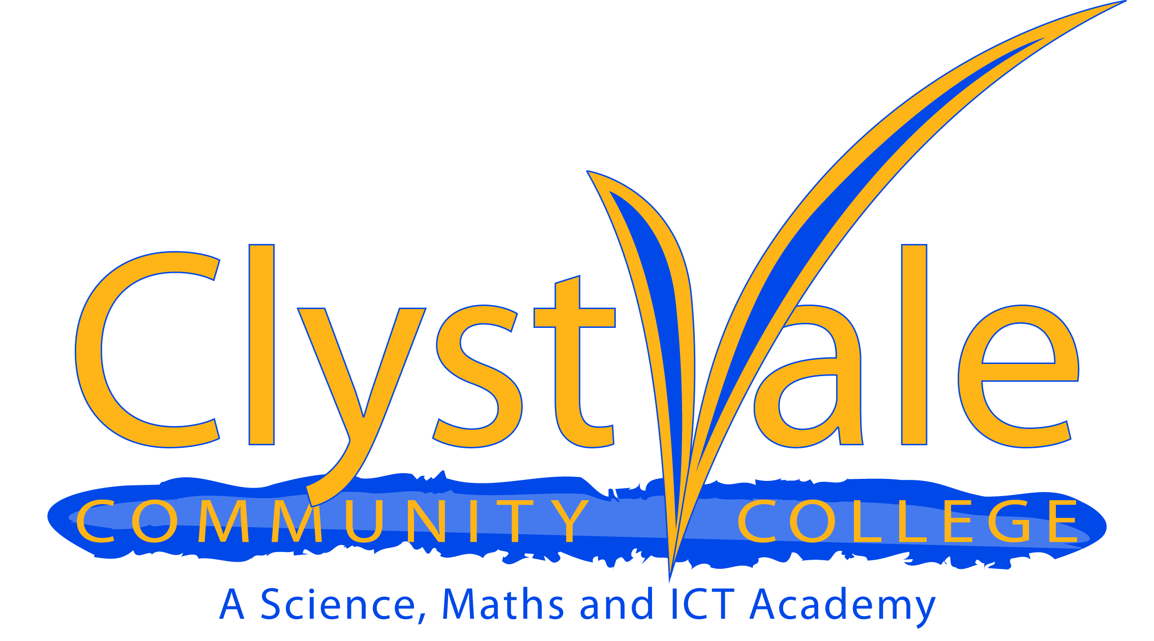

Job Description: Head of History

NAME:

SCHOOL: Clyst Vale Community College

ACADEMIC YEAR: 2020 - 2021

SALARY SCALE: CVCC MPS 1 -11

TLR: TLR2B

HOURS OF WORK: Outlined in “working time” section of the current
Teachers’ Pay & Conditions Document

SPECIFIC RESPONSIBILITIES OF THE POST
• Lead learning and teaching in History. (Responsibilities may be in liaison with Head of Geography and Head of Beliefs and Values (RS) as appropriate)
• Lead and support the History subject team and promote CPD in the team
• Be responsible for curriculum planning, monitoring and methodological development across the 11-19 age range
• Maintain liaison with other Subjects, the PSD Coordinator, Learning Support and the Examinations Officer
• Monitor and plan the evaluation of pupil progress and maintain regular contact with parents and Heads of Year
• Budget-holder for History, responsible financial management within LEA and College Regulations and safeguards in liaison with the Finance Officer

GENERAL RESPONSIBILITIES
Impact on educational progress beyond assigned pupils
Working with other relevant teachers in the History department:
• Identify appropriate attainment and/or achievement targets, and seek to ensure that these are met
• Monitor student standards and achievement against annual targets
• Monitor and plan curriculum coverage and learning outcomes
• Monitor standards of student behaviour and application
• Develop strategies and activities as appropriate to enrich curriculum provision within the subject, for instance visitors, visits, business links, special events
• Lead evaluation strategies to contribute to overall school self evaluation, including, where appropriate, lesson observation, work scrutiny and student interviews
• Plan and implement strategies where improvement needs are identified

Leading, developing and enhancing the teaching practice of others
Working with other relevant teachers in the History department:
• Maintain personal expertise and share this with other teachers
• Act as a role model of good classroom practice for other teachers, modelling effective strategies with them
• Monitor and evaluate standards of teaching and/or learning, identifying areas for improvement
• Plan and implement strategies to improve teaching and/or learning, where needs are identified
• Induct, support and monitor new staff
• Act as a performance management team leader for identified teachers (where appropriate)

Accountability for leading, managing and developing a subject or curriculum area or pupil development across the curriculum
Working with other relevant teachers in the History department:
• Identify relevant College improvement issues
• Define and agree appropriate improvement targets
• Co-ordinate CPD needs and opportunities
• Evaluate the impact of all improvement activities on the quality of teaching and learning
• Provide the Principal, SLT Link, or others as appropriate, with relevant subject, curriculum area or student performance information

TEACHER JOB DESCRIPTION

Job Purpose
To be an effective professional who demonstrates thorough curriculum knowledge, can teach and assess effectively, take responsibility for professional development and whose pupils achieve well.

Core Requirements of the Post
In fulfilling the requirements of the post, the teacher will demonstrate essential professional characteristics, and in particular will:
- Inspire trust and confidence in students and colleagues;
- Build team commitment with colleagues and in the classroom engage and motivate students;
- Demonstrate analytical thinking to improve the quality of students' learning, contribute to improvement planning, and promote the learning priorities of the College Improvement Plan;
- Contribute to the development and / or implementation of College policies;
- Use the performance management process to advance student learning and enhance professional practice in line with the College's aspirations and priorities;
- Have lead responsibility for a subject or aspect of the College's work and develop plans which identify clear targets and success criteria for its development and / or maintenance;
- Promote the wider aspirations and values of the College.

Areas of Responsibility and Key Tasks

Planning, Teaching and Class Management
Teach allocated students by planning their teaching to achieve progression of learning through:
- identifying clear teaching objectives and specifying how they will be taught and assessed;
- setting tasks which challenge students and ensure high levels of interest;
- setting appropriate and demanding expectations;
- setting clear targets, building on prior attainment;
- identifying and differentiating for students from vulnerable groups, including students with special needs, or who are gifted & talented;
- providing clear structures for lessons maintaining pace, motivation and challenge;
- making effective use of assessment and ensure coverage of programmes of study;
- ensuring effective teaching and best use of available time;
- maintaining discipline in accordance with the College's procedures and encouraging good practice with regard to punctuality, behaviour, standards of work and homework;
- using a variety of teaching methods to:
i. match approach to content, structure information, present a set of key ideas and use appropriate vocabulary
ii. make effective use of formative assessment including effective questioning, listening to students and giving attention to errors and misconceptions, in particular focusing on APP and AfL strategy materials
iii. select appropriate learning resources and develop study skills through library, I.C.T. and other sources;
- ensuring students acquire and consolidate knowledge, skills and understanding appropriate to the subject taught;
- evaluating own teaching critically to improve effectiveness;
- ensuring the effective and efficient deployment of classroom support.

Monitoring, Assessment, Recording, Reporting
- assess how well learning objectives have been achieved and use them to improve specific aspects of teaching;
- mark and monitor students' work and set targets for progress;
- assess and record students' progress systematically and keep records to check work is understood and completed, monitor strengths and weaknesses, inform planning and recognise the level at which the pupil is achieving;
- undertake assessment of students as requested by examination bodies, departmental and school procedures;
- prepare and present informative reports to parents.

Curriculum Development
- Have lead responsibility for an aspect of the College or Subject's work and develop plans which identify clear targets and success criteria for its development and / or maintenance;
- Contribute to planning activities beyond own teaching.

Pastoral Duties

In line with the College’s commitment to Every Child Matters,
- be a form tutor to an assigned group of students;
- promote the general progress and well-being of individual students and of
the Tutor Group as a whole;
- liaise with the Pastoral Leader to ensure the implementation of the
College's pastoral system;
- register students, accompany them to assemblies, encourage their full
attendance at all lessons and their participation in other aspects of College
life;
- contribute to the preparation of Action Plans and progress files and other reports;
- alert appropriate staff to problems experienced by students and make recommendations as to how these may be resolved;
- communicate, as appropriate, with parents of students and persons or
bodies outside the school concerned with the welfare of individual
students, after consultation with appropriate staff;
- contribute to PSD and related cross-curricular themes according to
College policy.

Other Professional Requirements
- have a working knowledge of teachers' professional duties and legal
liabilities;
- demonstrate a commitment to safeguarding and child protection policies
- operate at all times within the stated policies and practices of the
College;
- know subject(s) or specialism(s) to enable effective teaching;
- establish effective working relationships and set a good example through presentation and personal and professional conduct;
- endeavour to give every child the opportunity to reach their potential and
meet high expectations;
- contribute positively and effectively to the Every Child Matters agenda;
- co-operate with other staff to ensure a sharing and effective usage of
resources, and sharing good practice, to the benefit of the College, department and students;
- contribute to the corporate life of the school through effective participation
in meetings and management systems necessary to coordinate the
management of the school;
- take part in marketing and liaison activities such as Open Evenings,
Parents Evenings, Review days and events with partner schools;
- take responsibility for own professional development and duties in relation
to College policies and practices;
- liaise effectively with parents and governors as appropriate.

TO WHOM RESPONSIBLE
Deputy Principal – Curriculum

STAFF FOR WHOM RESPONSIBLE
Teaching Staff in the History Department

Whilst every effort has been made to explain the main duties and responsibilities of the post, each individual task undertaken may not be identified. Employees may be expected to comply with any reasonable request from a manager to undertake work of a similar level that is not specified in this job description.

This post is subject to the current conditions of employment for Teachers contained in the School Teachers' Pay and Conditions Document, the 1998 School Standards and Framework Act, the required standards for Qualified Teacher Status and Class Teachers and other current legislation. This job description should be read in conjunction with 'Clarification notes on the exercise of professional duties for all teachers, other than head teachers' contained at Appendix A, and the Professional Standards for Teachers.

This job description may be amended at any time following discussion between the Principal and member of staff, and will be reviewed annually.

