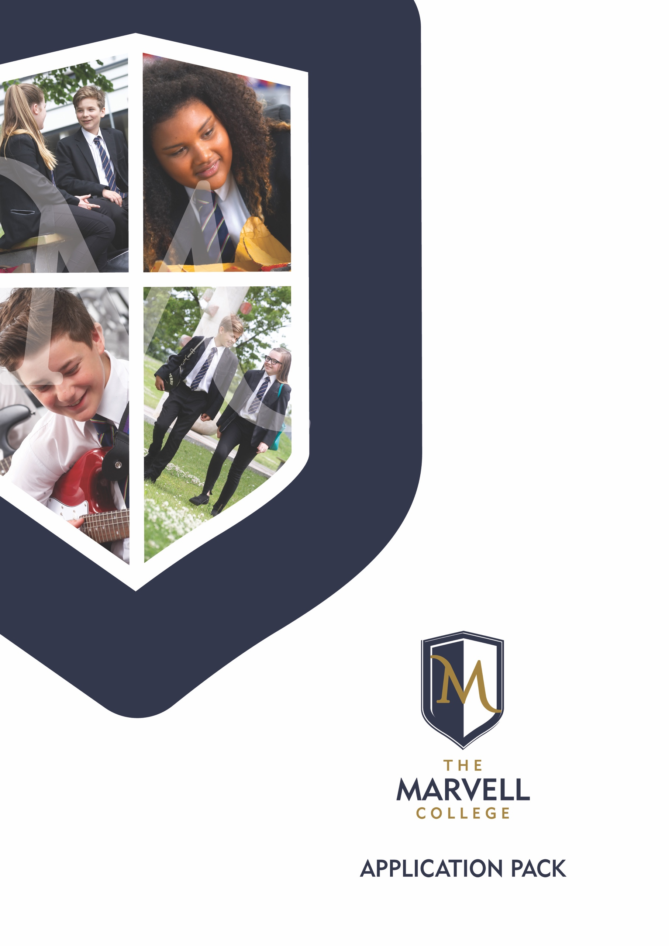

CONTENTS

1. Welcome
2. Curriculum
3. Pastoral Care
4. Outcomes
5. Requests to visit The Marvell College
6. How to apply
WELCOME

Dear Applicant,

Thank you for taking the time to consider the possibility of applying for a position within The Marvell College. We believe that working here is a great privilege and opportunity to be a part of something truly remarkable. We place a high value on collegiality and seek to build high performing teams that strive to succeed together.

Our vision is to be a restorative and inclusive school, working together to achieve excellence for children and is underpinned by our PRIDE values (polite, restorative, inclusive, determined, excellence).

The Marvell College is an 11-16 comprehensive Academy that opened on 1st September 2016. It is part of the hugely successful Hull Collaborative Academy Trust and works in formal partnership with St Mary’s RC College, which is one of the top performing comprehensive schools in the country. This unique partnership, led by National Leaders in Education ensures the very best of primary and secondary phase education collaborates effectively in the service of children and families.

We are increasingly popular with families and are now oversubscribed on entry in Year 7. We serve a catchment area covering the whole of East Hull and the East Riding villages of Sutton, Bilton, Preston and Hedon. We enjoy the benefits of a brand new £27 million, state of the art build, providing children and teachers with the very best facilities to learn and achieve together.

We are a rapidly growing school with 1035 pupils currently on roll. Over half of our children are in receipt of Pupil Premium and our outcomes are very good and continue to improve year on year.

The post of Lead Teacher of MFL is an opportunity for the right candidate to join our team. Please consider your application carefully and if necessary contact lwhite@themarvellcollege.com to arrange a visit to look around the school.

Yours sincerely

Marc Cooper
Headteacher
CURRICULUM

Our curriculum reflects the ambition that we have for our children. At key stage 3 our curriculum ensures that children enjoy learning and benefit from exciting opportunities to develop the essential knowledge and skills necessary to achieve well at key stage 4. Through the delivery of traditional academic subjects, the Arts, sport and cultural experiences, children become highly competent in literacy, numeracy, develop personally and emotionally. Commencing in Year 9, our key stage 4 curriculum is traditionally academic with the great majority of pupils following the English Baccalaureate pathway and additional option choices. Please see our website for further details of our curriculum structure.

PASTORAL CARE

We build the school on a foundation of high quality and high impact pastoral care. We strive to ensure that children feel welcome and cared for, whilst challenged to dare to be the best versions of themselves that they can possibly be. Our school sits at the heart of the community, and our pastoral curriculum serves to develop a strong sense of identity, belonging, pride and responsibility.

We invest heavily in our pastoral support systems; at the heart of this are our year teams where pupils are led by a high quality teaching Head of Year. Additional support is provided by a teaching Assistant Head of Year and a non-teaching Achievement Mentor in each year group.

Strategic pastoral leadership comes from one of our Deputy Head teachers who works with two Assistant Head teachers responsible for key stage 3 and 4.

As we operate a restorative high challenge/high support approach, children are expected to maintain excellent standards of behaviour. We reward pupils generously for working hard and making a contribution to our school community. Every teacher is also a personal tutor and is expected to provide individual support to each tutee regularly throughout the year.

OUTCOMES

Headline measures highlight the continued improvement of pupils at The Marvell College. Progress 8 is consistently in line with the national average and Attainment 8 is on a strong 3-year upward trend. Attainment in both English and Mathematics are also strong. The performance of our disadvantaged students is an increasing strength with students making similar progress to all children nationally for two consecutive years.

The Marvell College Key Stage 4 Performance Measures
Figures for 2018

Progress 8: -0.15
Attainment 8: 42.18
Basics (standard): 58.7%
Basics (strong): 33.7%

Pupils entered the English Baccalaureate (EBacc): 94.8%
Average EBacc Points Score: 3.72

REQUESTS TO VISIT THE MARVELL COLLEGE
We welcome potential applicants to visit The Marvell College during or outside of normal school hours to get an authentic insight into the culture and ethos of the college.
We are holding an open morning on: Wednesday 15th May 2019 from 8.30am until 10.30am.
If you wish to book a place, please contact lwhite@themarvellcollege.com.
If you are not able to visit at this time, please contact Mrs L White who will be happy to arrange an alternative visit, on which you will be accompanied by a member of the Leadership team.

HOW TO APPLY
If you are interested in applying for this post through Tes, please complete the application form and the equal opportunities monitoring form on the advert page, under the Apply now tab.
Alternatively please visit the vacancies page on The Marvell College website: https://www.themarvellcollege.com/the-marvell-college/staff-vacancies and apply by downloading the teacher application form and the equal opportunities monitoring form. All completed application forms must be returned to Mrs L White, The Marvell College, Barham Road, Hull, HU9 4EE or by email recruitment@themarvellcollege.com.
Successful candidates will be required to undertake an enhanced DBS check.
The School is committed to safeguarding and promoting the welfare of children and young people.
Closing date for applications: 11.00am on Monday 20th May 2019.

Interviews: To be confirmed

