And by

Tuesley Lane, Godalming, Surrey GU7 1RS
Principal: Emma Young

June 2024

Dear Applicant,

Thank you for your interest in the post of Graphic Design Technician (2-year Fixed Term Contract)

The following documents will assist you in your application:
- College and Department information
- Job Description and Person Specification
- Summary of Terms and Conditions for Support Staff
- Benefits summary
- Application and Monitoring Form

The application pack is available to download from the vacancies section of the College website https://www.godalming.ac.uk/Working_For_Us.html and as a hard copy from the HR Department – hr@godalming.ac.uk

Godalming College is committed to equality of opportunity and to safeguarding and promoting the welfare of children, young people and vulnerable adults and expects all staff and volunteers to share this commitment. Therefore, candidates must complete a full College application form and are required to complete a self-declaration of their criminal record or information that would make them unsuitable to work with children. If you would like further details the College’s Safer Recruitment, Data Protection and Safeguarding and Child Protection policies are all available on our website.

Completing and returning your application
Please complete the application form giving full details in each section as requested in order to demonstrate how you feel your skills and experience are suited to the role. This will enable the selection panel to assess each applicant’s relative strengths against the criteria in the specification.

Please return your application form by e-mail as an attachment to hr@godalming.ac.uk

The closing date for receipt of applications is Monday 1st July 2024 at 9am.

Short-listing and interview arrangements
Since we may not be able to respond to all applicants, if you have not been contacted by 4th July 2024, please assume that you have been unsuccessful. All applications are considered carefully and objectively against pre-determined criteria. Please feel free to contact HR if you would like to enquire about the progress of your application. We plan to hold interviews either at the end of the w/c 1st of July or the beginning of the w/c 8th July at the College and will notify short-listed candidates as soon as we can after the closing date.

Thank you for your interest in the College. I hope you will find the information useful and look forward to receiving your application.

Yours sincerely,



Emma Young
Principal

Telephone | Fax | E-mail | Website
01483 423526 | 01483 417079 | college@godalming.ac.uk | www.godalming.ac.uk



Godalming College

Godalming College is one of the best performing sixth form colleges in the country and a great place to work and study. We are very proud of the achievements of all our students and have a strong track record of consistently high results. Value added scores are excellent and the College was rated Outstanding by Ofsted in our inspection in December 2019. It was noted in that inspection that:

‘Leaders support staff very well. They take the well-being and workload of their staff into account when determining new processes and policies. Staff benefit from extensive investment in professional development opportunities, which helps them develop both their subject and classroom skills. Staff are highly positive about working at the College.’

More recently in our 2022 Staff survey, 96.8% of staff said they were proud to be a member of staff at the College and 96.2% of staff would recommend working at Godalming College. The following quotes are from members of our current team:

‘It is a supportive, positive, happy environment, which is great for both students and staff.’
‘As a member of staff I am given autonomy but always know that guidance, direction and support is available’
‘Senior Leaders do care and do consider staff welfare more than any other school/college that I have worked at.’

The College currently employs around 220 teaching and support staff on both a full and part time basis.

The success of Godalming College is also about community with students from all walks of life enjoying a whole range of opportunities in a welcoming and friendly environment. Students enjoy a stimulating, lively and challenging learning and social experience; they are treated as adults by specialist and dedicated teaching and support staff in facilities that have seen major investment over many years.

The campus comprises of nine newer large buildings and our older main building, which was the original grammar school, built in the 1930’s. Since the 2000s there has been a phased refurbishment and expansion of the College which included a new English and Modern Foreign Languages block, Media suite, netball and tennis courts and an 11 acre site for Rugby and Football pitches. We would invite you to take the virtual tour on our website to see for yourself the facilities of which we are so proud.

The College is within walking distance of Godalming town centre and the railway station, is easily accessible from the A3 and provides free car parking with EV charging stations for staff.

The College year runs for a period of twelve months from 1st September-31st August although the official start of the Autumn term varies. In 2023, the Autumn Term will begin on 29th August for all staff.

Full-time teaching staff have a time-tabled teaching commitment of 23.5 hours plus almost 9 hours directed time per week. Part-time staff will normally be appointed for a pre-determined number of time-tabled hours with an additional proportionate directed time element. In addition, a teacher will be expected to work such additional hours as may be needed to discharge their duties effectively including, in particular, the marking of student work, the writing of reports on students, preparation of lessons, teaching material etc.

Teaching salaries are paid according to the Sixth Form College Teachers’ pay spine and the Godalming College Single Leadership spine, depending on previous teaching experience. The Academy Trust Board reviews salary scales against any nationally determined pay agreements on an annual basis, the changes being implemented from 1st September. Incremental progression is subject to satisfactory performance review. The current pay spine is included in this application pack as is an infographic of the additional benefits we offer.

All offers will be subject to the receipt of satisfactory references, enhanced DBS disclosure, medical clearance, right to work in the UK check and proof of necessary qualifications. As the post is based in a Sixth Form College we have a responsibility to ensure that all staff are suitable to work in this environment and referees will be asked to confirm this.

Graphic Design Technician

The College is eager to appoint a part time Graphics Technician on a temporary basis to provide technical support to the Graphic Design Department in accordance with Health and Safety Regulations and to maintain those services to a high standard to enable the provision of quality education. The hours for this role are Monday- Friday, 36.42 hours per week between the hours of 8am – 4.45pm (exact hours to be determined) on a term time only basis. The salary for the role, based on 36.42 hours a week, 39 weeks of the year is £20,149.81. The role is offered on a 2-year FTC basis until 31st August 2026.

The Art and Design Department

- Graphic Communication sits within the Art and Design Department at Godalming College, which consists of five courses: 3D-Design, Art, Graphics, Photography and Textiles. In addition, the Department also offer GCSE Art to students who join the College on a Level 2 programme of study.
- Graphic Communication follows the AQA Art and Design ‘Art and Design (Graphic Communication)’ (7203)
- The course has an excellent record of achieving outstanding results. In the 2023 Summer series of exams, the course achieved a 100% pass rate and a 75.4% A*-B rate. Graphics also achieved an ALPS score of 3 in 2023, meaning that it is in the top 25% of all centres nationally for adding value to student outcomes. Please see the College website for more information on the results.
- The Art and Design Department has a strong and inclusive ethos. At its core is the belief that anyone can be an artist. The department offer a wide range of additional support, including lunchtime workshops, to help students achieve their potential.

- There is a strong collaborative environment in Art and Design. The five areas meet regularly to share resources and discuss ideas.

- The Department benefits from modern classrooms, with teacher access to PCs as well as individual Microsoft Surface Pros. Graphics is taught in a purpose-built classroom equipped with PCs. Students have access to the Adobe software for free and have access to a wide range of materials and resources including a laser cutter, printing press, Cricut machine, heat press, A1 printer and sewing machines.

- The Art and Design Department stages an exhibition of Year 2 work in the summer term of each academic year. This is part of the College’s ‘Arts Festival’ and is a celebration of the outstanding work our students produce.

- In 2021, Godalming College was awarded the Platinum Artsmark Award, recognising the leading role of our arts provision nationally.
- The College day is 8.45 until 4.15 and each teaching period is 45 minutes long.


JOB DESCRIPTION

Job Title: Graphic Design Technician

Line Manager: Course Leader of Graphics

Summary of Job

To provide technical support to the Graphic Design Department in accordance with Health and Safety Regulations and to maintain those services to a high standard to enable the provision of quality education.

Responsibilities

- Preparing rooms prior to lessons i.e. moving furniture, preparing materials and equipment, and homework packs

- Stock control and ordering of equipment

- Keeping workspaces and sink areas clean and tidy

- Maintaining equipment

- Mounting and framing student work

- Assisting with setting up the exhibition

- Provide students with technical support with Adobe (Photoshop and Illustrator) software and printing

- Laser cutting and cricutting

- Making screens and providing screen-printing assistance.

- Checking printers and liaising with IT when necessary

- Helping students with difficult projects e.g. Adobe Photoshop and Illustrator

- The Graphics Technician will undertake other duties as agreed between the Curriculum Lead of Art and Design, Course Leader and the post holder.

- To demonstrate an awareness and commitment to safeguarding, equality diversity and inclusion, health and safety and data protection, in line with College policies.

- To do other tasks as reasonably requested by the Principal from time to time.


PERSON SPECIFICATION FOR POST OF TEMPORARY GRAPHICS TECHNICIAN

The successful candidate will have the following essential qualifications, experiences, skills and qualities:

Essential Qualifications

- Good general level of education to a minimum of A-level or equivalent

Essential Experience and Skills

- Excellent communication and interpersonal skills
- Working in a busy environment and under time pressure
- Ability to work independently and manage time effectively to facilitate the smooth day to day running of Graphics course
- Flexibility and adaptability in responding to changes in teachers’ and students’ needs
- Experience of working effectively as a part of a team
- Practical experience of using different art material and equipment
- Skilled in using Photoshop and Adobe Illustrator
- Excellent IT skills including Microsoft 365 and experience with using relevant library catalogue software
- Stock control and cataloguing

Essential Professional Qualities

- Demonstrate the ability to be proactive and creative
- Strong attention to detail
- Strong organisational skills
- Regularly demonstrates initiative and continuous desire to improve
- Affinity with young people 16-19

Desirable

- Have previous experience of working in a school or college

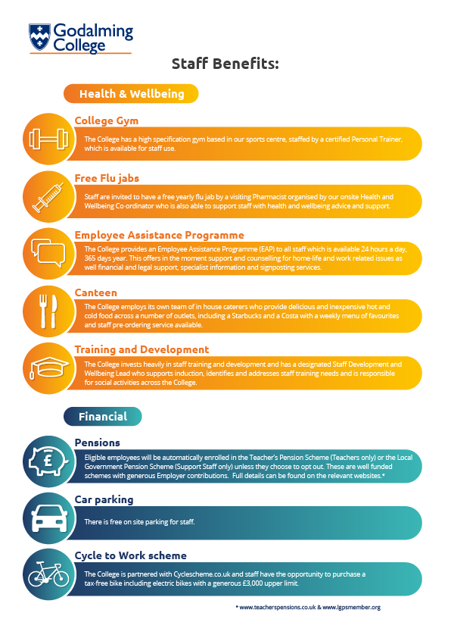

Godalming College Support Staff Payscale March 2024
Additional Surrey Allowance on all points of £1222 per year
Scale 1 | 18 | 21725 |  | Management 1 | 42 | 41298
 |  |  |  |  | 43 | 42265
Scale 2 | 19 | 21874 |  |  | 44 | 43332
 | 20 | 22312 |  |  | 45 | 44398
 |  |  |  |  | 46 | 45460
Scale 3 | 21 | 22735
 | 22 | 23175 |  | Management 2 | 47 | 46525
 | 23 | 23640 |  |  | 48 | 47691
 | 24 | 24464 |  |  | 49 | 48755
 | 25 | 25299 |  |  | 50 | 49913
 |  |  |  |  | 51 | 51077
Scale 4 | 25 | 25299
 | 26 | 26123 |  | Management 3 | 52 | 52238
 | 27 | 26950 |  |  | 53 | 53401
 | 28 | 27774 |  |  | 54 | 54568
Scale 5 | 29 | 28574 |  | Management 4 | 55 | 55757
 | 30 | 29374 |  |  | 56 | 56973
 | 31 | 30317 |  |  | 57 | 58220
 | 32 | 31251 |  |  | 58 | 59494
 |  |  |  |  | 59 | 60793
Scale 6 | 33 | 32291 |  |  | 60 | 62123
 | 34 | 33357
 | 35 | 34424 |  | Management 5 | 61 | 63481
 | 36 | 35486 |  |  | 62 | 64868
 |  |  |  |  | 63 | 66286
Senior Officer | 37 | 36454 |  |  | 64 | 67735
 | 38 | 37422 |  |  | 65 | 69217
 | 39 | 38391
 | 40 | 39362
 | 41 | 40328
Support Staff Salary Calculations
Salaries for term time only staff are calculated using a denominator of 1659 which is the nominal full time
equivalent annual hours taking into account holiday entitlements.
Full time working hours are 36.42 per week.
To calculate pro-rata payments
Hours x weeks x annual salary divided by 1659
Example: point 20 = £22,312 + £1,222 = £23,534
36.42 hours per week x 39 weeks per year = 1420
1420 x £23,534 divided by 1659 = £20,143.62 pa = £1,678.63 gross per month paid for 12 months
Hourly rate calculation
Full time annual salary / 365 x 7 / 36.42

