Presdales School

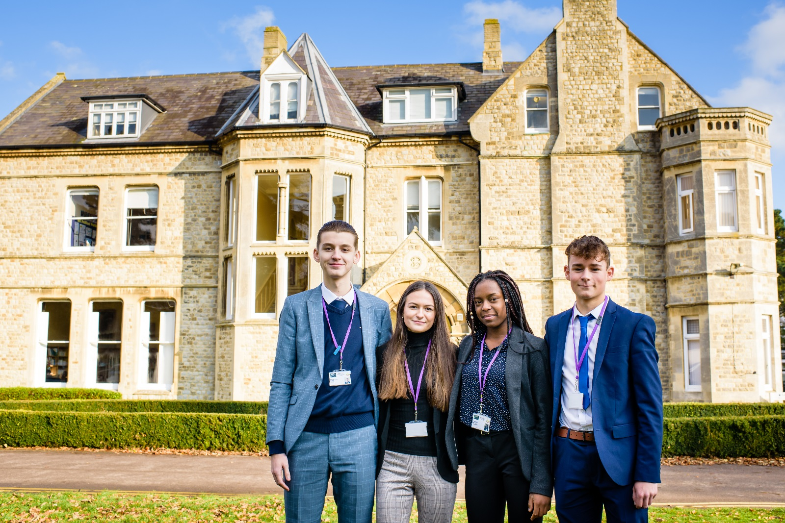

Candidate Information Pack
Head of Maths – Full-time
September 2020
MPS/UPS + TLR 1b17 – (currently £9,933)

Presdales School – Head of Maths

Information for candidates
Start date: September 2020
Full-time

Thank you for your interest in joining our team of outstanding staff. Please find enclosed in this pack general information about the school and also specific information about the post.

Presdales is a 11-18 non-selective girls school, with boys welcomed in to the Sixth Form. We have a long tradition of providing an outstanding education for our students. Formerly Ware Grammar School for Girls, which opened in 1906, we became Presdales School in the mid-1960s, and a fully comprehensive school in the early 1970s. The mansion house, which fronts the school, and our stunning grounds provide a calm and relaxed atmosphere for our school community. Presdales School is one of nine designated Lead Language Hub schools in England. We work with the National Centre for Excellence at York University, and with other Hertfordshire schools to enhance and improve opportunities for students in Modern Foreign Languages.

We are very proud of the high academic standards that our students achieve, regardless of their starting point. Our motto, ‘Achievement for all’, runs through all that we do. We understand that every student is an individual, with different interests, strengths and characteristics, and we celebrate the diversity that each one of them brings to our community. We believe that all students, with the appropriate balance of support and challenge, can be successful.

We aim to develop their creativity and independence inside and outside of classroom lessons. There is an extensive range of extra-curricular clubs and activities, including numerous trips throughout the school year, which provide students with the opportunity to develop their leadership skills, to be part of a team and to develop a ‘can-do’ attitude.

Our vision and values are instilled in our students throughout their time with us, whether this be through our House system, the excellent pastoral care they will receive or the culture of achievement for all that we foster in our community. We want our students to be happy and confident young women who are ready to make a meaningful contribution to our global society.

We are seeking a confident and enthusiastic Head of Maths to lead our enthusiastic and committed team of Maths specialist teachers. The department has a collaborative and focused style and are always keen to seek to improve the learning experience and attainment for all of our students. We use mini-whiteboards extensively for AfL and to encourage students' problem solving and have well-stocked resources to support learning. We have 5 dedicated Maths classrooms with smartboards, one of which also has 20 desktop computers and a further 20 laptops available for use in the department. We run two A Level Maths classes in each year of KS5 plus a Further Maths group, usually taking the Statistics and Decision options. We enter all the UKMT Maths challenges and often have students progressing to follow-on rounds. Over 30 sixth form students support younger learners, either in class, similar to a teaching assistant or with 1-1 booster sessions in registration.

The Mathematics Curriculum Vision
At Presdales School, we aim to provide a Mathematics curriculum which:

- Is inclusive and enables every student to achieve their full potential.
- Enables students to develop fluency in the fundamentals of Mathematics, building on prior learning, as well as deepening their understanding.
- Encourages students to develop reasoning skills to form logical and rigorous arguments.
- Develops problem solving, builds resilience and encourages creativity.
- Provides students with opportunities to appreciate the value of Mathematics in a wider context and develop their love of learning.
- Raises students’ aspirations and equips them with the mathematical knowledge, understanding and skills to flourish in their future careers.

Over the past year we have been working with staff to ensure that all staff have an appropriate work/life balance. Initiatives include: Free Yoga after school on Friday, free flu jabs, continual programme of replacing staff laptops/chrome books, allowing personal deliveries to school, staff can leave at 2.30pm if they are not teaching or needed in a meeting, an extra occasional day off per year for all staff. We believe that staff work more effectively when they have a manageable workload.

I do understand and appreciate the time and effort it can take to complete an application for a job such as this; thank you for considering Presdales School.

Matt Warren
Headteacher

Presdales School

Head of Maths
MPS/UPS + TLR 1b17 – (currently £9,933)
Start date: September 2020
Full-time

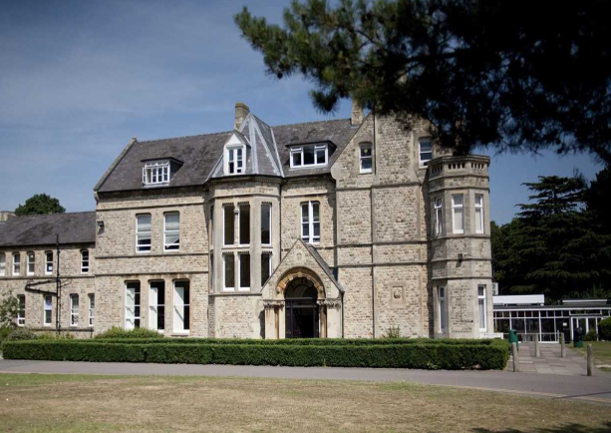
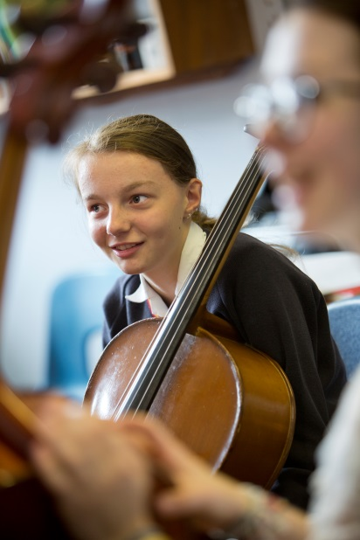
Presdales is a high achieving, all-girl, non-selective 11-18 school (boys are accepted into the sixth form).
We aim to provide an outstanding education that enables all students, regardless of their background and starting point, to achieve and surpass their academic potential.
We are committed to the development of independent minded young people who have active and creative minds.
We expect our students to acquire a sense of understanding and compassion for one another and to have the courage to act on their beliefs. We will equip our students with the skills and attributes to empower them to lead happy and successful lives, enabling them to make a meaningful contribution to our global society.
The school is committed to safeguarding and promoting the welfare of young people and expect staff to share this commitment. Applicants must be willing to undergo an Enhanced DBS disclosure and approved references will be required for the post

Closing date for applications: Monday 20th January, 2020 9.00am
(We reserve the right to close applications before this date, so early applications are advisable)
We expect to interview: w/c 27th January 2020

Please submit:

- A letter of application, no more than two sides of A4, outlining how you meet the person specification
- A completed application form (available on the school website)

You can post your application to the school, or send by email to recruitment@presdales.herts.sch.uk
Please note that CVs will not be accepted

Person Specification – Head of Maths

We are looking for a candidate who is able to demonstrate the following essential or desirable requirements

Qualifications
- A good honours degree
- Qualified teacher (QTS)
- A commitment to on-going professional development with evidence of further study or professional training
Knowledge and Experience
- Successful teaching of KS3/GCSE/A Level Maths/Further Maths
- Evidence of adding value to current students
- Knowledge of current educational developments in subject and implications
- Good understanding of how students learn and how to raise standards of achievement
- Evidence of active involvement in own professional development
- Experience of using data systems such as SISRA/4Matrix
Leadership and management
- Ability to contribute to the recognition and effective use of the talents of the teaching team
- Effective management of student behaviour within the department
- Ability to take difficult decisions and convey outcomes clearly and sensitively
- Ability to foster an open, fair and equitable culture within the faculty
Skills and Abilities
- Able to communicate well, both in writing and orally
- Excellent organisational skills
- Good ICT skills and be able to use them in own teaching
- Able to manage time effectively and work to deadlines
- An excellent classroom practitioner
Personal Qualities
- Committed to safeguarding and promoting the welfare of young people
- Excellent record of attendance and punctuality
- Ability to work well within a team
- Ability to work under pressure and meet deadlines
- The ability to motivate others
- Positive attitude
- Self-motivated and hardworking
- Creative
- Sense of humour

Job Description – Head of Maths

Vision and Purpose

- To lead and manage the Maths department, maintaining and striving to continually improve standards
- To teach across the age and ability range, as and when experience allows, and to provide a learning environment that enables all students to make progress regardless of their starting points
- To share the responsibility of all staff to ensure that our students are challenged, encouraged, nurtured and developed as all-round young people
- To develop and enhance the teaching practice of others.

Main Responsibilities

- Teach across the full range of age and abilities
- Committed to safeguarding and promoting the welfare of young people
- Lead by example with high quality teaching
- Monitor and evaluate the progress of students in the department in line with school policies, and lead on actions to address underachievement
- Support and develop staff within your team
- Actively engage in the performance management process to develop staff and monitor standards
- Ensure that there is a high quality curriculum for the department that is fit for purpose, up to date, engaging and can be accessed by all students
- Ensure that the department evaluation and improvement plans are completed and are implemented effectively
- Communicate effectively both orally and in writing with students, staff, parents and governors
- Have a commitment to your own continued professional development
- Lead department meetings
- Ensure that the department budget is utilised effectively and within budget
- Attend middle leaders’ meetings and contribute with others to the realisation of the school improvement plan and provide input for the school evaluation document
- Organise resources within the department effectively
- Be a form tutor as required
- Ensure that all students have equality of opportunity
- Promote the school’s ethos and culture within the department and wider community
- To comply with the school’s Health and Safety policy

Whilst this job description is current, and every effort has been made to explain the main duties and responsibilities of the post, each individual task may not have been identified. Employees will be expected to comply, following consultation, with any reasonable request from the Headteacher to carry out tasks and duties that are of a similar level, but not specified in the job description.

