Teacher of Spanish
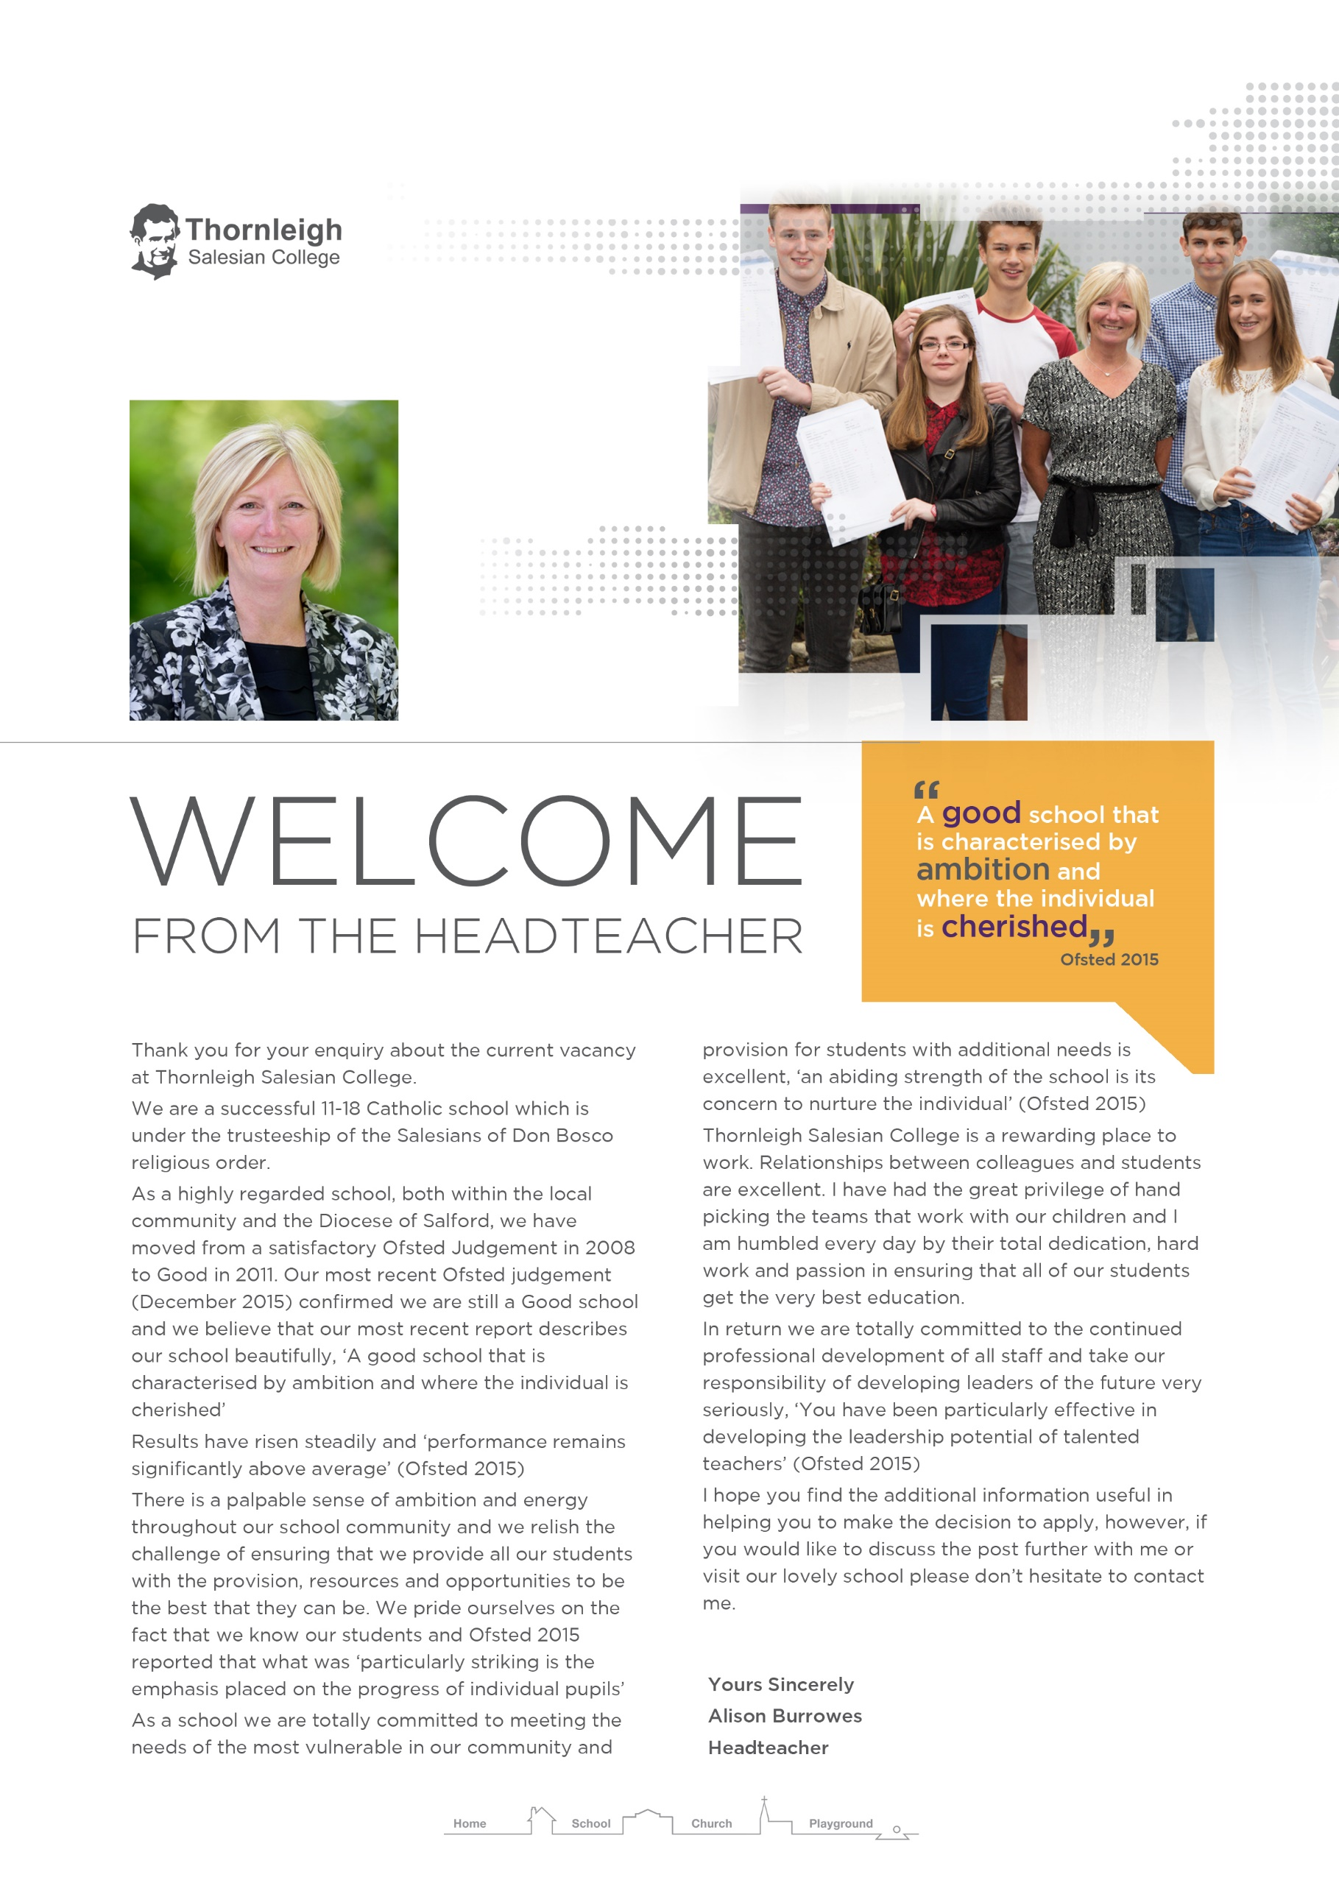

Job Description
Closing date: 12noon Tuesday 19th March 2019
Interviews: Monday 25th March 2019

Application forms can be downloaded from the school website www.thornleigh.bolton.sch.uk
Please return completed application forms to:
recruitment@thornleigh.bolton.sch.uk

Thornleigh Salesian College is committed to safeguarding and promoting the welfare of children and young people and expects all staff and volunteers to share this commitment. The successful applicant will be required to complete an enhanced DBS check.

Teacher of Spanish
The Governors invite applications from suitably qualified candidates for the post of Teacher of Spanish to work in a successful department.

If you are a dynamic classroom practitioner with:
- a clear sense of purpose and high expectations
- a flexible and creative approach that inspires and enthuses students
- a commitment to excellence

we would be pleased to hear from you.

Salary T1 – T9
Full time/permanent post
Required from September 2019
Professional Responsibilities
1 | Work within the School Teachers Pay and Conditions Document (STPCD)
2 | Support and promote the school’s ethos and values and work in accordance with the school’s aims, procedures and practices.
3 | Contribute to and implement the annual School Improvement Plan and agreed policies.
4 | Teach as directed throughout the school subject to appropriate training.
5 | Assess, record and evaluate the development and progress of students.
6 | Participate in the pastoral management of the school as requested.
7 | Take part in performance management procedures outlined in an agreed school policy.
8 | Take responsibility for their own professional development.

Specific Responsibilities

1 | Plan and deliver lessons using a range of strategies to meet students’ individual learning needs.
2 | Have a thorough knowledge and understanding of their subject, its teaching and place in the National Curriculum and that of the school.
3 | Set and mark homework according to school and department policies.
4 | Mark, assess, record and report on students’ achievements, setting appropriate targets for improvement.
5 | Meet deadlines for reporting, marking submission of assessment data, coursework, marks and forecast grades.
6 | Prepare students for examinations, taking part in standardising and moderating activities required by departments and examination boards.
7 | Contribute to the development of schemes of work, school and department policies as appropriate.
8 | Attend and contribute to appropriate meetings and professional development activities.
9 | Contribute to the process of department self-evaluation and improvement planning.
10 | Undertake whatever other duties might reasonably be requested by the Headteacher or Subject Leader of Department.

Specific Responsibilities- Form Tutors

1 | Take responsibility for day to day discipline routines and attendance in the form group.
2 | Review and discuss students’ work and welfare, setting targets as necessary.
3 | Promote good behaviour and positive attitudes at all times.
4 | Support form, year and school activities as appropriate.

Whilst every effort has been made to explain the main duties and responsibilities of the post, each individual task may not be identified. This job description details duties and responsibilities but does not indicate the amount of time to be spent carrying them out. No part of it may be so construed. In allocating time to the performance of duties and responsibilities, the post holder must use directed time in accordance with the school’s policy as published in the Staff Handbook and having regard to the School Teachers’ Pay and Conditions Document.

Person Specification

CRITERIA | ESSENTIAL | DESIRABLE
Qualifications & Training

- Qualified Teacher Status
- Member of GTC
- Good honours degree in related subject
- Masters degree in related subject

Experience

- Teaching experience at Key Stages 3 - 5
Skills & Knowledge

- Able to communicate effectively, orally and in writing.
- Able to demonstrate effective planning and teaching skills
- Able to present confidently to a large group of students
- Able to work with others to achieve common goals
- Able to use / analyse assessment data systems to raise standards
- Able to provide clear direction and to inspire, motivate and enthuse others
- Confident in own ability to be effective and to take on challenges
- Good ICT skills and effective use of other technologies
- Able to form good working relationships with staff and students
- Effective behaviour management
- Able to support students and staff in maintaining high standards
- Up to date awareness of the National Curriculum and specifically within their individual specialism
- Efficient and effective administrative, organisational and personal management skills

Personal Attributes

- Honesty, integrity and so builds trust
- Resilience
- Enthusiasm, commitment and perseverance
- Capacity to work hard, under pressure, to meet deadlines

- Adaptable and amenable with respect to working practices

- Ability to work independently and be a team player

Equal Opportunities

- Understanding of equal opportunities issues and an ability to demonstrate strategies to challenge discrimination and prejudice.
- A commitment to inclusive education.

Health and Safety

- An understanding of Health and Safety issues

