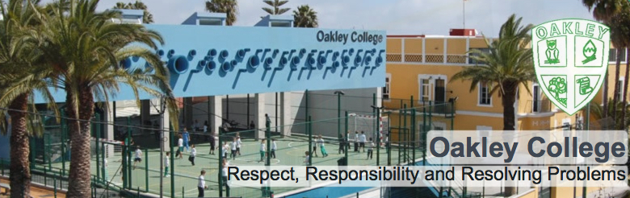

SECONDARY ENGLISH TEACHER

(Literature and language KS3-KS5)

INFORMATION FOR CANDIDATES
SCHOOL HISTORY
Oakley College opened in 1989 as a nursery school accommodating 30 children. Over the last 30 years we have developed to accommodate 550 students between the ages of 2 and 18. The school is privately owned and fully authorised by NABSS (The National Association of British schools in Spain), the Spanish government and one of only 4% of British International schools around the world to be fully authorised as a BSO (British School Overseas) school by the DFE (Department for Education in the UK).
The school continues to develop and grow and in the academic year 2018-19 we opened our new Oakley Park, a 5000m2 sports, natural and recreational area serving the school community. In the academic year 2019-2020 we will open our new primary school building, adjacent to the secondary site. The school has been recognised as one of the top 100 schools in Spain by the El Mundo newspaper and has been selected for the last 9 years (2011-2019) as in the top 20 International schools in the country.

SAFEGUARDING
Safeguarding is everyone’s responsibility. Safeguarding is defined as:
• protecting children from maltreatment
• preventing impairment of children’s health and development
• ensuring that children grow up in circumstances consistent with the provision of safe and effective care and
• taking action to enable all children to have the best outcomes” (Gov.UK 2014)
All members of staff must be fully aware of and fully complete their obligations.

LEARNING FOCUSED
We pride ourselves on our family atmosphere, positive links with the local community, our strong academic programme, and above all, the committed team of staff who care for and educate our students. We want our students to be happy at school and be an integral part of our confident, learning community.
The school seeks self-motivated professionals who can achieve excellence by positively adapting to an international setting, whilst maintaining the very highest expectations of their students and themselves.

LOCAL AREA
Oakley College is situated in Tafira, on the outskirts of Las Palmas, capital of the beautiful island of Gran Canaria. The school is 20 minutes from Las Palmas, 20 minutes from the international airport and located in the foothills to the national park and beautiful mountainous areas of Gran Canaria.

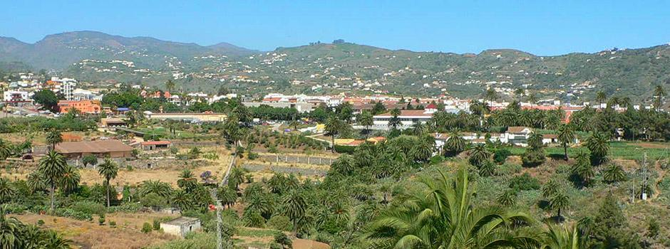
Tafira

The city of Las Palmas has a range of cultural events over the year ranging from cinema, international music, jazz and opera festivals, through to the month long carnival celebrations (http://www.spain-grancanaria.com/en/whats-on/las-palmas-events.html).

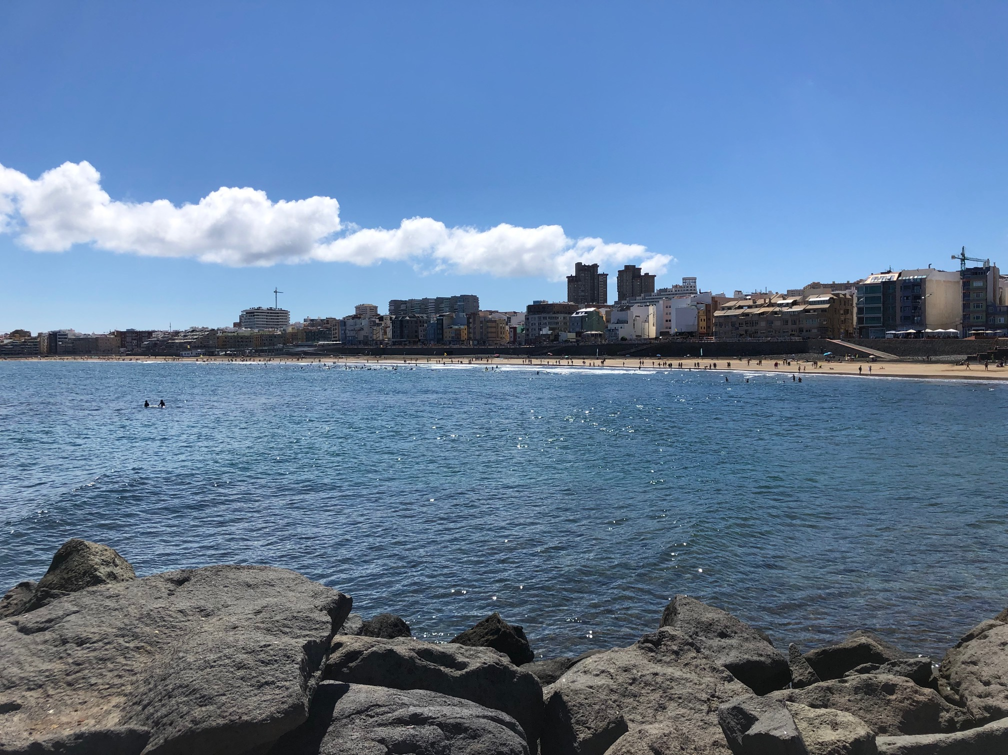
Las Palmas beach, Las Canteras

POSITIVE RESULTS
Over the last 3 years we have had an:

A-level pass rate of between 97 and 100%.

And an (I)GCSE pass rate of between 85 and 92%

We believe happy, self-confident students can perform well in what-ever they decide to do.

THE IDEAL CANDIDATE
The ideal candidate would be fully qualified (with QTS) and have a minimum of two years’ experience of teaching the National Curriculum.
Oakley provides its teachers with permanent employment contracts. Successful applicants will be expected to participate fully in the development of a vibrant, expanding learning community and, through our staff development programme, to further their own skills whilst contributing to our evolving vision for the school’s future success. The Oakley College community includes children from more than fifteen countries, although the vast majority are local Spanish children. All teaching is done in English (except for languages) and EAL experience is valued. The teacher will also teach some English skills classes preparing students for the B2 ESL exam.

LIVING AND WORKING IN SPAIN
It is very important that you carry original personal identification such as your passport or EU-UK driving license all the time while you are in Spain. You may need to show your identification when you pay using a debit/credit card. You must keep all your original car papers in the car, if you have one, all the time.
Work contract
In order to work in Spain, an ‘NIE’ number (a foreigner’s identity number), social security number and a contract of employment are needed. The School will help with all paperwork.

SIGNING ON WITH A DOCTOR
You must sign on with a social security doctor as soon as possible after receiving your work contract and social security number. Go to the local health centre and ask for a social security health card, “tarjeta sanitaria”. They will assign you a doctor and send the card to your address by post usually within 2 weeks.

ACCIDENTS AT SCHOOL
The school is insured against staff accidents with a company called MAC-MUTUA. It has its own clinics, doctors, and ancillary staff, including physiotherapists. They will arrange all the treatment you need. You are entitled to a free medical assessment from MAC-MUTUA every year.

SPANISH STATE PENSION
The years of contract at school will count towards a Spanish state pension. The present law says that you will need to contribute for 15 years to access a Spanish pension. These contributions may also be ́converted ́ into years that count towards the EU-UK state pensions if you return to your country.

UK PENSION CONTRIBUTIONS
Your salary will not include contributions to the UK state pension scheme or other EU pension schemes, e.g. teachers pension. It may be possible to keep paying your National Insurance stamp in the UK, please check with your pension provider before leaving the UK.

APPLICATION PROCESS AND DOCUMENTATION NEEDED TO APPLY
All applicants should submit their curriculum vitae, including details of professional references and a letter of application.
Our school is fully committed to safeguarding and the successful applicant will have to undergo safeguarding back-ground checks.

WORKING HOURS
There are 35 periods (of 50 minutes) a week in the secondary timetable. Teachers teach 30 periods (25 hours) a week and have 5 periods (of 50 minutes) PPA time.
The working day is from 8.30 (8.20 on a Monday) – 15.50, Monday to Friday plus staff meetings once a week (Wednesday 4-5pm). All staff should arrive in good time to be able to carry out their professional duties.

WORKING TIME
If the Teacher is employed full time, he/she shall be available for work for 185 days in any year, of which 180 days shall be days on which he/she will be required to teach pupils in addition to carrying out other duties. The 185 days shall be specified by the Principal.

OUR PHILOSOPHY

We believe that a caring and stimulating environment is essential to the development of children. We aim to provide a high quality educational experience to our students, ensuring a passion for learning and life.
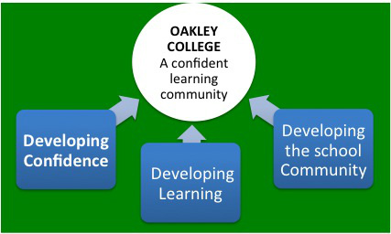

OUR VISION

A confident learning community

OUR MISSION

To provide a high quality British education in a caring family environment

OUR CORE VALUES

Respect, Responsibility and Resolving Problems

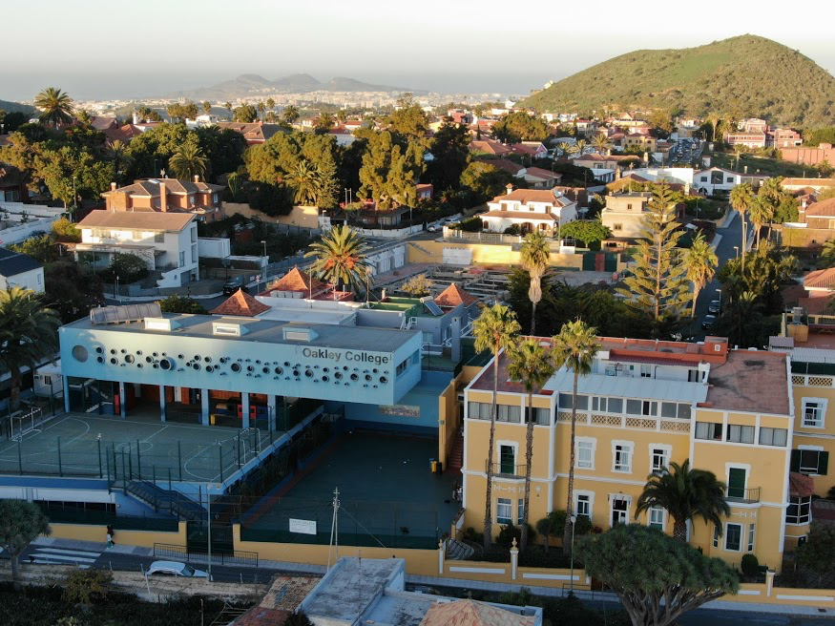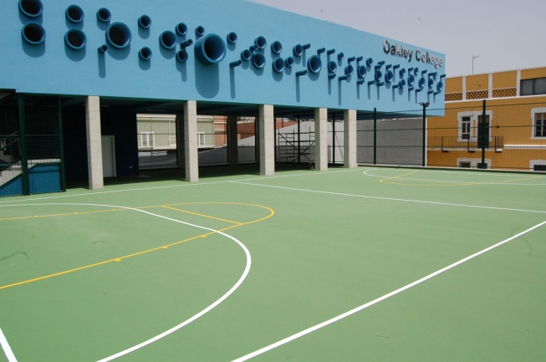
Oakley secondary campus

THE TEACHING DAY
The teaching day starts at 08.35 in secondary and finishes at 15.45.

SECONDARY TIMETABLE
8.20 on Monday  8.30e Tue-Fri  Required in school | 8.35 -8.50  Tutor period | 8.50 - 9.40  Lesson 1 | 9.40 – 10.30  Lesson 2 | 10.30 -11.20  Lesson 3 | 11.20-11.35  Break | 11.35- 12.25  Lesson 4 | 12.25- 13.15  Lesson 5 | 13.15- 14.05  Lunch | 14.05-14.55  Lesson 6 | 14.55-15.45  Lesson 7 | 15.45- 15.50  Required in school

Holidays
The school operates 180 teaching days each year, plus 5 in-service days. There are two months holiday in summer (July & most of August), 2/3 weeks at Christmas, 2 weeks at Easter and 2/3 days mid-term break, plus several Spanish bank holidays.

MEDICAL CARE
Medical care is provided under the Spanish medical system from the start of your contract. Full information in English can be obtained from the Spanish Health Service at http://www.msc.es/en/home.htm
MOVING ABROAD
When moving abroad it is important to be fully informed about all aspects relating to tax, pensions, etc. within the UK. For a detailed reference visit the UK website www.direct.gov.uk/en/index.htm

THE PACKAGE INCLUDES:

- A gross salary paid in Euros, 12 months of the year
- A three course school meal every day, including a vegetarian option
- A CPD annual allowance of 200€
- Free Spanish classes for beginners
- The school does not charge for the education of teacher’s children, over the age of 3 (Nursery).
- Free private medical care in the case of work-related injury or illness

The school also provides administrative support in meeting the legal requirements for foreigners wishing to live and work in Spain, including:

- support in obtaining the legal documentation necessary to work in Spain
- support in registering with your local doctor
- assistance in opening a bank account and organising Internet and mobile phones.

If you arrive during the summer prior to starting work it is a good idea to bring an EHIC medical cover form with you. You can get this from any post office in the UK.

SALARY

Salary for the post is in line with the teachers in Spain, terms and conditions document (national guidelines). Teaching salaries range between 22.990€ and 27.030€ gross per year depending on experience. Estimated Tax (IRPF): 16% plus Social Security tax: 6.35%

INTERVIEW PROCEDURES
Short listed candidates will have an interview by skype.

See the following link for cost of living information in Las Palmas:
The Cost of living index for Spain is on average 25% below UK.

Las Palmas - cost of living information
http://www.numbeo.com/cost-of-living/city_result.jsp?country=Spain&city=Las+Palmas

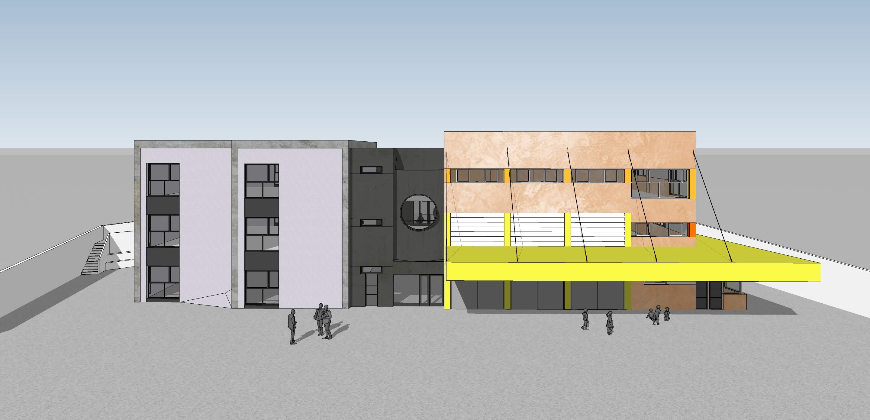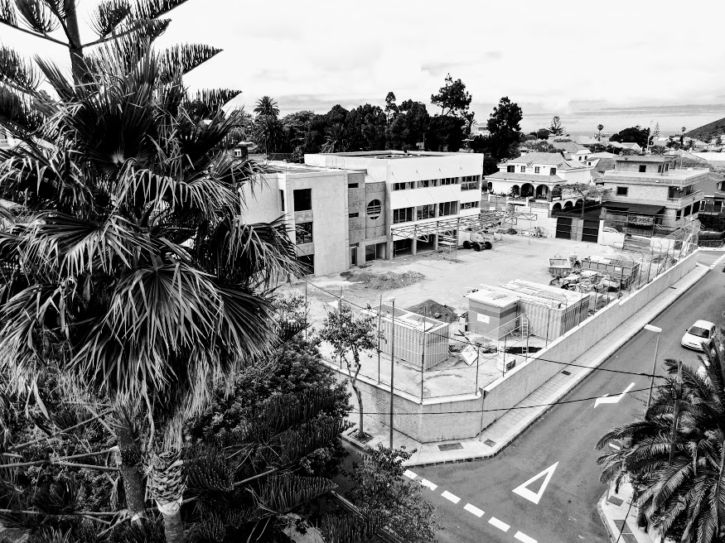
New Primary Campus opening January 2020

JOB DESCRIPTION FOR TEACHERS
Job Purpose | To teach students, creating an environment where they want to learn and where they can naturally discover their true passions, taking responsibility for their academic progress and pastoral care.
Line Manager | - Head of Primary/Secondary
Learning and teaching | - To plan, prepare and deliver schemes of work in accordance with school policies.  - To maintain a working knowledge of National Curriculum & other DFE documents.  - To maintain records of pupils’ progress including all statutory documents required by the UK DFE or the Spanish Ministry of Education.  - To produce reports and grades for pupils as per the school calendar.  - To conduct termly meetings with parents to discuss and explain their child’s  performance and progress in school.  - To provide and maintain an attractive and stimulating environment in which to foster effective teaching and learning.  - To monitor progress and the effectiveness of class work and to evaluate and modify planning and teaching as necessary
Managing | - To understand and implement:  - Regulations and correct procedures relating to attendance registers  - Emergency and evacuation procedures  - Health and safety policies  - All curriculum polices  - Any other organisational policies or agreed procedures  - To conduct standardised or other tests when required and document pupils’ performance  - To attend and participate in weekly staff meetings and also on other occasions as required  - To attend and participate in all training sessions  - To supervise playtimes and lunchtimes when required  - To supervise pupils in assemblies when required  - To liaise with colleagues enabling satisfactory transfers of children within school between schools and hand over to new staff  - To promote the subject(s) within the school and provide enrichment opportunities  - To provide additional activities and opportunities for pupils outside the classroom
Pastoral | - To be aware of the physical and emotional well-being of pupils and the need to respond to particular situations.  - To carry out duties of care as a form tutor and also during non-class times.  - To understand and implement all welfare and safeguarding policies.  - To liaise with other staff as required e.g. educational psychologist.  - To promote and safeguard the welfare of all pupils at school.
Other information | - Teachers at Oakley College are required to adhere to DFE Teachers’ Standards (published September 21012)  - Operate at all times within the stated policies and practices of the school.  • _Endeavour to give every child the opportunity to reach their potential and meet high expectations.  • _Contribute to the life of the school through effective participation in meetings and management systems necessary to co-ordinate the management of the school.  • _Ensure your own professional development.  • _Develop appropriate liaison with all teaching and support staff.  • _Liaise effectively with parents and actively promote their involvement in the life of the school.  • _Actively lead and develop the subject area as part of the wider, school curriculum

Person Specification

Qualifications

Essential
Degree or equivalent in relevant subject
QTS with at least two years’ teaching experience
Fluent English speaker
Eligible to work in the EU
Desirable
British educational background
International experience

Knowledge and Experience

Essential
A clear philosophy on how and why the
subject should be taught
Sufficient knowledge to challenge more able
pupils
Strategies to deliver differentiated lessons
Up to date knowledge of current educational
developments.
Desirable
Experience or awareness of pastoral and
academic roles and responsibilities as a tutor
EAL experience

Skills and Abilities

Essential
An understanding of how to use assessment for learning strategies to improve learning. Ability to motivate pupils and instil a love of
learning
Good communication skills.
Desirable
Ability to adapt and react positively in any given situation
Willing and able to offer enrichment and/or
extra-curricular activities

Personal Qualities

Essential
Flexible, positive approach when dealing with students
High moral and ethical values
Good interpersonal skills
Ability to work independently and collaboratively
Passion for teaching
Desirable
Willingness to engage in local culture and
learn basic Spanish
Creative when approaching challenges,
offering solutions rather than obstacles.

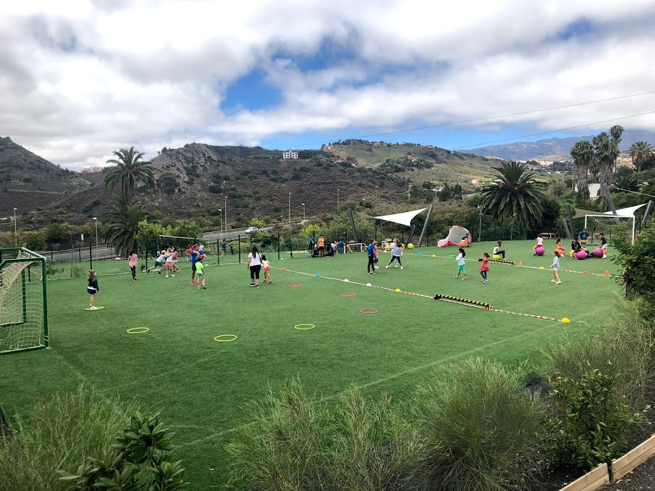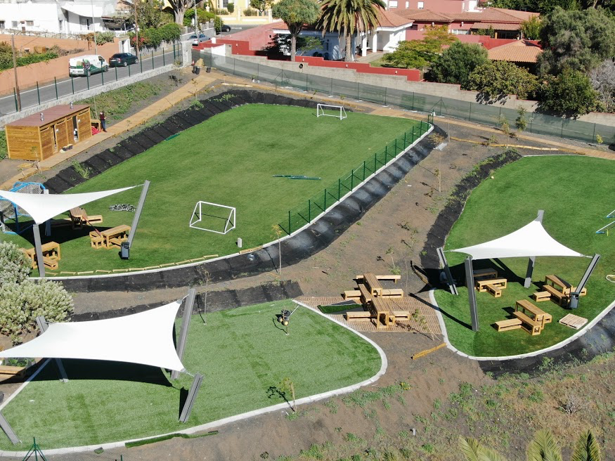
Oakley Park opened February 2019

Top 100 schools in Spain link http://www.elmundo.es/mejores-colegios.html

Oakley College Lipdub www.youtube.com/watch?v=IH-TcrFY1G0

HOW DO I APPLY?

Please send your CV (with two professional referees) and letter of application, along with a recent photograph, to the school Principal, Donat Morgan at jobs@oakleycollege.com
Successful applicants will be required to obtain a DBS check and complete a medical questionnaire to confirm they are medically fit to teach.

Oakley College
Calle Zuloaga 17,
Tafira Alta,
35017
Las Palmas de Gran Canaria
0034928354247
www.oakleycollege.com

