WE ARE ASTREA

ASTREA ACADEMY SHEFFIELD
PART OF ASTREA ACADEMY TRUST

WELCOME PACK
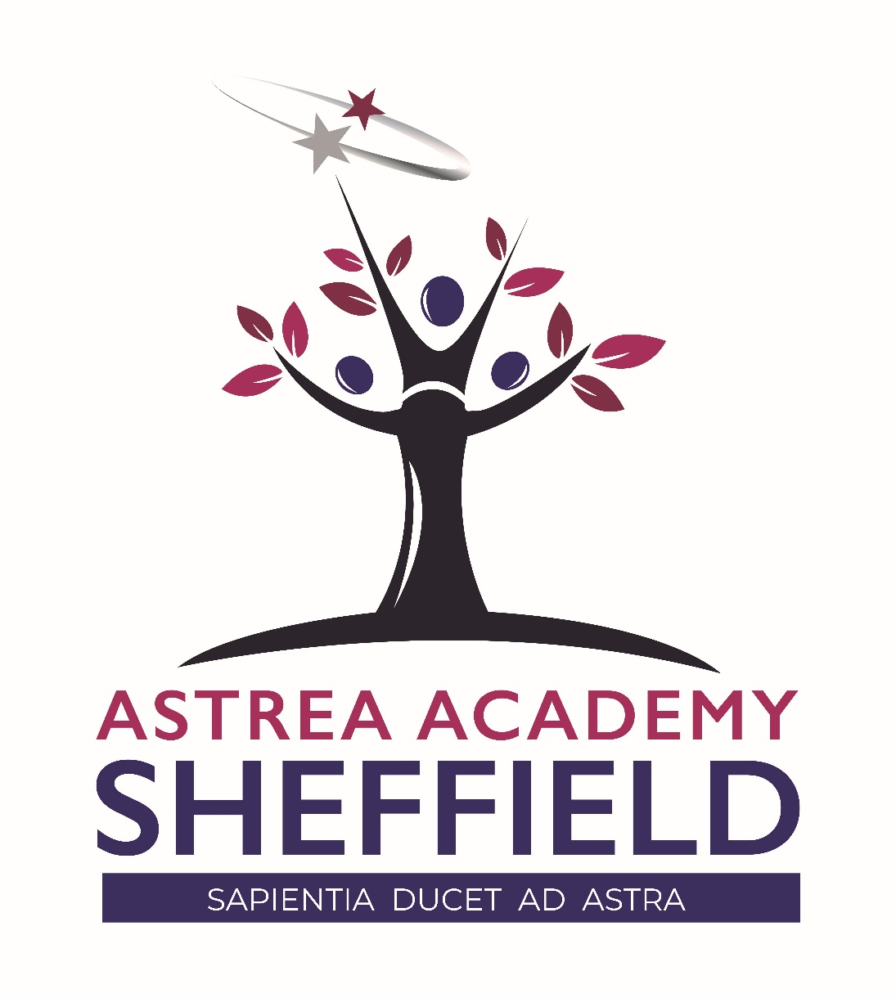

The Vision
‘A relentless commitment to excellence, every day’
Our Mission
A broad and balanced curriculum based on knowledge, skills and experiences will enrich scholars’ lives, build cultural capital and instil a love of learning. They will be able to apply their learning to real world contexts and problems, creating solutions in collaboration with others. Scholars will learn to value family, community and the environment. They will make a positive contribution to the life of the school and those around them. Scholars will become resilient learners who are motivated to take responsibility for their learning, health, well-being and happiness. Scholars will have high expectations of themselves, a culture of craftsmanship and a drive for excellence. They will understand the scope of possibilities that lie ahead of them and what is required to achieve their ambitions with the confidence and belief to make them a reality.
A Unique Education
At Astrea Academy Sheffield, our curriculum is the purpose of our school. The curriculum is everything that we want our scholars to know and to understand. It includes learning about discrete subject disciplines such as the sciences, humanities and the arts, and also how these disciplines relate to one another. Our curriculum is also what we want scholars to achieve, the opportunities we offer them and the experiences we believe all scholars are entitled to.
Classroom Culture
Learning is sacrosanct
All Astrea scholars deserve to explore the best of what has been thought and said. As staff who are unashamedly passionate about our subject disciplines and phases, we know that the greatest gift we can give our scholars is our expertise. We believe joy and wonder is found in learning and we fiercely protect every scholar’s right to access this.
Equity of knowledge
We believe that it is our moral imperative to impart as much knowledge as possible to all of our scholars. Staff thoughtfully select the most powerful knowledge which enables our scholars to understand and challenge the world around them. We maintain consistent expectations of all scholars because they have the right to access this powerful knowledge, regardless of barrier or starting place. It is the job of our staff to teach to the top and find ways to support all pupils to get there. We believe that the best differentiation is often invisible and relies on teachers knowing their scholars and ensuring that the classroom experience is tailored to them as individuals.
Time is precious
We know that knowledge begets knowledge. With this in mind, the time in our classrooms is precious and both staff and pupils must treat it as such. We are always interested in taking the shortest path to learning and we deal with disruptions to learning consistently and seriously: learning time should never be wasted.
True understanding is long-term
We understand learning to be a change in long-term memory. Staff sequence their teaching carefully and always consider their curriculums in the context of a through-school education. Our staff are mindful of poor proxies for learning and regularly interrogate what has truly been understood and transferred to longer-term memory.
Common approach
As we believe that all of our scholars deserve the very best educational opportunities, we think that it is important that our staff follow a common approach to classroom culture.

Our Pledge, Our Promise, Our Affirmation
I am strong
I am successful
I am Astrea
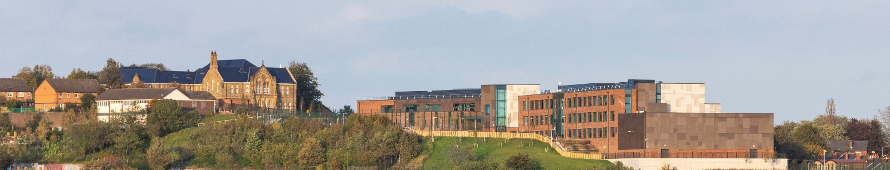

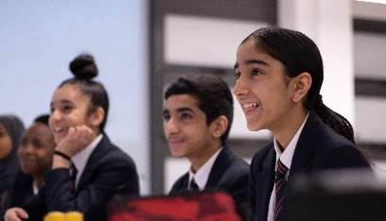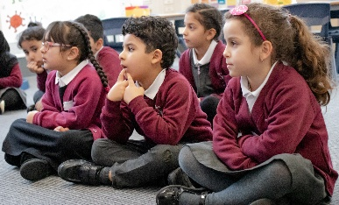

Our Motto
‘Sapientia Ducet Ad Astra’
Wisdom Leads to the Stars
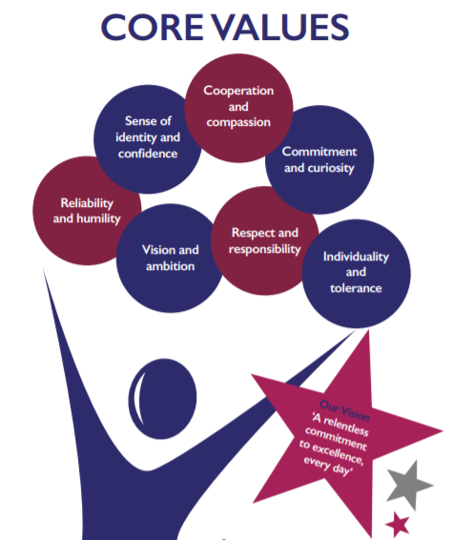
Ground Breaking Facilities – Primary
The beautiful Grade 2 listed Victorian Pye Bank Building has been restored with loving care. This impressive building currently houses our 52 place nursery, 2 reception classes, and 3 classes in Year 1 & 2 and will incorporate 2 more classes from September 2021, with more children joining us in reception. Scholars remain in this building until Year 4, where they then graduate to the secondary building from Year 5.
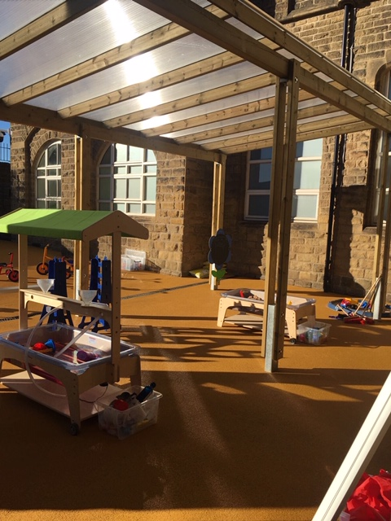

Primary School
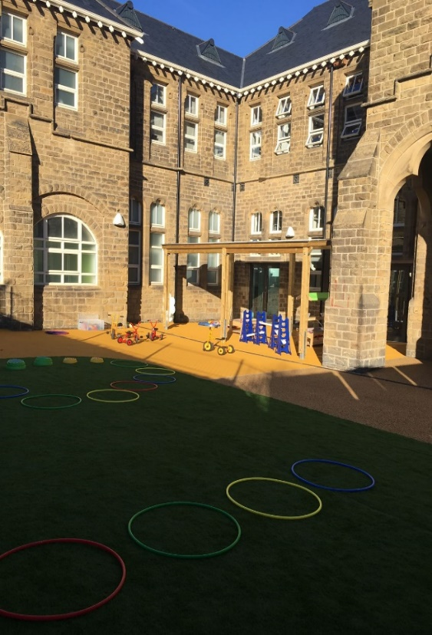

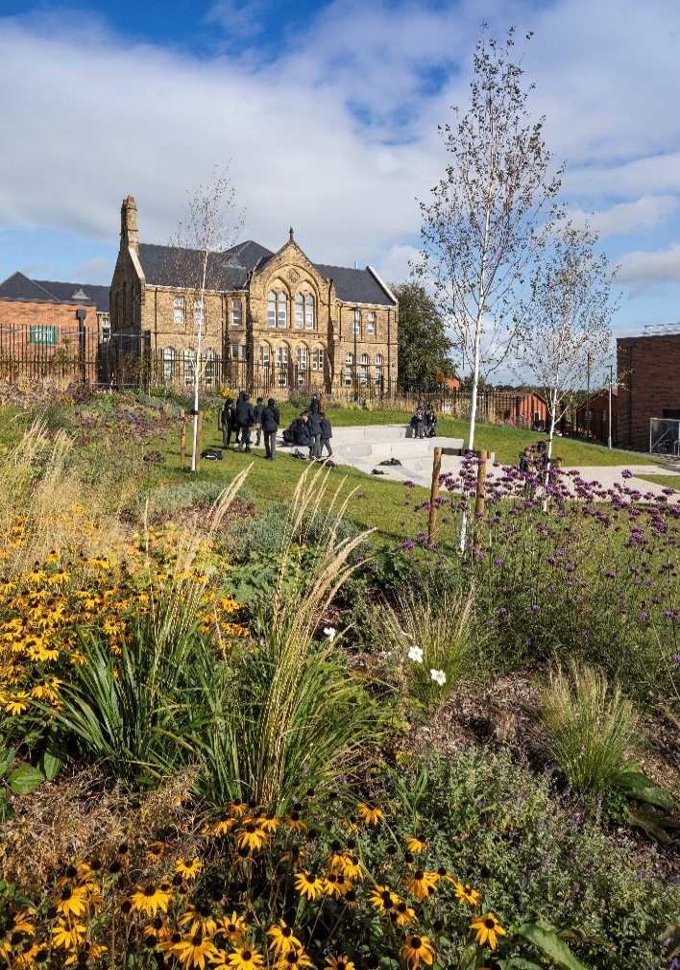

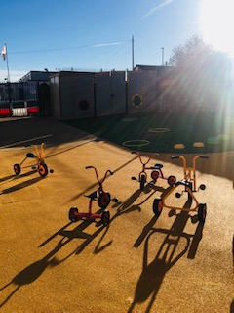

Secondary
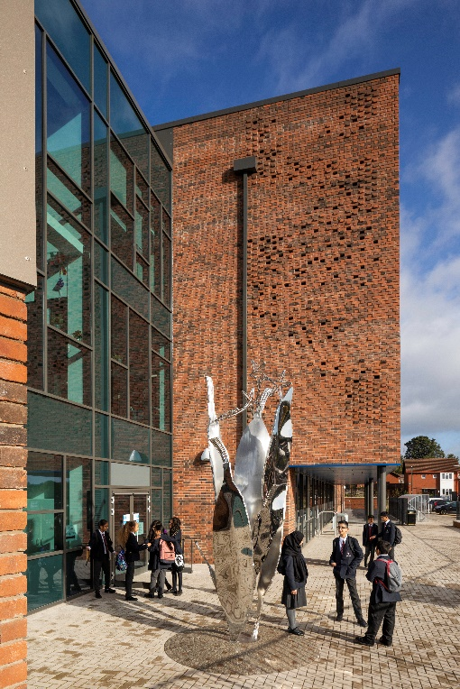
The ground breaking secondary building is a £25m new build that overlooks the city of Sheffield. Incorporating the highest quality facilities, this building is truly awe inspiring. Scholars from years 5 to 13 will attend this building with currently years 7, 8 & 9 in occupation. This will increase to year 10 from September 2021.
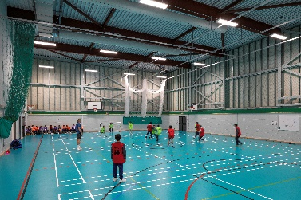
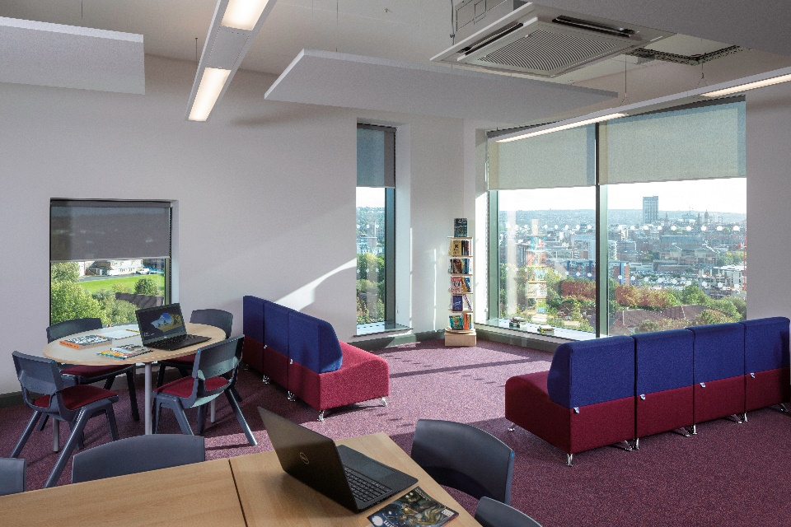

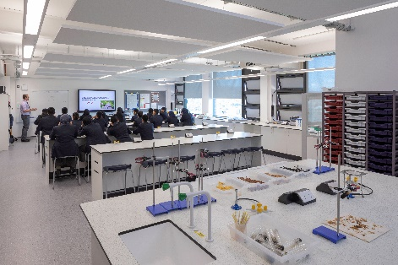

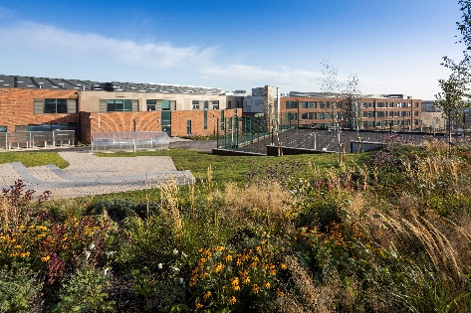
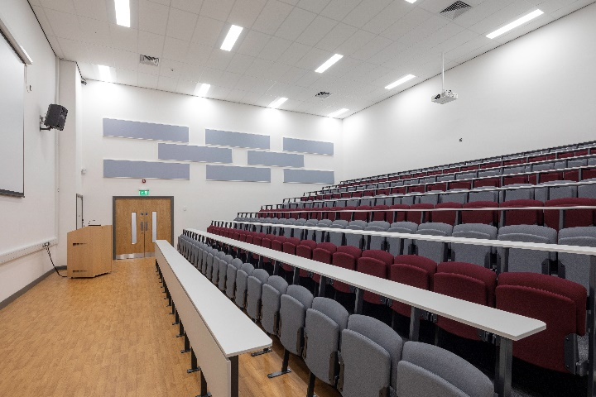

Scholar Life – Secondary
Scholar experiences since our opening in September 2018 have been wide ranging. Examples of just a few of these fantastic experiences are: The Girls Debating Club reaching the regional and national finals; Our electives which include dance, rock climbing, creative writing, Police Cadets and circus skills to name a few; Our Saturday morning cross country team; The Principal’s celebration with milkshake and cookies for Stars of the Week; A whole year group trip to Stratford Upon Avon to visit Shakespeare’s birthplace; A music masterclass by Status Quo; Scholars opening their end of year exam results and lectures at Sheffield Hallam University.
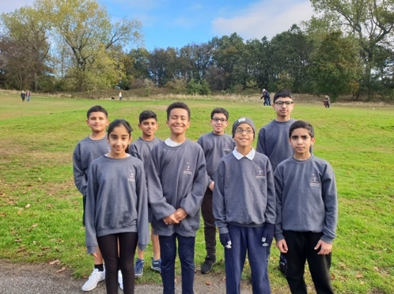
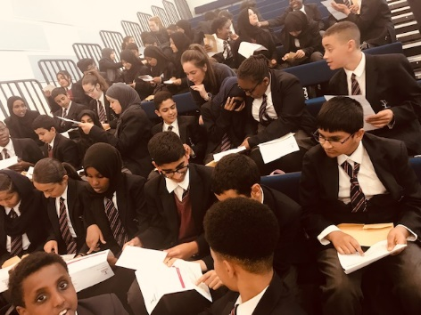
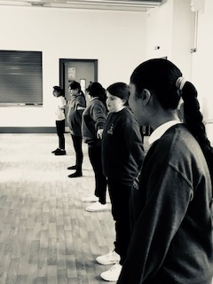
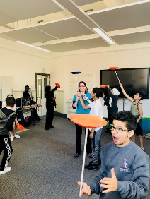
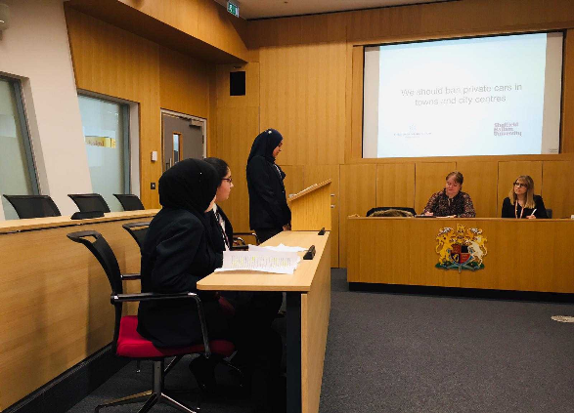
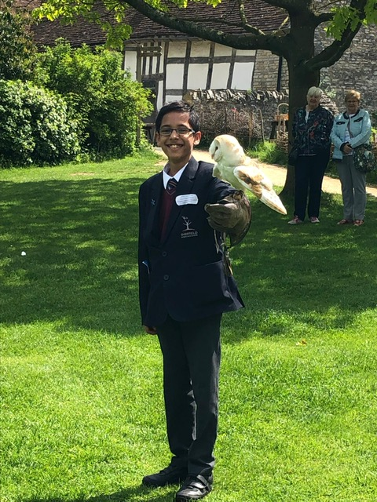

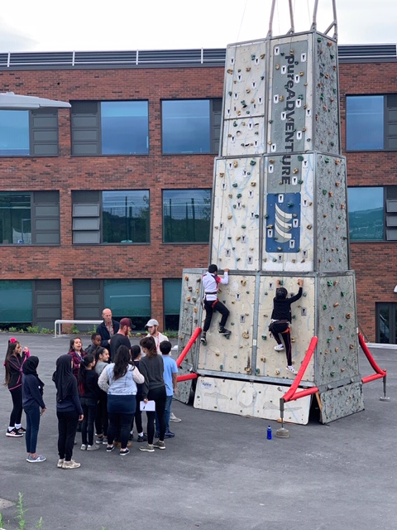
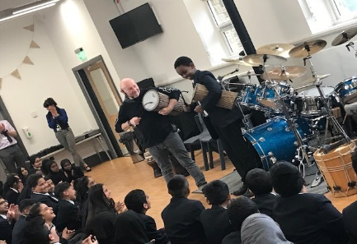

Scholar Life – Primary
In primary, scholars have experienced enriched activities both in and out of the academy. Examples include a visit to Cannon Hall Farm to see baby piglets being born; having access to high quality resources and displays to ensure interaction and communication are key in our children’s development; a visit from the Premier League Trophy Team; a clear emphasis on reading individually and as part of a group; valued and positive parental engagement and who can forget our visit from Dr Prediction!
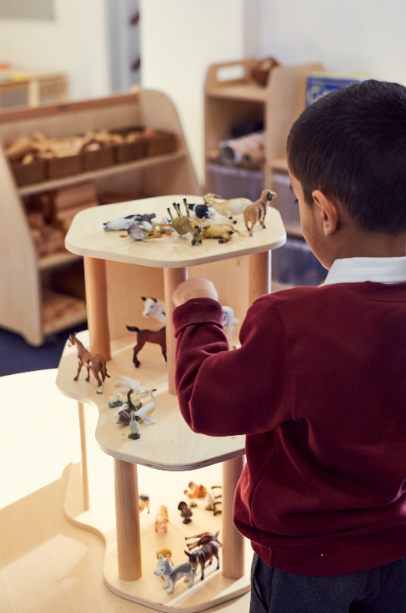
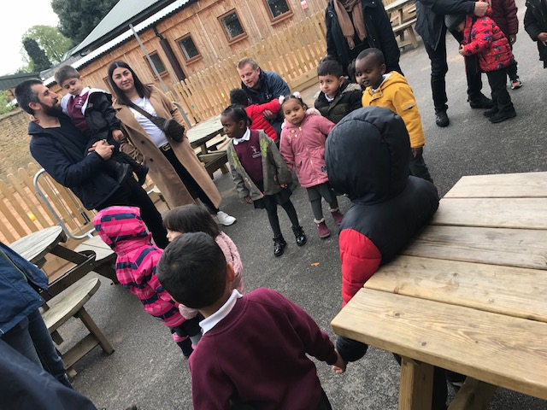

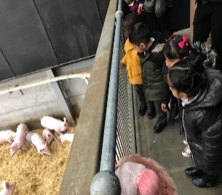
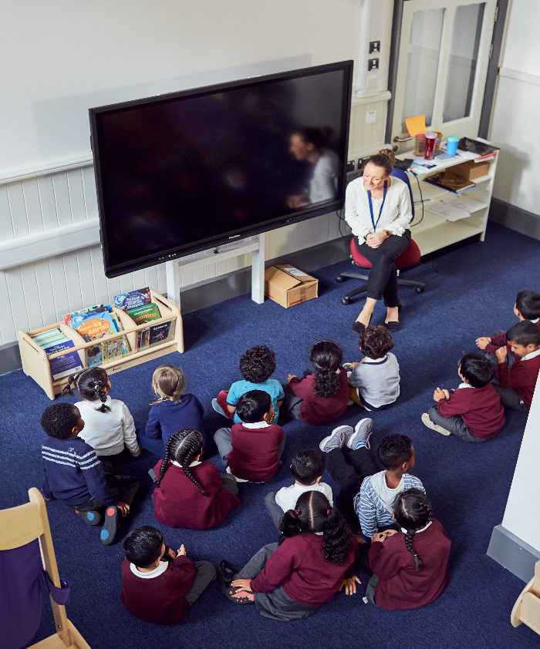

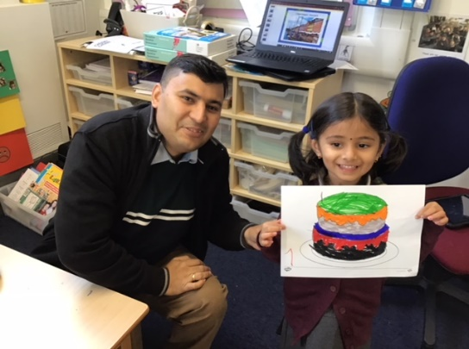

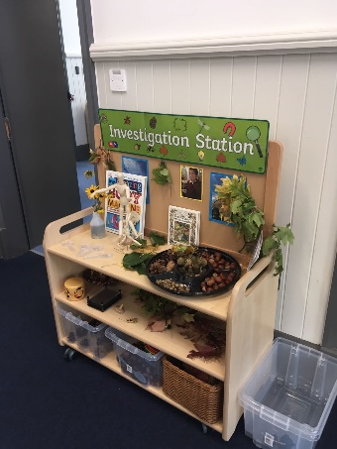
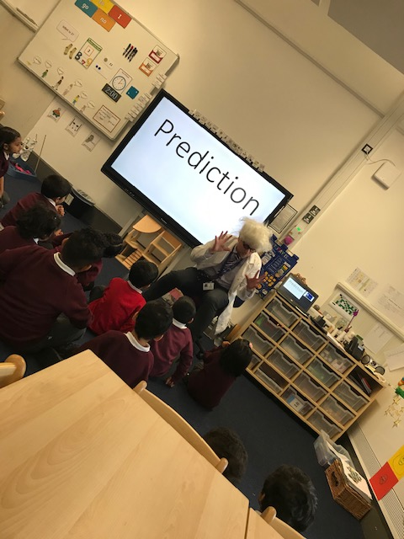

Staff Experiences
At Astrea Academy Sheffield we value our staff and we will support you with everything that comes with working with pupils on a daily basis. Your health and wellbeing matters and our ‘family’ ethos embodies a true sense of belonging and care for all. Your professional development and exposure to unique experiences is important to us. You will be expected to be part in academy life so our ethos and vision are a daily reality. Examples of how we have achieved this since September 2018 are: Full staff Halloween celebration; our 3 Early Years Teacher Status staff met Amanda Spielman, Ofsted’s Chief Inspector; celebrating our NQT’s graduations; taking part in a whole academy faith leaders forum; a presentation for Employee of the term for the whole of Astrea Academy Trust to our Campus Manager; an international trip to China; getting competitive in a staff go karting social event and dressing up for world book day – can you spot our theme?!
