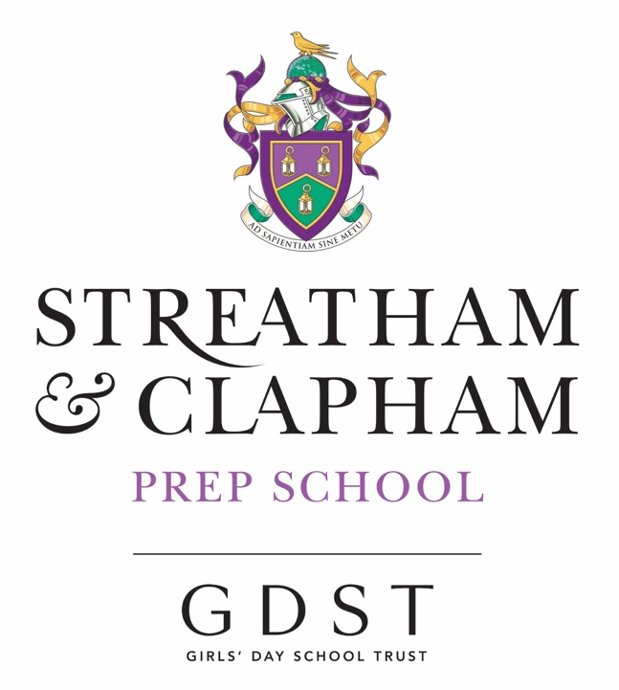
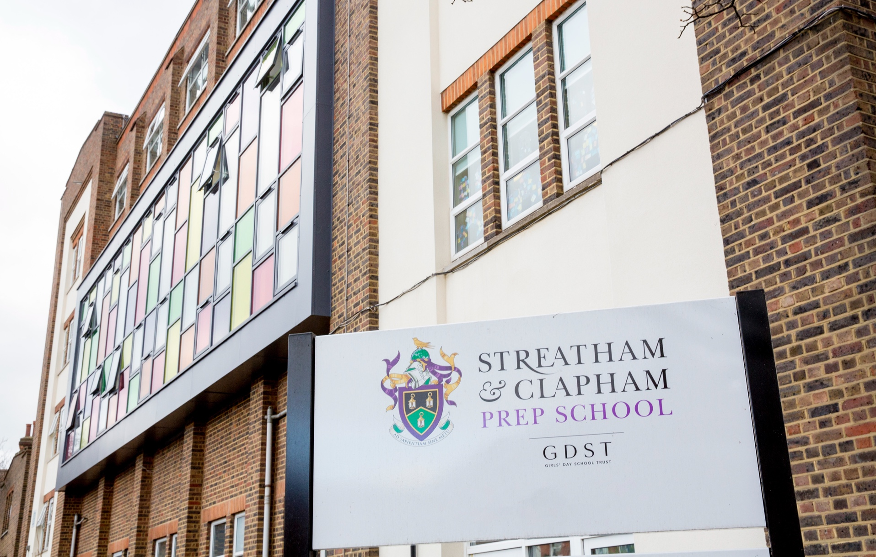
Job Application Information

Nursery / Reception Teacher

From September 2024
Contents
Executive Summary | 1 | Pastoral Care | 9
About Streatham & Clapham High School | 2 | Role Description | 10
Prep School (IAPS) | 4 | Person Specification | 15
Aims and Ethos | 5 | Terms of Employment and How to Apply | 17
Academic Life and Life Beyond the Classroom | 7
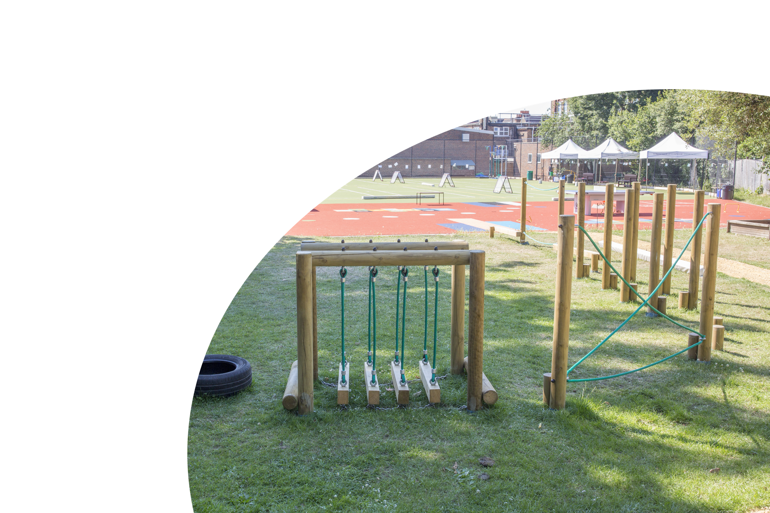
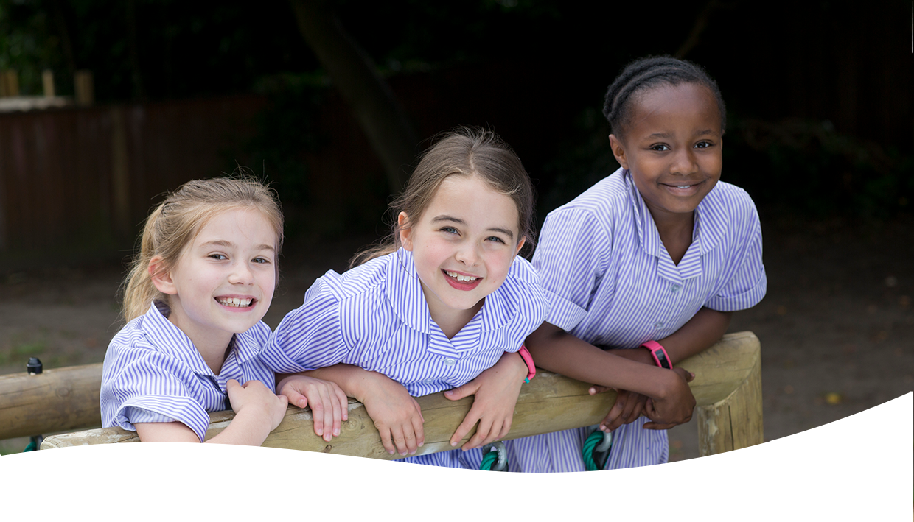
We are seeking a dynamic and innovative class teacher to join our talented and committed Prep team. The successful candidate will be educated to degree level, have qualified teacher status and a keen interest in teaching EYFS girls (Nursery (from 3 years old) and Reception)
Streatham & Clapham High School seeks an innovative, enthusiastic and inspirational EYFS teacher to join our talented and committed Prep team.

Executive Summary
They will have teaching experience relevant to EYFS and be able to demonstrate evidence of raising expectations and standards.
Most importantly are enthusiasm, flexibility, a sense of fun and an ability to bring out the best in pupils.
The post-holder is accountable to the Head of EYFS and the Head of Prep.

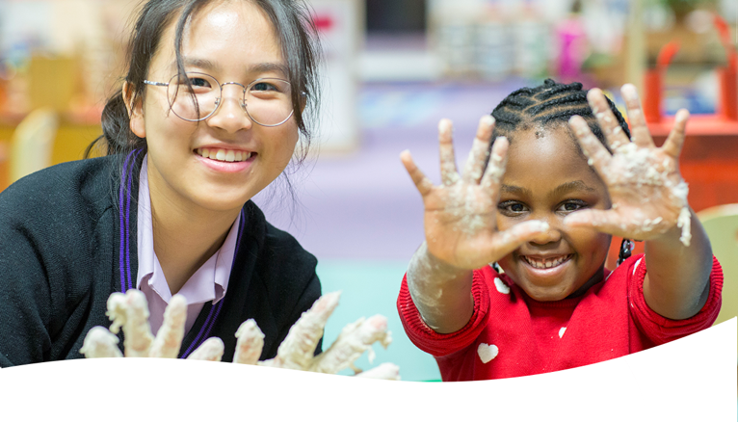
Streatham & Clapham High School is an independent, academically selective school for girls aged 3–18. There are over 880 pupils on the roll across the Prep and Senior Schools.
We are one of the UK’s leading private girls’ schools, educating pupils from Nursery through to Sixth Form. Pupils prosper in a vibrant setting that provides challenge and width of opportunity. They thrive on account of the school’s family ethos, and they draw strength from the school’s rich social and cultural mix

About Us
Girls aged 3-11 attend the Nursery and Prep School, located in spacious buildings with outstanding facilities in Streatham Hill. The Senior School inhabits a four-acre site focused on an imposing 1930s building in a delightfully tranquil and leafy oasis of south London.
The school is a distinguished historical foundation. It was founded, as Brixton High School, in 1887 by the Girls’ Public Day School Trust as one of its earliest member schools.
We are proud of our heritage and founding principles of breadth, fearlessness, inclusiveness, and a focus on developing the individual to achieve her potential.
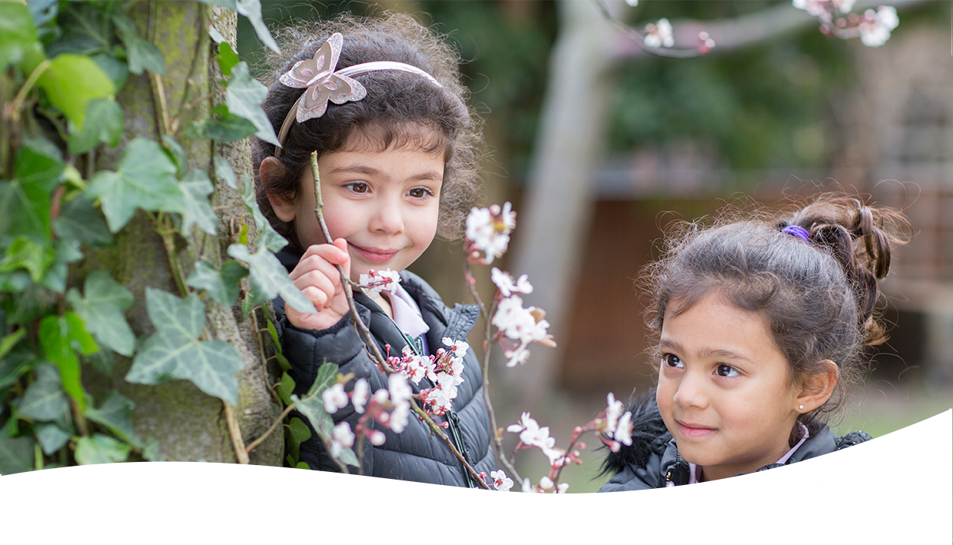
SCHS holds true to its founders’ mission, and we are proud of our exciting and challenging curriculum, with a commitment to innovative teaching and excellent relationships across the community.
About Us continued
School life embraces a broad range of sporting, artistic, social, and cultural opportunities in an environment specifically created to inculcate the values of independent learning, responsibility for others and the enjoyment of challenge.

The school has first-class facilities, providing an environment that enables pupils to develop their interests and strengths inside and outside the classroom.
The best outcomes and experiences for the girls are at the heart of all we do, characterised by a warm, supportive, and positive culture. This helps build pupils’ confidence, self-fulfilment, resilience, and happiness.
A richly diverse culture underpins this with kindness, generosity, opportunity, and social responsibility, combining a global outlook with a sense of local belonging.
The School is part of the GDST, the leading network of independent girls’ schools in the UK, founded in 1872.
The Head is a member of HMC and GSA. The Head of the Prep School is a member of IAPS.
The GDST is a founding member of the International Coalition of Girls’ Schools.


The Prep School, whose Head is in membership of the Independent Association of Prep Schools (IAPS), offers an inspiring and challenging academic education for its pupils in a lively, vibrant, and supportive environment. The family ethos of Streatham & Clapham High School enables the staff to know, value and nurture each pupil as an individual.
Prep School (IAPS)
The school celebrates diversity and draws strength from its rich social and cultural mix. The aim is to create a safe, happy, and secure learning environment so that each child achieves her or his maximum potential in all aspects of school life and daily endeavour. When pupils move on, the School wants them to be confident, responsible global citizens with a love of learning and a desire to contribute positively to society.
We are proudly inclusive of a range of academic abilities and judge success by development and progress. Our promise is that every girl will exceed beyond expectation.

The School’s priority is always for the individual child, and it seeks to encourage both academic and personal development through structured, meaningful, and enjoyable activities. The school’s pupils thrive in a family atmosphere where learning is fun; each day has exciting opportunities that encourage each pupil to develop her own strengths and nurture her extra- curricular interests.
The academic ethos of the School is firmly underpinned by its strong and supportive pastoral care, which enables its pupils to feel secure in trying new activities and to understand that making mistakes is part of their learning journey. The principles of care, courtesy and respect are central to the School, and it is through these values that all members of the school community thrive.
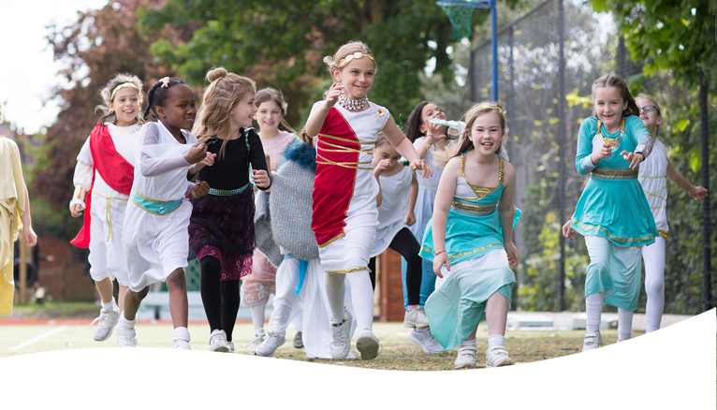
Aims and Ethos
Our vision is to be unrivalled in empowering our girls to discover, nurture and project their unique identities and character.

The school offers an inspiring, enlightened, and intellectually challenging education for its pupils in a lively, vibrant, and warmly supportive environment. Our family ethos School enables us to know, value and nurture each pupil as an individual. We celebrate diversity and draw strength from the school’s rich social and cultural mix.
This reflects the school’s belief that all members of the school community should be inspired to outperform expectations on a daily basis.

The pursuit of excellence is thus the school’s defining feature. It nurtures pupils to attain success across the widest spectrum of activity, extending far beyond the conventional ‘academic’ horizon.
The school’s pupils, whether they are very able or late developers, learn to navigate the landscape of the human spirit and achieve beyond the realms of expectation.

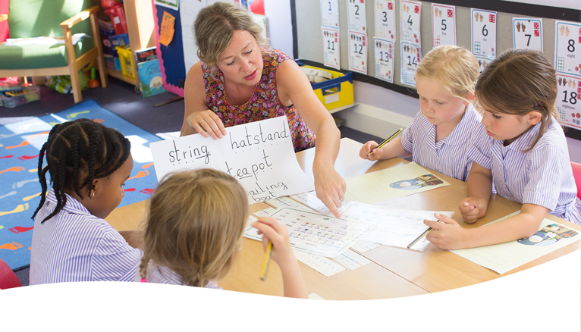
Our salient features are:
Aims and Ethos continued

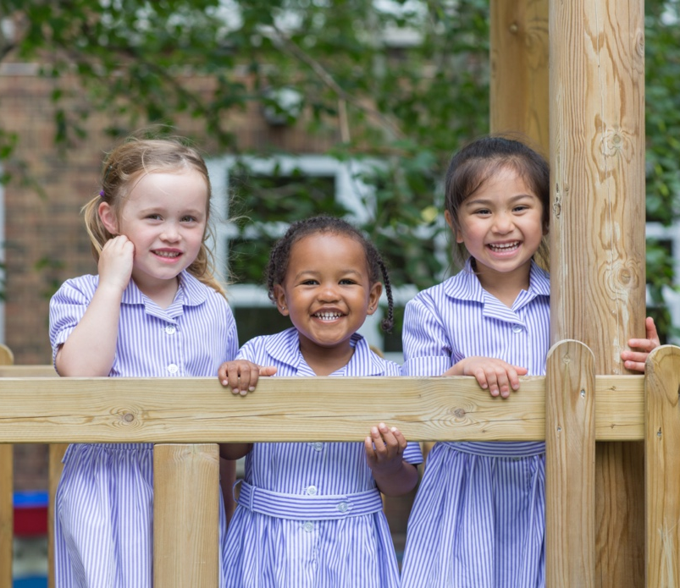
• We are pioneers in and the shapers of girls’ education
• Our curricular specialisation from an early age
• Our trailblazing and innovative approach, supercharging our girls with life skills enabling them to embrace and instigate change
• Our family, not factory, environment supporting individual families’ needs
• Our buzzy, diverse community, celebrating difference and drawing strength from all that is great about London
Our purpose is to enable every girl to achieve beyond the bound of expectation on a daily basis, across the spectrum of endeavour
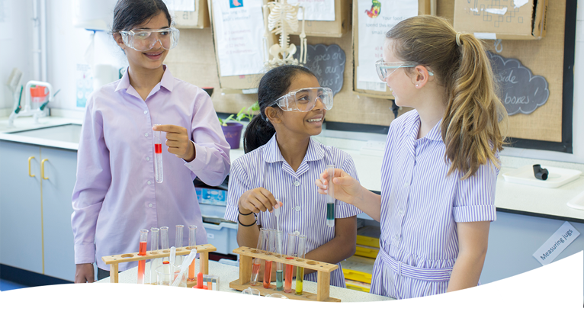
The Prep School aims to ensure that all learners benefit from a rich, broad, balanced curriculum presented in an interesting, exciting, and imaginative manner with opportunities for first-hand experience, practical work, investigation and learning through play.
Academic Life and…
All children from Nursery to Year 6 benefit from specialist language, music, and PE lessons. Our curriculum is independent, engaging, and inspiring.
Children are confronted with relevant experiences both inside and outside the classroom which provide opportunities to observe, investigate, experiment, and predict. A variety of technological, creative and aesthetic skills is also developed.
We have rigorous academic standards and focus on the core subjects of English, Mathematics, Science and Computing. We also expand our girls’ minds by teaching specialist subjects such as PE, Music, French and coding.
All of the lessons on our Prep School curriculum are carefully crafted and presented in accordance with each girl’s learning styles. We personalise the learning experience of every girl so each can understand and articulate her own specific goals.

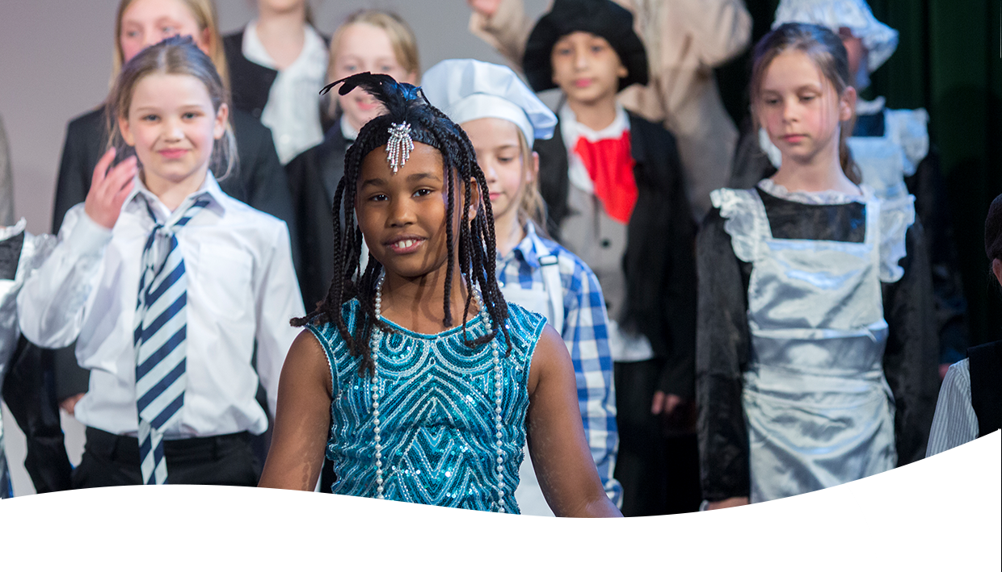
…life beyond the classroom
Being part of the GDST network and IAPS gives us a competitive opportunity to play with schools from across the country.
The Prep School has its own site and enjoys close links with the Senior School. Pupils benefit from outstanding facilities, far larger than one might expect in a primary school. These include a well-resourced library, full-sized Sports Hall, all-weather sports surface, excellent Science, Computing, Art and PE facilities, an Outdoor Learning Space, and a great deal of space, both inside and out.
We have an extensive co-curricular programme made up of clubs and societies. These offer our girls a diverse range of activities to pursue their interests and inspiring further achievement beyond the classroom and range from the arts to quizzes, debates, and dance.
Our clubs and societies provide an ideal foundation for girls to develop a life-long

love of learning for its own sake; a principle that lies at the heart of the ethos of both the Prep and Senior Schools.




Our pastoral care and personal development are of paramount importance and involve all children and adults who participate in the daily life of the school. We place strong emphasis on the creation of a supportive atmosphere, and we encourage our girls to strive to achieve their personal, social, and academic goals.
Pastoral Care
From the chef in the dining room to the PE teacher on the playing field, all of our staff know our girls. Each teacher offers his or her girls day-to-day support and communicates frequently with parents, through an informal chat at the end of the day or via email, a phone call, or a note in the girl’s diary.
We encourage our girls to take a ‘can do’ approach to their school lives and find that pastoral care encourages character-building. The girls become increasingly familiar with facing challenging situations with greater confidence when they apply the personal strategies they have been encouraged to adopt to their daily lives.
“Pupils are highly respectful of each other and exhibit qualities which reflect their concern for justice.”
ISI Report, 2019
On entry to the school, each girl is allocated to one of four Houses. This creates four, smaller ‘family’ units within the school community to which the girls develop a strong affinity.
Older girls play a responsible role whilst remaining accessible and familiar to other children. They are then better equipped to develop and foster relationships and to find the causes of conflict and seek appropriate responses.


Job Purpose
Role Description
To ensure that our youngest girls have the best possible care, have access to a broad and balanced curriculum and achieve the highest standards, in line with the ethos of the school.

KEY TASKS AND RESPONSIBILITIES
Teaching & Learning
- To plan work for the class in accordance with GDST and school policies and in co-operation with subject leaders to ensure that the children experience a broad, balanced, relevant and stimulating curriculum
- To ensure a close match between the learning experiences offered, and the individual needs of the children in the class, so as to give each child an opportunity to achieve to the maximum of her capability.
- To be flexible, creative and adept at designing learning sequences within and across lessons.
- Build on the prior knowledge and attainment of those you teach in order that learners meet learning objectives and make sustained progress
- To work closely with colleagues to undertake medium and short-term planning and the implementation of agreed schemes of work
- To make appropriate educational provision for children with additional educational needs and communicate with the SLN and pupil welfare leader when needed.
- Design opportunities for learners to develop their ICT and thinking and learning skills appropriate to the phase and context
- To provide children with opportunities to manage their own learning and become independent learners
- To teach challenging, well-organised lessons across the ability range

- To ensure that the school’s aims and objectives in relation to the curriculum, equal opportunities and discipline are promoted in everyday classroom organisation and practice
Role Description continued
- To liaise with support staff both school based and from other external bodies as required
- To take responsibility for the management of other adults in the classroom
- To participate in meetings which relate to the EYFS curriculum or the organization of the school, including pastoral arrangements
Assessing Monitoring & Giving Feedback
- To assess children’s progress, maintain records and provide written reports to parents and carers in accordance with school policies
- To communicate and consult with parents and carers and with outside agencies, as necessary, about children’s progress and attainment
- To use online systems to track, report and log pupil progress
- Make effective use of an appropriate range of observation, assessment, monitoring and recording strategies as a basis for setting challenging learning objectives and monitoring learners’ progress and levels of attainment
- Support and guide learners so that they can reflect on their learning and identify the progress they have made
- Use assessment as part of teaching to diagnose learners’ needs, set realistic and challenging targets for improvement and plan future teaching
- Mark work in accordance with the marking policy
Learning Environment
- To create a secure, happy and stimulating classroom environment, maintaining the highest standards of organisation and discipline
- To foster each child’s self-image and esteem and establish relationships which are based on mutual respect

- Be aware of and comply with policies relating to child protection, confidentiality and data collection, reporting all concerns to a nominated person
Role Description continued
- To maintain a high standard of learning focused display both in the classroom and in other areas of the school
- To arrange for resources, equipment and materials to be available in such a way that they are properly cared for, easily accessible and will encourage the children to become more responsible for their own learning
- Identify and use opportunities to personalise and extend learning through out-of-school contexts where possible
- Promote learners’ self-control, independence and cooperation through developing their social, emotional and behavioural skills
- Complete the action risk assessments for all potentially hazardous on/off site issues
Extra-curricular Activities
- Promote the extra-curricular activities programme through helping and attending events such as concerts, workshops, competitions as appropriate
- Contribute to the school website and publications
- Participate in at least one extra-curricular activity each week
- Organise termly visits/visitors to widen children’s knowledge of topics and enrich the curriculum
- Carry out lunch and playtimes duties as necessary
- Organise a termly class assembly and assist with the key-stage production as appropriate
Team Working & Collaboration
- Work as a team member and identify opportunities for working with colleagues, managing their work where appropriate and sharing the development of effective practice with them

Culture
Role Description continued
- Help create a strong school community, characterised by consistent, orderly behaviour and caring, respectful relationships
- Help develop a school culture and ethos that is utterly committed to achievement
Marketing & External Links, including Public Occasions
- Build effective partnerships with parents to ensure: a shared understanding between school and home about pupil progression, and how parents can support their child; an excellent local reputation for the school through the promotion, profile and success of the phase; extra-curricular activities that enrich the timetabled curriculum experiences
- Promote the phase excellence and reputation of the school through public occasions (parents’ meetings, open days, workshops, etc).
- Develop links outside the school in order to increase opportunities for sharing good practice, learning opportunities for pupils, etc.
Training & Development of Self & Others
- Regularly review own practice, set personal targets and take responsibility for own development
- Ensure that training needs with the phase are identified, appropriately met, and that all members of the phase are active in their own personal and continuous professional development
- Lead, co-ordinate and organise phase-related INSET initiatives to offer support, guidance, innovation and motivation to colleagues (as appropriate)

Monitoring, Evaluation & Assessment
- Participate in the school’s monitoring and evaluation cycle, providing constructive feedback and targets in order to raise standards throughout the phase

- Make effective use of performance benchmark data for monitoring, evaluating and assessing aspects of the school’s work in the phase to ensure continuity, progression and the achievement of consistently high standards
Role Description continued
General Requirements
All school staff are requested to:
- Work towards and support the school vision and the current school objectives outlined in the School Development Plan.
- Contribute to the school’s programme of extra-curricular activities.
- Support and contribute to the school’s responsibility for safeguarding students.
- Work within the school’s health and safety policy to ensure a safe working environment for staff, students and visitors
- Work within the GDST’s Diversity Policy to promote equality of opportunity for all students and staff, both current and prospective.
- Maintain high professional standards of attendance, punctuality, appearance, conduct and positive, courteous relations with students, parents and colleagues.
- Engage actively in the performance review process.
- Adhere to policies as set out in the GDST Council Regulations, GDST Hub and GDST circulars.
- Undertake other reasonable duties related to the job purpose required from time to time.


Qualifications
Person Specification
Qualified to degree level or above
Qualified to teach in the UK
Qualified teacher status
Experience
Experience of raising the attainment of all pupils
Evidence of continually improving the teaching and learning in their year group through schemes of work, assessment and extra-curricular activities etc
Experience of teaching EYFS
Professional Knowledge & Understanding
An excellent understanding of curriculum and pedagogical issues relating to learning and teaching
An interest and strength in ICT
Familiarity with age appropriate assessments
Teaching & Learning
Excellent classroom practitioner
Effective and systematic behaviour management, with clear boundaries, sanctions, praise and reward
Good communication, planning and organisational skills
Resilience, motivation and commitment to driving up standards of achievement
Ability to be a role model to staff and pupils
Commitment to regular and on-going professional development and training to establish outstanding classroom practice
Ability to create links across the whole school
Personal Qualities
A willingness to engage parents in order to encourage their close involvement in the education of their children
A flexible approach and a willingness to work as part of a team.
Openness and willingness to address and discuss relevant issues, allied with an ability to inspire and challenge others
Willingness and ability to contribute to whole school INSET
Willingness to share expertise, skills and knowledge and ability to encourage others to follow suit
Tact and diplomacy
A positive approach to change
Approachable and helpful attitude towards colleagues
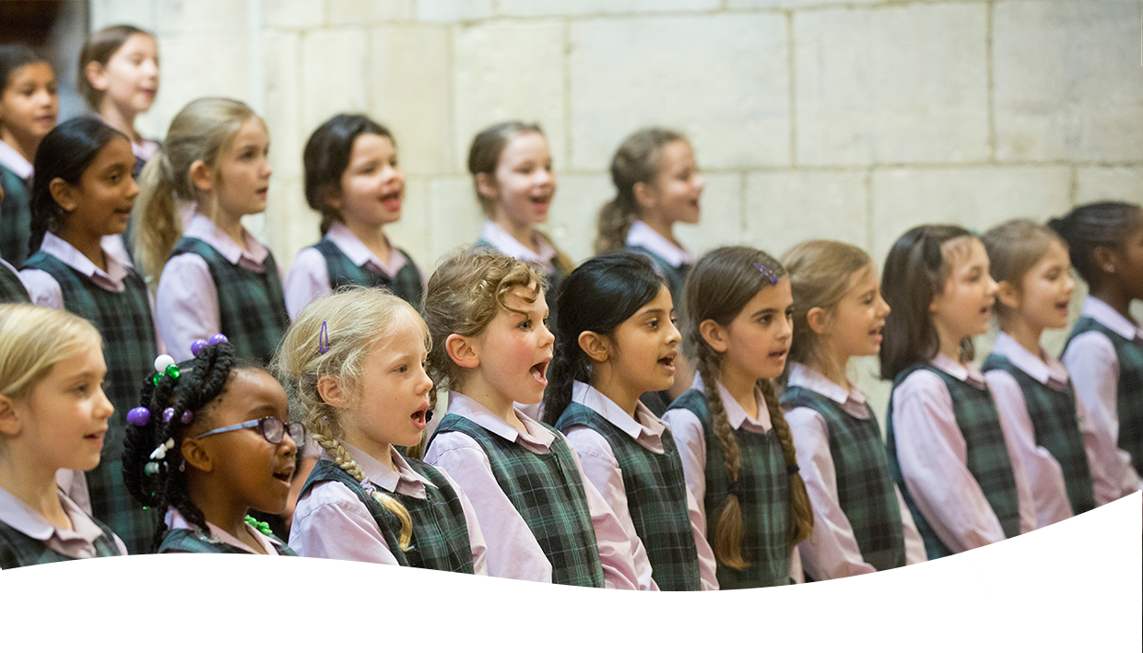
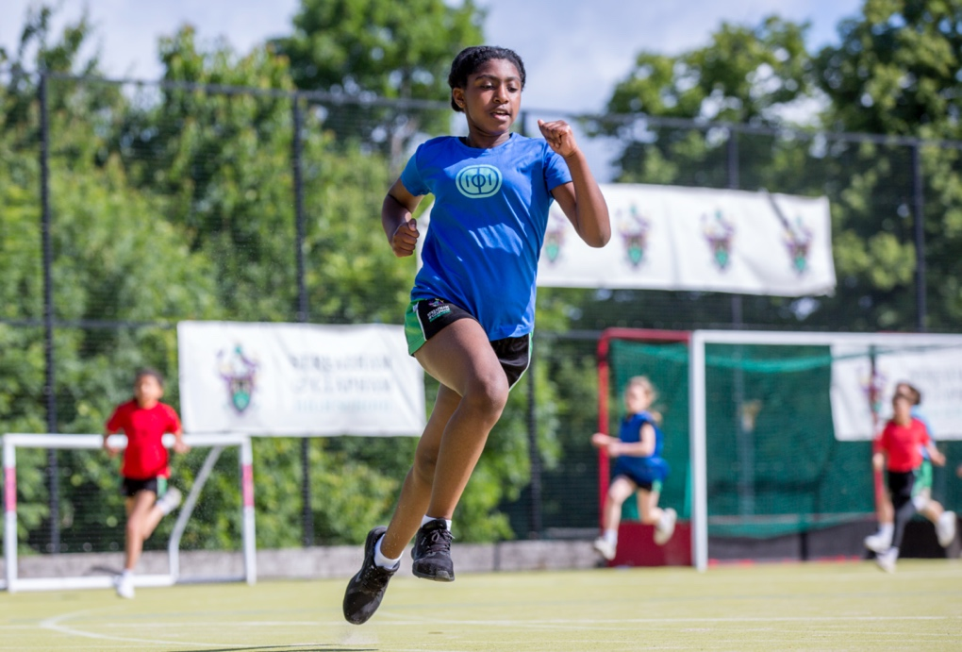
Person Specification continued

Terms of Appointment &
How to Apply
The role will attract a competitive salary in line with qualifications and experience, and the successful candidate will also be entitled to an interest-free season ticket and computer loan, and free lunches during term time.

Any candidate wishing to seek additional information about the post or to discuss any related matter should contact the HR, Compliance & Recruitment Manager, Mrs Angela Bolton via email a.bolton@schs.gdst.net. Applications should be received no later than noon on Monday,
18 March 2024 and candidates should use the following link.
https://my.corehr.com/pls/gdstrecruit/erq_jobspec_version_4.jobspec?p_id=034147
Interviews
Interviews will take place from Wednesday 20th March, though the school reserves the right to appoint an exceptional candidate at any stage of the application process.
All candidates invited to interview must bring original documents confirming any educational and professional qualifications that are necessary or relevant for the post (e.g. the original certificates). Photocopies or certified copies are not sufficient.
If original certificates are not available for the successful candidate, written confirmation of the relevant qualifications must be obtained from the awarding body. All candidates invited to interview must also bring with them:
An original passport and/or other appropriate document proving your eligibility to work in the UK;
- One other form of identification, such as a driving licence or birth certificate;
- Two other documents, such as utilities bills, TV licence, bank, building society or credit-card statements confirming your current address.
- Documents confirming your educational and professional qualifications.
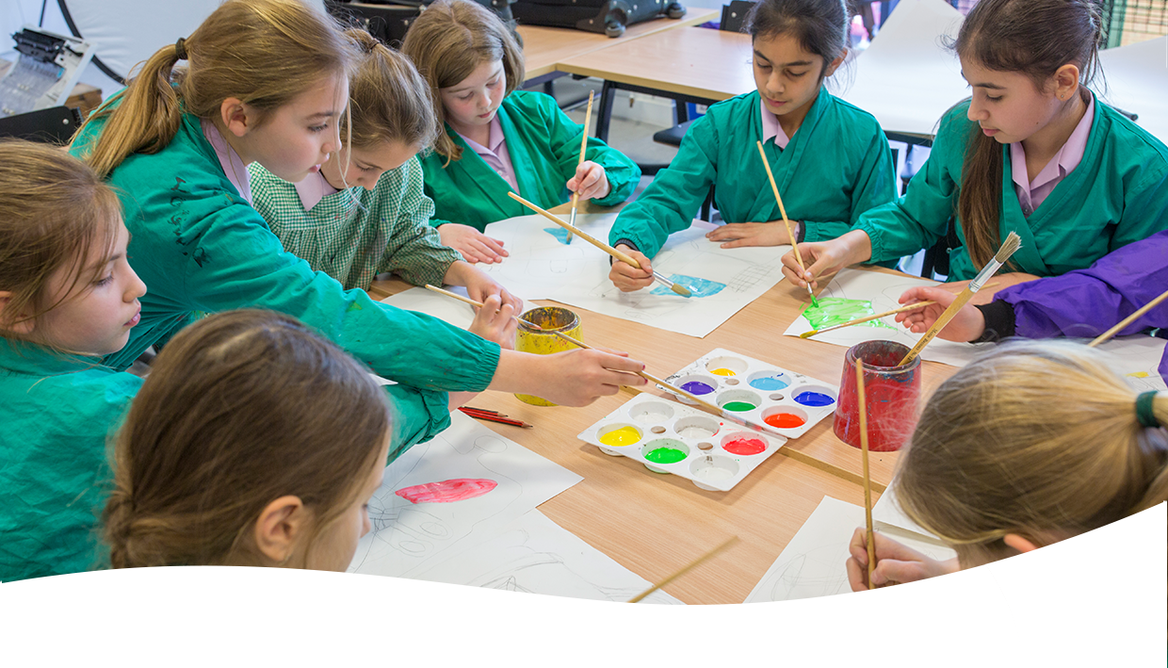
- Please note that candidates must bring originals of the above documents. Photocopies or certified copies are not acceptable
Terms of Appointment &
How to Apply Continued
Appointment
Any offer to a successful candidate will be conditional upon:
- Receipt of at least two references, satisfactory to the school (if not already received), prior to appointment;
- Verification of identity and qualifications;
- A satisfactory DBS Disclosure at the enhanced level;
- Where the successful candidate has worked or been resident overseas in the previous five years, such checks and confirmations as the school may require in accordance with statutory guidance;

- satisfactory completion of any pre-employment checks as relevant such as an online search and those to check whether you are registered for or prohibited or restricted from practicing certain professions or roles
- (for teaching posts) Verification of medical fitness in accordance with DfES Circular 4/99 - Physical and Mental Fitness to Teach of Teachers and Entrants to Initial Teacher Training;
- Satisfactory completion of the probationary period.

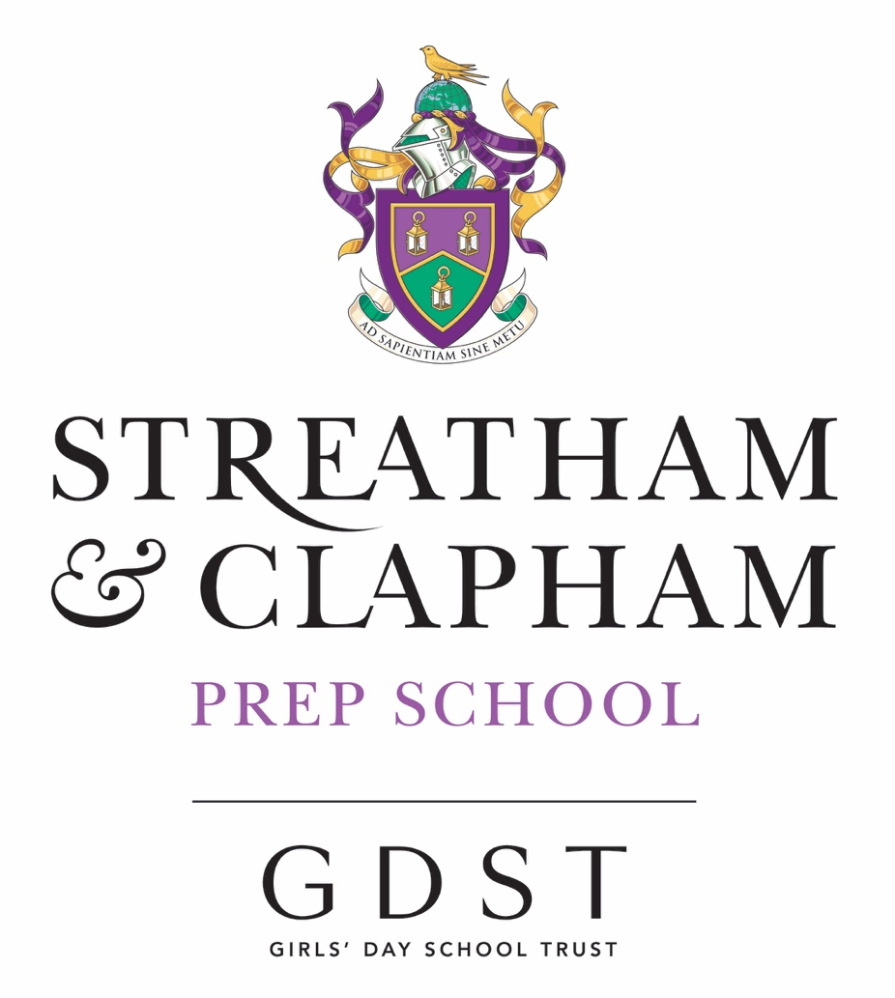

Senior School  42 Abbotswood Road  London, SW16 1AW  020 8677 8400  seniors@schs.gdst.net | Nursery & Prep School  Wavertree Road  London, SW2 3SR  020 8674 6912  prep@schs.gdst.net
https://schs.gdst.net

