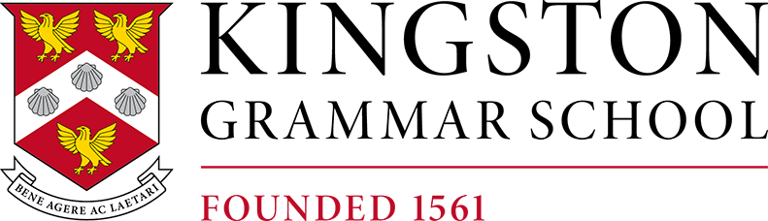

**Hockey Coach**

**Job Description**

|  |  |
| --- | --- |
| **Reporting to** | Head of Hockey/Director of Sport |
| **Salary** | A competitive rate, dependent on experience |
| **Hours** | Part time to include afternoons between 1-6pm and  Saturday mornings through the Autumn and Spring terms.  Morning or afternoon hours available in summer term depending on fixtures. |

**Summary of the Role(s)**

To play a key role in developing and delivering a highly competitive & ambitious hockey programme

**Roles and responsibilities**

* Be an ambassador for sport & hockey, upholding the school’s reputation & sporting ethos
* Play a leading role in ensuring every student’s experience, at any level, is a positive and enjoyable one
* Lead on one or more of our A teams & assist in the coaching at all levels
* Assist with the ongoing refinement of the hockey programme, in collaboration with the Head of Hockey and other coaching staff
* Meet regularly, at least weekly, with the Head of Hockey and other coaching staff
* Contribute to delivering and detail within the Hockey Development plan
* Monitor and help manage holistic player progression in conjunction with other coaching staff and the Head of Hockey
* Monitor individual players’ training and work-life balances, offering support and advice where necessary in collaboration with the Director of Sport
* Feedback to staff & players through a range of formats; presentations, video analysis
* Work with the Head of Athletic Development to improve player performance & reduce injury risk
* Promote and represent KGS Hockey within the hockey community, e.g., establishing links with clubs, positive social media and word of mouth
* Help in the development of year-round hockey support to our most ambitious players, optimising the use of KGS facilities and resources throughout the season and off-season
* Assist the Head of Hockey and Director of Sport with the identification on potential Sport Scholars at 11+, 13+ and 16+ entry points.
* Assist & lead delivery of hockey staff inset, acting as mentor to less experienced coaches
* There will also be an opportunity for candidates to contribute to the summer sports programme

**Essential characteristics, experience and qualifications**

* A passion for coaching hockey
* A desire to learn and willingness to be challenged
* Ambition to be part of developing an outstanding sports programme
* Commitment to personal development
* Excellent communication skills
* A desire to coach collaboratively as part of a team
* England Hockey Level 2 coaching qualification
* Experience coaching hockey across a variety of levels, including pathway level
* Ability to coach a second sport in one of our team sports – football, netball or cricket

**Desirable qualifications, experience, and characteristics**

* Experience of coach development
* England Hockey level 3 or higher coaching qualification
* A significant track record of developing young players
* Experience working with both boys and girls

**Working hours**

* Part time coaching roles available. Part-time coaches will be required through the two-term hockey season and in the summer with varying number of hours required, depending on circumstances.