Welcome to the English department
at All Hallows
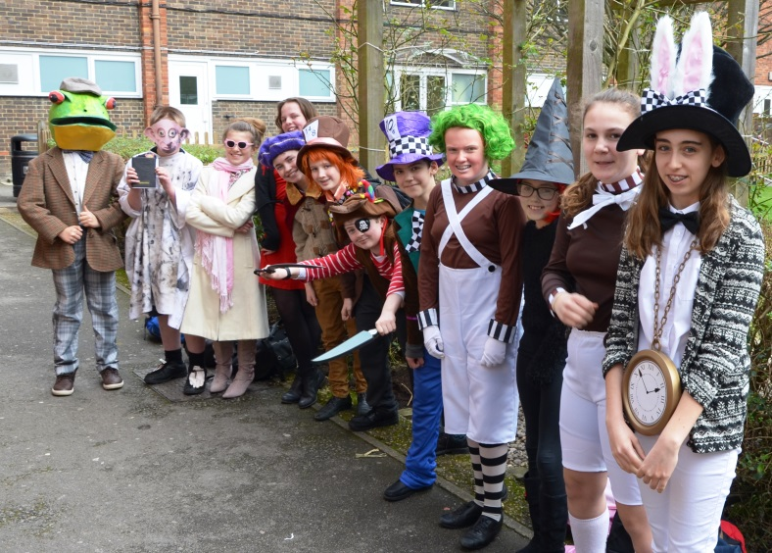
If you want to teach English in a high performing department within an Ofsted-rated outstanding school; if you want to share your love of English literature and the English language; and if you want to make a difference to the lives of your students, then we would love to hear from you.
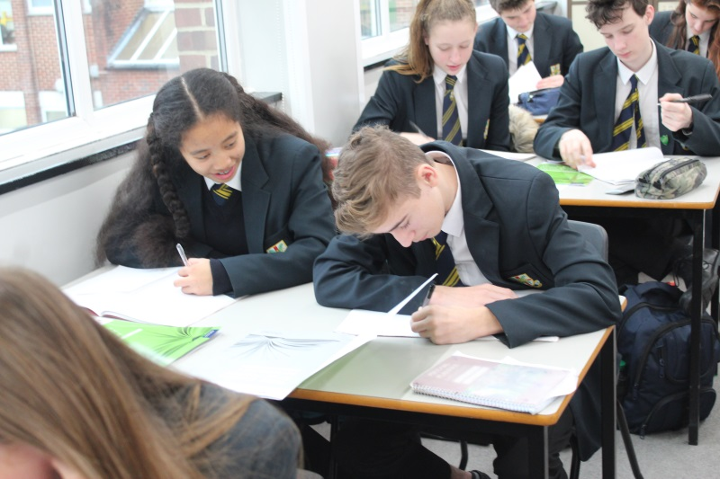
English is highly valued at All Hallows. We believe that giving students access to exciting and inspirational literature is an entitlement, not a privilege, and so all of our students study both GCSE English Literature (Eduqas) and GCSE English Language (Edexcel). Current GCSE texts include The Strange Case of Dr Jekyll and Mr Hyde, An Inspector Calls and Macbeth. Teachers are encouraged to bring their expertise to the table and teach the texts they are most passionate about.
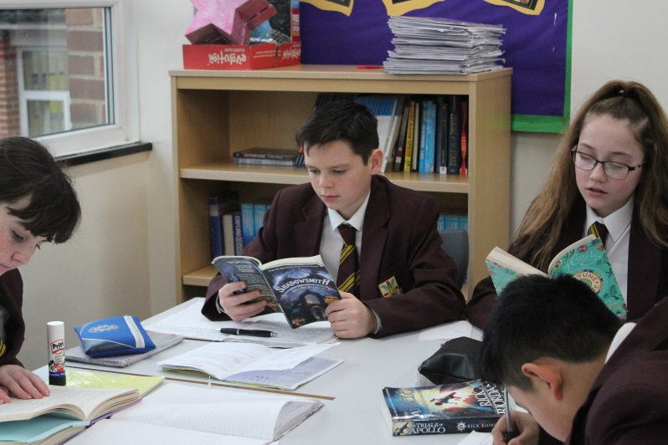
As a department, we are proud of our track record of success: our GCSE results have been consistently strong, with 83% of students achieving grades 9-4 in English Language and 85% 9-4 in English Literature last year. This success is built upon a culture of high expectations, both of students and of staff. We are looking to recruit a colleague who will work collaboratively, sharing best practice with the department to help us all develop further.

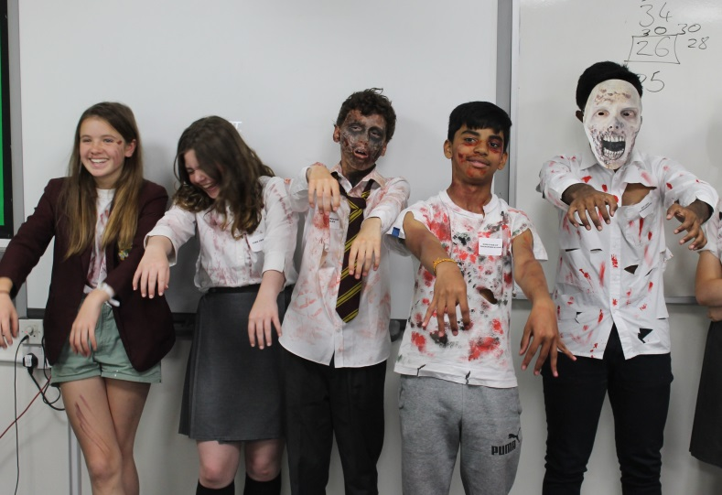
At Key Stage 3, we currently teach three fifty minute lessons a week to years 7 and 8, and four lessons a week to year 9. We follow the National Curriculum, exploring traditional texts from the literary cannon, as well as a mixture of more recent, innovative practice such as the Grammar for Writing series developed by Deborah Myhill at Exeter University. We also have three speaking and listening competitions – one for each year group – during the year, including a zombie themed debating day for year 9.
The department also has a strong presence in the sixth form, offering three A-levels: English Literature (AQA specification A), English Language (Edexcel) and Media Studies (Eduqas). As with GCSE, we have a strong record of success – in 2017, for example, over 80% of students achieved A or B grades in English Literature. We aim to foster A-level students who share our passion for their chosen subject, and have been delighted by the number of students who go on to pursue English related degrees at university.
We are a strong department with a blend of young teachers and older, more experienced colleagues. None of us is the same, but our success has been built on sharing ideas and resources and supporting each other – and having fun along the way. If your ambitions match ours, then please do apply. For more information, please do not hesitate to contact me via d.morrish@allhallows.net.
