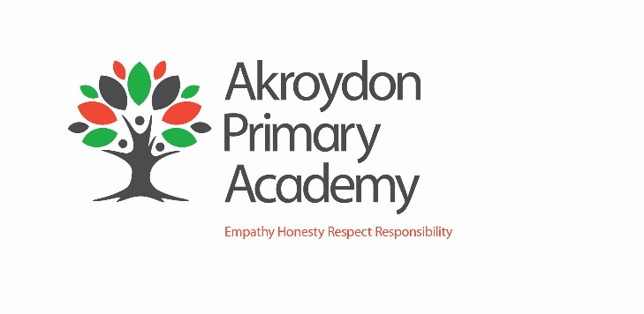

Akroydon Primary Academy

Job Description

Job Title: | Forest School Leader
Job Scale: | Scale 5 (Points 22-25)

BASIC JOB PURPOSE

- To be responsible for, plan and oversee the day to day delivery, organisation and smooth running of the Forest School
- To plan, prepare and deliver a range of Forest School lessons
- To create and maintain an engaging, fun and supportive environment, demonstrating flexibility in planning and running sessions in response to varying/changing needs of the children
- To provide a high quality education and care for children, in line with the aims and objectives of the school
- To develop positive relationships with parents and carers

MAIN RESPONSIBILITIES

1 | To help provide a variety of curriculum activities, which create a stimulating atmosphere where the children are able to explore, experiment and make discoveries.
2 | Select and use a range of different resources and teaching styles, appropriate to the forest school experience.
3 | To ensure lessons are appropriate and all needs and expectations are met.
4 | To assist in the preparation of teaching materials and displays to support the Forest School.
5 | To support the pastoral work in the school by developing good, positive relationships with children in your care which build their self-esteem, thus contributing to their effective learning.
6 | Observe, monitor and maintain written or electronic records to ensure children’s developmental progress.
7 | To develop and maintain professional links with parents and carers, other agencies working with the school and the local community.
8 | To liaise with staff in the school and prepare reports that will assist in the child’s development.
9 | To report any injury or accident in line with the academy health and safety policy, ensuring that health and safety of the individual is maintained.
10 | To evaluate lessons and to continually strive for improvement.
11 | To report any suspicious or suspected non-accidental injury to follow and comply with the academy Child Protection Policy.

Other Specific Duties:

- All staff are expected to demonstrate consistently high standards of personal and professional conduct and maintain high standards of ethics and behaviour, within and outside school.

- Treat all students with dignity, observe proper boundaries and understand that every adult in the academy has a responsibility to safeguard children and young people.

- To continue personal professional development as required

- Attend staff and other meetings and participate in staff training and development events as required

- To actively engage in the performance review process

- All support staff may be used to perform appropriate duties as and when required by the academy, commensurate with the salary grade of that post if it is higher than the employee’s current salary

- To work in the best interests of the academy, students, parents and staff

- To adhere to the academy’s policies and procedures with particular reference to Child Protection, Equal Opportunities, Teaching and Learning and Health and Safety

- Take part in the academy’s pastoral structure.

- To work flexibly, including some evening work, and to travel, as required, to meet the needs of the role

- To work at locations across the academy trust, as required.

Whilst every effort has been made to explain the main duties and responsibilities of the post, each individual task undertaken may not be identified. Employees will be expected to comply with any reasonable request from a manager to undertake work of a similar level that is not specified in this job description.

This job description is current at the date shown, but, in consultation with you, may be changed by the Principal to reflect or anticipate changes in the job commensurate with the grade and job title.

__________________________________________ Post Holder

__________________________________________ Line Manager

__________________________________________ Principal

__________________________________________ Date

PERSON SPECIFICATION
Job Title: Forest School Leader
KEY CRITERIA | ESSENTIAL | DESIRABLE
Qualifications & Experience | - basic numeracy and literacy skills  - relevant professional qualifications (such as Forest School Level 3 certification)  - recent and significant experience in leading Forest School/outdoor education sessions with children of a range of ages  - First Aid trained  - experience of working in close partnership with parents and carers |  | - experience of working in partnership with other agencies  - experience of working with children with SEN or behavioural issues
Knowledge & Understanding | - knowledge of a range of factors which create stress for children and families  - strategies for ensuring equal opportunities for students, staff and other stakeholders |  | - current knowledge of child protection issues and their roles and responsibilities in the protection of children
Skills & Abilities | - proven ability to plan and deliver environmental education based activities to a wide age range of children  - ability to communicate with a wide range of people individually, in groups and at all appropriate levels  - work as an effective team member and apply given instructions  - set high standards and provide a role model for students and staff  - demonstrate initiative  - identify and develop creative and imaginative solutions to solve problems  - seek support and advice when necessary  - able to motivate children and sustain their interest in play activities  - able to prepare written reports to support children’s development and well being  - evidence of sound judgment skills |  | - willingness to develop own understanding and capability through advice and training  - think clearly in emergency situations
Personal Qualities | - enjoyment in working with young people and families  - an excellent record of attendance and punctuality  - commitment to inclusive education  - resilience and perspective |  | - reliability, integrity and stamina  - respect confidentiality

