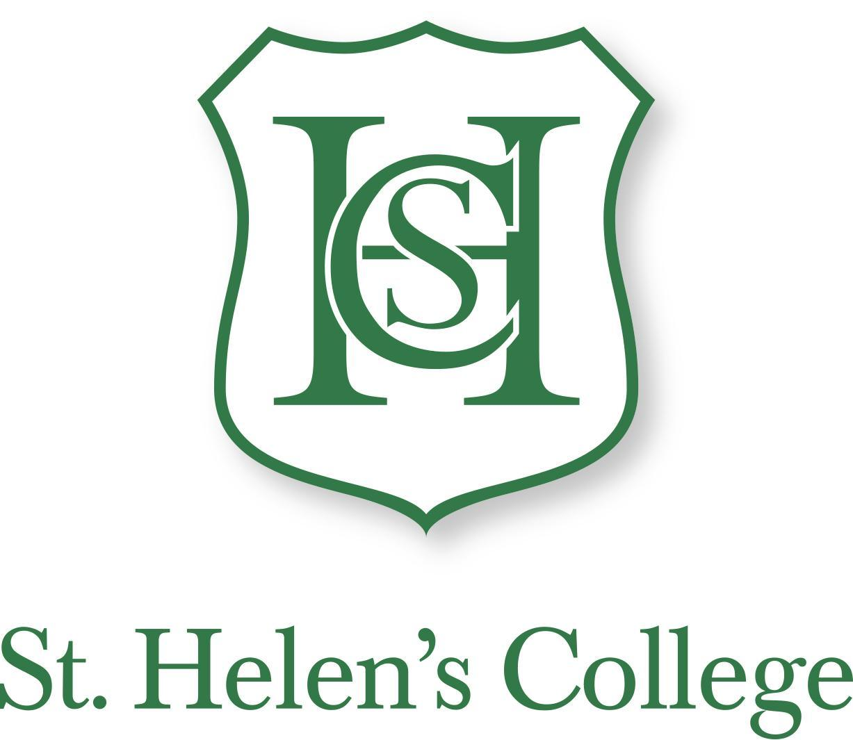
Parkway, Hillingdon, Middlesex, UB10 9JX
01895 234371 www.sthelenscollege.com

February 2020

Dear Applicant,

Head of English

Thank you for your enquiry about the teaching post that we are currently advertising.

We wish to appoint a full-time, qualified teacher at the start of the Autumn Term 2020 to lead the teaching of English across the school. English is a highly successful and flourishing subject, and we are seeking a creative and dynamic teacher to inspire further development and success. In addition to English, the successful applicant will spend some time teaching other subjects (dependent on expertise) and will be a form teacher.

The successful applicant will be a strong all-rounder, with excellent ICT skills (all classrooms have interactive whiteboards and access to laptops and tablets), and the ability to inspire devotion and diligence, encourage high standards of attainment in all areas, liaise closely with colleagues and parents, and create an atmosphere of care and interest for the children. The children are diligent, conscientious and well behaved, and we have excellent parental support.

The person appointed will be joining a remarkably dedicated, experienced and friendly team of teachers. CPD is given a high priority, and all teachers are supported in their professional development. We offer our own generous salary scale and pension.

St. Helen’s College is committed to safeguarding and promoting the welfare of children and young people and expects all staff and volunteers to share this commitment. Employment at the school is subject to a satisfactory DBS Disclosure at Enhanced level.

Pre-application visits are welcomed: please telephone Su Smith on 01895 234371 to make an appointment if you would like to visit. An application form and further details are available at www.sthelenscollege.com and applications should reach the school by the closing date of Monday 24th February 2020. We look forward to receiving your application.

Yours sincerely,

Mrs. Shirley Drummond
Head

