

Class Teacher

Application Pack

Geraldine Gallagher

Headteacher

**Contents**

|  |  |
| --- | --- |
| 1. Letter to applicant |  |
| 1. History of the school |  |
| 1. Job description |  |
| 1. Person specification |  |
| 1. How to apply |  |
| 1. Application form |  |
|  |  |
|  |  |

**To nurture and inspire our children to develop a love of learning in a supportive Christian community and become the best they can be.**

Tuesday 31st October 2017

Dear Applicant,

**CLASS TEACHER**

Thank you for taking an interest in our advertisement for the above post at St Michael’s CE School. The school is set in beautiful grounds in Highgate. It is near to the underground station and a variety of shops, restaurants and other amenities. There are excellent transport links to Central London and to outlying areas.

We have high expectations and consistently perform above expectations in all areas of the curriculum, providing the best opportunities and outcomes for our pupils. We are looking for someone to work with our very enthusiastic and committed teaching staff who constantly strives to get the best from all our children. We are looking for an enthusiastic person with excellent interpersonal skills to support and nurture our pupils to become the best they can be.

To sustain and continue to build our creative and very effective practice across all aspects of the school we are committed to developing our staff. Our staff have access to in house and outside training development opportunities to enable them to keep up to date and to develop their skills and become the best they can be.

All the information you will need is in the application pack. If you would like to visit or require anything further please contact the school business manager, Nicola Purvis via [jobs@stmichaelsn6.haringey.sch.uk](mailto:jobs@stmichaelsn6.haringey.sch.uk), she will be happy to help.

The closing date for applications is Friday, 17th November 2017.

I look forward to receiving your application.

Yours sincerely,

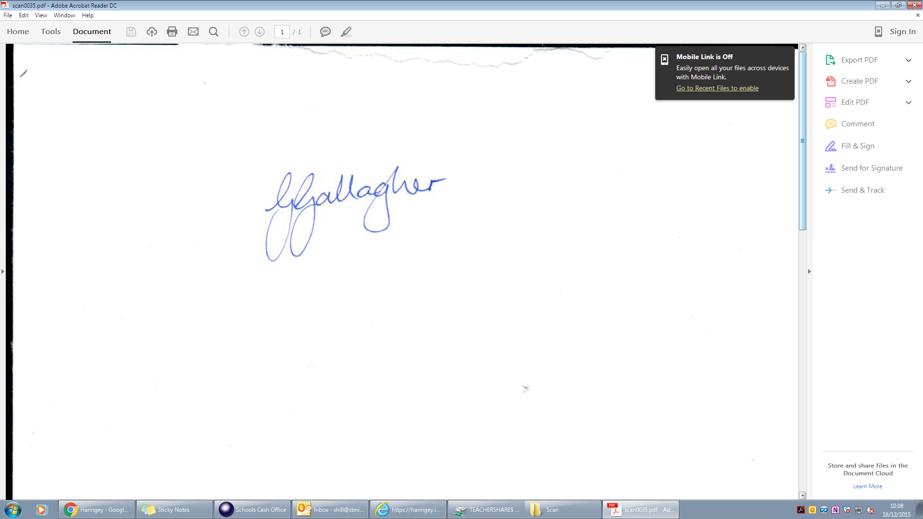

Geraldine Gallagher

**Headteacher**

**History of the School**

In 1565 Sir Roger Cholmeley had founded a boys Grammar School in Highgate, and in 1733 the Highgate Girls Charity School had been established by Mr Edward Pauncefoote in Southwood Lane. In 1833 a National School for boys and girls was built next door in Southwood Lane, to accommodate increasing numbers of children who could not get into the Grammar School (which now charged fees), or the Charity School (which was too small). The Highgate National School held 160 children but even so it was overflowing; an 1850 Inspector's Report criticised the accommodation, drainage, heating, ventilation, and play-space - the boys' play space was too small, and the girls had none. The children played in the street, and there was no house for the Head Teacher. The site was too small for any improvement. Thus it was that in 1850 a "numerously attended Meeting" got together in emergency session and issued a memorable statement.

Local magistrate and educationalist Harry Chester was a key organiser and fundraiser, bringing in a crucial £1,400 grant from the Privy Council. The London Diocesan Board, "though unable to make a grant", gave its "cordial approval". The citizens of Highgate, Muswell Hill and Kentish Town gave generously, from the pennies and farthings from the Grammar School boys, to the £400 of Miss Burdett Coutts who then lived at Holly Lodge. The purchase of 4 acres on North Hill from the Bishop of London for £135 went well; but there were then "great difficulties" arising from a late decision to move the school back from the road to its present site, and having to buy access land and build deeper foundations.

In July 1852 the St Michael's National and Industrial School was opened at a total cost, including equipment, of £6,700 - rather more than the £3,000 originally estimated, and very much more than the £500 it cost to build the old National School. The architect was Anthony Salvin, and the result was a model school which became quite famous in its early years. As Joan Schwitzer has said; “For a decade the school was a showplace. Lord Mansfield chaired the Annual Meetings when the grounds were thrown open to subscribers and parents. Lady Burdett Coutts ... came to call ... Local maiden ladies helped with the teaching."

In 1857 an Industrial Act was passed giving grants for Boarding Schools for the care of children in need, the main object of which was to provide training (as a begging-letter from the 1850 St Michael's Sub-Committee put it) of "elder girls in Household-work, Washing, Cooking &c ... [with] boys in Out-door pursuits, and qualified for employment, as Cottagers, Farm-Labourers, Gardeners, Mechanics, or Emigrants". There was considerable scope for this type of work in the large houses of Highgate, and the great support shown by the Annual Subscription Lists makes it clear that the wealthy inhabitants were very willing to support such a worthy cause, and incidentally provide themselves with a regular supply of excellent domestic servants. So St Michael's in its early years took in boarders as well as day pupils; it is not known when precisely the boarders were given up. From the 1860's the school gradually transformed itself (says Joan Schwitzer) into "a more conventional elementary and finally primary school, albeit with unusually spacious playing fields, play-grounds,  resident staff accommodation and garden plots which were still being cultivated for annual prizes in the nineteen forties."

The buildings themselves consisted of Boys', Girls' and Infants' Schools, or schoolrooms (see Plan). The Infants' Schoolroom was under the dormitory area: originally the dormitories were occupied by staff and pupil teachers, but they were then converted into 16 cubicles for room should be as comfortable and pleasing as possible, with a few bright maps, a few good diagrams, a few well-chosen texts on the wall. Texts such as "Our God is a consuming fire" and "All liars shall burn in the lake that burneth with fire and brimstone" are to be avoided. The school should provide washing facilities, but not on a large scale as the children should come to the school with clean hands. There should also be small gardens, a pigsty, rabbit hutches, beehives, hen runs and a wash-house and laundry. The children should be encouraged to make and classify a natural history section, learn drawing and have the opportunity of practising music, vocal and instrumental."

By the end of the century the school had settled down to its average number of 200 pupils, which it maintained until extra classrooms were added after the 2nd World War. There was one pupil teacher for the boys, two in the girls' room, and one infant teacher. In 1890the curriculum included Drill, History, Geography and Singing. The infants had Object lessons on such things as Air, Water, or Nature. This syllabus was probably not much different from the original and is in its essence is still continued today (with, or course, many additions). The main change is that the teachers no longer expect the children to help maintain the school.

**JOB DESCRIPTION FOR CLASS TEACHER**

**CORE PURPOSE**: To safeguard the welfare of children and to be in sympathy with, and supportive of, the Christian ethos and Christian values the school promotes. To be an effective classroom practitioner, demonstrating high standards of teaching and learning in accordance with school policies and the most recent School Teachers’ Pay and Conditions Document.

**RESPONSIBLE TO**: The Headteacher

* To expect high standards of learning and behaviour, providing a high quality education experience for all children.
* To be responsible for a class in the 4 to 11 year age range with a full time teaching commitment.
* To plan and deliver the curriculum for all pupils in the class in relation to the National Curriculum, the Primary Strategy, the Agreed Syllabus for Religious Education and guidelines for PSHCE, Citizenship and Modern Foreign Languages.
* To carry out assessments and maintain records of children’s attainment and progress in line with the school policy.
* To be responsible for the pastoral care of children in your care.
* To select and make good use of ICT skills for classroom and management support.
* To manage the deployment of Teaching Assistants and Learning Support Assistants to best meet the needs of the children in the class.
* To liaise with parents regarding their children’s progress in academic, physical and personal development, both informally and at Parents’ Meetings. To complete end of year reports for parents. To support the work of the School Association.
* To ensure the classroom environment is stimulating and that the children’s work is attractively displayed. To take responsibility for other designated display areas around the school.
* To lead and share in school and class worship, promoting the Christian ethos.
* Comply with policies and procedures relating to child protection, health, safety, welfare, security, confidentiality and data protection and report any concerns to the appropriate person.
* Actively support the school’s and Local Authority’s equal opportunities policies and ensure that all pupils have equal access to opportunities to learn and develop.
* Contribute to the overall aims and targets of the school, appreciate and support the roles of other members of the school work team and attend relevant meetings as required.
* To take responsibility for the planning, development and co-ordination of a curriculum area.
* Be aware of and take part in the school’s performance management framework and participate in training and development activities as required.
* To be familiar with and follow the school’s systems as outlined in policy documents and guidelines.
* To participate, as required, in meetings with professional colleagues and parents and maintain effective working relationships.

**JOB DESCRIPTION FOR CLASS TEACHER**

The successful applicant will be required to:

* Safeguard the welfare of children and to be in sympathy with, and supportive of, the Christian ethos and Christian values the school promotes
* Be an effective classroom practitioner, demonstrating high standards of teaching and learning
* Take responsibility for the planning, development and co-ordination of a curriculum area

**Experience**

* Previous teaching experience in a good/outstanding school would be an advantage
* Experience of working effectively in a team

**Qualifications**

* Qualified Teacher status or equivalent

**Training**

* Evidence of attendance at courses relevant to the primary phase
* Evidence of commitment to personal professional development

**Skills and attributes**

Applicants should:

* Be an excellent classroom practitioner
* Have a clear understanding of the teacher standards
* Be able to demonstrate effective implementation of these standards in their work
* Have good written and oral communication skills
* Possess effective inter-personal skills and be able to relate to children, staff, parents, governors and the wider community
* Be able to provide a stimulating, organised and educationally rich learning environment
* Have the ability to lead others and work effectively as part of a team
* Work co-operatively with all professionals, parents and children
* Have proven classroom organisation and management skills
* Maintain a positive approach to the management of behaviour
* Use ICT to support learning
* Show a willingness to be involved in the delivery of INSET
* Have an expertise and a passion for a specific curriculum area
* Be able to plan and implement an appropriate curriculum
* Show a commitment to high expectations and target setting to ensure continuing improvement
* Have the ability to use assessment as a tool to aid future learning
* To be able to use Assessment for Learning effectively

**How to apply**

Please complete the application form attached with this email and send back to [jobs@stmichaelsn6.haringey.sch.uk](mailto:jobs@stmichaelsn6.haringey.sch.uk)

**To nurture and inspire our children to develop a love of learning in a supportive Christian community and become the best they can be.**