**Job Application Pack**



## Our Vision

***To be the unique and vibrant sixth form college of choice, celebrating individuality, pushing boundaries, achieving excellence and launching exciting careers***

**Principal –** **David Shaw**

Bilborough College Sixth Form

College Way

Nottingham

NG8 4DQ

**Tel:** 0115 8515000

**Email:** [personnel@bilborough.ac.uk](mailto:enquiries@bilborough.ac.uk) **Web:** [www.bilborough.ac.uk](http://www.bilborough.ac.uk)



**Introduction from David Shaw, College Principal**

I’m delighted that you’ve expressed an interest in the position XX

at Bilborough College. This post provides an excellent opportunity for an aspiring

leader to join our successful sixth form college at an exciting stage in its development.

You will be joining a flourishing institution with strong student outcomes, fantastic enrichment and development opportunities, and an innovative and creative teaching and learning culture. As a result of its excellent reputation, student numbers have grown in each of the previous two years taking the college to its capacity of 1800 students. Our dedicated team of staff are committed to providing the very best learning opportunities and support for the young people we serve. All members of the college community benefit from a bright, modern and well-equipped, purpose-built college campus, located close to junction 26 of the M1 between Nottingham and Derby.

In December 2018, the Bilborough College Board decided to convert to Academy status and join the Better Futures Multi Academy Trust, a new Multi-Academy Trust, designed with sixth form colleges in mind and sponsored by Coventry University. We anticipate that Bilborough will join King Edward VI College, Nuneaton, as a founding member of the Trust on 1st November 2019. After conversion to academy status, Bilborough will remain a sixth form college in name, ethos and educational character and as a result will retain its unique position in Nottinghamshire and Derbyshire.

We feel very fortunate to have the opportunity to work with so many able and enthusiastic young people who make a commitment to learning when they decide to come here at 16. Our challenge is to respond to them by meeting their needs, raising their aspirations and helping each one to achieve their full potential. We know that it’s the quality and commitment of our staff and their relationship with students that makes the real difference and will help us to build and maintain excellence for the future. As a learning organisation we strive to ensure that our staff are provided with regular professional development opportunities to enhance their abilities and to support their career progression whilst also ensuring a supportive working environment where staff wellbeing is a priority.

We are a dedicated Sixth Form College and our students have the right to expect that we will help them to maximise their potential. Therefore the college’s most important set of performance indicators are based on its students’ examination results and their destinations. Students’ performance, the progress that they make while they are with us and their progression routes are key priorities for us all.

However, there is a lot more than that contributing to Bilborough College’s strong reputation and its popularity. Alongside good and outstanding teaching, the experience of being a student here involves a wide range of enrichment opportunities, including sport, foreign exchange visits, direct involvement in running and managing College events and many, many more. We believe that all of this – underpinned by strong support services, positive and productive staff student relationships and a sense of community – provides an environment where students are able to develop as individuals, personally and academically, in line with their particular talents and abilities. Every member of staff, whatever their role, has a vital part to play in creating that environment by putting our values into practice

I hope once you’ve read through the details that you decide you’d like to play a part in ensuring our students’ future success and that of the College. If you are then invited in to see us, I very much look forward to meeting you.



Best wishes

**David Shaw**

**Principal**

**College overview**

Bilborough Sixth Form College came into being in 1975 when it converted from Bilborough Grammar School and the college continues to operate from the same location catering solely for students aged 16-19.  The college attracts students from the city of Nottingham and large areas of surrounding Nottinghamshire and south-east Derbyshire as well as the city of Derby.

Having moved into its current, purpose-built campus in 2005 the college has been effective in increasing student numbers over the intervening period. There has been steady growth of around 7% in each of the last 3 years and we currently have just over 1800 funded students enrolled on 16-18 Study Programmes involving A Levels, BTEC Level 3 Diplomas, or a combination of the two. The college’s main qualification aims comprise approximately 80% A Level and 20% BTEC and other Applied General qualifications. Our most recent Ofsted report describes a ‘culture of collective endeavour’ which we believe accurately captures our approach to success for all.

**Academisation: Better Futures Multi Academy Trust**

Bilborough College plans to convert to academy status and join the Trust on or soon after 1st November 2019. We see this not only as a natural next step in our collaboration with a leading university and other Sixth Form Colleges, but also as an opportunity to provide a unique student experience at Bilborough Sixth Form College.

We believe the proposal will also enhance the financial resilience and capacity of the College, ensure continuity for students and support our strategic vision. Membership of the Trust will provide fresh and innovative opportunities for our students that raise aspirations, accelerate progression and ensure even better-quality provision for all students through sharing expertise with new partners. New and high-quality staff development opportunities with Coventry University will help us to retain talent and continue to attract the best staff.

Upon academisation Bilborough Sixth Form College will be the second Sixth Form College member of the Trust. The Trust, as a single legal entity, has overarching responsibility for the governance of its member academies, although the key principle is that all members operate with a high degree of autonomy which will preserve and enhance our unique identity.

With the college due to join BF MAT at such an early stage there will be opportunities for college staff to play an important part in helping shape the Trust’s future vision, its policies and ways of working.

*“Bilborough college has allowed me to aspire and achieve goals I thought were never achievable. It truly is the best college ever!!” Abdus (Year 12)*

**Bilborough College quality and performance**

The college was last inspected by Ofsted in September 2016 and was found to be ‘Good’ for overall effectiveness and ‘Good’ in all key judgements. Inspectors judged that ‘leaders and managers at all levels have a clear and effective focus on ensuring that teaching is consistently good and students work hard’. They noted that we had ‘focused on keeping things simple and getting them right’.

The college has an ambition and a plan of action to deliver consistently excellent teaching, learning and assessment and an outstanding student experience and outcomes through a combination of individualised challenge and support.

Since September 2016 students’ experience and outcomes have improved further. We are still awaiting the outcome of some re-moderation and re-marking and so not in a position to confirm the 2019 outcomes, but it is already clear that they are broadly in line with 2018 outcomes which are shared on this page.

Student outcomes 2018:

* The A Level pass rate was 98.2 per cent, meaning that the pass rate has exceeded 98 per cent for the past 14 years.
* A total of 55 per cent of grades were A*-B, a rise of three per cent from last year and up from 50 per cent in 2016.
* A total of 606 students took A-Levels, including those taking two A-Levels alongside a BTEC Subsidiary Diploma. A total of 502 students took three or more A-Levels and 12 per cent of these gained three or more A and A* grades.
* In terms of measures of students’ progress,
* the ALPS Quality indicator for A Level in 2018 was grade 4 (above the 60th percentile from the national dataset) and for BTEC was grade 5 (between the 40th and 60th percentile).
* The A Level T Score for 2018 – an indication of the effectiveness of teaching across the curriculum - improved to grade 3 (above the 75th percentile).
* Level 3 Value Added for A Levels was +0.14 (top 22% of providers)
* Level 3 Value Added for Applied General Qualifications was +0.23
* The GCSE maths and English scores were +0.77 and +0.56 respectively

The college has self-assessed as Good for 2018 and the quality improvement plan identifies the areas requiring attention and the steps we are taking to address these on our journey to Outstanding.

*“Where else would you go for great A-levels other than Bilborough College?”*

*Poppy (Year 12)*

**Bilborough College ethos**

The college’s vision is “to be the unique and vibrant sixth form college of choice, celebrating individuality, pushing boundaries, achieving excellence and launching exciting careers.”

Our mission is to offer outstanding teaching, learning and support to 16-19-year olds to facilitate progression from school into university, further training, apprenticeships and employment. We provide a relevant, broad and rich curriculum so that our students can reach their full academic and wider potential while developing the independence, resilience and awareness necessary for success as responsible global citizens.

Students also benefit from a very broad and varied enrichment and extended studies programme presented under the ‘Bilborough Extra’ brand which is a distinctive feature of our offer. This provides an important element of individual study programmes, helping students to develop transferable skills and make themselves more attractive to universities and employers. It involves additional qualifications, work experience and encounters with employers / higher education as well as a host of other informal activities and learning experiences. Ofsted commented on the programme, saying that ‘students benefit from a highly effective enrichment programme that broadens their experience and enables them to develop a wide range of skills and attributes that will help them to become thoughtful and productive citizens’.

The college has a minimum entry requirement of 5 GCSE passes at grade 4 and above, usually including maths and English language. We also provide a very effective resit programme for the small minority of students who have not yet achieved a grade 4 or above in one or other of these subjects.

Expert teachers, specialist personal tutors and support staff work together to provide a purposeful learning environment where students can be themselves, are treated as responsible individuals and given the support and challenge they need.

**Our values**

* **Ambitious** for our students, challenging them to reach their full potential, academic and otherwise.
* **Inspiring** in our students an enjoyment of learning and a sense of what might be possible.
* **Supportive** of our students, helping them to address their needs in order to achieve successful outcomes.
* **Inclusive** of all our students, celebrating their diversity and responding to their different backgrounds, cultures, faiths and talents.
* **Committed** to helping our students rise to challenges, learn from doing so and overcome any barriers to achieving everything of which they’re capable.
* **Open** to new ideas and to opportunities for working with others – academies, universities, employers and the local community - for our students’ benefit

These values inform the way we work – staff, leaders and governors – to achieve our aims. We encourage our students to adopt the same approach.

*“Diversity in not just people, but in the range of experiences to become involved in, makes Bilborough quite extraordinary” Meegan (Year 12)*

**Student Progression**

Approximately 80% of our students go on to higher education - a large proportion to research-intensive universities such as the Russell Group - and the remainder into higher level apprenticeships, employment or further training.

The college places a high priority on preparing students for successful progression, supporting them to develop the necessary skills, attitudes and resilience. In terms of the impact of this on students’ progression to university, UCAS data indicates that a high proportion of our applicants to higher education are successful in gaining places overall at university. In addition, the most recent HESA reports show that a high proportion of our alumni who progress to higher education leave university with first or upper second-class degrees (10% above the state sector average for schools and colleges in 2016-17). This is a particularly strong characteristic for those of the college’s students who live in areas with low participation rates (11% above the national average in 2016-17).

The large majority of the remainder of our students progress directly into work or onto higher level apprenticeships with high status regional and national employers.

*“Here, my future is already taking shape”*

*Daniel (Year 12)*

*“Coming to Bilborough is taking a leap of faith. And now I'm flying”*

*Siena (Year 12)*

**Governance and leadership**

The college corporation has 13 governors with a wide range of relevant professional skills and backgrounds represented. This includes two student governors and two staff governors plus one parent governor. The large majority of current independent governors have indicated an intention to transfer to the new Local Governing Body (LGB) which will come into being at the point of the college’s conversion and transfer to the MAT. This continuity will be important in ensuring a smooth process of conversion particularly as the high degree of delegation means that the LGB will retain many of the responsibilities that were exercised by the predecessor Corporation prior to conversion.

Along with the Principal, the Senior Leadership Team comprises:

* Assistant Principal – Guidance and Support
* Director of Curriculum and Quality
* Director of Human Resources
* Director of Marketing, Information and Administration
* Director of Teaching, Learning & Assessment
* Interim (part-time) Director of Finance:
* Administrative Officer for SLT/ Clerk of corporation

The College has a wider Curriculum Management Team comprising 8 Heads of Faculty, a Head of BTEC, Head of Student Support and Head of Bilborough Extra. The team meets regular with SLT members and acts as a vital forum for refining strategies and policies and as an engine for implementing improvement across the college. The College staffing comprises around 100 teachers and 62 support staff.

**College finances**

The college has a financial health rating of Satisfactory with the ESFA. In-year performance is in line with the budget for the year and the forecast for 2019-20 indicates further improvement with a return to Good financial health. All members of the senior leadership team contribute to the process of financial planning and budgeting. Management accounts are produced each month and scrutinised by SLT and governors.

*“At Bilborough I can finally be myself”*

*Elissa (Year 12)*

**Location**

Bilborough College is a Sixth Form College situated on a large campus adjacent to a new 11-18 Academy with which there are very productive partnership links. The College is located on the North-West boundary of Nottingham, three miles from the City centre, one mile from the M1 and close to the Derbyshire border. The college has bus links throughout Nottinghamshire and parts of Derbyshire.

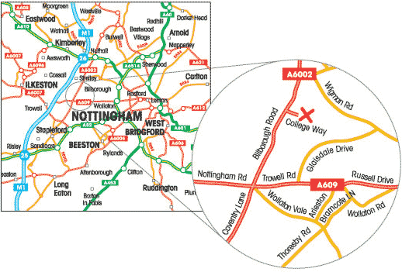

**College facilities**

The college operates from a purpose-built, single site which incorporates the main college building, playing fields and courts and a sports centre which is managed as a community resource out of college hours by Nuffield Health. Other curriculum delivery spaces include science and technology labs, fine art and photography studios, a theatre, dance studio and rehearsal space as well as standard classrooms. There is a central library and independent study spaces plus distributed break out areas, a student support hub, refectory, cafe and shop.

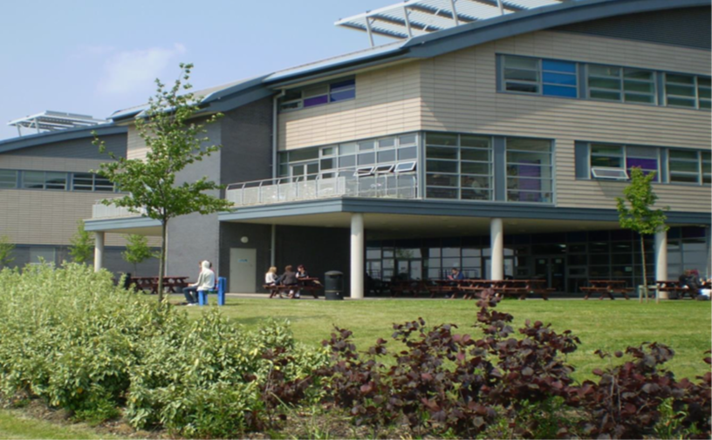

**About Working at Bilborough**

**Recruitment & Selection Policy & Procedure**

Bilborough College is committed to safeguarding and promoting the welfare of children and young people and expects all staff and volunteers to share this commitment. The College will seek to observe best practice in the recruitment and selection of staff, and to work within a framework which offers equality of opportunity to all.

Recruitment Checks

The procedure requires a formal application form (including statements relating to any criminal records and a confidential form for equal opportunities monitoring and identification of special arrangements for candidates with disabilities), formal interview, checking previous employment history and exploring any gaps, obtaining references, and for successful candidates, further verification of qualifications, identify and right to work in the UK check, medical check, ISA Children’s List and DBS check (including oversees ‘Certificate of Good Conduct’, as appropriate).

Recruitment of Ex-Offenders

Bilborough College complies fully with the DBS Code of Practice and undertakes to treat all applicants for all posts fairly. The company will not discriminate unfairly against any subject of a disclosure on the basis of a conviction or other information revealed. The College welcomes applications from a wide range of candidates, including those with criminal records.

We undertake to discuss any matter revealed in a disclosure with the person seeking the position before withdrawing a conditional offer or terminating employment.

Disclosure of a criminal offence need not necessarily debar you from appointment. This will depend on the nature of the position and the circumstances and background of the offences. However, should you fail to disclose a criminal conviction prior to appointment this could result in your dismissal or other disciplinary action being taken against you.

All information will be treated in the strictest confidence.

The Application

The application form can be made available in other appropriate formats if requested. On-line applications can be made through the College’s website ([www.bilborough.ac.uk](http://www.bilborough.ac.uk)).

Incomplete applications, or any anomalies or discrepancies, may affect an applicant’s success at any stage during the recruitment and selection process.

Providing false information relating to Criminal Convictions is an offence and could result in the application being rejected, or summary dismissal if the applicant has been selected and possible referral to the police.

CV’s will not be accepted due to the difficulty of removing personal details which would identify the applicant; if a CV is received it will be removed from the application prior to shortlisting.

**Equality, Diversity & Inclusion**

Bilborough College is committed to the promotion of Equality & Diversity, encompassing age, disability, gender reassignment, race, religion or belief, sex, sexual orientation, marriage and civil partnership and pregnancy and maternity. This is reflected in the College’s Equality, Diversity & Inclusion Policy.

**Health and Safety**

The College policy is to provide a safe and healthy environment for staff, students and visitors. The College will ensure that systems are in place, allowing us to maintain, monitor and where necessary, improve safety performance. Communication and consultation will be inherent to this process. The College expects all employees to exceed their minimum legal duties, including cooperating on safety matters and taking care of their own safety and that of others, who may be affected by their actions. Any information, instruction, training or supervision necessary to meet these commitments will be provided.

**Staff Development**

Training and development of all employees is crucial to the successful, high quality delivery, of the College services. It should enable the College to meet its strategic aims, through development activities which are relevant to business needs and which facilitate a positive workplace culture. We have an annual INSET programme designed around the needs of the College and its staff.

**Salary**

The College operates the Sixth Form College’s Teachers and Support Staff Pay Spines. These are negotiated nationally and considered and approved as appropriate locally, by Bilborough Corporation. The College also has a number of hourly rates which are additional to the two main pay spines. Staff who have been in post for over six months and are not on a spot point or the top of their spinal column band will be eligible for a spine point increment or 1 August (for Support Staff). Teachers who meet the new teaching standards as evidenced by acceptable appraisal outcomes will be entitled to pay progression from 1st September.

The normal starting salary for support staff will be the first spine point of the grade. For Teaching Staff, there is a points assessment based on years’ experience and qualifications. There is discretion to recognise relevant ‘additional’ experience outside teaching. The Teachers Pay Spine is split into 2 sections, the main grade and the Management Range. Teachers with School Threshold certificates will be matched to the appropriate equivalent point on the Teachers Pay Spine.

**Pensions**

Teaching staff are eligible to join the Teachers Pension Scheme and Support Staff the Local Government Pension Scheme. Both are contributable schemes and are heavily subsidised by the employer. Both schemes are considered to be a valuable part of the pay and reward package. Further details of the schemes can be found at [www.teacherspensions.co.uk](http://www.teacherspensions.co.uk) and [www.nottinghamshire.gov.uk/npf](http://www.lgps2014.org) (Local Government Pension Scheme).

**Holidays**

Holiday entitlement increases with service for Support Staff, starting with 22 days (25 for Grade SO1 or above), plus 5 closure days and 8 statutory holidays. For Support Staff working term time only, the holidays are worked into the annual salary (calculation available on request). Staff working term time only are not eligible to take holidays during term time.

**Family Friendly & Work-Life Balance Policies**

The College has a positive attitude towards family friendly and work life balance. Policies and procedures are in place, which are supportive in considering and meeting staff needs.

**Other Benefits**

Bilborough Sports Centre, situated on the same site, offers discounted gym membership to Bilborough College Staff.

**Car Parking**

Since April 2012 Nottingham City Council introduced the workplace parking levy (WPL). As a result, staff who use the College carpark are required to pay a charge to contribute to WPL costs. More details will be available on request.

There are secure shelters for bicycles and motorbikes as well as changing and shower facilities. Drying cabinets are provided for anyone who needs to dry outdoor clothing due to adverse weather conditions, ready for the home journey.

