

EXPLORE OUR WORLD

**Teacher of Latin and Classics**

**Required September 2019**

**Permanent**

**INFORMATION FOR CANDIDATES**

**A Catholic Independent Day School for Girls 2-18**



# cid:image022.jpg@01CFD347.D2E5AD80

**The School**

Set in 26 acres of beautiful parkland in Cobham, Notre Dame School nestles in a picturesque 18th century mansion beside the River Mole. Notre Dame is a Catholic School and is a Foundation of the Company of Mary Our Lady with an ethos shaped by the life and work of St Jeanne de Lestonnac. Despite the tranquil setting Notre Dame School is a hive of activity, with over 600 children and teachers working hard in the important business of education. The school has an enviable reputation for the highest academic standards and a progressive, holistic, academic education that is underpinned by over 400 years of international educational tradition in 30 countries. Established in England in 1937, the school has always had the philosophy that the greatest success comes from knowing how to learn and how to ask the right questions; training pupils to take an active role in reaching and exceeding early expectations. From the vibrant Nursery to the exciting Sixth Form, tomorrow's professionals acquire the skills, knowledge and qualifications that give them the best possible start in life.

The school is filled with a strong sense of purpose, offering a wide-ranging and active education with facilities encompassing new science laboratories, music and drama studios, sports fields, indoor swimming pool, dedicated Sixth Form Centre, a forest school for the youngest pupils, and a fully equipped, West End quality theatre seating over 350. The school is currently developing its all-weather facilities to complement the existing outdoor and indoor netball and sports facilities. The girls participate in choirs, sports teams, orchestras, language groups, outreach work, craft clubs, swimming squads and debating societies. The school councils for the different age groups and the peer mentoring and 'big sister' system provide pastoral care in a place that values the individual and always stretches a hand to help others, leading to charity initiatives as well as a happy and fulfilled community.

Leadership is prized and all are encouraged to fully engage in the life of the school. In recent years educational research has shown that this type of all-round education adds limitless value to the lives and experiences of our young people, as well as enhancing academic success and personal confidence, so it is a delight to find a world-class school on the doorstep that has promoted this so strongly and so successfully for over three quarters of a century.

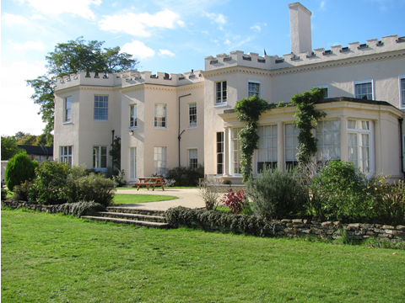 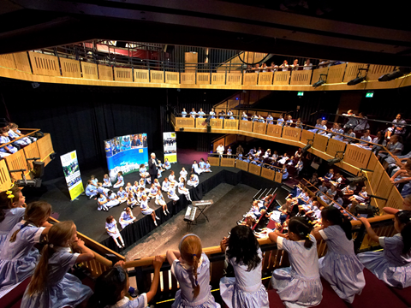 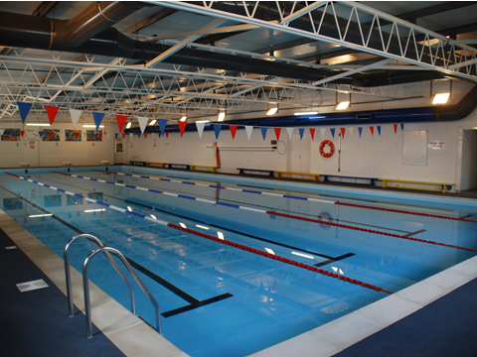

**Heritage and ethos**

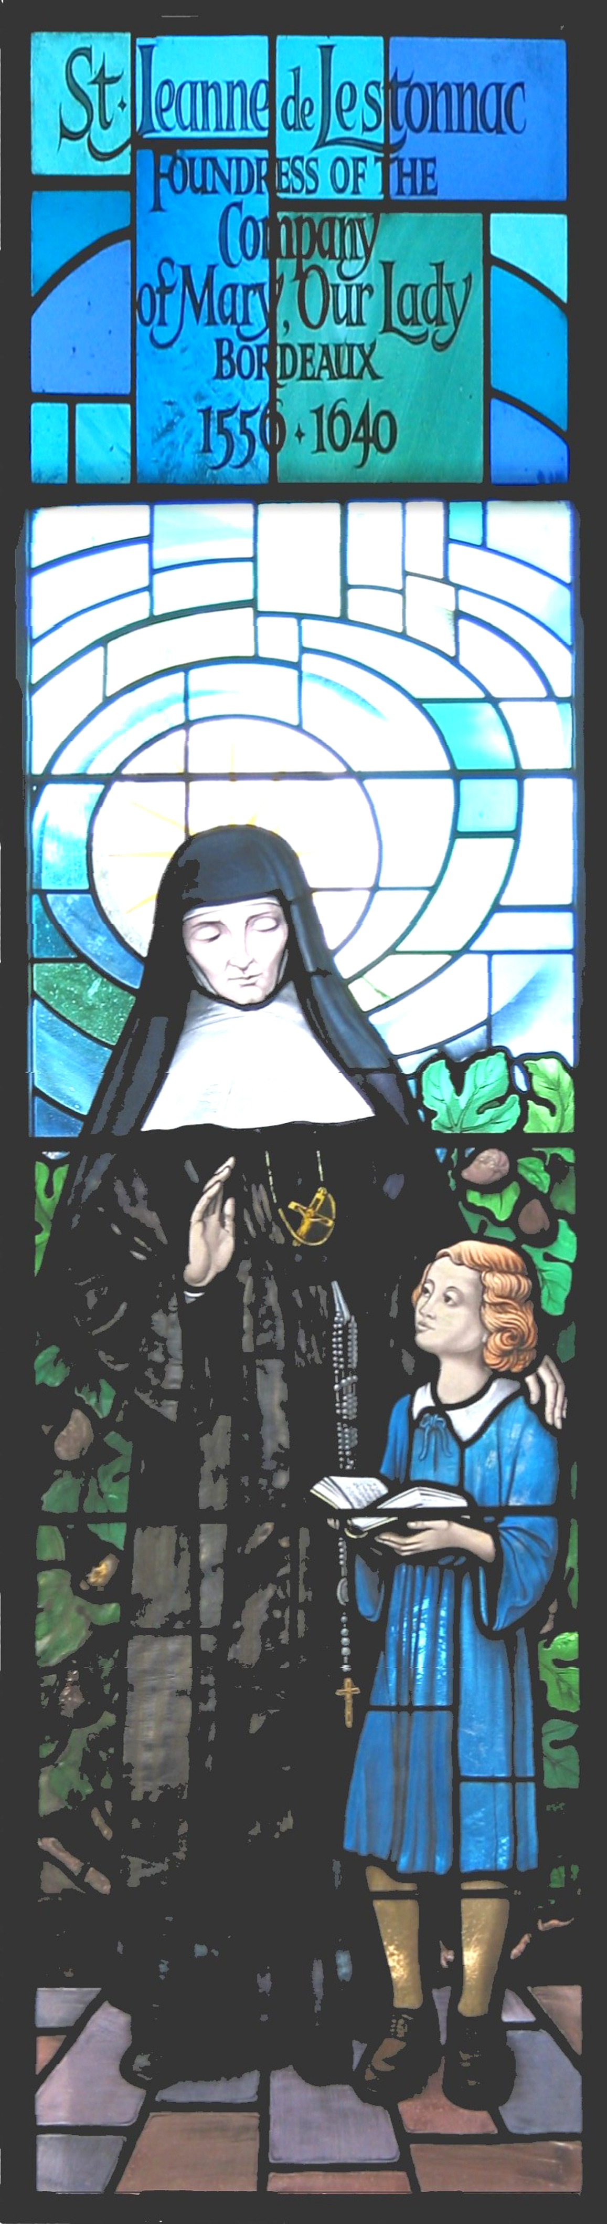

The School has a long heritage in matters spiritual and philosophical. Notre Dame, Cobham is a Catholic School, but with an ecumenical attitude to those of other faiths. It was established in 1937 by the Sisters of the Order of the Company of Mary Our Lady. The Company of Mary was founded in France in the 17th century by St Jeanne de Lestonnac and has over 300 educational establishments throughout the world. The Sisters of the Company of Mary continue to play a very important role in the pastoral life of the school ensuring that the ethos is maintained. Our values are rooted in our heritage, however, as an inclusive, outward-looking School; we are committed to encouraging a questioning spirit of mutual tolerance and informed dialogue based on openness, reciprocal respect and trust. We welcome girls of all faiths and none.

**The Department**

Latin is taught within the Languages Department. It forms part of the Lower School curriculum and is offered through to GCSE and A-Level. Taster lessons are taught to Year 6 within our Preparatory School to provide an introduction to the subject. Notre Dame recently hosted a GCSE revision conference in conjunction with the Guildford Classical Association which was attended by a number of our neighbouring schools. Visits to museums and university departments currently play an important role in fostering interest in this subject.

Classical Civilisations is offered as an A Level option within the Sixth Form and is taught by the Teacher of Latin under the management of the History Department. The syllabus allows students to examine various aspects of the classical world that are significant to the development of the modern world.

**The Role**

###### **Pastoral**

* The successful applicant will also be expected to play an active role in the pastoral care of girls showing such qualities as empathy, compassion and sensitivity to all.

**Staff Management**

* This role does not have line management responsibility.

**Health and Safety**

* All employees have a legal duty to ensure the safety of him/herself and all the pupils and staff within the school as detailed in the Health and Safety at Work Act 1974.

**Data Protection**

* All employees should familiarise themselves with and follow the Data Protection guidelines and practices.

**Safeguarding**

* The school is committed to safeguarding and promoting the welfare of children and young people and expects all staff and volunteers to share this commitment.

**Professional Standards**

* Has thorough up to date subject knowledge.
* Has a thorough knowledge of public examination syllabuses as appropriate.
* Uses assessments to inform future planning.
* Communicates professionally with parents through reports and consultation evenings.
* Offers, where required, additional ad hoc lunchtime teaching sessions to support pupil learning.
* Aspires to the aims set out in the Policy on Teaching and Learning.
* Maintains high standards of discipline, behaviour and courtesy.
* Carries out duties as assigned each year.
* Provides a positive role model for students through own personal conduct.
* Participates in the school’s Professional Review and Development Scheme, taking a pro-active role in own continuing professional development.
* Participates in up to ten INSET days per year
* Attends masses and assemblies.
* Attends all weekly staff briefings and meetings.
* Attends prize giving and open days and supports school functions such as the summer fete, plays and concerts.
* Dresses in accordance with the staff dress code.

**Function of the Post**

* To implement and deliver an appropriately broad, balanced, relevant and differentiated curriculum for students and to support a designated curriculum area as appropriate
* To monitor and support the overall progress and development of students as teacher
* To facilitate and encourage a learning experience which provides students with the opportunity to achieve their individual potential
* To contribute to raising standards of student attainment
* To share and support the school’s responsibility to provide and monitor opportunities for personal and academic growth

**Main Accountabilities**

* To plan and produce interesting, varied and effective lessons, with clear and appropriate objectives
* To take account of girls’ prior levels of attainment and use them to set targets for future improvement
* To set appropriate and demanding expectations for girls’ learning, motivation and presentation of work
* To mark work regularly and promptly, in accordance with the school’s assessment policy providing constructive oral and written feedback, and clear targets for future learning as appropriate

**The Person**

Notre Dame School are seeking an outstanding Teacher of Latin and A Level Classical Civilisations who has a strong tradition of academic success, innovation and enrichment.

We are looking foremost for a dynamic, talented practioner. You will be a good Honours Graduate with Qualified Teacher Status who can teach up to A Level.

You should be innovative, enthusiastic, highly committed and have a clear vision of the future of Latin, and the ability to translate this into real learning experience for the pupils. You will have the capacity to inspire them, and to provide a lively, stimulating, tolerant, and supportive environment that can engender the highest levels of achievement through clear leadership and efficient administration.

You will communicate your love of the subject beyond the confines of the timetable.

The represents an outstanding opportunity for you to work in a school where teachers have a strong sense of community and enthusiasm and in which, involvement, pastorally, and in the broader curriculum, is the expected norm.

**Knowledge/Skills/Ability**

* Ability to teach and motivate pupils
* Ability to communicate passion and enthusiasm for his/her subject
* Excellent knowledge of Latin and Classics
* Good knowledge and understanding of subject related issues such as assessment, target setting etc.
* Good organisational and administrative skills
* Ability to use ICT
* Communicate clearly and concisely both verbally and in writing
* Positive and enthusiastic
* Capacity for sustained hard work – able to work under pressure
* Ability to solve problems, achievement driven
* Passionate, conviction and a clear personal philosophy which supports the ethos of the Department/School
* Creative, imaginative and resourceful
* Ability to make good professional relationships – with staff, students and parents
* Ability to motivate and make strong, resilient relationships with young people
* Integrity and loyalty

**Benefits of Service**

**Hours:**

* Permanent, full-time

**Remuneration**

* A competitive package dependent on skills and experience

**Benefits**

* The School has high expectations of its staff, and therefore looks to reward them with a competitive salary scale and beneficial conditions of service
* There is an extensive induction programme for all new colleagues and ongoing professional development is encouraged
* There is ample opportunity to take on additional responsibility

**Personal**

* The School enjoys a fantastic situation: central London is 30 minutes away, the M25 and A3 are 5 minutes away. Heathrow is less than half an hour.
* Fee concessions are available for the pupils of any member of staff who meet the school’s entry requirements
* Longer holidays than the state maintained sector
* Free on-site parking
* School Nurse on site during term time

**For Recreation**

* Free use of the school’s leisure and sporting facilities, including a heated indoor pool during certain times.
* Free lunch and refreshments are available throughout the working day

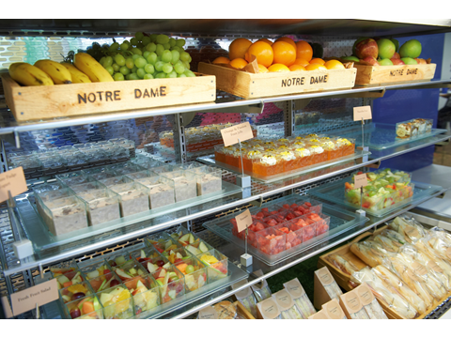

**Selection Process**

Please complete the online application form available on our career site on eTeach:

notredame.careers.eteach.com

# Applications to:

Human Resources Department

Notre Dame School

Burwood House

Convent Lane

Cobham

Surrey KT11 1HA

Email: [HR@notredame.co.uk](mailto:HR@notredame.co.uk)

Any questions, please contact HR on 01932 589092.

**Closing Date: 21st March 2019**

**Interviews: w/c 25th March 2019**

**Start date: September 2019**

Shortlisted candidates will be interviewed by senior members of the School and take a tour of the school.

The School is committed to safeguarding and promoting the welfare of children and young people and expects all staff and volunteers to share this commitment. Applicants must be willing to undergo child protection screening appropriate to the post, including checks with past employers and the Disclosure and Barring Service.

The School is an equal opportunities employer and is fully committed to a policy of treating all its employees and job applicants equally and does not discriminate on the grounds of race, sex or marital status.