Bishop Ramsey CE School

Teacher of Sociology and Psychology

The Social Studies Faculty

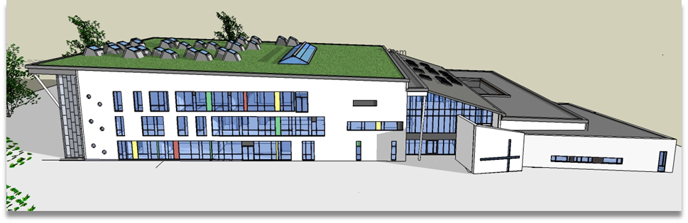

The Social Studies Faculty is multidisciplinary comprising 8 subjects. In addition the Careers Department has a Careers/Work Experience Administrator.
Members of the Faculty are as follows:
Mr Nick Appel Psychology
Mr Derek Carter Head of Business Studies and Economics
Mr Andy Jeffries (Head of Year 13), Economics, History
Mrs Kathryn Lovewell Head of Social Studies Faculty, Head of Psychology
Mrs Amanda Miell Head of Food and Nutrition, Child Development
Mrs Amanda Murphy (Assistant Head), Sociology
Mr David Poole (Assistant Head), Economics
Miss Hannah Smith Psychology, Sociology
Mr Reuben Wellstead 2nd i/c Social Studies Faculty, Head of Sociology
Mrs Debbie Wiseman (Head of Inclusion), Child Development

Business Studies and Economics

Business Studies is an option subject at KS4 and KS5. Students study for their GCSE from Year 9 and follow the Edexcel specification. Students can continue their studies at A Level and follow the full 2 year A Level course also based upon the Edexcel Specification.

Economics is a popular option choice which is only offered to students at KS5. The AQA specification is followed via 4 60 minute sessions per week in Year 12 and 5 in Year 13.

Child Development

Child development is an option for KS4, beginning in Year 9. Students study the OCR Cambridge National Level 1 / 2 qualification. This comprises 50% coursework and 50% examination.

Food and Nutrition

Food and Nutrition is studied by all students in Years 7 and 8 having a 1 hour lesson a week for half of the academic year. At KS4 Food and Nutrition is an option choice. We follow the AQA specification in Food Preparation and Nutrition which is assessed through 50% NEA and 50% examination.

PSHCE/Citizenship and Careers Education, Information, Advice and Guidance (CEIAG)

PSHCE is delivered to all students in Years 7 to 13 in a single 60 minute lesson and covers age appropriate content across a wide range of issues including teaching children about good physical and mental health, how to stay safe on and offline, and the importance of healthy relationships.
In Addition Year 7 students have a single Citizenship lesson per week where they work through a programme of study exploring the key themes of Rights and Responsibilities, Diversity and Democracy. In Year 10 students also have an additional PSHCE lesson focussing on helping them prepare for working life.

CEIAG provides students with an action plan to investigate future career options and access requirements, including qualifications at KS4, and support in making choices at KS5 and beyond, for example, University, Apprenticeships, and Employer School Leaver Programmes.

Sociology and Psychology

Sociology at KS4 is a popular option subject. For GCSE Sociology students opt to study the subject from Year 9 and follow the AQA GCSE Full course. Many students then continue with their studies at KS5.

Psychology and Sociology at KS5 are very popular option choices, attracting many students from within Bishop Ramsey as well as those joining our 6th form. Both Sociology and Psychology follow specifications offered by AQA and students work towards the full A Level taught across 2 years. All classes are taught in mixed ability groups by subject specialists. Exam results within Sociology and Psychology are strong, with the majority of students achieving above their TMG. A large number of students choose to continue their studies in either Sociology, Psychology or related disciplines with successful applications to the top universities.

The Faculty
The Social Studies Faculty has its own office space and a suite of classrooms all located in a relatively new build section of the school. All staff are issued with lap tops and all classrooms have audio and whiteboard facilities.
The Faculty makes a large contribution to the wider life of the school. We run a number of events within school such as Enterprise Day and the Careers Fair, local trips to London for enrichment activities or conferences as well as overseas visits such as the Psychology/Sociology trip to New York. We regard our teachers as learners and so with that in mind, we foster an environment of collaboration and encourage each other to continuously enhance our skills and knowledge through regular sharing of best practice as well as facilitation and/or participation in the wide range of CPD opportunities available. We also enjoy social time together, taking the opportunity to stop for a weekly faculty lunch gives us time to catch up and half termly evenings out provides us with plenty of humour.
We hope this brief synopsis will have given you something of the flavour of Social Studies at Bishop Ramsey. We extend a warm welcome to new members of our friendly, lively and hardworking faculty.

