Church Lane
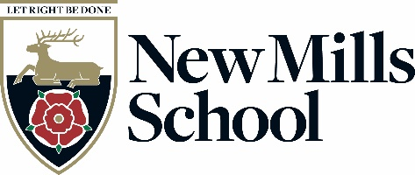
New Mills
High Peak
Derbyshire
SK22 4NR

Tel: 01663 743284
Fax: 01663 745134
email: head@newmillsschool.co.uk
web: www.newmillsschool.co.uk
Headteacher:
Mrs H Watts

Cover Supervisor Manager
G7 PP8-11 (£26,248-£28,161 pa, pro rata)
Full Time (35 hours per week), Term Time only
To start as soon as possible

Join a thriving school rated ‘Good’ by Ofsted – Inspire Excellence in our students!
New Mills School is a small 11-16 secondary school in the High Peak, close to the stunning Peak District National Park, yet within easy reach of Stockport and Manchester.
Following a very positive Ofsted report rating us ‘Good’ in all areas, we are looking for an exceptional cover supervisor to join our team. Ofsted praised our ambitious leadership, high-quality teaching, and strong student attitudes to learning, and we are now seeking an inspirational cover supervisor to support our successful Faculties.
You will find New Mills School a warm, welcoming place, where we are proud of our inclusive ethos, high expectations, and strong sense of community. Our values—Think Big, Do the Right Thing, and Team Spirit—underpin everything we do. We believe in the power of education to transform lives and are looking for a cover supervisor who shares this passion.
This is an exciting opportunity for a dedicated Cover Supervisor manager to join our committed team. The successful candidate will play a key role in supporting students with their learning, ensuring all learners are challenged and encouraged to achieve their full potential. You will be working alongside passionate staff who are determined to remove barriers and provide exceptional opportunities for every student.
We are looking to appoint a Cover Supervisor who will provide cover for planned and unplanned teacher absence to ensure the continuity of learning for our students, as well as follow our behaviour and learning policies and support Heads of Faculty.

The role involves:
- Supervising classes of students in the absence of the teacher and delivering pre-prepared lessons in line with the relevant curriculum medium term plans.
- Assisting in the administration of cover arrangements.
- Taking on tasks as directed by your line manager when lesson cover is not required.

We are looking for an individual who is able to prioritise workload and resolve issues that arise independently. The successful candidate will be confident, have a good general education and be able to build relationships quickly.

If you share our values, have a passion for supporting young people, and want to be part of a forward-thinking and ambitious school, we would love to hear from you.

Application packs may be obtained from, and should be returned to Pete Eckersley, Office Manager, New Mills School, Church Lane, New Mills High Peak, SK22 4NR, or via email to jobs@newmillsschool.co.uk or from the school website www.newmillsschool.co.uk.
If you would like to discuss the post further, or arrange a visit to the school, please contact jobs@newmillsschool.co.uk and this can be arranged.

New Mills School is committed to safeguarding and promoting the welfare of children and young people and expects all staff and volunteers to share this commitment.

New Mills School is committed to creating a diverse workforce. We will consider all qualified applicants for employment without regard to sex, race, religion, belief, sexual orientation, gender reassignment, pregnancy, maternity, age, disability, marriage or civil partnership.

The successful applicant's appointment will be subject to satisfactory pre-employment clearances including references and a Disclosure and Barring check.

Closing date is 1st May 2025, no later than 23:59

Interviews TBC.

Kind Regards

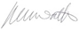

Haether Watts
Headteacher

