THE MATHEMATICS DEPARTMENT

The Mathematics Department consistently achieves results above or in-line with the national average. In Summer 2018 our GCSE grades 4+ was 80.7%, 5+ was 57.6% and 7+ was 19.1%. Our GCSE Maths Progress 8 was +0.480, placing us in the top Quintile nationally. Our Disadvantaged outcomes were above the National for other students. A level grades A* - E was 100% and A level Further Mathematics 100% A* - B in the summer 2018 exam series.

The Mathematics Department is one of the largest in the School, housed on the ground floor of a purpose-built block, opened in 2004. We have 11 teaching rooms, an ICT suite and a staff work room. We employ 11 full time and 2 part-time teachers.
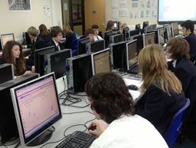

Plymstock School has a 50 period fortnight of hour long lessons. Students are currently allocated 8 hours of Mathematics a fortnight across years 7 to 11, and 10 hours per fortnight in years 12 and 13. We set classes according to student pathways and target grades which are both based on their prior data.

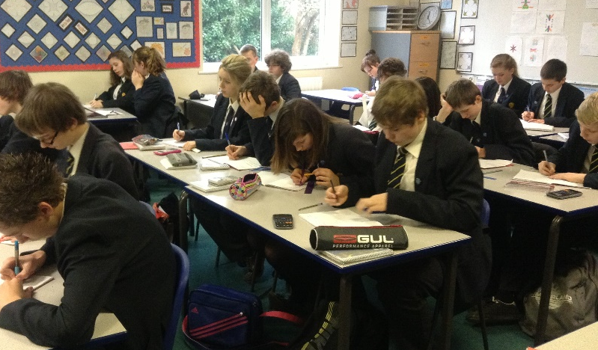
Students enter for Edexcel GCSE and AQA A level examinations. At GCSE our year 10 and 11 students use the Collins GCSE text books and at A Level, years 12 and 13 use the Oxford AQA textbooks.

Across all year groups we use a variety of teaching resources and subscribe to and use a number of online resources such as mymaths, mathswatch, mathsbox, timestable rockstars, to name but a few. We have embraced the use of Kagan co-operative learning strategies and use these regularly within our teaching.

We enter our more able groups in years 7 to 13 for the UK Mathematics Challenge and Team Maths Challenge. We encourage a bright and stimulating learning environment and there are relevant wall displays in all of our classrooms and along the Mathematics corridor.

We are a department committed to excellence in the teaching of Mathematics and giving each student every opportunity to learn and succeed, achieving their full potential at all levels.

Please contact Kate Marshall, Head of Mathematics, if you have any questions about any aspect of our work in the Mathematics Department at kmarshall@plymstockschool.org.uk

The interview day will allow time for a tour of the school, but we are very happy to arrange a time for you to visit us either during the school day or after school if you wish to do so. If you don’t have time for a visit but would like us to give you a call to answer any questions you have about working at Plymstock School, we can arrange this. Please email lduff@plymstockschool.org.uk if you would like to arrange a visit or a phone call.

