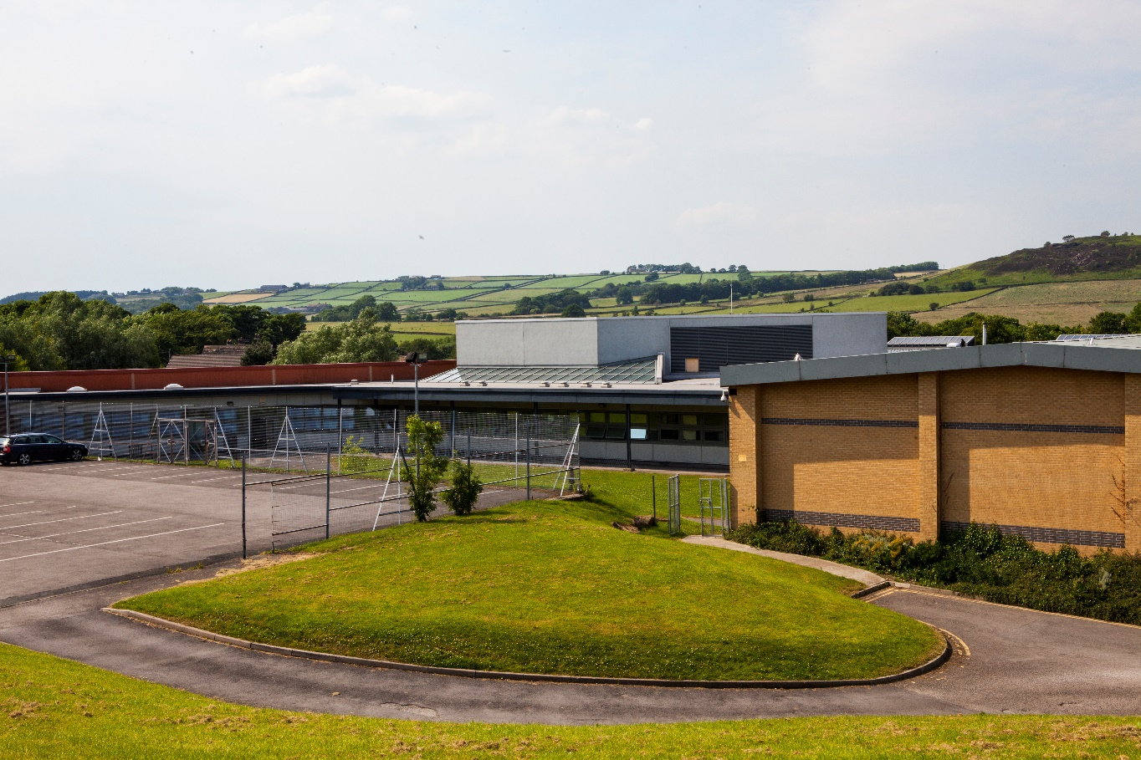
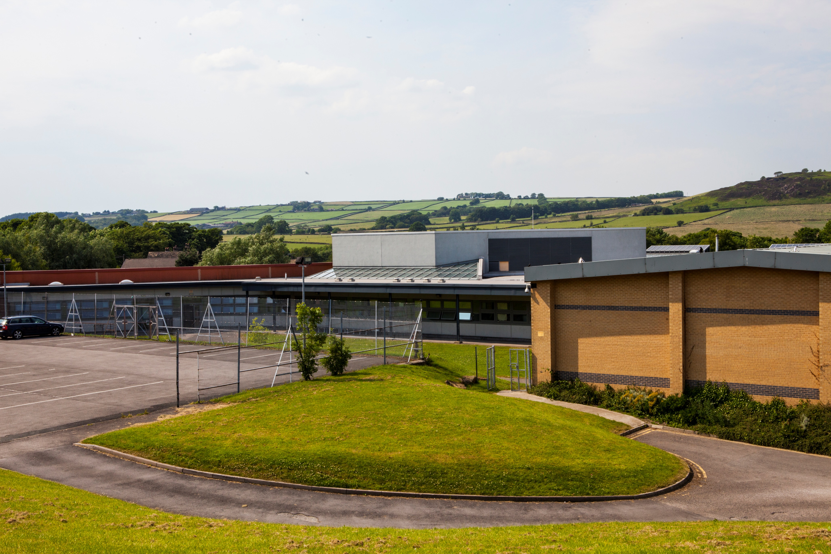

TEACHER OF SCIENCE
APPLICANT PACK
CLOSING DATE: FRIDAY 17 JANUARY 2020 @ 10:00
INTERVIEWS: w/c 20 JANUARY 2020

Application Information.

Thank you for your interest in our recently advertised post for a Teacher of Science at Parkside School.

Please apply by completing the application form and ensure this is returned by the closing date and time published on the advertisement.

Your application should explain why you feel that you are a suitable candidate for this position and should demonstrate how you meet both the Personnel Specification and the Job Description. Details must be provided with regard to three references and these should be relevant to the post’s roles and responsibilities, one of whom must be your current employer. References will always be taken up, however please indicate on the application form if you do not wish your present employer to be contacted prior to interview. In order to consider your application we ask that the application form is fully completed and returned by the closing date and time.

Parkside School is committed to safeguarding and promoting the welfare of children and the protection of the child from all forms of abuse. The school adheres to Bradford Council and statutory guidelines in respect to safe recruitment and the Equality Act (2010). All persons employed by the school, in any capacity, will undergo an enhanced DBS check, and confirmation of employment is subject to this and receipt of satisfactory references. All teaching staff recruited by the school have their eligibility to teach checked with the DfE and other staff will be checked for any prohibitions in relation to working with children. The school seeks the three references on a standard form which includes whether or not the applicant has any issues relating to suitability to work with children.

All offers of employment at Parkside School are conditional, subject to the receipt of satisfactory references and a successful DBS check.

Candidates who have not been notified before the interview date are asked to assume their application has not been successful in this instance. Unfortunately, we are unable to provide feedback to applicants who are not shortlisted.

If you require any further information, please do not hesitate to contact me at school.

Yours sincerely

Jill Britton
Personal Assistant to Mr Andy Taylor

