

Welcome to Rushden Academy
I am delighted that you have taken the time to consider this post carefully and warmly welcome you to our rapidly improving school, Rushden Academy. It truly is the right time to join our academy as you will be part of the winning team as we move out of special measures. We have fostered a strong sense of team work and passionately believe in working together to ensure our pupils achieve the best possible outcomes that they can.
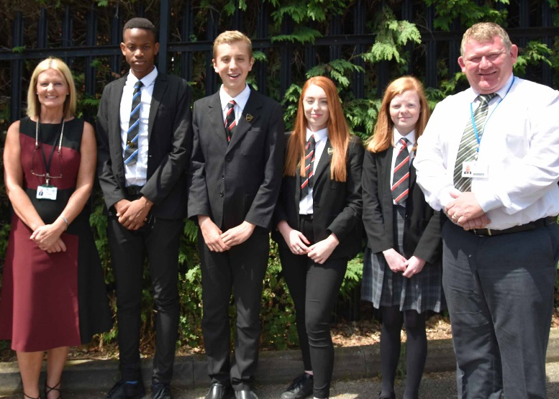
There is a strong drive to excel in lessons and to behave respectfully towards each other and our community. We are proud of the curriculum that we have on offer, not only does it deliver the content pupils need to excel in today’s society it also develops their imaginations. Performing Arts and PE are strengths of the school and we regularly showcase excellent performances or coach youngsters in local schools.
Our pupils fully understood the rules, routines and values; the anti-bullying charter is also well understood. We have a highly supportive pastoral system, which is focused on ensuring our pupils succeed and leave us as confident, articulate and aspirational young adults.
Everyone in Team Rushden has a role and responsibility, we have built a culture where together, students and staff are united in transforming our school. We are proud of our achievements, and produce a weekly bulletin keeping parents/carers informed of what is happening in Team Rushden.
This school has dramatically transformed since the Ofsted inspection in 2016 and this has been reflected in the monitoring visits. Examples of many positive aspects include:
- Pupils say that senior leaders are everywhere and staff feel utterly supported in all that they do.
- Staff morale is high
- The ‘Team Rushden’ ethos permeates through all aspects of the school.
- Pupils and staff feel that Rushden Academy is ‘on the up’.
- There is a clear sense of collaboration and determination to improve further.
- The leadership of the quality of teaching, learning and assessment is strong.
- Pupils recognise the positive atmosphere that has been created and understand the importance of behaving well. As one pupil said, ‘We’re here to learn.’
- Pupils say that bullying is rare and they remain confident that staff would deal with it swiftly and effectively should it occur.
- Far greater emphasis is now placed on celebrating success. Pupils report a sense of ‘healthy competition’ and say that school is more enjoyable as a result.

In 2017 the attainment measures for standard 4 and above were the best yet, but the progress measures were not so there is still work to be done to rectify the historical issues. However, that said our current year 11 data is looking positive and so too is the data for the rest of the school. Staff, parent and pupil feedback is good, behaviour in school is much improved and there is a strong sense of determination to succeed.
It really is a great place to work with fantastic opportunities to grow and develop; you will also have an opportunity to make a big difference too. I want you to enhance what we do here and help us in our journey to outstanding, J2O! Thank you for considering this carefully and I do hope that you complete an application and visit us soon.
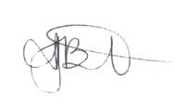

Mrs Jane Burton
Principal

