WALTHAMSTOW SCHOOL FOR GIRLS
“Neglect not the gift that is in me”

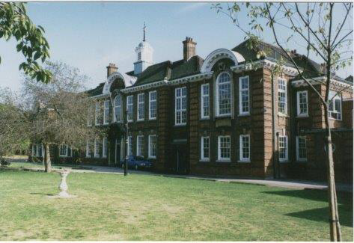

Information for applicants for the post of
Learning Mentor
November 2017

November 2017

Dear Applicant
Thank you for requesting an application pack for the post of Learning Mentor at Walthamstow School for Girls.
Walthamstow School for Girls is a high achieving, oversubscribed multi-cultural school which is regularly in the top 5% nationally for progress and the top 10% nationally for attainment. We have an ambition to become ‘world class’ and a commitment to work with other professionals both locally and nationally. In 2015 we won the national High Aspiration Award for the progress made by disadvantaged students and have won SSAT Achievement and Progress awards annually since 2014. Our students are ambitious and hard-working, they embrace the opportunities offered to them and this is highlighted by our exceptional examination results. They are a delight to work with.
We offer excellent facilities to both staff and students. Our acclaimed architect designed site is a pleasure to work in and is well served by transport connections, being just ten minutes’ walk away from Walthamstow Central tube and overground station and five minutes’ walk from the popular Walthamstow ‘village’, and creative and restaurant quarter. We pride ourselves on working hard to retain our role as an important part of the local community. Examples of this commitment can be seen in our weekly Greensheets. Our staff are inclusive and friendly, with social and wellbeing events organised on a regular basis. Other incentives for staff include membership of a child care voucher and cycle to work scheme.
The school is committed to safeguarding and promoting the welfare of children. We are committed to Safer Recruitment practices and procedures and shortlisted applicants will be questioned about their commitment to the safeguarding of young people. The successful candidate will be subject to an enhanced DBS clearance.
Thank you for taking an interest in this position. I do hope that having read more about the school you will decide to apply for the post. I look forward to receiving your application. Please note that it will not be possible to give feedback to unsuccessful applicants, other than those called for interview. Thank you for your understanding.

Ms Meryl Davies
Headteacher

The History of Walthamstow School for Girls
In January 1890, a circular stated that a “school for girls” was to be opened. Walthamstow was described as a pleasant suburb on the borders of Epping Forest. Hoe Street was almost a country road, with a few houses on either side and meadows in which were sheep, cattle, hawthorn and wild roses.
Miss Hewett was the first Headmistress, at the age of 27 until she retired in 1924. There were 49 girls, whose ages ranged from 7-16 years. At this time there were only five teachers, two of whom were graduates. The School’s original Staff Book gives details of the first one hundred teachers. Of them 30 remained at the school for ten years or more, 22 giving over twenty years’ service. Until 1944 all the teachers were women and not married.
The original building was in West Avenue Road and when the numbers grew the school moved to Church Hill House, where a church now stands. At this time there were also boys up to the age of 13 years at the school. It was in September 1913 that 243 girls came into the present building with the Greek Theatre being added in the 1920s. However in July 2008 the whole school moved off site for a period of four school terms to facilitate the building and refurbishment programme that has resulted in the unique blend of traditional and state of the art facilities found at the school today.
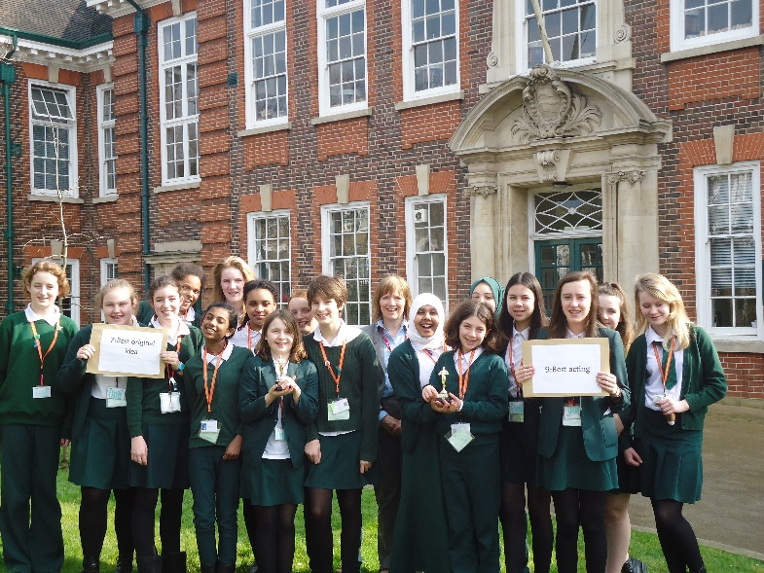
Walthamstow School for Girls is a place of high achievement. Effective teaching and learning are at the heart of our school. The school motto “Neglect not the gift that is in thee” underpins all the school’s work. Every girl is expected, encouraged and supported to achieve her very best academically and our pastoral system supports our students’ academic and social experiences.
Our role is to educate tomorrow’s women through a range of activities and opportunities to be confident, secure and happy individuals as they prepare for further education, careers and future lives.

WALTHAMSTOW SCHOOL FOR GIRLS
JOB DESCRIPTION
KS4 Learning Mentor

Reporting to: Assistant Headteacher (Pastoral)
Liaising with: Line Manager (KS4), Student Progress Leader KS4, tutors in Years 10 & 11, Heads of Faculty, Leadership Team, Parents, governors, external agencies, Teaching and Learning Leader, relevant support staff, LA personnel, Learning Mentor linked to the school.

Job Purpose
- To support identified students in overcoming barriers to learning in order to realise their full potential
- To help support the track the progress and achievements of mentored students in KS4

Responsibilities
- Monitoring and enhancing curriculum and pastoral Provision for Years 10 & 11 Quality Assurance

- To liaise closely with the Student Progress Leaders in assessing referral to the Learning Mentor
- To liaise with the SENCO, Leadership Team including other relevant staff, to ensure coherence between the work of the Learning Mentor and the school’s wider pastoral and learning programmes
- Where appropriate, to liaise with external agencies including School’s Safer Schools Police Officer and RIO post holder
- To meet regularly with the Student Progress Leader (as line manager) to report on progress
- To liaise closely with the staff in the school to maximise understanding of the Learning Mentor’s role and works
- To enhance the learning of students in the relevant year groups by the promotion of activities beyond the classroom

- Tracking the progress and achievements of students in Years 10 & 11 and ensuring, through intervention strategies, that their attainment is maximised

- Through regular communication with the Student Progress Leader establish monitor maintain a register to show the progress of referred students
- To maintain and regularly renew a register of students receiving support from the Learning Mentor and the intervention set up by the Learning Mentor
- To develop and maintain links with feeder primary school Learning Mentors, in order to communicate information about students at risk of underachieving on transfer to Walthamstow School for Girls
- To ensure that Learning Mentor support programmes are integrated within school systems and structures. To evaluate the success of these programmes
- To assist in the identification of early signs of disengagement and contribute to specific interventions to encourage re-engagement
- To support students in the setting of SMART action targets, e.g. For Academic Review Days

C. Line management
- To meet regularly with the designated line manager to report on progress in regards to the Learning Mentor Programme
- To participate in the Annual Performance Management process. Agreeing targets and undertaking relevant training and professional development
- To ensure that all school policies are followed by all team members
- To oversee the work of the managed staff, ensuring the effective implementation of their responsibilities
- To operate within agreed legal, ethical and professional boundaries
- To research into specialist programmes on offer from external agencies and, where appropriate (and after approval of Student Progress Leader and Leadership Team) introduce, coordinate, monitor and evaluate such schemes, maintaining strategic oversight of and responsibility for them

D. To support students in the Key Stage
- To support referred students via 1:1 or small group sessions, maintaining comprehensive paperwork and ensuring regular feedback to relevant staff
- To keep up to date with a range of activities, courses, opportunities, organisations and individuals that could be drawn upon to provide additional support to students
- To foster positive relationship with all members of the year group whereby each girl can turn to you for support and guidance if needed
- To help coordinate social, charity and extra-curricular activities for the year groups, including informing students of out-of-school opportunities
- To promote and celebrate year group activities and individuals’ achievements e.g. (newsletter and head teacher postcards home)
- To be a high profile member of staff around school and a positive role model in terms of challenging infringements of school rules and insisting on high standards of conduct and behaviour

- Implement effective strategies for raising attendance and punctuality among the allocated cohort and to liaise where appropriate with the Student Attendance Manager
- To support the smooth induction of new entrants to the year group
- To support/oversee effective strategies for raising attendance and punctuality in the year group and to eliminate truancy

E. To ensure effective liaison with parents
- To develop and maintain appropriate contact with the families and carers of students who are supported by the Learning Mentor, keeping parents/carers informed about the students’ needs and progress, and maintain a positive relationship with families
- To respond speedily to parental communication and be available for effective home-school liaison
- To help keep parents informed about transition issues of new entrants to the year group
- To support transition events to help ensure the smooth running for the appropriate year group
- To assist in the smooth induction of new entrants to the year group

F. Whole School Contribution
- To contribute to school publications such as the Newsletter
- Responsibility for checking and reporting evacuation of area in the event if fire
- To contribute to the development of whole school policy
- To support the school, aims, ethos and policies
- To ensure that risk assessments and H&S checks are carried out in line with school policy
- To support the school SIP aims and objectives
- To attend professional development sessions

G. Additional Duties
  - To undertake other duties, appropriate to the post from time to time, as may be required
  - To play a full part in the life of the school community, to support its distinctive aims and ethos and to encourage students to follow this example
  - To continue personal professional development
  - To engage actively in the performance review process
November 2017

This school is committed to safeguarding and promoting the welfare of children and young people and expects all staff and volunteers to share this commitment.

Walthamstow School for Girls
Learning Mentor
Person Specification

Experience
- Experience of working on own initiative with minimum supervision and meeting tight deadlines | Essential
- Experience of devising, implementing and developing effective systems and procedures | Essential
- Knowledge/experience of Education sector and/or schools | Desirable
- Special abilities / aptitudes
- Flexibility and ability to work as part of a team | Essential
- Interpersonal skills - dealing with parents, students, colleagues and outside agencies | Essential
- Ability to deal sensitively and in confidence with a wide range of issues | Essential
- Ability to communicate effectively at all levels both verbally and in writing and to produce high quality correspondence | Essential
- Ability to work effectively under pressure, to manage own workload and conflicting priorities | Essential
- ICT Literacy | Essential
- Ability to work accurately ensuring attention to detail. | Essential
- Numeracy  - A positive outlook and can-do mentality | Essential  Essential
- Drive and energy | Essential
- Honesty and integrity | Essential
- Commitment to supporting young people to reach their potential | Essential

- Other job specific requirements
- Committed to the Authority’s Equal Opportunities Policy and acceptance of their responsibility for its practical application | Essential
- Education and Training
- Good general standard of education Essential
- Counselling, mediation or coaching qualification Desirable

Indication of sexist, racist or anti-disability attitudes or any other inconsistent with the Authority’s Equal Opportunities Policy.
November 2017
This school is committed to safeguarding and promoting the welfare of children and young people and expects all staff and volunteers to share this commitment.

That the school provides opportunities for each girl to feel confident to strive to push beyond their current capabilities to achieve through hard endeavour and a belief that anything is possible.

What do you value most
about our school?
A sample of responses from a survey of parents (February 2016)
The sense of community; the high standards and expectations set by the school; the holistic approach to learning for the girls; the extra curriculum activities which supports learning and the fact that the staff team is a good diverse one.

The professionalism and reputation over such a long number of years.

It is welcoming, my daughter quickly settled into school life. It has high expectations of students but these are adapted for each individual so each is encouraged to do the best they can.

The diversity of all the students and accepting all religions, cultures and traditions.
The value placed on education for young women, standards of behaviour expected, opportunities for activities which extend my daughter's understanding and interests, diverse community.

High-quality learning environment and culture: comprising motivated, well-behaved pupils, strong and inspiring teachers and good resources.

