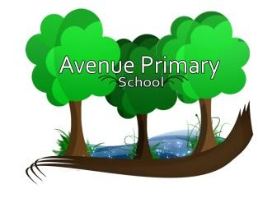

Dear Applicant,
Appointment of Head Teacher
We are pleased that you have expressed an interest in applying for the Headship of Avenue Primary
School and look forward to receiving an application from you in due course.
From September 2024, Avenue Primary School will be a three-form entry school. The school is a
maintained school within the London Borough of Newham, serving a multi-ethnic community.
We are seeking to appoint an outward looking, solution focussed, driven and enthusiastic
individual who can continue to inspire and motivate our pupils and staff and understands the
strengths of working in partnership.

As a school we can offer:
- A committed and supportive governing body.
- A highly skilled staff team, dedicated to providing the best for the children, including developing pupil's character, self-esteem, positive learning behaviour etc.
- An emphasis on high standards of academic achievement, by valuing the efforts our children put into their learning.
- A positive working partnership with parents/carers.
- A strong leadership team.
I would encourage you to take the opportunity to visit the school. This will offer you the chance to
see the running of the school, teaching and learning, together with a chance to talk about
operational and strategic arrangements within the school. If you are looking for an opportunity to
support the school to continue its journey of educational success, we will be delighted to hear
from you.
Good luck!
Geetha Unnithan (Mrs)
Chair of Governors

