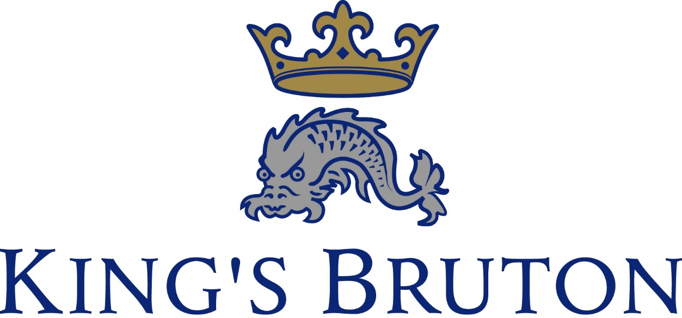

*HMC co-educational boarding school*

*situated in the small Somerset town of Bruton*

Appointment of

**Boarding Housemaster**

For September 2024

**King’s Bruton**

King’s School, Bruton is a co-educational boarding and day school for pupils aged 13 to 18 years.  It is situated in the historic town of Bruton about an hour from Bath, Bristol, Salisbury and Taunton.  There is a train service from Bruton and Castle Cary (First Great Western) and Gillingham, (South West Trains).

The School was founded in 1519 and re-founded, after the dissolution of the monasteries, in 1550.  Girls were admitted for the first time in 1969, initially in the 6th Form, but throughout the School from 1997.  There are currently 360 pupils of which 140 are in the 6th Form.

Pupils come from a wide geographical area in the South-West of England, and across the social spectrum.  King’s is predominately a boarding school with 3 boys’ boarding houses, and 3 girls’ boarding houses.  Over 60% of pupils board with 13% of the intake coming from abroad. Day pupils are fully integrated into boarding houses. Our main feeder school is Hazlegrove Preparatory School, but pupils also come from a number of other preparatory schools as well as a small proportion from the state system.

The School prepares pupils for GCSE, BTEC, EPQ and AS/A level qualifications and the expectation is that leavers will go on to tertiary education.

There is a standard of excellence in a wide variety of extra-curricular activity, including a strong reputation in sport, music and drama.  Pupils participate in the CCF, Duke of Edinburgh Award Scheme and Ten Tors, and there are over 80 weekly activities on offer.

In 2015/16 the school passed its ISI Compliance inspection and in 2018 the school was rated as ‘Good’ and ‘Excellent’ in its ISI Quality Inspection. In 2023 the school passed its ISI Compliance inspection.

Hazlegrove Preparatory School (3-13 years of age, 360 boys and girls) is located some 8 miles south at Sparkford, and is governed under the same Foundation.  King’s Bruton and Hazlegrove offer concessions on fees for the children of teaching and support staff of both schools.

Further details of the School can be found by visiting our website: *www.kingsbruton.com.*

The Post

King’s Bruton is seeking to appoint an energetic, inspirational and committed Housemaster. At King’s there are 186 boys split across three boarding houses, with all 3 houses containing both day and boarding pupils. This vacancy is in Blackford House and presents an exciting opportunity to lead a very successful boarding house of 60 boys (13-18).

The Housemaster will provide a positive family orientated atmosphere in the boarding house and look to provide pupils with the support and encouragement that they require to thrive both at King’s, and beyond. The Housemaster will be a key role model for our boys and should inspire them to achieve in all areas of school life. The Housemaster will be expected to lead a team of academic and resident tutors that aim to deliver exceptional pastoral care and academic support to the boys in the boarding house.

The successful applicant is expected to have a strong background in providing pastoral support, looking to utilise the experience that they have developed to help support the boys in the boarding house. We are looking for a Housemaster that will help to further strengthen the outstanding pastoral support provided to all pupils at King’s.

The successful applicant will be a highly motivated, well organised, dynamic and caring person, that will be willing to commit to the life of a full boarding school. Strong administrative and communication skills will be required to lead and ensure the smooth day-to-day running of the House. You will be expected to commit to the ethos of a full boarding school, contributing to the extra-curricular programme, supporting school events and playing a key role in a very vibrant and supportive community.

All Housemistresses/ Housemasters at King’s also teach a reduced timetable. For this position, all subjects will be considered.

This is a residential role and rent-free family accommodation is provided attached to the boarding house.

The primary responsibility of the Housemaster is to maintain the highest standards of Safeguarding and Child Protection for the students both in their house and across the school, whilst fostering and promoting the welfare of pupils.

Housemistresses/ Housemasters (HsMs) post involves the following:

# •



•



•



•



•



•



•



* Ensure the completion of full termly reports, references, and UCAS applications. References should be fairly written, giving all relevant information; reports should be positive with as much encouragement as possible.
* Have overall responsibility for the academic progress of their pupils, so that they move towards the appropriate courses at GCSE, BTEC, A level and then to university/ HE/ apprenticeships etc.
* Have overall responsibility for the pastoral care of their pupils. They should be available to all pupils in their Houses for help and guidance, be it academic, social or personal.
* Keep clear, well-sorted records of all pupils; these include assessments, reports, letters/ e-mails from parents and prep schools, and occasional notes that may have importance in the future.
* Take responsibility for the tidiness of their House, see that the buildings and furniture are properly cared for, ensure that breakages and faults are reported promptly to the Estates Manager, and encourage their pupils to treat school as well as personal property with care and respect.
* Support their pupils at school assemblies, services, concerts, plays and sporting events whenever possible. House roll-calls should be held to give pupils information and guidance at appropriate times in the week.
* Be responsible for planning and managing annual house budgets (for miscellaneous improvements and running costs beneficial to their students), as well as formulating proposals for a House Development Plan.
* Be responsible for financial controls in their House, and for organising a House Bank.
* Monitor the activities of their pupils throughout the week, but especially at weekends.
* Ensure that the Matron is kept well informed about school life. Also, HsMs should liaise carefully with the Health Centre staff and the School Doctors over medical matters concerning their pupils.
* Manage the arrangements put in place for the beginning and end of term, fixed exeat weekends and for half-term.
* See that any requirements relating to National Legislation are strictly adhered to (eg NMS, KCS etc).
* Promptly report incidents that need to be brought to the attention of the Headmaster/ Deputy Heads.
* Set high standards of personal behaviour and manners, and expect these from all pupils.
* Assist in the recruitment of pupils to the school by showing prospective parents round their House and discussing domestic and educational matters with them.

**The successful candidate should ideally be:**

* Hard working and fully committed to the ethos of a seven day a week boarding school;
* Someone who has high expectations of their pupils, but at the same time fully appreciates the need to provide encouragement and support to pupils of all abilities;
* Someone who appreciates and applauds success and development in all areas of school life, not just in the Boarding House;
* Capable of working with staff from all areas of school life;
* Enthusiastic and willing to try new ideas and take responsibility for new initiatives.

It is hoped that the person appointed will be a friend, guide and philosopher to pupils, as well having a genuine love of supporting pupils within the Boarding House.

**Other Duties**

King’s Bruton expects its teachers to contribute to all aspects of school life by drawing upon their own interests and enthusiasms. The richness of the school depends upon teachers who, for example, coach games, direct plays, support and organize society meetings, and take pupils on trips. A full, seven-day-a-week boarding school such as King’s must look after and cater for the pupils entrusted to it after school and at weekends. Applicants should be aware that King’s teaches on Saturday mornings and expects teachers to participate enthusiastically in the activities programme offered to pupils after school and at weekends, including sport, art, music, social events, chapel services and weekend trips locally.

**Safeguarding and the Welfare of Children**

King’s School, Bruton, is totally committed to safeguarding and promoting the welfare of children. The school has a range of policies and procedures for child protection and security. All staff at King’s are expected to understand and follow all of these policies and procedures as part of their professional responsibilities.

During the interview process, candidates should expect to be questioned about issues that are relevant to safeguarding children. Candidates should also be aware that referees will be asked to comment on a candidate’s disciplinary record and whether or not the candidate has been the subject of any child protection concerns.

The successful candidate will be subject to an enhanced DBS (Disclosure and Barring Service) disclosure and other vetting checks suitable to the post.

**Applications**

Letters of applications, together with a completed application form and Curriculum Vitae should be sent to the HR Department at King’s Bruton [**recruitment@kingsbruton.com**](mailto:recruitment@kingsbruton.com)by 12 noon on Wednesday 11th October 2023. Interviews are expected to take place during the week commencing Monday 16th October 2023.

Applicants are invited to contact the Headmaster, Mr I S Wilmshurst, if they wish to discuss details of the post.