

Raising Standards – Developing Excellence

Application Pack for the Director of Music
December 2017

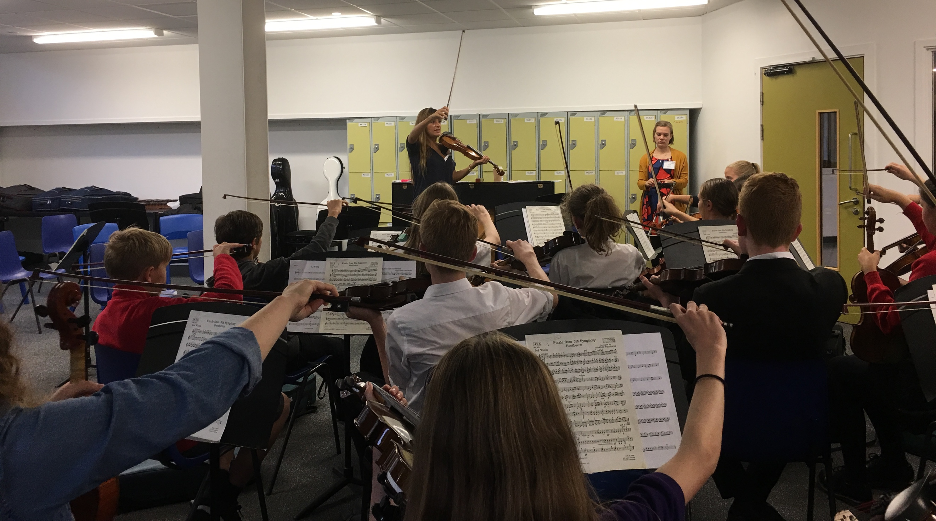

Patron – Nicola Benedetti

Number of schools on the programme:  11  Number of students on the programme  3600  Location of programme schools:  London  Closing date:  Wednesday 11 December 2018 at Midday  Interviews:  Held during December  Start Date:  April 2018   | MiSST Director of Music  Full Time  L1 – L5  £46818 – £50 906  The Music in Secondary Schools Trust was launched in April 2013. With 11 partner schools currently in London, the programme has reached almost 5,000 teenagers, providing classical instruments and 3 years of group tuition. The charity also runs a Saturday Music School, an annual concert and a music residential.  The Trustees are looking to appoint a successful music teacher who is strong leader and passionate about the power of music, within education, to be transformative for individuals and communities.  If you would like to discuss the role, please email:  truda@misst.org.uk  The Music in Secondary Schools Trust is committed to safeguarding and promoting the welfare of students. Successful applicants will be required to undergo a Disclosure and Barring Service (formerly CRB) check. All partner schools operate a non- smoking policy  Charity number: 1151662  Registered address: 320 City Road, London EC1V 2NZ

Letter from Truda White CEO of MiSST

MiSST
320 City Road
London
EC1V 2NZ
28 November 2017

Dear Candidate

MiSST Director of Music

Thank you very much for indicating you would be interested in becoming the MiSST Director of Music.

Our charity has its roots in the very successful music programme that was developed over a number of years at Highbury Grove School. MiSST was launched in 2013 and the aim was to roll the programme out to other schools by providing funding to buy classical instruments and enhance staff so that students were guaranteed a minimum of 3 years of group tuition. Since 2013, the numbers on the programme and the reach has been extraordinary.

There are currently 3,600 young people on the programme and we have reached more than 5,500.

MiSST is at an exciting point in its development with funding already secured for the next few years and ambitious plans to reach even more young people.

To ensure MiSST continues to develop excellence in all our partner schools, staff appointed need to be exceptional professionals and for this role an accomplished classical musician. A passionate belief in the power of music, within education to be transformative for individuals and communities is essential.

If you would like to discuss the role before submitting an application please feel free to email your mobile number to truda@misst.org.uk and I will call you.

Thank you again for showing an interest in this role.

Best regards

Truda White
CEO MiSST

Contents

Information about MiSST 5
- Number on current programmes
- Key dates for 2017 – 2018

Job Description 8

Person Specification 10

Safeguarding statement 11

How to apply 11
- Application Form 12
- Monitoring Form 19

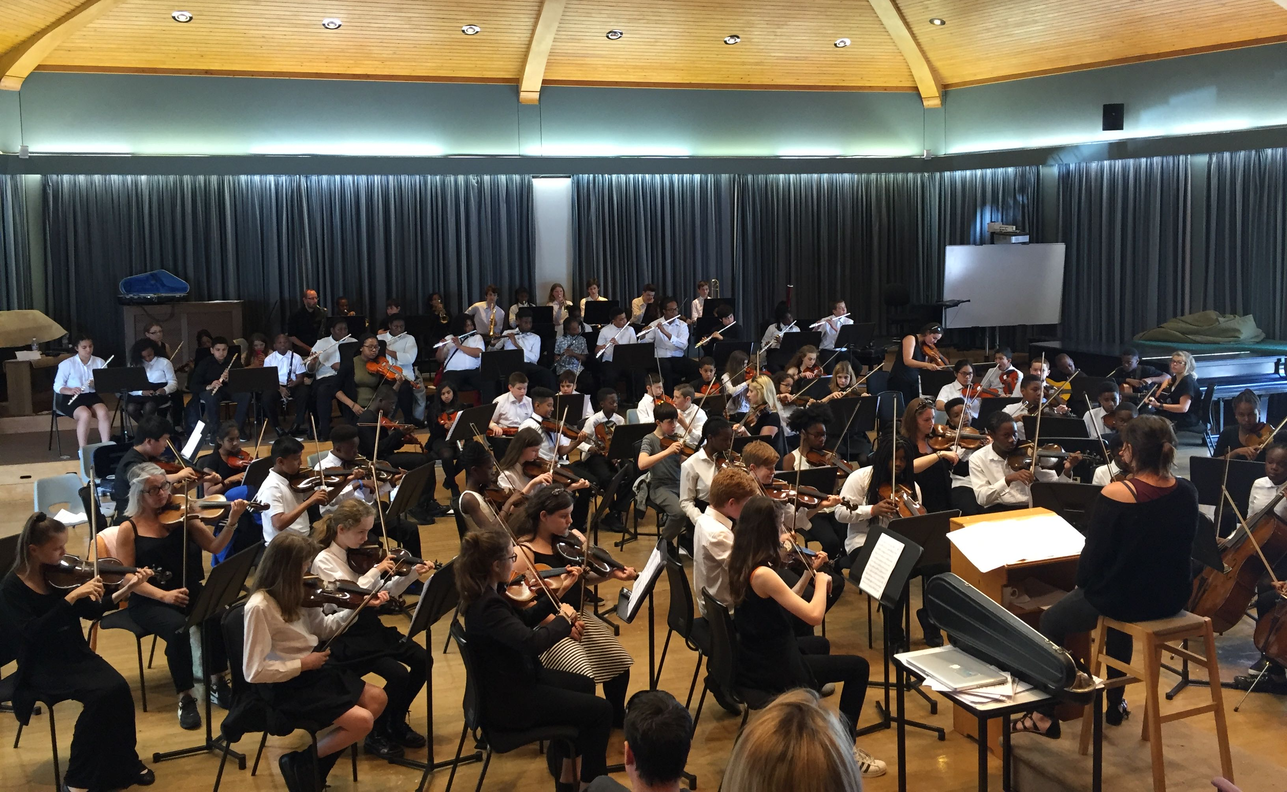

Radley College – MiSST Residency July 2017

MiSST in Numbers for 2017 - 2018

Secondary | KS3 ALWP | KS4 and KS5 | Alumni Y10 and Y11
Highbury Grove | 630 | 35 | 420
Lister | 750 | 30 | 500
Frederick Bremer | 540 | 30 | 180
Sedgehill | 485 | 20 | 200
AMSI | 0 |  | 350
Mount Carmel | 200 |  | 70
SMMA | 550
Holloway | 280
Whitefield | 150
Samuel Rhodes | 10
Sub Total | 3595 | 115 | 1720
Primary | KS2 | Alumni School
NNA | 120 | AMSI - Ensemble | 30
Sub Total | 120 | Sub Total | 30
Grand Total | 5580

MiSST Saturday Music School Orchestras

MiSST Orchestra 35
MiSST Chamber Orchestra 18
Radley Reunion Orchestra 40

MiSST Student Leader Programme 12

Radley Residential School 240

Key Dates in 2017 – 2018
21 22 23 September 2017 3 x 3 hour workshops with Nicola Benedetti
25 November 2017 MiSST and PICO orchestra – Side by Side
1 - 3 December 2017 MiSST 3-day Leadership Training – Outward Bound, Ullswater
17 January 2018 Brewers’ Livery Company visit to observe MiSST@Islington
23 April 2018 MiSST’s 5th Anniversary Concert @ the London Palladium
10 – 19 July 2018 3 x 4-day residential music schools @ Radley College, Oxford

Further Information

MiSST Music Curriculum
Key Stage 3
The MiSST KS3 programme called the Andrew Lloyd Webber Programme is built around solo performance, ensemble work, improvisation and composition. Music theory is integrated into the teaching.

All students are assessed at the end of the Autumn Term on solo performance. The data gathered helps schools and MiSST track progress and underachievement. In additional all students sit a Listening, Analysis and Theory (LAT) paper. The assessments have been matched as far as is possible at this stage to the revised GCSE grades of 9 – 1.

Additional Support for KS4 and KS5
MiSST Directors of Music who work in schools to support the programme and staff also advise, if appropriate on GCSE.

Currently 3 MiSST schools are part of a composing project, which began in 2016 and has raised the standard considerably of this element within the GCSE and A Level

MiSST Saturday School
The MiSST Saturday School began in September 2016, with the aim of developing the higher attainer from MiSST schools and those musicians identified as gifted and able. Currently students attend from 6 MiSST schools.

In 2016 – 2017 the standard set was a minimum of Grade 3 and there we 30 regular attenders.

This academic year the criteria for attendance has been widened in order to increase the diversity of the orchestra. As a result, MiSST is now running both a MiSST Orchestra and a Chamber Orchestra

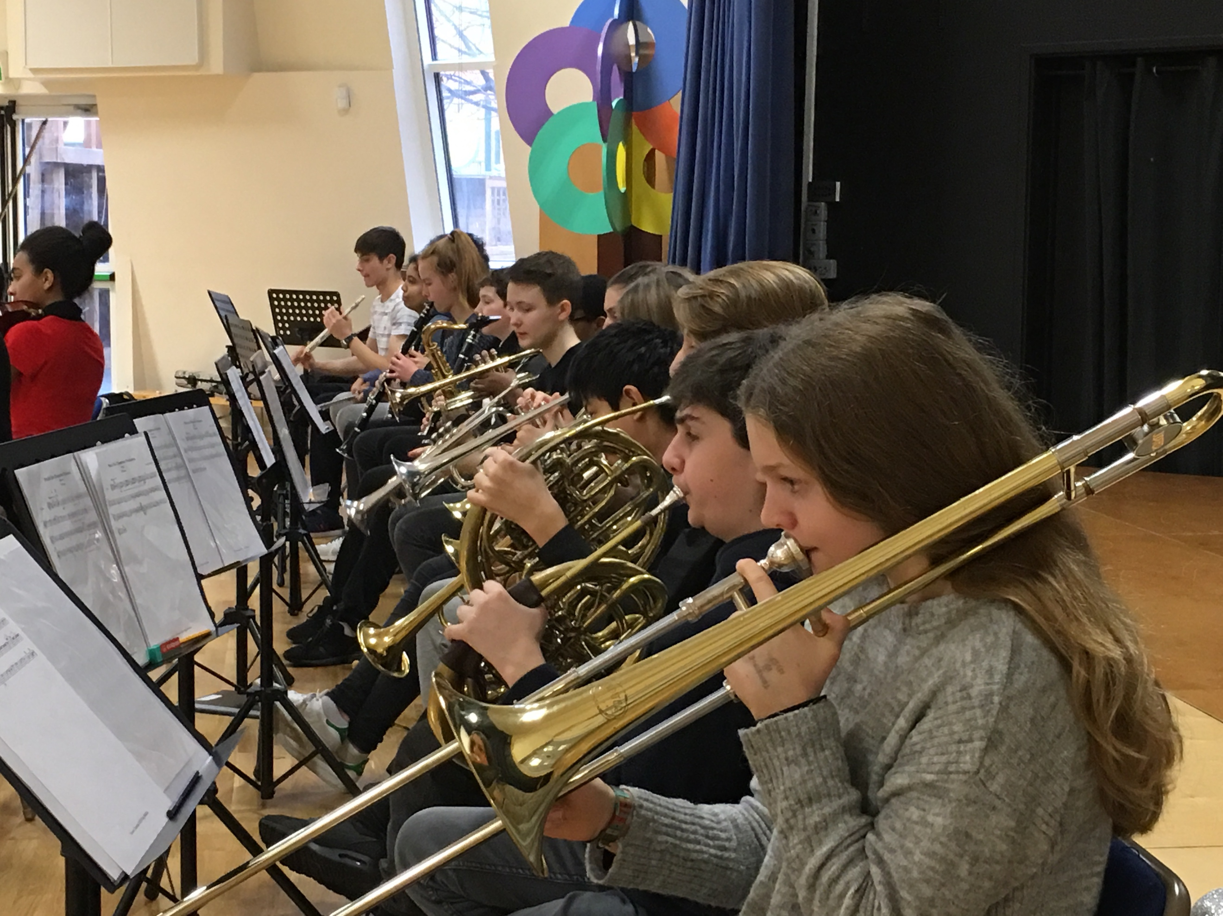

Saturday Music School – New North Academy December 2016

MiSST Residential School – Radley 2015 – 2017
In July, over the last 3 years students from each MiSST school have had the opportunity to spend 3 nights and 4 days at Radley College for an intensive music residency. To date, 250 students have benefitted from the experience.

Evaluations have shown a number of very positive outcomes from this, including musical progress after 6 months being double that of comparable students within each school.

CME Training 2016 – 2018
MiSST currently runs the Certificate for Music Educators in partnership with ABRSM for peripatetic staff who work in MiSST schools. The course covers important aspects of teaching groups in order to improve further the quality of classroom teaching

Fundraising for Centre Point
In January 2017, the Saturday Music School students undertook additional practice for which they were sponsored. This culminated in a ‘Sleep-Out’ for Centre point. £2500 was raised by the students for this charity.

Concerts 2015 – 2017
Each year MiSST holds and annual concert to enable young people to have a platform for performance. To date concerts have been held at the Barbican, Goldsmiths University and LSO St Luke’s. Each year the repertoire has been more challenging as the level of musical skill increases.



Deronne White Rehearsal for the Barbican Concert 2015

Job Description

Job Title: Director of Music
Responsible to: CEO
Responsible for: Leadership and implementation of the MiSST programmes in partner schools and programmes run as part of MiSST’s Pathway to Excellence
Salary Scale 2017 – 2018: L1 – L5 £46818 – £50 906
Start Date: 16 April 2018
Full Time: London based

In a time of rapid change job descriptions cannot be prescriptive. It may be that some alteration is necessary as circumstances dictate and new needs arise.

You are required to carry out your duties in accordance with the current School Teachers’ Pay and Conditions Document. In addition, you will carry out all aspects of the following job description.

Purpose of the job
- To lead on all aspects of the curriculum – teaching, learning and assessment - and ensure the implementation of agreed programmes intended to raise musical outcomes
- To lead and line manage other staff who work directly in MiSST schools to support the development of music and improving standards
- To lead an agreed orchestra and ensure they are well rehearsed and at performance standard
- To work as part of the MiSST team to lead and support aspects of the professional development programme
- To lead on and manage the relationship with agreed external partners
- To continue to teach music in an agreed school to ensure professional practice is maintained and developed

Specific Responsibilities
- Curriculum Leadership
  - To provide curriculum leadership which takes into account models of good practice in the teaching of instrumental playing through group tuition
  - To use the above to keep under review the MiSST curriculum and work with schools to develop this
  - To work with other MiSST and school staff to develop additional curriculum models which ensure opportunities for gifted and able as well as high attaining musicians to make rapid progress and achieve exceptional outcomes
  - To ensure resources are devised, developed or purchased in order to deliver agreed schemes of work
  - To build into any curriculum models assessment points to measure student progress
  - To ensure that all assessment data is entered and analysed with impact reports written
  - To visit other MiSST schools on an agreed basis to further support the music department

- In school support
  - To work with the Head of Music in agreed schools to ensure a clear understanding of the programme
  - To support the implementation of the programme by ensuring each partner school has the necessary musical instruments and appropriately qualified staff to work with students
  - To ensure that on a weekly basis the agreed programme is being delivered during music lessons
  - To work with the Head of Music and other senior leaders to develop an enhanced music provision for students who are motivated and show musical potential
  - To support schools in developing ensemble groups, choirs and an orchestra

  - To keep agreed a record of visits and conversations which will form the basis of feedback to the MiSST team
  - To keep the CEO informed of any issues that occur within your schools which may have a direct bearing on the work of MiSST

- Staff development
  - To support the review and development of the MiSST professional development programme
  - To lead agreed aspects of training
  - To support staff in your schools as required

- Staff and Relationship Management
  - To support the Deputy Director of Music and any MiSST consultants who work in schools on a weekly basis, according to their needs
  - To ensure staff who work directly in school are familiar with the curriculum and the appropriate assessment instruments at timely points during the academic year
  - To work with the MiSST team to support staff through discussion and problem solving
  - To build positive and appropriate relationships with school music staff and senior leaders

- Orchestras and Ensembles
  - To lead an agreed Orchestra, ensuring that the standard reached for performance is high
  - To attend additional rehearsals within school time and after school hours as required
  - To lead if appropriate an in-school ensemble at an agreed school

- Partner Relationships
  - To lead on agreed relationships with external partners that have a direct link to students and the work in schools
  - To meet with key personnel from our partner organisations to plan the activity/workshops/residential within the parameters set and any agreed budget
  - To work closely with the Executive Administrator ensuring all administrative elements are covered
  - To ensure that the appropriate MiSST staff are kept appraised of plans and any role they need to play in order to make the activity / workshop a success
  - To evaluate as agreed the outcomes and impact of this work

- School Performances and MiSST Concert
  - To ensure that each of your agreed schools has a published performance calendar which includes year group assemblies as well as showcase performances throughout the academic year
  - To work with other MiSST staff to ensure the annual concert and other performance opportunities are of a high standard musically
  - To lead on key elements as required to ensure MiSST concerts are successful

- Administration
  - To keep agreed records in relation to visits, records of conversations and specific support given to schools and individuals
  - To ensure all aspects of data administration, with regards to student progress, are covered

- Other
  - To undertake other tasks that would be considered reasonable within the remit of this role
  - To work at all times to further the aims of the MiSST
  - To operate within all agreed policies of MiSST and the partner schools

Job Description Director of Music 24 11 17

Person Specification

1. Qualification and Experience Essential/Desirable Method of Assessment

  - Qualified to degree level E Certificate(s)
  - Qualified teacher E Certificate
  - Experience of being a successful middle
leader and music teacher in a secondary school E Application Form/Letter
  - Formal, high level music qualification E Application Form

2. Knowledge, Experiences, Skills and Abilities
2.1 Up to date knowledge and understanding of
pedagogy in relation to secondary music teaching E Interview Activity
2.2 Strong classroom management skills E Interview Activity
2.3 Successful experience of leading other professions
and achieving successful outcomes E Letter of Application
2.4 Strong interpersonal skills and high level of
communication skill, orally and written, along
with inspiring presentational and advocacy
skills E Letter / Interview
2.5 High level of decision making skills E Interview Activity
2.6 Innovative and independent problem solver E Interview Activity
2.7 Strong interpersonal skills and high level of
emotional intelligence E Interview Activity

3. Personal Attributes and Qualities
3.1 Ability to work independently and engage in
cooperative working to help the team achieve
its goals E Interview Activity
3.2 Ability to use authority to positively enhance
outcomes for students E Interview Activity
3.3 Ability to set and maintain the highest
standard of professional relationship and
behaviour with staff and partners E Interview Activity

Person Specification MiSST Director of Music 24 11 17

MiSST safeguarding statement

MiSST is committed to safeguarding and promoting the welfare of children and young people and expects all staff and volunteers to share this commitment. The recruitment process will include an enhanced DBS check, confirmation of right to work in the UK and all other pre-employments checks in line with safer recruitment requirements.

How to apply for the position

Complete the enclosed application and monitoring form
Include a letter which is no more than 2 sides of A4, font size 12 which addresses the following:
- Why you believe you are suited to leading the next phase of MiSST’s development
- 3 things you would want to achieve in the next 2 – 3 years and how you would measure the impact
- How your experience and skills match the following in the person specification:
1.3 Experience as a successful middle leader
2.1 Leadership experience in developing operational plans, change and delivery management

Send to truda@misst.org.uk by midday on Monday 11 December 2017. Interviews will be held shortly afterwards.

Internal use only

Ref No 3. Director of Music

Date Received ___________

Patron: Nicola Benedetti

Employment Application Form
The Trustees of MiSST are committed to safeguarding and promoting the welfare of children
and young people and expects all staff and volunteers to share this commitment.

Please ensure that you complete all sections of Part 1 and Part 2 of the application. Please note that providing false information will result in the application being rejected, or withdrawal of any offer of employment, or summary dismissal if you are in post, and possible referral to the police. Please note that checks may be carried out to verify the contents of your application form. Please complete the form in black ink. CV’s are not accepted.

Vacancy Job Title | MiSST Deputy Chief Executive Officer

Part 1. INFORMATION FOR SHORTLISTING AND INTERVIEWING

Initials: Surname or Family name: ____________________________

2. LETTER OF APPLICATION Please enclose a letter of application. Please refer to the applicant information pack
which may include instructions on completion of the letter of application.

3. PRESENT / LAST APPOINTMENT:

Name, address and telephone number of school
1 Type of school (if teaching) | Boys Girls Mixed Age range Number on Roll
2 Type of school (if teaching) | e.g. Community, Aided, Foundation, Academy, Free School, Independent etc
Job title Please enclose a copy of your current job description
Subjects/age groups taught or description of your current role and responsibilities
Date appointed to current post
Current salary
Date available to begin new job

4. FULL CHRONOLOGICAL HISTORY Please provide a full history in chronological order since leaving secondary education, including periods of any post-secondary education/training, and part-time and voluntary work as well as full time employment, with start and end dates, explanations for periods not in employment or education/training, and reasons for leaving employment.

Job Title | Name and address of school, | Number | F/T  or P/T | Dates |  |  |  |  | Reason
or Position | other employer, or description of activity | on roll and type of school, if | F/T  or P/T | From |  | To |  |  | for  leaving
 |  | applicable | F/T  or P/T | Mth | Yr |  | Mth | Yr
1

2

3

4

5

6

Please enclose a continuation sheet if necessary

5. SECONDARY EDUCATION & QUALIFICATIONS
Name of School/College | From | To | Qualifications Gained with Date

6. HIGHER EDUCATION
Names and Addresses of University or College and/or University Education Department | Dates  From To | Full or Part-time | Courses/subjects taken and Passed | Date of Examination and  Qualifications Obtained | Age Groups for which Trained

7. PROFFESSIONAL QUALIFICATIONS

Names and Addresses of Awarding Institution | Dates  From To | Full or Part-time | Courses/subjects taken and Passed | Date of Examination and  Qualifications Obtained | Age Groups for which Trained

8. PROFESSIONAL COURSES ATTENDED Please list relevant courses attended in the past 3 years.

Subject | Organising Body | Date(s) | Duration

9. OTHER RELEVANT EXPERIENCE,
INTERESTS AND SKILLS

10. REFEREES
Give here details of two people to whom reference may be made. The first referee should normally be your present or most recent headteacher or equivalent person. If you are not currently working with children please provide a referee from your most recent employment involving children. Referees will be asked about disciplinary offences relating to children, which may include any in which the penalty is “time expired” and whether you have been the subject of any child protection concerns, and if so, the outcome of any enquiry or disciplinary procedure. References will not be accepted from relatives or from people writing solely in the capacity of friends.

First referee
Title and Name
Address and post code
Telephone number
Email address
Job Title
Relationship to applicant

Second referee
Title and Name
Address and post code
Telephone number
Email address
Job Title
Relationship to applicant

Part 2 Internal Ref No._______
This section will be separated from Part 1 on receipt. Relevant contents may be verified prior to shortlisting but will not then be used for selection purposes.

11. PERSONAL INFORMATION
- Surname or family name
- All previous surnames
- All forenames
- Title
- Current Address
- Postcode
- Resident at this address since
- Home telephone number
- Mobile telephone number
- Date of birth
- Email address
- DfE reference number
- National Insurance Number
- Did you qualify as a teacher after May 1999? | If Yes, in which school was induction completed?
- Have you ever been subject to a child protection investigation by your employer or the General Teaching Council or Independent Safeguarding Authority? | If YES please state separately under confidential cover the circumstances and the outcome including any orders or conditions.
- Are you subject to any legal restrictions in respect of your employment in the UK? | If YES please provide details separately
- Do you require a work permit? | If YES please provide details separately
- Do you have a current full driving licence?
20. Are you related to or have a close personal relationship with any pupil, employee, or governor? | If YES give details separately under confidential cover
21. NQTs ONLY:
Have you provided evidence of passing the Skills Tests? Please tick or cross
22. Are there any special arrangements which we can make for you if you are called for an interview and/or work based assessment? | No  If Yes please specify, (e.g. ground floor venue, sign language, interpreter, audiotape etc).
12. COMPULSORY DECLARATION OF ANY CONVICTIONS, CAUTIONS OR REPRIMANDS, WARNINGS OR BIND-OVERS

Jobs in schools are exempt from the provisions of Section 4(2) of the Rehabilitation of Offenders Act 1974. You must therefore declare, whether spent or not, any convictions, cautions or reprimands, warnings or bind-overs which you have ever had and give details of the offences. The fact that you have a criminal record will not necessarily debar you for consideration for this appointment.

Do you have any convictions, cautions or reprimands, warnings or bind-overs?
Please tick the relevant box

Yes No

If the answer is "yes", you must record full details in a separate, sealed envelope marked with your name and 'Confidential: Criminal Record Declaration' and enclose it with your application. In accordance with statutory requirements, an offer of employment will be subject to satisfactory DBS clearance. A copy of this notice will be sent to your referees.

13. DATA PROTECTION ACT 1998

The information collected on this form will be used in compliance with the Data Protection Act 1998. By supplying information, you are giving your consent to the information being processed for all employment purposes as defined in the Data Protection Act 1998. The information may be disclosed, as appropriate, to the governors, to Occupational Health, to the Teachers Pensions Agency, to the Department for Education, to pension, payroll and personnel providers and relevant statutory bodies. You should also note that checks may be made to verify the information provided and may also be used to prevent and/or detect fraud. This form will be kept strictly confidential but may be photocopied and may be transmitted electronically for use by those entitled to see the information as part of the recruitment process. When the recruitment process is completed, the form will be stored for a maximum of six months then destroyed. If you are employed as a result of this recruitment process then this application form will be retained as part of your personnel record.

14. NOTES

a) When completed, this form should be returned in accordance with the instruction in the advertisement for the job or in the applicant’s information pack.
b) Canvassing, directly or indirectly, an employee or governor will disqualify the application.
c) Candidates recommended for appointment will be required to complete a pre-employment medical questionnaire and may be required to undergo a medical examination.
.
15. DECLARATION

I certify that, to the best of my knowledge and belief, all particulars included in my application are correct. I understand and accept that providing false information will result in my application being rejected or withdrawal of any offer of employment, or summary dismissal if I am in post, and possible referral to the police. I understand and accept that the information I have provided may be used in accordance with paragraph 13 above, and in particular that checks may be carried out to verify the contents of my application form

Signature of Applicant Date

Print Name

PART 3 EQUALITY AND DIVERSITY MONITORING

This section will be separated from part 1 and part 2. Collection of equality information is solely for monitoring purposes to ensure that our policies and procedures are effective. We also collect this data in accordance with the general and specific public sector equality duties under the Equality Act 2010. Any data you enter onto this monitoring form will only be used for monitoring purposes and will not be used in assessing and or scoring your application or during the interview process. This information is kept fully confidential and access is strictly limited in accordance with the Data Protection Act.

Ethnic Group
Workforce
Census Code Please tick
White | WBRI | British English Welsh Northern Irish Scottish
White | WIRI | Irish
White | OOTH | Irish Traveller
White | OOTH | Gypsy
White | WOTH | Other White background
Mixed | MWBC | White and Black Caribbean
Mixed | MWBA | White and Black African
Mixed | MWAS | White and Asian
Mixed | MOTH | Other Mixed background
Asian  or Asian British | AIND | Indian
Asian  or Asian British | APKN | Pakistani
Asian  or Asian British | ABAN | Bangladeshi
Asian  or Asian British | CHNE | Chinese
Asian  or Asian British | AOTH | Other Asian background
Black or Black British | BCRB | Caribbean
Black or Black British | BAFR | African
Black or Black British | BOTH | Other Black background
Other ethnic group | OOTH | Arab
Other ethnic group |  | Write in:
Prefer not to say | REFU

Religion Disability Please tick Do you consider that you have a disability? Please tick
No religion
Christian (including Church of England, Catholic, Protestant and all other Christian denominations)
Buddhist
Hindu
Jewish
Muslim
Sikh
Any other religion write in
Prefer not to say

Yes Please complete the grid below
No
Prefer not to say
My disability is: Please tick
Physical Impairment
Sensory Impairment
Mental Health Condition
Learning Disability/ Difficulty
Long standing illness
Other
Prefer not to say

Sexual Orientation Please tick

Bi-sexual
Gay
Lesbian
Heterosexual
Other
Prefer not to say

Gender Please tick
Female
Male
Transgender
Prefer not to say

Single
Living together
Married
Civil Partnership
Prefer not to say

