Therefore, choose
St Michael’s Church of England High School
A Church of England Academy

Growing in Body, Mind and Spirit

Finance Manager
Candidate Information

Thank you for your interest in the position of Finance Manager currently being advertised at St Michael’s CE High School, a Church of England Academy.
Letter from the Headteacher

St Michael’s is a special place to learn and work with a strong Christian identity. Our mission statement is:
As a vibrant learning community
we choose to serve God
pursue excellence
and
celebrate the uniqueness of each individual
We aim to achieve this mission through a Christian learning experience which focuses on opportunities for growth in body, mind and spirit:-
Where the safety, happiness and wellbeing of pupils are paramount. Where every child matters and more crucially, know that they matter.
Body

High expectations and aspirations in all areas of school life create a disciplined and ordered learning environment where creativity, passion and enthusiasm help to engender a life-long love of learning and secure excellent pupil outcomes.

Mind

Where pupils are supported to find for themselves the person that God wants them to be and really experience the joy and hope of ‘life in all its fullness’.
Spirit

As a thriving, oversubscribed Church of England Academy within the Diocese of Blackburn, our values are rooted in the Christian faith. Serving God, pursuing excellence and celebrating the uniqueness of each individual are at the heart of our distinctive ethos as we strive to ‘be the best that we can be’. We create and sustain our caring Christian community by encouraging positive supporting relationships based on Christian values and striking a genuine balance between the highest academic standards and opportunities for personal growth.
Worship is at the centre of our school life and is usually led by various staff, the Christian Youth Worker and/or pupils, with occasional support from local clergy or visitors. The school Chapel Choir (Hughes Tutorial) and the school Worship Band are regularly involved in worship helping to create a contemporary vibrant experience. Each day begins with a year group worship, assemblies and school prayers. In addition we hold Eucharist services in the school chapel throughout the year both at the start of the day and at lunchtimes. These services are led by various members of the local clergy who are always willing to support the school.
The chapel in the magnificent Armstrong Centre is also used for staff prayers and reflections which take place at the start of each working week. We hope that the school’s distinctive Christian ethos shines through in all aspects of our life and work here. We have numerous student leadership roles within school and an active charities committee. Each year group within school is linked to a particular charity.

All staff take responsibility for behaviour and wellbeing around school on a day to day basis and model the qualities and Christian values we believe are important for self- worth, respect, responsibility and stewardship.
St Michael’s has been in the top 10% of non - selective schools nationally for attainment for the last five years. In 2018 91% of pupils achieved 5+ 9 – 4 (A*-C) grades including English and mathematics and 74% at grade 9-5. Progress of pupils was well above average in 2018, with a Progress 8 measure of 0.58. However, we are not complacent and remain ambitious for further success and the opportunities these results will provide for our pupils.
We want all at St Michael’s to ‘be the best that they can be’. We are confident that our pupils are provided with a rigorous and productive learning environment where they are both challenged and supported. We have talented, dedicated, caring and dynamic staff who are willing to develop innovative approaches to learning and teaching for our young people, provide outstanding care and guidance and support our distinctive Christian ethos.
This is an exciting time to join our ‘Finance hub’ as we also seek to appoint a new Chief Finance Officer and Business Director. The position arises due to the forthcoming retirement of our dedicated and long serving finance assistant.
St Michael’s is currently financially secure as an academy, providing ‘good value for money’, with a budget of over £5 million, a staff of over 100 employees and a pupil admission number of 1125.

I hope the information provided on our website gives you a clear flavour of our ethos, of what to expect at St Michael’s and also helps you to prepare for the application process.
I look forward to receiving your application.
Yours sincerely
Jayne Jenks
Mrs Jayne Jenks
Headteacher

Information about the RE Department Department

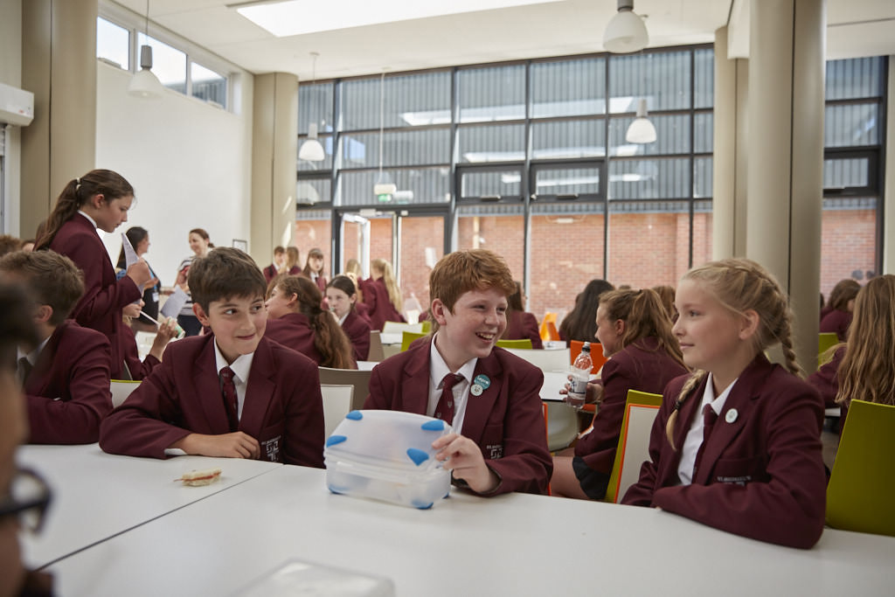
Letter from the Governors

Thank you for requesting details for the post of Finance Manager at St Michael’s Church of England High School.

Most of the information you will need is displayed on the school website. However, the governors are proud to emphasise the ‘excellent’ SIAMS inspection in November 2018. This was achieved by a whole school community approach of teachers, support staff, pupils, parents, carers and governors working together.

The strong academic, sport, and performing arts record is supported by the active Christian ethos apparent throughout the school; providing the opportunity for pupils to grow in body, mind and spirit. Staff focus on continually raising attainment, encouraged by inspiring, forward thinking leadership and management.

The governors will expect the successful applicant to become a full and active member of ‘Team St Michael’s’ and to support our distinctive Christian ethos.

Thank you for your interest and I look forward to hearing from you.

Yours sincerely

Mr C M Metcalfe
Chair of Governors
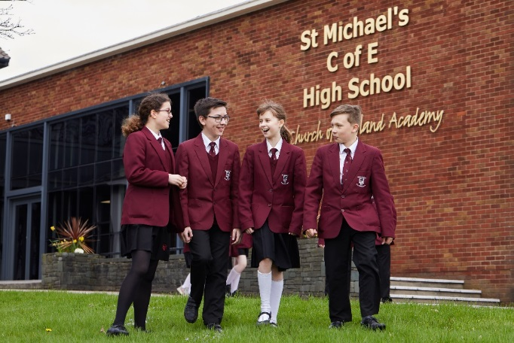
We appreciate your interest in the role of Finance Manager at St Michael’s Church of England High School. St Michael’s is an outstanding school with exceptionally high standards, allowing pupils to develop both academically, physically, spiritually and socially.
‘Team St Michael’s’ is a significant phrase used within our school life. The ‘team’ encompasses parents, pupils, staff and governors, who all work closely together allowing pupils to, “be the best that they can be”. This ‘team’ helps create a strong pupil teacher relationship which is necessary to create mutual respect and a sense of community. Exceptional examination results already demonstrate that this is in place.
Christianity is at the heart of all that happens at St Michael’s. ‘Growing in body, mind and spirit’ is the school’s philosophy and this can be seen throughout school. At St Michael’s, pupils’ faith in Christianity is developed and encouraged. Each year group has a weekly worship, tutorial worship and prayers every morning and Christian values are embedded within lessons, helping to produce a compassionate environment.

St Michael’s Church of England High School really is a fantastic place to learn. Pupils experience engaging and productive lessons, which challenge and support us.
‘Celebrating the uniqueness of each individual’ is another key focus, which is already well integrated into school life. We hope the member of staff appointed will be passionate and enthusiastic and willing to go the extra mile to support us in all that we do.

Yours sincerely
Ellie and George
(Head Boy and Head Girl 2018- 2019)

Head Girl and Head Boy Letter of Welcome

Finance Manager
Required as soon as possible
Permanent 37 hours per week- All Year Round
Grade 6 spine point 11-19 (£21,166 to £24, 799) with the possibility of Grade 7 spine point 19-25 (£24,799 - £28,785) for a suitably experienced/ qualified candidate.
Applicants are asked to provide a fully completed application form and a supporting letter (no longer than 2 sides of A4 in length in Arial point 12) that clearly sets out how your
experience to date prepares you for the advertised post (with reference to the enclosed
person specification).

Closing date for the receipt of completed applications: 9am Wednesday 17 April

Interviews: Friday 26 April

Applications should be returned by email to: vacancies@saint-michaels.lancs.sch.uk

Applicants will be asked to produce original certificates for all education qualifications stated in the application form prior to the appointment being confirmed. All appropriate safeguarding and attendance at work checks will be requested.

Application: Supplementary Information
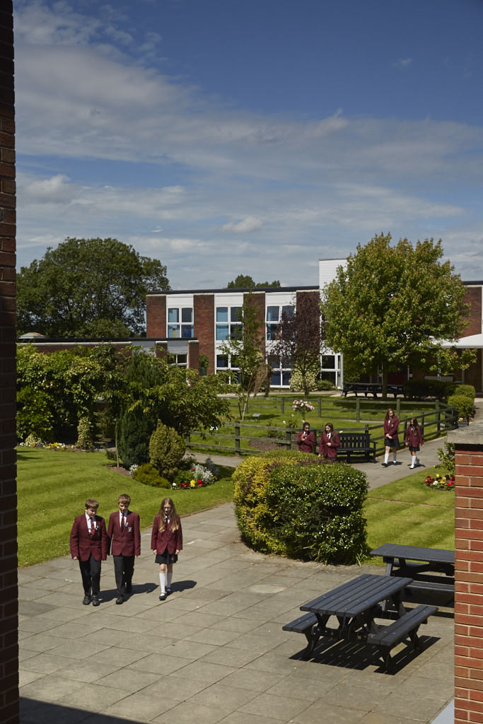
The applicant will be required to safeguard and promote
Person Specification/Selection Criteria
Finance Manager
the welfare of children and young people and be faithful to the trust deed.
Note: Candidates failing to meet any of the essential criteria will automatically be excluded
Section A Qualifications, Experience and Professional Development
Training, Qualifications and Experience
5 GCSEs at C or above or equivalent, including Maths and English | E | A
Educated to GCE A level or equivalent | D | A
Educated to Degree level or equivalent | D | A
NVQ Level 4 or equivalent professional qualification (CIMA, CIPD, CSBM) | D | A
ICT certification to support word processing skills, database and spreadsheet skills | D | A/I
Experience of processing of requisitions, orders, invoices, journals and BACS payments | E | A/I
Substantial experience in management of finance including reconciling of accounts, month end procedures, month end procedures, pre-payments, accruals and year-end accounting practices | E | A/I
Five years relevant experience in finance, personnel or administrative management | D | A/I
Previous experience in computerised finance, pay, personnel and administrative systems | E | A
Experience in the SIMS computerised packages commonly used in schools | D | A
Willingness and motivation to develop own skills. | E | A/I
Experience of working with children/young people within an education setting | D | A/I
Section B Professional Knowledge, Skills and Understanding
Ability to organise one’s own work, to prioritise tasks and keep to deadlines | E | A/I
Ability to manage the financial resources of the school to best practice standards | E | A/I
Excellent listening and interpersonal skills with an ability to communicate/engage with a range of stakeholders | E | A/I
Ability to manage the information and data requirements of the school and a variety of outside agencies | E | A/I
Ability to utilise a variety of ICT systems | D | I
Ability to write effectively for a variety of different audiences | E | A/I
Ability to work flexibly and under pressure | E | A/I
Meticulous and methodical in approach | E | A/I
Commitment to undertake in-service training | E | A/I
Section B Professional Knowledge, Skills and Understanding continued…

Thorough understanding and knowledge of financial and accounting procedures | E | A/I
Ability to demonstrate a commitment to the Equal Opportunities policies in practical terms in the context of service delivery, employment issues and commitment to customer care practices | E | I
A thorough understanding of health, safety and security issues in schools | D | A/I
Section C Personal Skills and Attributes

Fully supportive of the Christian ethos of the school | E | A/I
Enhanced DBS Disclosure will be required | E | A/I
Ability to maintain confidentiality and discretion at all times. | E | A/I
Driving licence and car | D | A
Smart appearance in accordance with the school dress code | E | I
Section D: Confidential References and Reports

Positive and supportive faith reference from the priest/minister where the applicant regularly worships | D | R
Positive recommendation from all referees, including current employer | E | R

KEY
E = Essential
D = Desirable
A = Application
I = Interview
R = References

The successful candidate will be joining a highly dedicated and effective ‘Team St Michael’s’ with a commitment to providing excellent support for pupils, to help us continue to raise standards, achievement and enhance wellbeing. The ability to work with the highest levels of confidentiality and professionalism and to relate well to young people, parents and carers and staff are essential for this role.

The role and responsibilities may evolve over time in accordance with the grade of the post. As a vibrant and successful school there are many demands on time, so flexibility and the ability to work under pressure are essential skills for this post; although you will benefit from working alongside supportive colleagues in a well-established support staff team.

This post will involve occasional evening work in support of school events/meetings.

Job Description for Finance Manager

Responsible to: Chief Finance Officer and Business Director

Our mission statement:

As a vibrant learning community we choose to
Serve God
Pursue Excellence
and
Celebrate the uniqueness of each individual

Job Purpose
- To assist the Chief Finance Officer and Business Director in the provision of efficient and effective support services to ensure the academy achieves its stated aims and objectives.
- To assist in the planning, development, and implementation of financial and administrative services within the academy. This will include:
- accounting and financial management
- administrative systems, procedures and services
- personnel and payroll administration
- general academy administration and support to the governing body and its committees and sub committees.

Responsibilities for this post:

- To seek at all times to assist the school in the achievement of its aims, supporting its Church of England foundation.
- To be responsible for the day to day business and financial management of academy resources, ensuring control and coordination of purchasing, orders, invoices, BACS payments and reconciliation.
- To manage the administration of payroll, payroll reconciliation and assist in the preparation of annual returns and other statistical or data returns as required.
- Effective management of the academy financial management software and online payment systems.
- Effective management of the Academies bank accounts and online banking procedures.
- Working with the Chief Finance Officer and Business Director to produce a budget, management and monitoring of the SLA’s and capitation of all cost centres, regularly reporting to department budget holders and Senior Leadership Team and account closing.
- To work with and respond to the requirements of the Auditors at year end and specific times throughout the year, ensuring EFSA returns are completed on time.
- To work with and assist the Chief Finance Officer and Business Director, responding to the audit requirements of the Responsible Officer and the Internal Financial Regulations.
- Work with the Chief Finance Officer and Business Director in identifying and prioritising improvements.
- To assist with home communication systems, income generation activities and promoting and marketing of the academy.
- Arrange the provision, analysis and evaluation of data, detailed reports and information to the Senior Leadership Team, the governing body and outside agencies as required.
- To assist in the procurement process, including securing appropriate service contracts, licences and insurance, liaising with the Network and Resources Manager to ensure the business needs are met.
- To work with the Network and Resources Manager to ensure all premises, ICT, cleaning, catering and grounds maintenance SLA’s are being effectively managed and financial reports received.
- To assist in the preparation of bids for supplementary external funding and sponsorship.
- Work with the Chief Finance Officer and Business Director in creating and updating the Academy policies relating to Business and Finance needs.
- Keep up to date with DfE and other bodies policies relating to business and finance in academies.
- To work with the Network and Resources Manager to ensure the Health and Safety and Safeguarding of all visitors on site.
- To work with the Network and Resources Manager on the management of school lettings ensuring agreements are signed and effective procedures are in place for monitoring and invoicing.
- To be willing to undertake line management duties and complete appraisals with staff on a lower grade if required.
- To ensure the safeguarding of all pupils and staff.
- To ensure compliance with expectations in relation to GDPR and digital usage.
- To attend skill training and participate in professional development as required.
- To attend staff training/meetings as appropriate.
- To be aware of the confidential nature of financial matters.
- To support the distinctive Christian ethos of the school.

Individuals in this role may also have to:

- Attend governors meetings, Senior Leadership Team Meetings and/or advise as appropriate.
- Be willing to learn other administrative roles in school to assist or cover for absent colleagues.
- Be willing to learn and manage personnel administration
- Deputise for the Chief Finance Officer and Business Director, overseeing all financial aspects of the Business Manager role.
- Deputise for the Network and Resources Manager if required, including management of premises and facilities management, ICT systems, health, safety and security, cleaning, catering and grounds maintenance.

The school expects flexibility within the duties and responsibilities specified above. This means that the post holder may be expected to carry out work that is not specified in the job profile but which is within the remit of the duties and responsibilities.

Therefore, choose
St Michael’s C.E. High School
A Church of England Academy
Astley Road
Chorley
Lancashire
PR7 1RS
Tel. 01257 264740
www.saint-michaels.com

