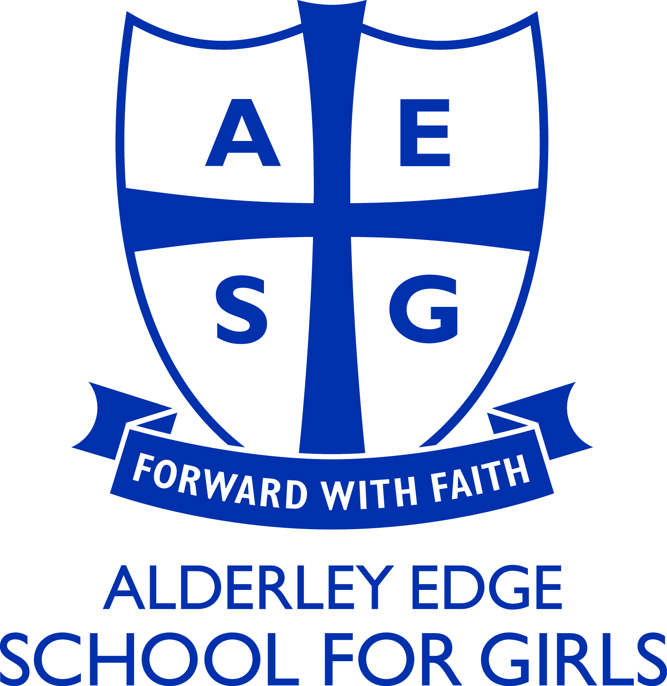

The English Department

The English Department is successful across all Key Stages with with a fine record of academic success at GCSE and A-Level. We have a strong uptake at A-Level where we offer both English Language and English Literature. We follow the OCR specification for English Language and the Cambridge Pre-U qualification for Literature. The ability to offer both subjects at A-Level may be an advantage.

Pupils are set according to ability groups in Years 7 – 11 and each group has a teaching allocation of between 6 to 8 lessons of English per fortnight. At the end of Year 11 all pupils are entered for both English Language and English Literature GCSE (AQA).

There are also many opportunities for involvement in the extra-curricular life of the school. The Department runs a variety of writing workshops throughout the year. Public Speaking forms a significant part of our extra-curricular provision with teams from Year 12 being entered for the Rotary Club “Youth Speaks” Competition. We organise lunchtime debates for the whole school.

