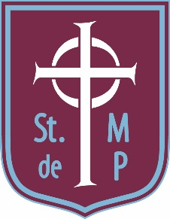 | 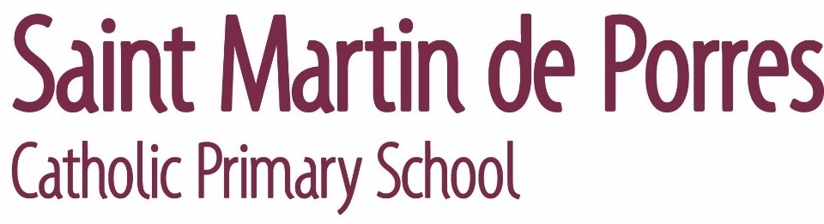  Oakland Road  Moseley  BIRMINGHAM  B13 9DN
Tel: 0121 464 5500 Fax: 0121 464 4691
e-mail: enquiry@st-martindeporres.bham.sch.uk
School Website: www.stmartindeporres.org.uk

Head Teacher: Mr. J. GRAY M.Ed
Assistant Heads: Mrs. K LAIRD B.Ed and Mrs. S BRAITHWAITE B.Ed
22nd March 2021
Dear Applicant,

On behalf of the Governing Body, thank you for your interest in the position of Head teacher at our wonderful school. St Martin de Porres Primary School is a popular one form entry, voluntary aided Catholic primary school, which is situated in Moseley, 5km south of Birmingham City Centre. The school opened in 1969 and is one of two schools serving the diverse parish of SS John and Martin. The school was previously inspected by Ofsted in December 2016 and was graded ‘good’. This reflects all the hard work put in by all staff members, many of whom have served the school for many years, resulting in a supportive, nurturing school community which fully engages pupils in learning and all the activities which create a successful school.

Our Catholic faith is at the heart of everything we do at St Martin’s and our aim is to create a happy, enthusiastic and loving community through which Christ’s message flourishes. Within this, we strive for the fulfilment of each person’s academic potential and the realisation of their unique God-given gifts. We do this through a curriculum which promotes learning across all areas, including sport, the arts and outdoor activities. Our children come from many ethnic and faith backgrounds and we encourage them to develop and live by values and virtues including generosity, compassion, faith, truth, and being curious about everything and active in their engagement with the world.

We are looking for a strong, practising Catholic who has a heart for leading this school. We want somebody who is an effective practitioner, as well as an inspiration to staff and pupils and who has a vision for the strategic development of the school. The new Head teacher will develop the school’s many strengths, including pupils’ progress, a varied and enriching curriculum, and excellent support for the most vulnerable pupils. Education is always challenging, and the Covid pandemic has revealed many needs in the school community, while the financial context stretches resources. St Martin’s is a member of the Tolkien partnership of eleven primary and two secondary schools and benefits greatly from the sharing of expertise and resources within the partnership. The Tolkien partnership is looking closely at the implications of The Archdiocese of Birmingham’s academisation policy for its schools.

If you join us you will be supported by caring, dedicated and very professional staff, polite, active and hard-working pupils, and a committed parental and wider community. St. Martin’s serves a vibrant, exciting and multi-cultural community and children thrive under its Catholic ethos. Thank you for your interest in this position, and I would encourage you to look at the school’s website to find out more about us. I strongly encourage you to apply for the Headship of St. Martin’s and I look forward to meeting with you in the near future.

Yours faithfully

Chris Packham
Chair of Governors

