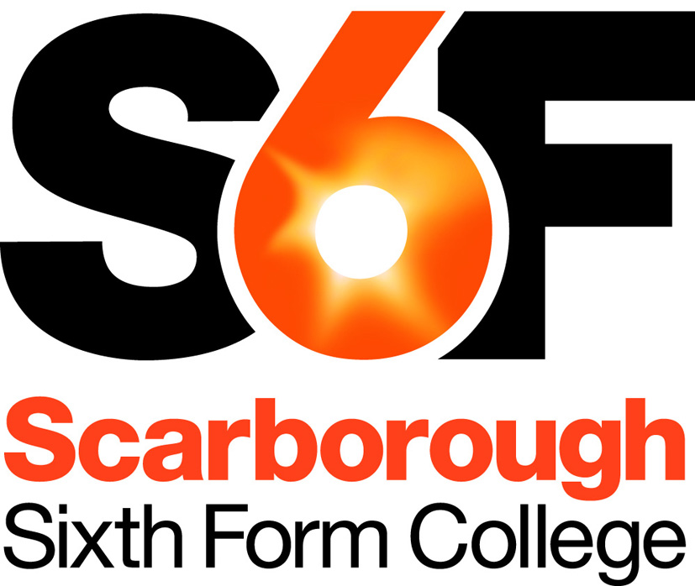
Person Specification
Lifelong Learning Tutor

Our aim is to recruit highly talented and competent people, fully committed to the College’s aims and values. Below we have identified the qualifications, skills, experience and attributes ideally required for this post. Applicants need to demonstrate how well they meet this profile and/or their potential to develop to meet the requirements of the post. This will initially be assessed based on quality of application, and then, if shortlisted, based on a combination of relevant task(s) and interview(s).

Qualifications
- Appropriate subject specific qualification(s)

Desirable:
- Appropriate teaching qualification

Professional Skills & Experience
- Up-to-date knowledge and skills appropriate for the requirements of the subject
- Understanding and use of good teaching practices or willingness to develop
- An ability to relate well to, and motivate, adult learners

Desirable:
- Previous teaching experience (either as a teacher or as a trainee)
- Previous experience of teaching adult learners
- Familiarity with assessment and examination processes in the subject.

Personal Skills & Attributes
All staff are expected to demonstrate commitment to the college’s aims and values, including:
- Passionate about learning and its importance in life
- Having high expectations of self and others
- Honest, open, reflective and self-critical
- Doing one’s best, adapting well to change and always seeking to do better
- A supportive team worker
- Treating staff and students fairly and with respect, valuing their diverse contributions
- Fully committed to promoting & safeguarding welfare of children & young people.

Updated: July 2017

