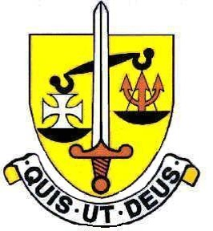

The Science Department

This is a very successful and lively department. We offer both Dual and Triple Science at GCSE and we have a large number of students staying on to take Science subjects in the Sixth Form. We also attract many new students from other schools into Year 12 to take Biology, Chemistry and Physics at A Level.

Staff
There are currently twelve staff in Science teaching. There are Teaching and Learning Responsibility posts for Head of Science (Biology), Head of Physics, Head of Chemistry and for Key Stage 3 Science.

We are well supported by Technicians in each department.

Laboratories
There are seven well equipped laboratories – 3 of which are brand new.

The Curriculum
Key Stage 3 – In Years 7 and 8 the girls are taught Science in their form groups. In year 9 the group sizes are smaller. During the course of Years 7, 8 and 9 two topic units each of Biology, Chemistry and Physics are taught. We have developed our own schemes of work and the pupils use the Collins series of resource materials. We provide a varied and challenging course with plenty of practical work.

Key Stage 4 – All students are taught by separate subject specialist teachers for the Biology, Chemistry and Physics components of the Dual Science or separate three sciences course. We follow the Edexcel GCSE specification. Although Science is a compulsory subject to GCSE a high percentage of students achieve top grades and the percentage of students achieving 7 or above is around 90%.

A Levels – Chemistry and Physics can be studied following Edexcel specifications – and AQA for Biology.
A Level results are excellent. Teaching is usually shared between two teachers in each subject. There are currently six Biology, six Chemistry and four Physics groups.

We are looking for an enthusiastic and well qualified scientist to teach Chemistry. In addition, participation in Departmental visits would be expected.

Feb 2020

