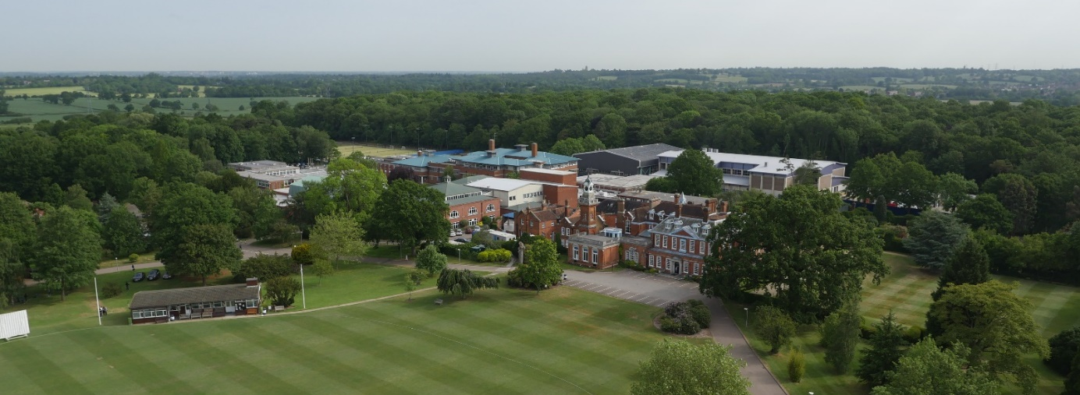

Graduate Sports Assistant – September 2020
We have an exciting opportunity for a dynamic graduate to be a part of developing a busy and successful PE Department, where pupils are bright, highly motivated, results are outstanding and facilities are excellent. We are seeking to appoint an enthusiastic and suitably qualified person to work as part of our PE department, from September 2020 to July 2021. The successful candidate will assist with the teaching of both PE and Games, working with PE staff, professional sports coaches and other staff across the curriculum, from Year 1 to Year 13. The applicant should be able to coach at a high level in at least two of our priority sports – Rugby, Football, Hockey and Cricket. This would represent an outstanding opportunity for an individual looking to gain experience before following a career in teaching or sports coaching. They will have the passion and expertise to ensure all pupils make excellent progress across a wide range of physical activities, encouraging all to understand and adopt healthy lifestyles, whilst striving for the best individual and team performances possible.
The post is full time during term time, with the need to support evening and weekend fixtures.

Applications
If you wish to discuss this post informally, please contact the Director of Sport, Mr McIntosh, on 0208 266 1758
An application form is available from the School’s website: www.habsboys.org.uk. Curriculum Vitae are not accepted.
The completed application form should be sent to the Human Resources Department (staffvacancies@habsboys.org.uk) as soon as possible.
It must be received no later than 8am on Friday 20 March 2020
We intend to interview for this role on w/c 23 & 30 March 2020

The Senior School
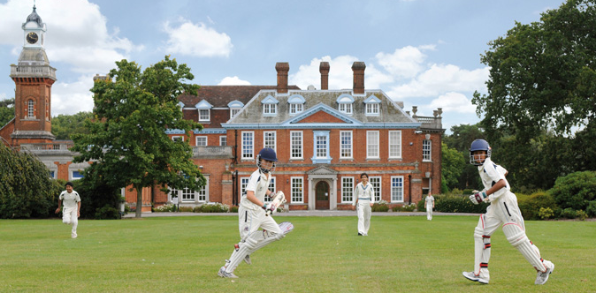
The Haberdashers’ Aske’s Boys’ School (‘HABS’) has an international reputation for academic excellence and success, combined with exceptional pastoral care and co-curricular achievements.
The School is an independent day school with around 1,200 11–18-year-old boys in the Senior School and another 200 boys from the age of 7 in the Preparatory School, which is situated on the same site. A Pre-Prep School for 75 boys aged 5 and 6 is located nearby. The School’s grounds adjoin those of its sister school, the Haberdashers’ Aske’s School for Girls and an extensive and long-established coach service brings pupils and staff from across a wide area.
HABS moved to its current 100-acre rural location in 1961, occupying the grounds of a former stately home: Aldenham House, a Grade 2* listed building, located 15 miles North of the centre of London. A series of magnificent new buildings have been opened in the last decade including a new £13m Sports Facility in 2016. The construction of a state-of-the-art classroom complex at the heart of the campus, specifically designed to reflect international best practice in school design and pedagogy will open in the near future.
HABS’ aim is to nurture excellence within its established values of wisdom, integrity and humility. ISI have graded the School as outstanding in all aspects. The members of the teaching staff are united by a caring approach, passion for their subject areas and the aspiration to be dynamic, modern and reflective practitioners.
Examination results are outstanding placing the School 7th in the UK League tables; places are heavily oversubscribed; and entry is extremely competitive. Boys achieve national prominence in many fields from music, drama and sport to science and Mathematics Olympiads, chess and public speaking.
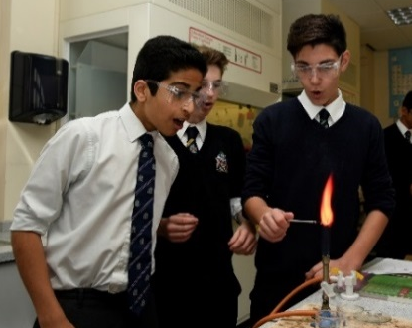
The current intake of boys is exceptional, and the School has been placed at the top of the national league tables. Education at HABS, however, is about more than just academic success. The boys are bright, articulate and open, interested and extremely rewarding to teach. They have a great sense of humour and are very well mannered.
Pastoral care is exceptional, with a strong House-based system. Out-of-class activities abound, with many boys assuming responsibility for the running and organisation of events and societies. Music, drama and sport are strong, and there is also a thriving Outdoor Leadership programme and CCF together with a strong and active Community Service programme. HABS’ boys regularly reach the finals of national competitions, such as chess, bridge and debating, but there is also a remarkable commitment to outreach and charity work, reflecting the rich and harmonious ethnic and religious diversity of the School. A Church of England School by tradition, other religious communities flourish with popular, voluntary assemblies on Thursday mornings for the many different faith groups which are represented in the School. This approach to all faiths was highly commended in the current ISI inspection report.

The School awards a number of scholarships on entry, but the majority of its funding goes into the provision of bursaries for cases of financial need. A very successful Development Foundation exists to broaden participation in the life of the School and encourage philanthropic giving.

More detailed information about the School and its history is available on the School website: www.habsboys.org.uk and through the Good Schools Guide www.goodschoolsguide.co.uk

The Teaching Staff
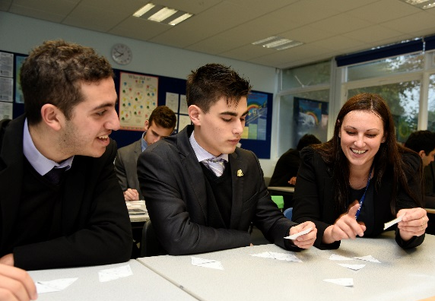
The members of the Teaching Staff are drawn from a wide range of backgrounds and reflect the diversity within the School. All are well qualified (but not necessarily with a formal teaching qualification) and have strong subject knowledge with a deep sense of commitment to the welfare of the boys and to help them achieve their very best. There is a strong sense of community within the Common Room and it is a harmonious and dynamic place where staff work hard in a collaborative and purposeful atmosphere. There is a growing international dimension to the work of staff with regular visits overseas and links with the best schools across the globe.
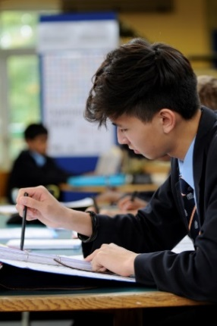
Support for staff at every stage of their career is exceptional, with one of the foremost and forward-thinking professional development plans in the UK. Pedagogy and teacher development take a collaborative approach which is both voluntary and open-minded. Many teaching staff regularly attend Learning Lunches where their peers will demonstrate new developments or ideas with which they have been experimenting. In addition, teachers can request specific training which is often run in well attended Twilight Training sessions at the end of a school day. The School operates an ‘open door’ approach with teachers regularly observing each other and learning from their colleagues.
Every member of the teaching staff is a form tutor and is expected to participate in the School’s rich array of co-curricular and sporting subjects. The main sports are Rugby, Hockey, Soccer, Athletics and Cricket and the magnificent new swimming pool facility will raise the profiles of Swimming and Water-Polo. There is a sixth form Enrichment and Enhancement programme within which members of staff are encouraged to share a personal academic interest, pastime or pursuit. The list of available subjects ranges from Geology to Salsa dancing with a gamut of topics in between. Members of the teaching staff lead over 60 clubs and societites which include outreach programmes and charity fundraising projects. HABS will also find ways to encourage members of staff to share and support appropriate interests.
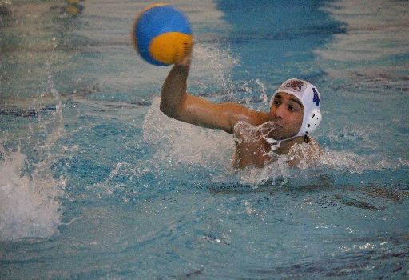
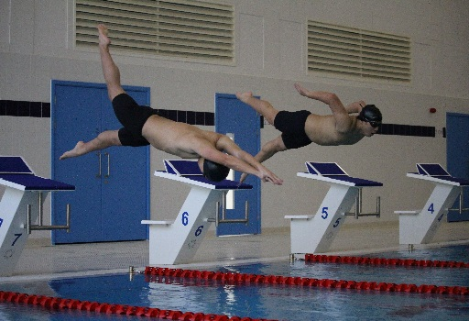
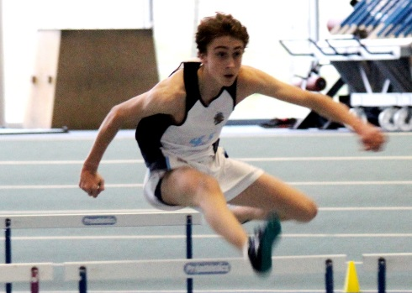

The Physical Education Department
Departmental Accommodation and Facilities
The Physical Education Department is housed principally within the fantastic new Medburn Sports Centre. All teaching staff are provided with their own desk in the spacious departmental office, along with a school computer. The wide-ranging teaching resources are electronically networked, including the videos and media. A reprographics facility, newly refurbished School Library with approximately 15,000 volumes, and extensive ICT facilities support the work of the Department and individual to ensure teaching at HABS is as visual and vibrant as possible.
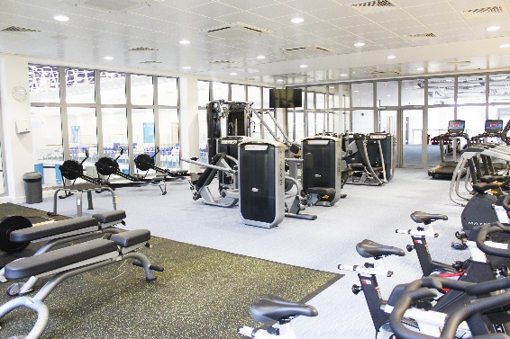
Our outstanding sports facilities, all on the school site, place us amongst the very best in terms of sporting provision. These include 7 Rugby and/or Football pitches, 2 all-weather floodlit Hockey pitches which become 18 Tennis courts in the summer, 3 grass Cricket squares, 3 artificial Cricket wickets (plus grass and artificial Cricket nets), the Solai Indoor Cricket Centre (featuring in-built video analysis system), a double size Sports Hall, 25m 8 lane Indoor Swimming Pool with variable depth capability, Gymnasium, State of the art Fitness Suite, Climbing Wall, Squash Courts, Multi-Use Mezzanine area, 400metre grass running track with synthetic sprint track and jump/throw areas, Shooting Range, Conference Room, School Shop and Café.
Physical Education and Games
Physical Education and Games play an integral part of school life. All pupils are provided with opportunities to participate at some level. Involvement in sport and physical activities are seen to be important in creating team spirit, positive relationships and pride in individual and team achievements beyond the classroom.
The priority sports are Rugby for all year groups, although boys from Year 9 and up can select to play Football as the main sport instead (Autumn Term), Hockey (Spring Term) and Cricket (Summer Term). Additionally, there are opportunities to train and participate in sports including Athletics, Cross Country, Gymnastics, Archery, Sailing, Tennis, Squash, Badminton, Basketball, Golf, Orienteering, Table Tennis, Rugby Sevens, Real Tennis, Shooting (including Clay Pigeon Shooting), Ultimate Frisbee, Swimming and Water Polo amongst the near 40 sports on offer.
The broad nature of the curriculum offered, particularly as pupils progress to the upper age groups, is a real strength of the Department. This leads to the School achieving success across a wide range of sporting activities instead of just a narrow focus. Sports Science is offered at GCSE, AS and A Level where the boys achieve very good results in each of these areas.
Each priority sport involves substantial numbers of boys and maintains a full list of block fixtures on Saturdays, plus regular mid-week matches. The opportunity to take part in School sport is extended to include A, B, C and D teams where possible. Additionally, boys currently represent County sides or higher in Rugby, Hockey, Cricket, Athletics, Badminton, Golf, Judo, Orienteering, Swimming and Water Polo.
The extensive Inter-House programme offers further competitive matches for almost every boy in the School. All boys are encouraged to participate at a level appropriate to them.

Those who want to be involved beyond the competitive route can enjoy recreational levels of activity to maintain healthy lifestyles within the School. Pupils are monitored by using the Fitmedia software to provide individual fitness profiles. This information is then used to provide specific support appropriate to each pupil. A growing emphasis on fundamental movement lower down the school is encouraging boys to be involved far more in physical activity of all sorts, with an aim that participation continues long after they leave us to go on to university and beyond.

The School organises a number of trips and sports tours during the school year and in the holidays. Recently, there have been tours to Sri Lanka, Dubai, Greece, Portugal, Spain, France, Ireland and South Africa.

Departmental Staff

The Department is friendly and informal, with high standards and a general readiness for open discussion and innovation. It is always keen to respond to individual interests and enthusiasms.

The Games Department comprises of over 50 teachers who coach/supervise a range of sporting activities throughout the week. Many of the teachers also run co-curricular sessions as well as running teams for school fixtures throughout the week and at the weekends.

The PE Department includes 5 members of staff who deliver core PE up to GCSE and AS/A2 Level. In addition to this we have a Head of Prep PE and Games, and the department is assisted by a Fitness Coach, Sports Assistant, Graduate Assistant and Sports Centre staff. There are also a number of external coaches employed to help with various sports in each of the three terms.

Traditionally, colleagues enjoy considerable flexibility and room for initiative, with a measure of delegated responsibility. In-service training is encouraged and teachers regularly attend courses and conferences.

The Physical Education and Games Curriculum

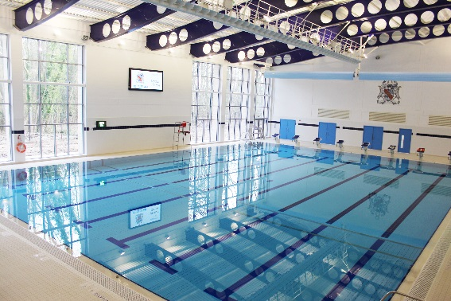
PE lessons are taught by PE specialists in the first four periods of the school day. This should be seen as a separate area of the curriculum from Games.
Games is taught by both PE specialists, non-specialists (academic staff) and professional coaches in the three periods of the afternoon starting at 1.45pm.
Although some PE curricular time is devoted to ‘games’ (invasion, net and striking/fielding), this time should not be confused with the afternoon Games programme.
The Year 7 programme of study is duplicated in Year 8 and is taught in mixed ability form groups. This repetition and reinforcement of work allows pupils to participate with greater confidence and offers the satisfaction of improved performance in the second year of study. Similarly, the Year 9 and Year 10 programmes offer the same opportunities for reinforcement. PE is set according to ability in Years 9 and 10.
The programme offers the opportunity to extend the knowledge and skill accrued in the previous years and prepares these students for the diversity of programme available in Senior Games on Wednesday afternoons.
Principal Duties
To be read in conjunction with the terms of employment.
The Graduate Sports Assistant will assist with the delivery of the PE and Games curriculum in the Prep and Senior Schools. They will be line managed by the Director of Sport. They will also work closely with the Head of Senior PE and the Head of Prep PE and Games in order to develop a co-ordinated approach towards sports and fitness across the whole school. The post holder is expected to make a significant contribution towards the games and co-curricular programmes, and should be prepared to work across the full age range of 7-18 years of age.

The responsibilities of the post are not restricted to, but are likely to include:-
- Supporting the departmental vision and strategy for the development of sporting excellence in the Pre-Prep and Prep Schools and the development of the participation rates for all pupils as part of our ongoing focus on exercise and health leading to lifelong engagement in physical activity.
- Promoting and safeguarding the welfare of children and young persons for whom I am responsible and with whom I come into contact
- Planning and coaching games sessions, and team teaching or providing cover for PE lessons throughout the year for pupils of all ages and abilities, including some sessions with boys in the Prep and Pre-Prep Schools.
- Consideration of the needs of individual pupils to ensure that all pupils are working and developing at an appropriate pace.
- Assist in developing individual sporting needs, as well as team strategies.
- Selecting and managing teams throughout the week and on a Saturday.
- To referee/umpire fixtures.
- Working with the Director of Sport and Heads of Sport to ensure all pupils are suitably challenged.
- Promoting professional standards of punctuality, discipline and sportsmanship with the pupils.
- Attendance at departmental meetings and INSET meetings
- To be responsible for looking after the kit and equipment and to assist with the set up/breakdown as required for sports sessions.
- To assist with departmental administrative tasks as required.
- Working with the Sports Centre Manager and Director of Sport to ensure the best use of the facilities and equipment for provision of PE, Games and the co-curricular programmes.
- Helping to ensure that all aspects of Departmental Health and Safety requirements relating to Pre-Prep and Prep PE and Games are in place and adhered to: including the reporting and monitoring of accidents, risk assessments, inspection of equipment and ensuring that First Aid and medical requirements are being made.
- Attending Departmental meetings and other school meetings as required.
Any other reasonable and related activities at the discretion of the Director of Sport at all times making a positive contribution to the wider life and ethos of the Schools.
Support Staff Salary and Benefits
The School has its own generous salary scale. The salary for the successful candidate will depend upon their qualifications and experience and will be discussed at interview.
Candidates should note that all appointments are subject to an enhanced check with the Disclosure & Barring Service and references from past employers.
Benefits
Currently the School offers a wide range of benefits to staff, including:

- A strong commitment to professional development, with a substantial budget for whole school training and individual courses. Support is given for sabbaticals, post-graduate degrees and other relevant qualifications;
- Enrolment into the School’s pension scheme, with 12% employer contribution, based on 5% individual contribution
- Group Life Assurance (4 x salary);
- Childcare Vouchers; where eligible
- Free lunches, other meals and refreshments;
- Free parking on the School campus;

- Free coach travel on the service provided by the School (subject to availability);
- Tax free bicycles for work through the Cycle to Work Scheme;
- Free use of the state-of-the-art Medburn Centre including fitness suite, swimming pool and squash courts,
- Access to the School Counsellor.
- Free lunch provided
- Employee Assistance Programme
- Tax free bicycles for work through the Cycle to Work Scheme;

We look forward to receiving your application.

Gus Lock
Headmaster

