

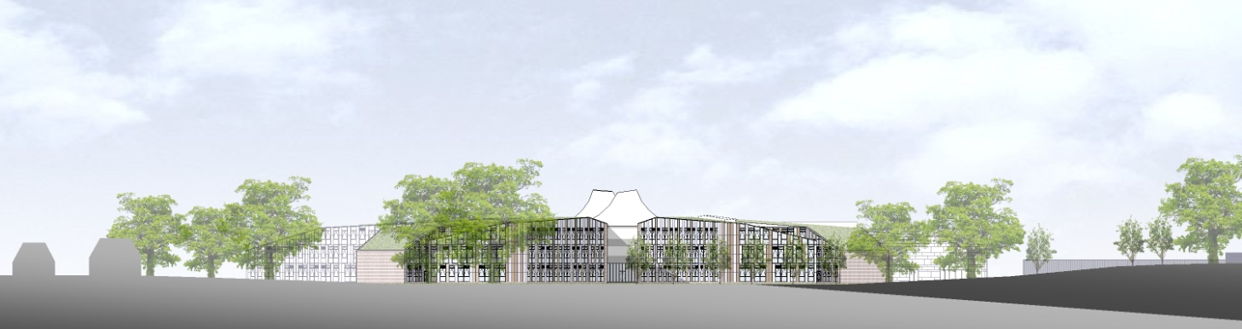

**ST BARTHOLOMEW’S SCHOOL**

**HEAD OF DEPARTMENT: DANCE**

**FULL-TIME, PERMANENT**



**Andover Road**

**Newbury**

**Berkshire**

**RG14 6JP**

**Tel: 01635 521255**

**Email:** [**recruitment@stbarts.co.uk**](mailto:recruitment@stbarts.co.uk)

**Website:** [**www.stbarts.co.uk**](http://www.stbarts.co.uk)

Dear Colleague,

Thank you for your interest in the position of Head of Department: Dance at St Bartholomew’s School. I hope that the details contained in this pack will provide you with a clear picture of this post and give you a flavour of the school and its values. This post really is an exciting opportunity as you will be joining a highly achieving faculty in the school with outstanding facilities.

Working at St Bartholomew’s is very rewarding, and the Governors and I look forward to hearing from you if you feel you have the qualities and experience we are looking for.

If you would like to have a discussion with me or the Head of Expressive Arts about this post or require any further information please contact Human Resources, on the above number or [recruitment@stbarts.co.uk](mailto:recruitment@stbarts.co.uk).

Yours faithfully,

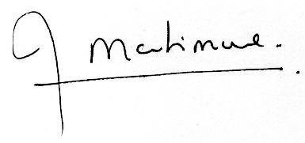

Julia Mortimore

Headteacher

**ABOUT OUR SCHOOL**

**Academic Success**

For the last 4 years St Bart’s has secured the highest level of student attainment in West Berkshire state schools. We think our academic success is something to be very proud of.

Our key headlines are:

1. This year 83% of our students achieved both GCSE English and Mathematics at level 4 or better and 29% of all grades were 9 – 7.
2. Last year our Progress 8 score was 0.66 which put St Bartholomew’s in the top 8% of schools nationally which we are very proud of and this year it is again strong at 0.48.
3. A level results are above national averages with 27% of all grades A*/A and 75% of all grades A* – C.

**Ofsted and School Development**

This is an important appointment for the school at an exciting time when we are working towards becoming outstanding as recognised in our recent short Ofsted Inspection. At St Bartholomew’s we all work together as a team to share good practice, and really develop outstanding teaching and learning to ensure every student makes expected or greater than expected progress.

Every member of staff is part of an Action Research Group and you will also contribute to whole school development in this way. The staff at St Bartholomew’s care very much about the community and are ambitious for the school in terms of learning and enrichment opportunities for all the students.

Teaching at St Bartholomew’s School is a rewarding experience. Our students are eager to learn, well behaved and proud of their school, and this was reflected in our last Ofsted inspection which judged students’ behaviour and safety as outstanding. As a school we are committed to ensuring that all the students and staff realise their full potential. Students leave the school as good citizens and this is underpinned by an exceptional house system and a vast range of extra curricular activities.

**Professional Development**

The professional development of staff is a significant factor in ensuring that we achieve our aim of improving on our previous best and there are rich professional development opportunities at St Bartholomew’s (see CPD offer on our website under Job Opportunities) at all levels. We are praised for our induction and NQT programmes for new staff which are supportive and thorough. Coaching is available for all staff across the school upon request, or maybe you’d like to become a Coach yourself?

**Our School**

Our modern building reflects the importance of the House system, with House blocks (Curnock, Davis, Evers and Patterson) sited around a covered outdoor Hub space.

Our school buildings include outstanding teaching facilities: drama and dance studios, extensive music practice rooms, IT and media suites, specialist design technology rooms and well-equipped laboratories. Sports provision is exceptional including a multi-purpose sports hall, a well-equipped gym hall, an outdoor synthetic turf pitch, a multi-use games area and extensive playing fields.

The wide range of extra-curricular enrichment offers all students new opportunities for learning and enjoyment. This includes clubs and activities such as debating, equestrian, moth club, craft and horticulture, as well as Chinese and Latin classes and a huge range of activities in music, drama and dance. House competitions and activities involve all students. Sporting traditions are very strong with an exceptional range of sports teams competing successfully at the highest standard. Our students love representing their school.

**What’s in it for me?**

1. Excellent IT infrastructure.
2. Smaller than average class sizes.
3. All staff are issued with their own laptop.
4. All faculties have their own office within which teachers have their own designated workspace.
5. A subsidised meal at Activity Time.
6. Ample on-site parking.
7. Staff may be eligible for student places at the school for their children.
8. Staff Forum – an opportunity for staff to meet and voice their suggestions for improvements to the school.

**The Faculty**

The Expressive Arts Faculty (also known as Bart’s Arts) is a busy and thriving aspect of the school. We have an extensive extra-curricular programme and offer GCSE and A-level courses in all disciplines. The Faculty is composed of Photography, Art, Dance, Drama, Graphic Design and Music. Each department has autonomy over its own teaching, and regularly co-operates to co-ordinate similar teaching concepts across the subject areas.

The faculty has an excellent reputation for promoting achievement and success within our subject areas. In addition to Concerts, School Productions, Dance Shows and Art Exhibitions, the Expressive Arts subjects also host an annual House event for different subject areas, which feeds into the whole school House structure. Students regularly lead such initiatives themselves, with teacher support offered as appropriate.

As recognition for their work and as part of our praise and support outlook, Bart’s Arts also reward students for their contributions to the Arts within the wider school context. The department’s award subject colours to KS3 and KS4 students and KS5 students are attributed Bart’s Arts Ambassador status. School visits to see professional artists in action or the arrangement of workshops within school time are regularly pursued within the Faculty and are fully supported by the school Leadership team.

St Bart’s new facilities offer teachers the opportunity to teach in exciting ways, and enable students to learn in state of the art environments. The annual School production has become a showcase for our talented youngsters and staff always take the opportunities to strive for professional outcomes. Class sizes do not exceed 28 and students have hourly lessons in years 7 and 8 (Dance and Drama rotate each half term), whilst opting for their chosen Arts subjects in year 9 and receiving two teaching hours per week. GCSE and A level numbers are thriving and students receive on average two to three hours of teaching at KS4 and four to five hours at KS5.

Bart’s Arts are held in high esteem within the wider community, and as such are frequently approached by local and national organisations to participate in specialist events. We welcome new ideas and initiatives to continue to build upon our students’ success.

**The Post**

* We are seeking to appoint a suitably qualified inspiring Head of Department: Dance to join the Expressive Arts faculty with effect from 1 September 2020 on a permanent basis.
* The position is full-time.

**The Salary**

* The successful candidate will be appointed to the main or upper pay scale in accordance with her/his experience and qualifications.
* A Teaching and Learning Responsibility 2b of £4657.00 gross pa is payable for this role.

**How to Apply**

Full post details, an application form and instructions on how to upload your completed application are available via the Jobs & Training / Job Opportunities section on the School’s website:

[**www.stbarts.co.uk**](http://www.stbarts.co.uk)

(Please note that curriculum vitae and covering letters cannot be accepted)

Successful candidates will be subject to a DBS enhanced check along with other relevant employment checks.

## Closing date: Wednesday 1 April 2020

Thank you for considering St Bartholomew’s School, we look forward to hearing from you.