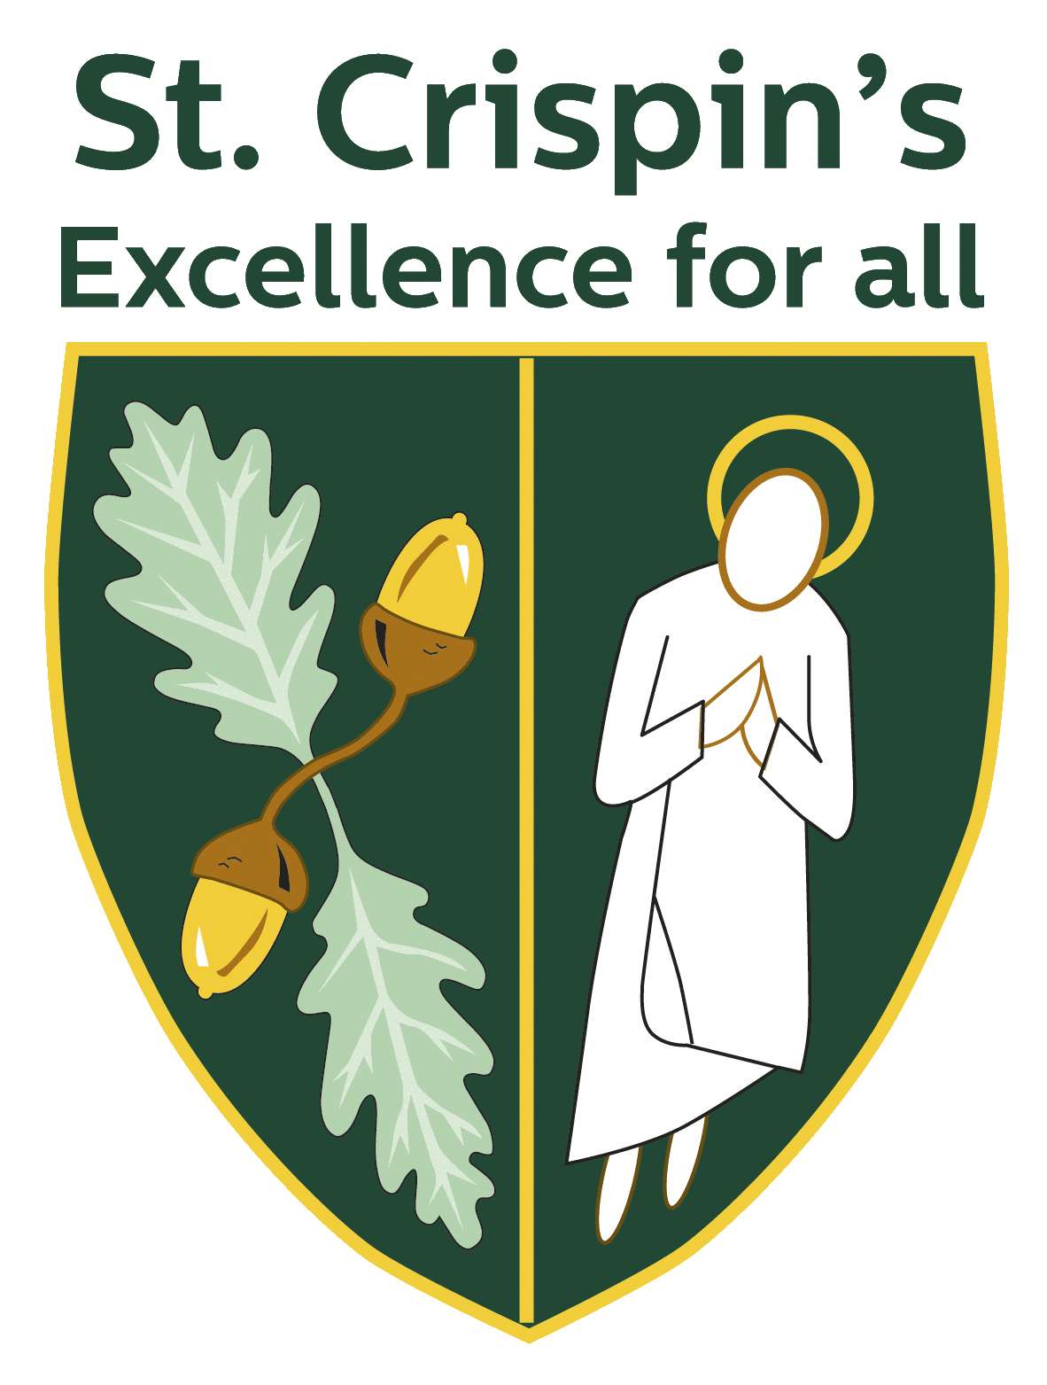
St Crispin’s School – A great place to teach

As a dedicated, ambitious teacher, you put your heart and soul into your work.
You want to enjoy coming to work and feel supported and valued as part of a happy, friendly team. You share our ethos of “Excellence for All” which encapsulates our commitment to do the very best for both our students and staff.

A popular, successful school
St. Crispin’s is an oversubscribed 11-18 mixed comprehensive that in March 2017 was described by OFSTED as “good” with “outstanding” features.

We have a strong focus on the basics: excellent learning and teaching, a safe disciplined environment and an ethos that promotes the highest aspirations. We are a high-achieving school as our staff work exceptionally hard to get the best possible results for every student.

We have an outstanding pastoral care system in place and are immensely proud of our record of being an inclusive school.

We understand the importance of building positive relationships between staff, students and parents.

Strong, supportive, inclusive leadership
We have a well-established senior leadership team acknowledged for its “outstanding” leadership and management by OFSTED.

Turnover of staff is very low but as the school continues to grow, new appointments have been made. We have a good balance between those new to teaching and those with more experience.

We know how hard our staff work and fiercely protect their work life balance.

Recognition and development
We care about your career as much as you do.

You will benefit from our well developed Performance Management system and CPD programme that will reflect your ambitions.

Each year there is also the opportunity for middle leaders to join the senior leadership team to further develop their management skills.

Vibrant learning community
We never want to rest on our laurels and always know we can do better.

Academic performance is strong but there is always work to do in ensuring good progress for all students. To this end, we are part of the PIXL group (Partners in Excellence) which allows leaders at all levels to identify new ways of supporting all students to achieve their full potential.
We collaborate closely with other local secondary schools and we have a unique strategic partnership with the world-renowned independent school - Wellington College. This provides our staff with the opportunity to share best practice.

Great teaching facilities, on-site parking and delicious food
In addition to our state of the art science block and Multi Use Games Area (MUGA), we also have a new £3m sixth form building that has been designed with great care to meet the needs of the 21st century teacher and student.

In addition, we have a specialist centre for young people with Autistic Spectrum Disorder (ASD), “The Oaks.”

St Crispin’s staff enjoy free on-site parking and delicious food in our restaurant, which uses quality ingredients, freshly cooked on-site daily by our in-house chefs, who are busy baking bread from 5am.

We work hard but also find time to enjoy ourselves through regular events organised by our ‘Wellbeing Team’ – be it after-work drinks in the local pub just across the road, Friday football or curry nights.

Comprehensive induction process
We’ll make sure you feel well prepared for your new role through a well-structured induction programme.

Wokingham – a great place to live AND WORK!
Wokingham is a lovely market town that is renowned for its great schools and quality of life:

- There are good transport links with the M3 and M4 within immediate access of the school. It’s commutable from central London with a direct train link to London Waterloo and you can be in Paddington within 50 minutes. We are also just a 30-minute drive from Heathrow airport.

- There is a great deal of investment in the area with many new housing developments offering key worker housing.

- Wokingham has a wide range of leisure facilities including ski and snowboard centre, tennis club, swimming pool, bowling, golf courses and nearby countryside.

- It’s a great place for a night out with plenty of pubs and places to eat.

- We are also just 8 miles from the university town of Reading with great nightlife, culture and shopping.

St Crispin’s is part of a multi-academy trust called “The Circle Trust” more information for which can be found on www.thecircletrust.co.uk

What our staff have to say about St. Crispin’s
“Joining St Crispin’s for my NQT year and the start of my teaching career has been a great decision. The breadth of knowledge and experience from the teaching staff is invaluable, with countless opportunities to grow and develop my teaching practice. The standard of support I have been given from my department and SLT has been extremely high, and that, coupled with the warm welcome from all members of staff, both teaching and support, has really made me feel like a part of the St Crispin’s team. St Crispin’s has supported my career development fantastically and I have now progressed as Deputy HOY to Acting HOY. “

Sarah – Art & Photography Teacher & Acting Head of Year.

