Denefield School
SUCCESS FOR LIFE

Application Information

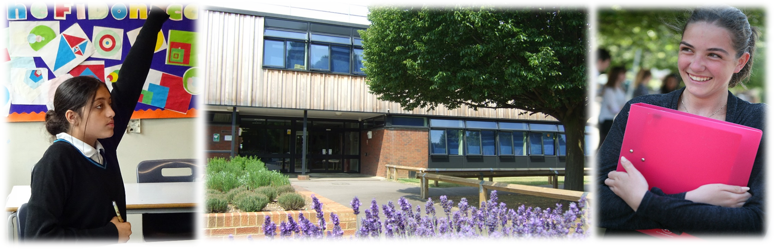

Welcome from the Headteacher

I am delighted to welcome you to Denefield School. Denefield is an ambitious, successful and over-subscribed school located in the western Reading suburb of Tilehurst.
I believe passionately that every young person should gain the qualifications and develop the character skills to have, as we say at Denefield, ‘success for life’. To prepare them for this, Denefield offers a rigorous and engaging curriculum at GCSE and A Level, with creative and practical subjects alongside traditional academic courses. In addition, students at Denefield work hard at the school’s nine CHARACTER values – confidence, happiness, articulacy, resilience, ambition, courage, tolerance, empathy and respect. They have the opportunity to develop these during subject lessons, during assemblies and house competitions, and during the many extra-curricular activities during and outside the school day. Further information on our CHARACTER values can be found here.
I am particularly proud of the school’s supportive pastoral system, including its vertical tutor groups and houses, where students of different year groups learn alongside each other. I am also very proud of the excellent achievements of Denefield’s many sports clubs and teams. Denefield students also benefit from a very wide range of extra-curricular opportunities, including designing and building racing cars, taking part in mock trials or debating competitions, taking the Duke of Edinburgh qualification or joining the Combined Cadet Force, or undertaking residential visits in the UK and abroad. The breadth of these opportunities in many ways sets Denefield apart from other schools, and these activities play a major part in helping students develop the CHARACTER values that contribute so much to a young person achieving success for life.
I am delighted at the achievements of Denefield students and that many choose to join the school’s Sixth Form. As at GCSE, we offer a rigorous and engaging curriculum in the Sixth Form designed to ensure students can access the most competitive universities, including Russell Group and Oxbridge, and the most sought-after apprenticeships. I am very impressed with the rapid success of the newly-formed Sports Coaching and Player Development Programme, a combined venture with Reading Football Club, which leads to advanced sporting qualifications and performance in addition to A Level qualifications.
I believe that students at Denefield do enjoy success for life. This is partly because of the school’s talented, committed and supportive teaching and support staff and governors (or Trust Board). It is also because of the school’s excellent facilities. Denefield is situated on a generous school site, with many playing fields and plenty of outdoor space. Most recently the school benefited from nearly £10m of investment, creating an expanded canteen area, along with new facilities in the Science and Art, Design & Technology departments, as well as a new display and assembly space – fittingly called the Da Vinci auditorium.
I hope that you will take the time to visit us and to reflect carefully on the potential this post will offer you. If you like what you see and wish to be considered for the role, please complete the relevant application form. You should also write a letter (no more than two sides of A4) which outlines the skills, qualities, attributes and experience you would bring to the role based on the information provided in the job and person specification. Please also visit the school if you can. To arrange a convenient time please contact my PA, Mrs Sue Ellison, on 0118 941 3458.
At Denefield we take safeguarding very seriously and consequently the successful candidate will be required to complete a DBS enhanced check for regulated activity. Please do not include CVs with your application as these will be disregarded for safeguarding purposes.
I hope you will consider joining my team and I look forward to receiving your application. Please either apply through the TES or directly to the school. Electronic applications are fully acceptable and these should be emailed to recruitment@denefield.org.uk. Please do not hesitate to contact me, or indeed one of my colleagues, should you wish to discuss the role further or arrange a visit.

Mr E Towill MA (Oxon)
Headteacher

Our school

Denefield is a thriving and expanding school on the outskirts of Reading with over 1,100 students on the roll, including 180 in the Sixth Form. The school has been serving the local community for over 40 years since its inception in 1976. It has steadily grown over the last few years reflecting our good reputation and the continued the support from our local community.
The school is a stand-alone academy trust having converted in January 2012. We have an active partnership with our local partner primary schools. Each year, we admit approximately 75% of students from our partner primary schools and the remaining 25% from the wider area. Our standard admission number is 180 students for entry into Year 7, however due to continual demand for places we have admitted, on average, an extra 20 students for the last four years and have also operated a waiting list during this time.
For further information about our school, and for copies of the job description, person specification and application form, please visit our website - www.denefield.org.uk

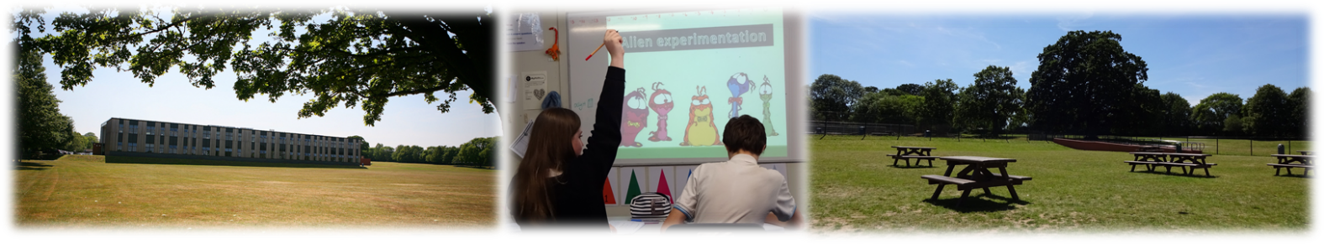

Our distinctive ethos

We are very proud of our distinctive ethos which is based on a set of CHARACTER values and a belief that every student deserves success for life.
Developing CHARACTER values is a key focus of our work and we encourage students to become: confident, happy, articulate, resilient, ambitious, courageous, tolerant, empathetic, and respectful individuals. We host annual CHARACTER Awards to recognise and celebrate students who have displayed CHARACTER values.
We strive to equip our young people with the skills, academic qualifications and personal attributes to thrive in the modern world. We passionately believe that our role is to prepare students for the tests of life and not for a life of tests.

Our Senior Leadership Team
Denefield has a team of six senior leaders, including the Headteacher, Deputy Headteacher and four Assistant Headteachers. Guided by a shared vision, the SLT is focused on delivering the present and long-term success of the school. We actively seek to learn and grow together, ensuring a high level of trust, transparency and support. We set the pace and tone for the wider staff body, building confidence and cooperation, whilst seeking to ensure accountability. We place the nurturing and education of our students at the core of our priorities.
The SLT oversees the management of the school, both academically and pastorally, and ensures the distinctive ethos permeates everything we do.
Our Sixth Form

We are immensely proud of our Sixth Form and their achievements. Many work extremely hard in school, and progress to high level apprenticeships, employment or to university. In 2019, 55% progressed to university, including to Russell Group universities, and overall 96.5% went into further education, employment or training, or took gap years abroad. Our students are welcoming and supportive, and in many cases play a leading role in school or in the local community – most recently the excellent work they have done promoting the school’s CHARACTER values of tolerance, empathy and respect via LGBT History Month. Sixth Form students benefit from good facilities, including the Sixth Form common room and work room, and are well supported by their subject teachers and the Sixth Form pastoral manager. In addition, the Sixth Form curriculum, with over 25 subjects, is broad and inclusive. Students can study traditional, so-called ‘facilitating’ A-Level subjects, such as English Literature, all of the three Sciences, Maths (including Further Maths) or History. They can study more practical A-Level subjects such as Art or Business Studies, or they can study vocational and BTEC subjects such as Health and Social Care, BTEC Business or BTEC Sport. These are extremely solid foundations to build upon.
Yet there are many challenges and opportunities open to the Denefield Sixth Form. Current priorities include:
- Working with Sixth Form students, staff and parents to help build a vision of the Sixth Form for the future
- Further developing the role of the Sixth Form student leadership team, to maximise its impact in the Sixth Form and across the school
- Continuing to build positive relationships with Sixth Form students and their parents, including further development of Sixth Form student voice
- Providing further support, challenge and intervention with students who are falling behind
- Ensuring that results in every subject are as good as the results in the best subjects
- Further developing the Sixth Form pastoral programme
- Acting on student suggestions including more focus on areas such as study skills, finance and managing risk, as well as on progression routes including both apprenticeships and university options
- Working with Sixth Form students to further develop community service in and out of school
- Ensuring the Sixth Form remains financially viable by growing student numbers, including converting at least 50% of Year 11 students into Sixth Form students
- Reviewing the Sixth Form curriculum to ensure it meets students’ needs and is financially viable.

This is thus an extremely exciting time in the development of the Denefield Sixth Form, and the new role of Assistant Headteacher – Head of Sixth Form – provides a great opportunity for the right candidate to make a real impact.

Working at Denefield

We currently employ approximately 75 teaching staff and 70 support staff.

Professional development opportunities for staff in this school are outstanding. We have developed an exceptional in-house annual training programme enabling staff at all levels to follow a personalised programme linked to their performance management needs. Each year staff have the opportunity to review their work, to set targets at an annual appraisal meeting which is followed up with an interim review meeting part way through the year. We have a robust system in place for pay progression for both teaching and support staff.
Senior and middle leaders are supported to take part in recognised senior and middle-leadership qualifications with NPQSL and NPQH providers and the local authority.
Newly qualified staff are effectively supported and are provided with a reduced timetable, a planned induction programme and mentor support. We have welcomed a number of teachers from overseas with a supportive induction programme to help with transition to the UK.
In order to manage the on-going challenge of finding and retaining high quality teachers, we have implemented a ‘Grow Your Own’ strategy. As the lead secondary school for the Berkshire Teaching Alliance, we recruit and train our own trainee teachers. The school has created a bespoke teacher training programme which is delivered by high quality practitioners within our organisation. Since September 2016, this has resulted in the recruitment of 15% of our teaching staff body, with the vast majority of these new teachers in hard to recruit subjects.
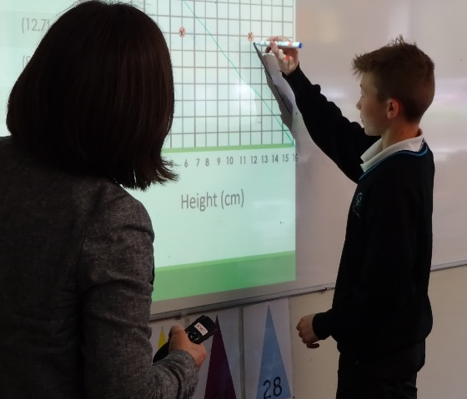

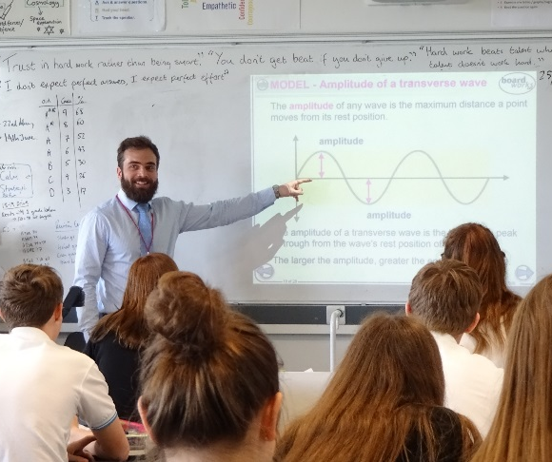
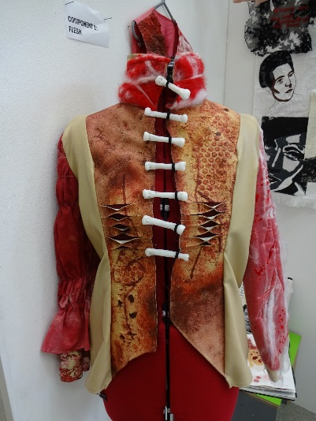
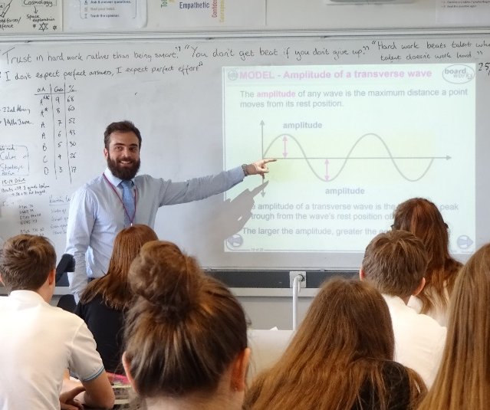
Facilities

The school is located in Tilehurst, a densely populated suburb of Reading, some four miles from the town centre. Our estate backs on to farmland and woods and is generous in size extending to some 23 acres and boasts well maintained buildings and grounds. Recently the school received £9 million of government funding which was used to build a new science block, to provide state of the art design & technology and music classrooms, workshops, a recording studio, an art exhibition space, a community room equipped with a dance floor and a new Sixth Form common room and work areas.

Little Oaks Day Nursery operates on the school site providing care and education for up to 28 children aged 0 to 5 years.

Since academy conversion, we have successfully bid for £2.66 million of Government capital grants to improve the fabric and condition of our buildings. Past projects include: window replacement, new lighting and ceilings, heating controls, and a significant extension to our canteen and outdoor seating area. Our most recent successful project has seen the installation of electronic exit gates and new fencing, external doors and alarms, car park lighting, an extension to the outdoor student supervised area including a ramp for accessible access and classroom doors with viewing panels.

Current aspirations to further enhance our facilities (subject to affordability) include: improvements to the sports hall and gym, fire safety improvements, window replacements and upgrades to the IT infrastructure.
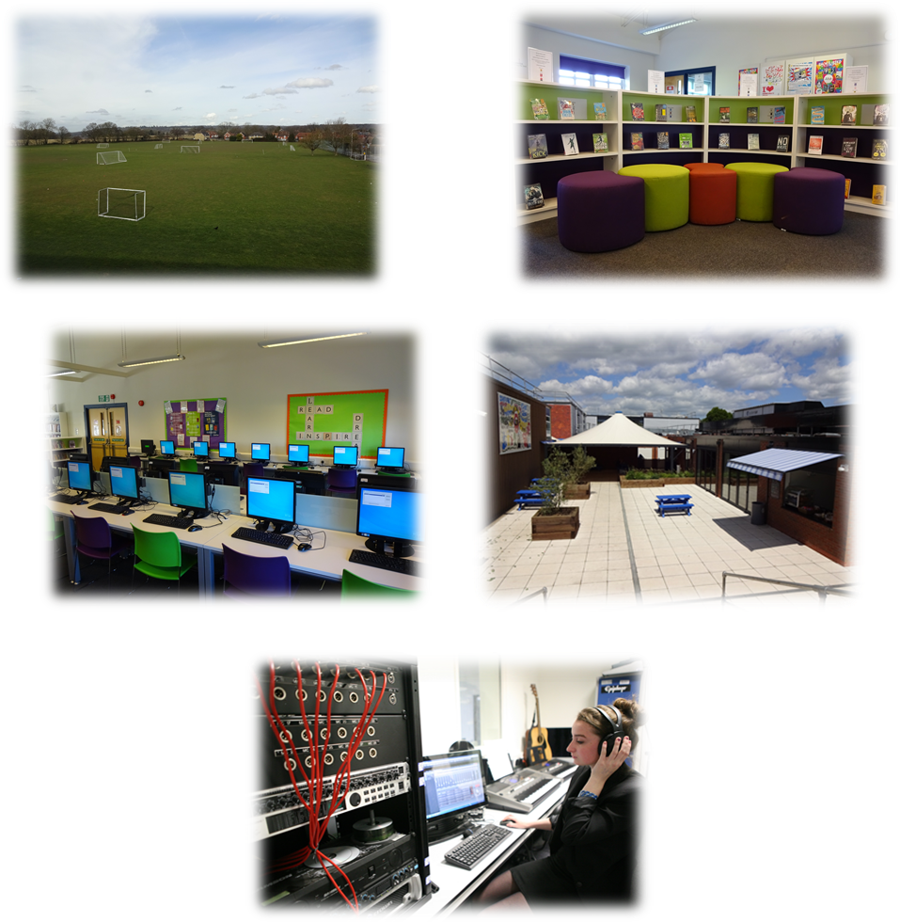

Staff benefits

Salaries and benefits
The school follows the pay and conditions for teaching staff as set out in the current School Teachers’ Pay and Conditions Document, and teaching staff are invited to enrol with the Teachers’ Pension Scheme (TPS). Pay and conditions of service for support staff are governed by the National Joint Council for Local Government Services and support staff are invited to enrol with the Local Government Pension Scheme (LGPS).
Wellbeing
Staff wellbeing is a key priority at Denefield and we are proud to offer a supportive workplace. Teaching is hard work, but we strive to foster a better work/life balance for our staff through a number of initiatives. These include: restricting when emails can be sent; encouraging staff to leave early on at least one evening a week; offering yoga classes, healthy eating and mindfulness training to staff; and by cultivating an environment where it is acceptable to say ‘I am finding this hard’. In addition, our training days end with a selection of wellbeing activities and staff organise regular social events which are enjoyed by many staff, teaching and support staff alike.
Child Care
A day care nursery operates from the site and provides places for children aged 0 to 5 years. The nursery, open all year around, offers term time only contracts and currently has space to accommodate 28 children.
Cycle to Work Scheme
Denefield partner with the Green Commute Initiative to offer all staff the opportunity to purchase a bike through our cycle to work scheme.
On-site parking
Free, on-site, parking is available to all staff.
Flu Vaccinations
The school provide vouchers to those staff who wish to be vaccinated against influenza, covering the cost of the vaccination.
Tea and Coffee
Free tea, and coffee are available to staff, in the staffroom.
Joint Consultative Committee
Following academy conversion, the Trust Board implemented a Joint Consultative Committee (JCC) as a means of consulting with staff on an array of employment, pay and conditions issues. Members of the Trust Board attend meetings to discuss any new developments and work-related issues with staff representatives, trade union representatives and senior leaders.

Working and living in and around Tilehurst
Tilehurst railway station is located approximately a 15 minute walk from Denefield School. It has regular Great Western Railway services between Reading (5 minutes), London Paddington (40 minutes) and Oxford (40 minutes)
The school is served by the number 16 Reading bus which operates up to four times per hour during peak times, providing a 20 minute journey into and out of the centre of Reading.
The vibrant town of Reading sits 5 miles east of Denefield with its thriving shopping centre, constantly evolving restaurant scene, museums and medieval abbey. With its great array of bars, pubs, comedy clubs, live music venues and theatres, there is a nightlife to suit everyone. For those who prefer to spend their free time in a greener, more natural, environment, there is plenty to choose from. Reading has the longest Thames frontage of any borough, most of which is formed by public parks, part of the Thames Path (a long distance walking route) and National Cycle Route 4.

