Our Ref: TJ/LS

March 2021

Dear Applicant

TEACHER OF SCIENCE – SEPTEMBER 2021

Thank you for your request for information and the interest you have shown in the post of Teacher of Science.

I do hope that you will apply to join our College and, if you do, please complete the application form including a letter of application of no more than two sides of A4, addressing these issues:

- the experience you have that fits you for the post;
- your suitability for the post, particularly the qualities mentioned on the enclosed person specification

Interested candidates are positively encouraged to speak to the Headteacher, Tim Johnson. The College telephone number is 01653 693296 and the following information is enclosed for your information:

- Job Description & Person Specification;
- Advert;
- Why work at Norton College?
- Faculty Details

The closing date for receipt of applications is 9.00 am on Monday 12th April 2021. We anticipate interviews will take place week commencing Monday 19th April 2021 and shortlisted candidates will be contacted to confirm arrangements for the day. Please be aware that this may operate remotely.

The College is committed to safeguarding and promoting the welfare of children and young people and expects all staff and volunteers to share this commitment. The successful applicant will be required to undertake an enhanced Disclosure & Barring check.

Thank you for the interest you have shown in this post. I look forward to receiving your application in the near future.

Yours faithfully
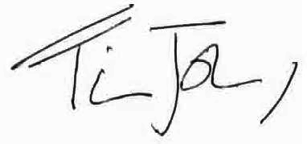

Mr Tim Johnson
Headteacher

Headteacher: Mr Tim Johnson
Deputy Headteacher: Mr Barry Evans
Langton Road, Norton, Malton, North Yorkshire, YO17 9PT
Tel: 01653 69 32 96
Fax: 01653 69 33 38
Email: admin@nortoncollege.net
Website: nortoncollege.net

