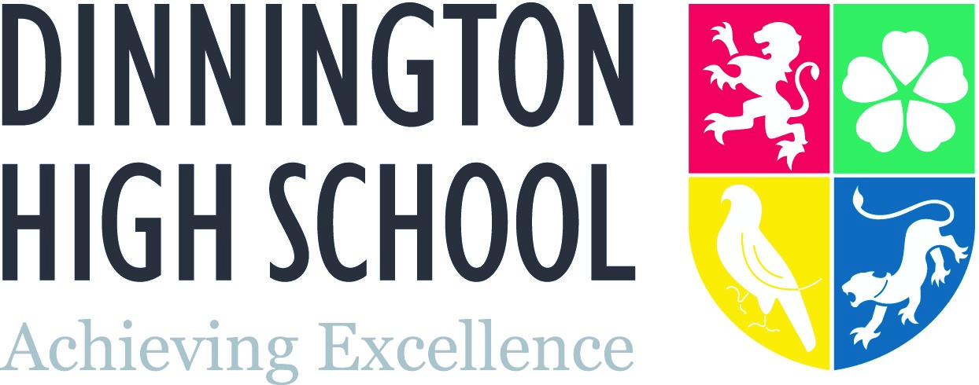

EBACC FACULTY

Information for Applicants

Staffing

The EBacc Faculty at Dinnington High School is a committed and professional team. It comprises of four separate departments: French, Geography, History and Spanish. There are 4 specialist History teachers, four specialist Geographers, 2 French specialists and 2 Spanish specialist teachers.

Faculty Vision

We believe our subjects are vital in developing the ‘whole child’. All of our subjects develop students’ cultural understanding and foster attitudes that encourage students to embrace difference. Students learn things that make the world outside the classroom comprehensible, they learn to embrace change, and accept others. Students are enriched by our subjects. Students develop analytical skills that allow them to develop as fully engaged citizens.

We seek to develop life-long learning habits in our students. We want them to be enthralled by our subjects, to find learning compelling, enjoyable and exciting. We set out to fire curiosity in our students and develop resilience and a strong work ethic. We seek to develop students as active learners, building the qualities of independence and interdependence.

It goes without saying that our subjects also develop students academically. All of the subjects are robust and challenging. A GCSE or A level in any of our subjects is a gateway to the next step in students’ educational journey. All EBacc subjects help students to develop high levels of literacy. History and Geography develop students’ ability to assess, analyse, evaluate and to produce judgements using both sophisticated technical and general vocabulary. Modern Languages obviously develop students’ proficiency in French and Spanish but also allow students to make a ‘comparative’ study of English- helping them to better understand grammatical aspects of their primary language too.

Subject Information

EBacc subjects comprise a good proportion of students’ KS3 timetable. In Year 7, students have 2 lessons of Geography, 2 lessons of History and 2 lessons of either French or Spanish (the year group is split 50/50 across the two subjects). In year 8, the pattern for History and Geography is the same. The most promising linguists are also given the opportunity to study a second language for an additional period a week in order to allow them to opt for two languages at GCSE.

Our KS4 curriculum starts in Year 9, students must opt for at least one of our subjects, but there is no proscription on them following more. Currently most students opt for two. The options system is set up so that there is no proscription on a History/Geography combination. From 2018 , students will also be able to opt for French and Spanish if they have studied both in Y8. Students follow the AQA Specification for both French and Spanish. History students follow these units from the AQA specification: Norman England, Power and the People, Germany 1888-1945 and the Cold War. Geography students follow the OCR B specification.

All four subjects are offered at A level with History, French and Spanish continuing with a study of the AQA specification. In History students are currently preparing for examinations on the units for ‘Tudor England’ and ‘Imperial, Weimar and Nazi Germany’. The coursework element is on Civil Rights in the USA. Geography students continue with their study of the OCR specification.

Resources

The faculty takes up a floor of the most modern building at Dinnington High. Each teacher has their own classroom and all are equipped with interactive whiteboards. There are two full computer suites that can be booked out and a smaller IT room (with 10 computers) suitable for A level classes. All subjects are well stocked in terms of textbooks, DVDs and other teaching resources. There is an EBacc staffroom with a working space (with three computers) and fridge, kettle, toaster and microwave for staff use.

Opportunities

We are a forward looking Faculty and we will seek to develop the practice and careers of all colleagues. For us, potential is the key. We look to ‘talent-spot’ and to develop every member of our team (and to develop as a team), so that we all become more reflective and better practitioners. From within the Faculty we provide our own bespoke CPD, augmenting the school’s own program. Meeting time takes place most Thursdays and is used as a forum to discuss pedagogy, share good practice and develop collaborative planning.

Mark Cooper
Line Manager for EBacc Faculty
Assistant Principal - Teaching & Learning

Nov 17

