Providing care & education for over 50 YEARS


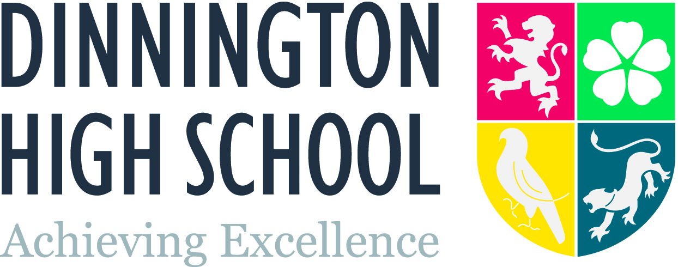

INFORMATION FOR CANDIDATES


Dinnington High School, is committed to providing, promoting and achieving excellence and being the best we can be for our students. I took up post in January 2017 as the new Principal, and I am proud to lead such a caring, positive school.

Dinnington High School is a large school with almost 1200 students in KS3, KS4 and Sixth Form, and our numbers coming in Year 7 are rising. Achieving Excellence is at the heart of everything that we do across our curriculum, beyond our curriculum and within our pastoral care of our students. Strong relationships, built on trust and mutual respect are central to all members of the community, having the opportunity to learn and be successful, both in and out of the classroom.
We aim to provide students with an inspirational learning experience through which they can develop into confident, resilient young adults, with a drive to do their very best.
Everyone at Dinnington High School is valued. We recognise and celebrate the meeting of expectations and those who go the extra mile. We challenge people to push themselves, take a lead and have high aspirations, whilst ensuring they receive the right support care and guidance to make them feel safe and secure.

Achieving excellence is the overriding ambition of the LEAP Multi-Academy Trust
We place students at the centre of everything we do, creating a culture of success and a love of learning which enhances students’ achievement and their personal, social and emotional development.
Our aim to achieve excellence drives policy, practice and governance across our schools. Professional excellence at all levels underpins our approach. A high quality educational experience will be an entitlement for every student: it is an absolute priority that every student, irrespective of their starting point, succeeds and achieves.
In raising standards for our students we will contribute to the raising of educational standards and secure significant benefits for business and the wider communities that we serve.
We seek at all times to build positive partnerships with parents/carers, primary schools and the wider community to achieve excellence for all of our young people.
We recognise, value and embrace each school’s uniqueness and the communities we serve. Drawing on very best practice, we share expertise across the trust in order to achieve excellence.
Staff Development
We are committed to staff development. We have a Head of Teacher Development who supports NQTs, RQTs, trainees & new staff. She has very close links with Sheffield Hallam and Learners First. We support staff undertaking further training at NPQML, NPQSL or NPQH level.
We seek to recognise the contribution to staff over and above the expectations of being a teacher in a number of ways. As we seek to develop our work to improve the life chances of our young people, we are involving staff in the work. For example, recent whole-school CPD included contributions from members of staff who successfully engage boys and Pupil Premium students in learning & achieving. We have just embarked on a review of our approach to Assessment for Learning to ensure that all we do has impact, is manageable and is not a waste of teachers’ time and energy to create an unnecessary paper trail; members of staff from each department are getting involved in this work.
We do not believe in taking up staff time with unnecessary meetings; our focus is on staff training and development. So in 2017-18, we will have two INSET days, and three disaggregated days that mean we use an hour and a half on Thursdays weekly for faculty collaborative planning, staff training, form tutor training.

School Location and Setting
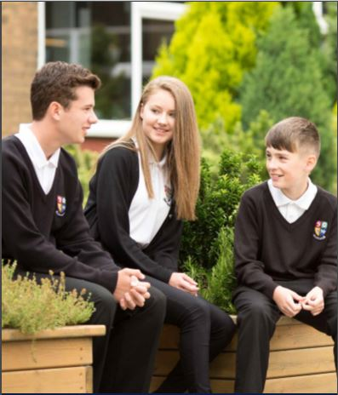
Dinnington High School (formed in 1963) is located on a superb and extensive campus with over 30 acres of grounds and superb views, within easy distance of Derbyshire’s Peak District and other areas of outstanding natural beauty; and also within easy commuting distance of Sheffield, Rotherham, Doncaster and Worksop. It benefits from an excellent location, just 3 miles from the M1, and giving access to all major road networks in the region.

Dinnington is a bustling, ex-mining village that is experiencing significant regeneration. A number of small thriving villages including Thurcroft, Laughton, Anston, Woodsetts, Langold and Carlton-in-Lindrick, contribute students to the school and we regularly take students who lie outside the school’s catchment area. A series of new housing developments are planned in the next few years.

The School Site

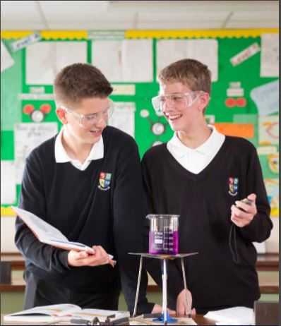
The school is housed in a number of separate buildings, some linked by ‘skywalks’ with the largest and newest building (over 40 classrooms) being built in 1998. There is a rolling programme of refurbishment to ensure that the learning environment is of a high quality, and departments are grouped together.

Students who attend the school come from a diverse background area.

Staff have a large staff room at their disposal. Each department also has their own staff facilities.

We have four dining areas on site which continue to be re-furbished regularly.

The sports facilities and the Main Hall are open to the public on evenings, weekends and during school holidays. The Astroturf pitch, in particular, is extensively used by the community. There is also an exciting holiday programme of activities which operates during each holiday period – it is not unusual for over 100 young people to attend holiday activities.

School Structures

The student pastoral system is organised into a vertical tutoring system in Y7-11. From Sept 2017, Y12 and Y13 will have separate forms. We are retaining three houses in our pastoral system; Hatfield, Osborne and Segrave (incorporating students in Y7-11). This year, we will no longer have Athorpe House (represented by the falcon on our badge) as sixth formers will retain their original house as they move up the school. Members of SLT take the lead on different houses and over the coming year we will seek to raise the profile and inter-house competition even further.

Working across this vertical House system are our year groups. So each year group has a Year Leader who is a member of our support staff. Students also have year group assemblies at times. This team are overseen by our KS3 and 4 leaders who are also members of support staff.

The Curriculum 2017/18

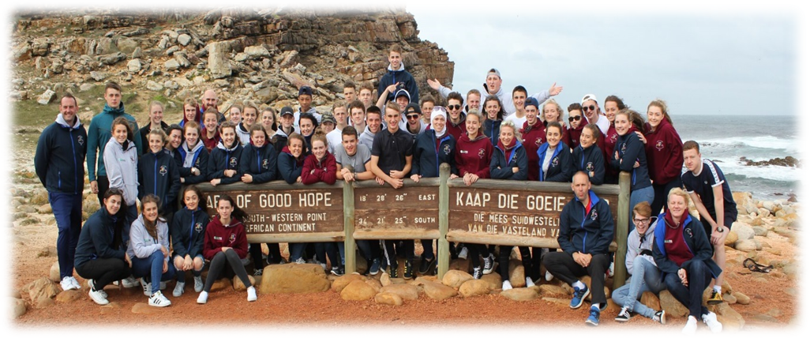Key Stage 3: Y7-8 from Sept 2017

All students will follow a programme of study which includes: English, maths, science, art, drama/music/performing arts, geography, history, ethics & Life, modern foreign languages, PE, and technology.

Key Stage 4:

Core studies are: English, maths, science, PE, ethics & life (this is studied one lesson per week in Y9 and in drop down days in Y10 & 11. Students select 1 of 4 key subjects from history, geography, French or Spanish. In addition they have selected 3 options for Y9 going into Y10 (last year having two years at KS4), and four options for Y8 going into Y9, which include art, business, childcare, construction, engineering, French, geography, health & social care, history, media studies, music, performing arts, PE, Spanish, and technology.

Post 16:

The school currently offers an extensive range of academic and vocational courses: art & design, business studies, English language, English literature, engineering, French & Spanish, geography, government & politics, health & social care, history, ICT, maths, further maths & statistics, media studies, music, philosophy and ethics, product design, physics, chemistry & biology, PE & sport, performing arts, psychology, and sociology.

These courses are complemented by Extended Project and an Enrichment Programme including a Football Scholarship.

Now we have a newly appointed Assistant Head of Post-16 across the Trust, we will take advantage of being able to offer some courses across the Trust.

Sixth Form at DHS

We have a vibrant sixth form at Dinnington High School with high expectations and an excellent track record of preparing students for a successful future whether that is university, further training or employment. Our sixth form has 190 sixth form students on roll and offers a varied and individualised curriculum. A particular strength is evident in the vocational offer, here staff have an excellent track record with student performance achieving well above national averages. Our achievement in academic courses is more varied, and we are keen to ensure that all courses support students in achieving the best results possible.

The sixth forms at DHS and at our sister school within the Trust, Brinsworth Academy, are overseen by a Trust Assistant Principal for Post-16 who has considerable experience of growing and developing a sixth form. We are keen to expand our post-16 provision and develop the range of courses we offer to our students. As we increasingly work together across the two sixth forms, we are seeking ways to extend opportunities to sixth formers and to share expertise.

Extra Curricular Activities

The school has an extensive range of after-school activities and clubs ranging from music to PE, and we are keen to extend our offer even further. We also have an extra-curricular programme linked with our feeder schools through our School Sports Co-ordinator and through sixth form ambassadors.

The school runs a number of annual residential experiences, both nationally and abroad. Students have a very broad range of off-site activities to complement their education. The sports tour in the summer of 2014 was to Los Angeles, in 2016 to South Africa and in 2018 it will be to Canada and North USA. The Duke of Edinburgh Awards are an important part of our offer to students.

An extensive range of holiday clubs and activities take place. These are well attended by young people aged between 5 and 16. Our own students often volunteer a considerable amount of time to assist at these events.

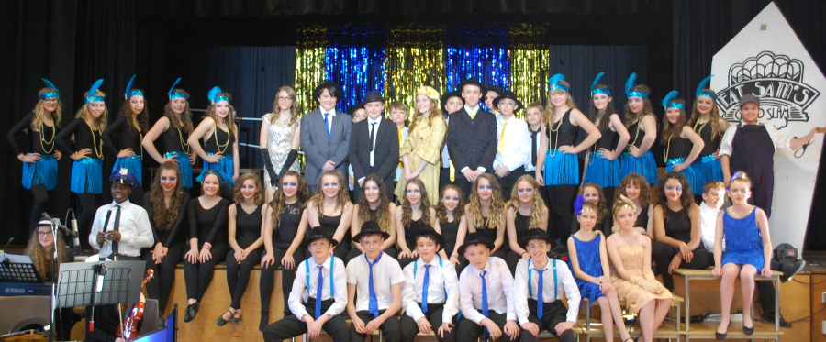

Finally

Our aim is to provide all students with quality first teaching, expert advice and guidance and opportunities beyond the classroom that ensure they are given the best possible life chances. Our high expectations and commitment to ensuring the very best with both staff and students allows us to secure a safe working environment that celebrates the academic and personal achievements of the students. Together through the LEAP Trust, our aim is to achieve excellence by providing students with challenging, inspiring and worthwhile experiences that lay solid foundations for their future success.

Dinnington High School is a dynamic school in which to work, and we hope you want to be part of our journey to secure not just Ofsted Outstanding but an inspirational place for students and staff.

With kind regards
Yours sincerely

Ms Rebecca Staples
Principal

