Head of Department: Humanities

Salary Range: Main Scale plus TLR

St Aidan’s Church of England Academy is a school on its journey to becoming outstanding, inspiring all of our wonderful students and delivering transformational change.

We expect high quality, consistent teaching using the St Aidan’s tool box (from the Thinking Schools model). It is our expectation that all students are independent learners, are motivated, enjoy their learning, grow in self-awareness and self-esteem and experience success on many levels.

If you embrace our vision, we are looking for an ambitious individual who is knowledgeable in their subject. An individual who is passionate in assisting young people make more than expected progress and is committed to supporting and further embedding the vision for St Aidan’s within the successful Humanities Department.

Our ideal candidate will:

- be an outstanding classroom practitioner and role model, demonstrating high personal and professional standards
- work as part of the Curriculum Leadership Group
- inspire, motivate, enthuse and lead staff and students alike within the Humanities Department
- work collaboratively across the Academy to develop and implement new strategies and ideas that impact on a positive classroom learning climate

Further details and an application form are available from Alex Simpson Tel: 01325 373 778 or Email: a.simpson@staidansacademy.org.uk or alternatively downloaded from our website: www.staidansacademy.co.uk

Applications must be returned to Alex Simpson via the above email or by post to the below address.

The Academy is committed to safeguarding and promoting the welfare of children and expects all staff to share this commitment. The post is subject to a successful DBS clearance and pre-employment checks will be undertaken before an appointment is confirmed.

Closing Date: 22 May, 12 noon
Interviews: 23/24 May 2019
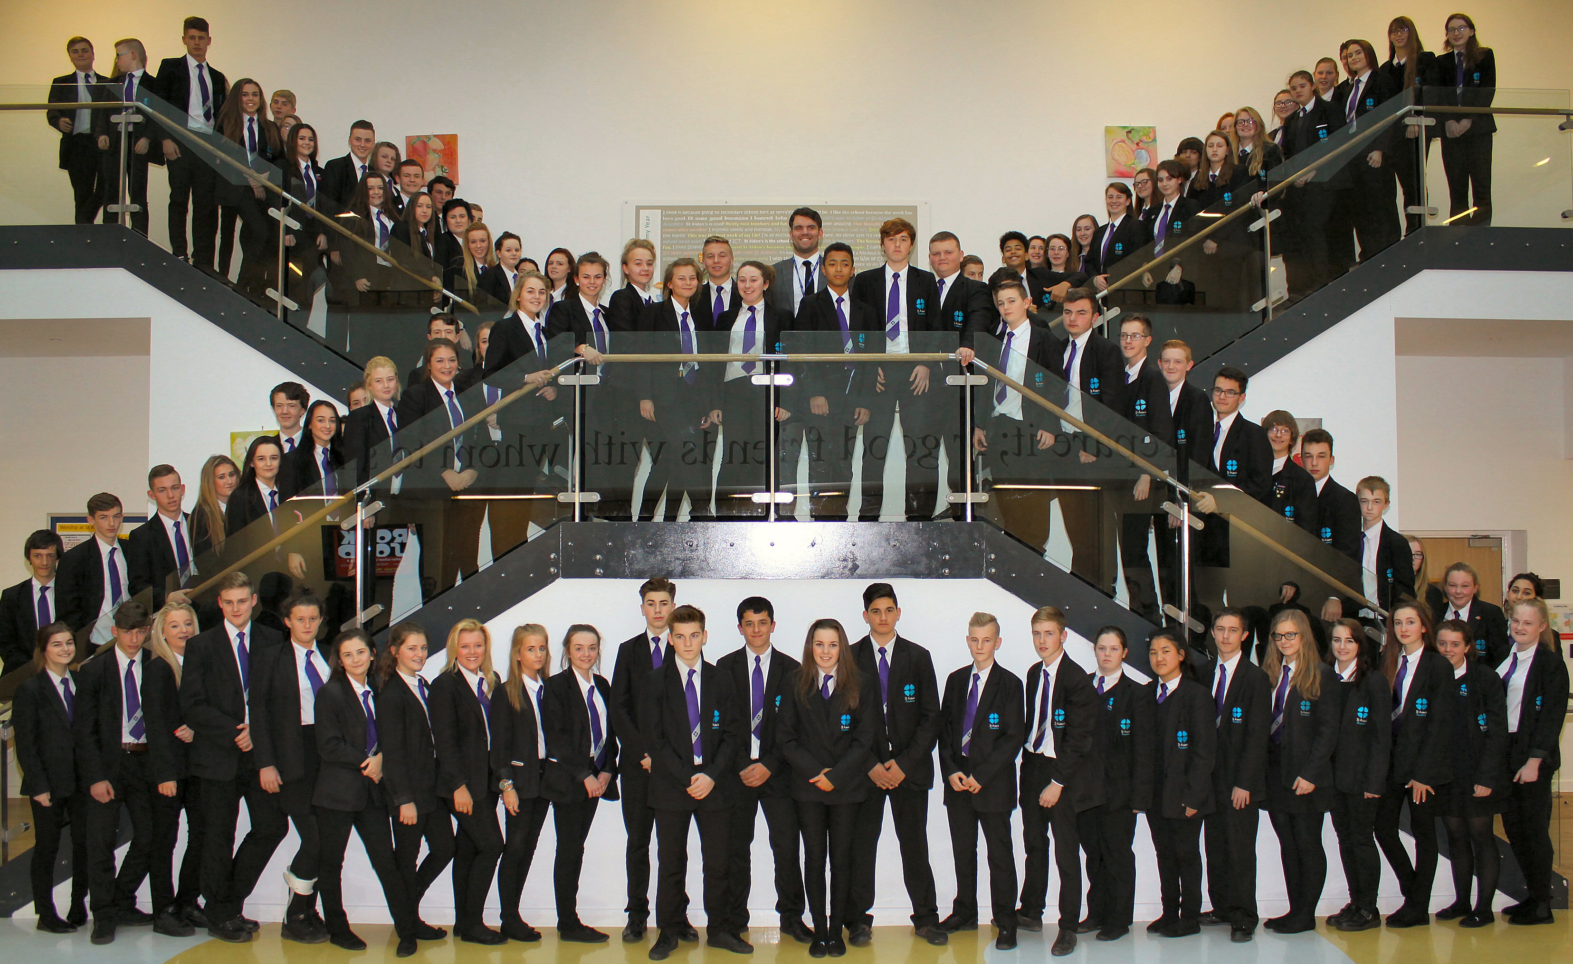
St Aidan’s Church of England Academy
Hundens Lane, Darlington
DL1 1LL

Phone: (01325) 373770

Principal: Mrs Nicole Gibbon

