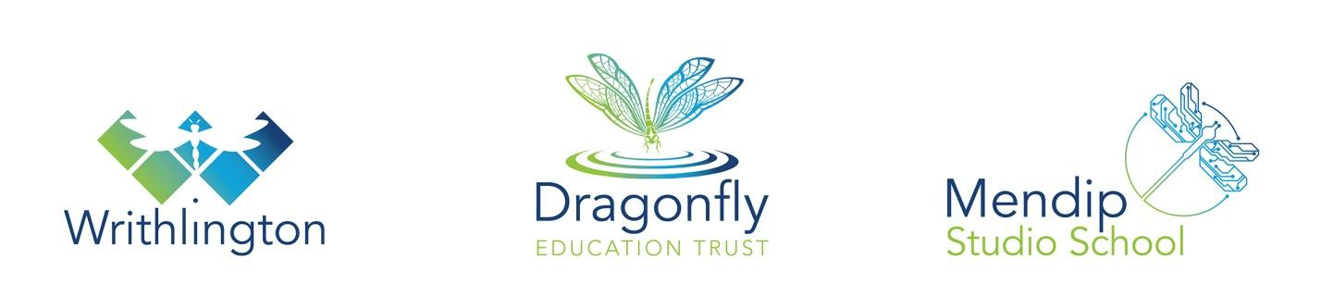
The English Department 2017

The English department is a strong team of twelve teachers and three support staff with a broad range of experience and expertise. There is a strong emphasis on professional development with regular in-house CPD. The department is housed in ten well-equipped classrooms on the ground floor with a large office space situated near a new, well-stocked library.

Curriculum Organisation

All English teaching groups are set according to students’ current levels of attainment. Students are set from year 7 onwards in their respective Bands. Sets in each Band are parallel with larger class sizes for more able groups. Lower ability groups have smaller class sizes and may also receive additional support where appropriate. At Key Stage 3, each class follows the same curriculum which is differentiated to ability. The content provides a coherent course, preparing students for the subject demands of Key Stage 4 and 5. Average group sizes at Key Stage 3 are 26. Class sizes at Key Stage 4 are normally around 24. At Key Stage 5, A Level English Literature is taught with two groups each in Y12 and Y13.

Target Setting and Monitoring of Student Progress

All students are given minimum target levels for the end of each academic year in accordance with expected progress. Each class in Key Stage 3 is assessed using termly formative and summative assessments throughout the year. The work is moderated across the year group and progress against targets is recorded on a central database. This database is used to identify students for early intervention and generate regular progress reports for parents, copies of which are given to tutors.

Special Needs

In class, support is provided by teaching assistants attached to the department and classroom assistants who are based in an Individual Learning Centre. This is negotiated with the Special Needs Department on a termly basis. All English teachers are issued with IEPs for students on the Code of Practice and lesson plans are differentiated in order to comply with the school’s policy on inclusion.

Curriculum Planning & Development

The English Department works as a team to revise schemes of work at all Key Stages. It is our aim to develop lessons which are engaging and relevant to the students’ interests and needs whilst preparing them for the next phase of their education.

At Key Stage 4 all students complete the AQA GCSE English Language and Literature courses.

At Sixth Form, AS and A2 English Literature is taught through the AQA syllabus. There are normally two or three classes in each year group. In addition, we will be running the AQA A-Level course in English Language.

Enrichment Activities

There are a number of initiatives in place outside the classroom. These include “Film Club” (in line with National Film Club) who study and watch films regularly at lunch time. Students take part in a calendar of events as they take place (e.g. Readathon, World Book Day, author visits). We have a programme of theatre trips to ensure that students in each year group are given the opportunity to experience drama first hand annually. There is a new school library which opened in September 2013 and the school places great emphasis on promoting reading for pleasure.

Leadership

The department is led by a Subject Leader and people with responsibility for each key stage. However, there is a strong emphasis on department staff working as a team in order to promote the very best teaching and learning strategies to enable all students to make progress. The department have worked together to develop our Key Stage 3 courses in response to the new programme of study. All colleagues participate in the school’s performance management process which is linked to individual staff targets in the School Improvement Plan.

Dragonfly Education Trust is committed to safeguarding and promoting the welfare of children and young people and expects all staff and volunteers to share this commitment. An enhanced DBS check is required for the successful candidate.

