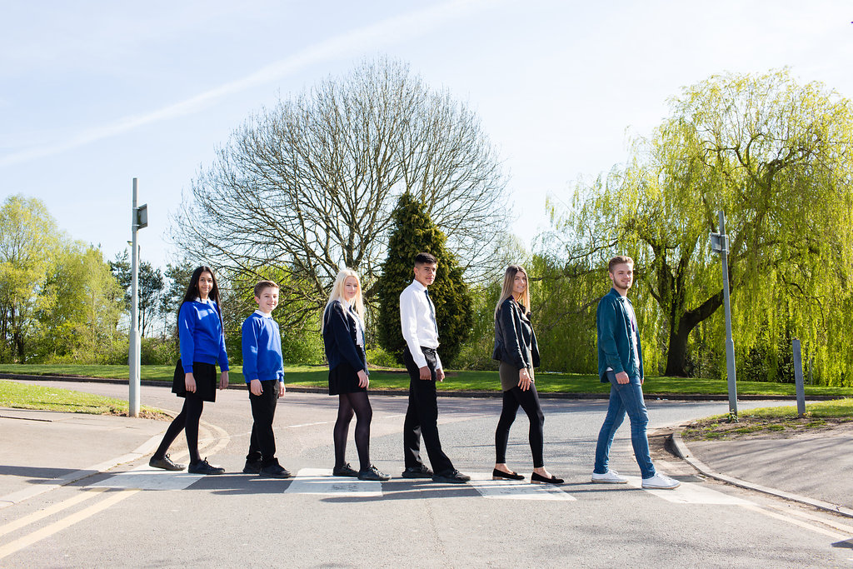

Premises Officer

Grade 7 - £18,499 per annum
Rising to £20,139
37 hours per week
To be worked over various shift patterns with occasional
weekend overtime

Content

Vision, Values and Ethos |  | Page 3
Testimonials |  | Page 4
General Information |  | Page 5
The Application Process |  | Page 6
Vacancy Advert |  | Page 7
Letter from the Headteachers |  | Page 8
Job Description |  | Page 9-11
Person Specification |  | Page 12-13

Vision, Values and Ethos
The shared vision and values of the Trust underpins all that we do, including the governance arrangements for the Trust.

Our Vision
Valuing Everyone, Achieving Excellence

Our Motto
Work Hard, Be Kind

Our goals
The goals of our trust:
- Outstanding levels of progress and achievement for all
- Outstanding levels of wellbeing for all
- Outstanding preparation for adult and working life
- Outstanding family and community engagement
- Outstanding levels of professional learning for all
Informed by “Schools of Tomorrow”

Testimonials
Extract taken from email correspondence, following a tour of the school by a prospective parent
(April 2016):
‘I would just like to say thank you for the time spent with me today on my tour of the campus, and state how impressed I was with the school. There seems to be a very calm, relaxed and organised approach to how the school operates, and I believe that obviously shows in the way your students behave’.

Written comments from parents following Year 9 Progress Evening (2017):
‘My child always talks positively about school to other children the same age, which I think is a good indicator that he is enjoying school’

‘Welcoming, approachable, friendly and knowledgeable staff’.

Written comments from parents following Year 11 Progress Evening (2017):
‘The teachers have pride in their teaching and in the pupils’ progress. They really care and are prepared to go the extra mile to support the students’.
‘My son seems to have progressed so well in most subjects. I feel this is due to good relationships he has been able to form with teachers and the standard of the lessons’.
Written comment from parent at the end of KS5 (2016):
‘This is my final parents evening after my youngest daughter is coming to the end of her years at GCE. Thank you for very happy years for my three daughters and for their excellent education!’
Thank you from parent of ex-student taking up a place at Cambridge University (2013):
‘To all the staff at Brookvale Groby Learning Campusl.
My son has just started at Cambridge University studying Engineering. It was his ambition to go there and this summer, he achieved the grades he needed. We want to acknowledge the great teaching and support he received during his time with you. He progressed well academically, but also grew so much in maturity and confidence. With thanks to you all for your hard work and dedication.’

Extract of letter from staff member:
‘I have thoroughly enjoyed my time on campus. It has been a real pleasure working with staff who are always friendly, extremely supportive and willing to share ideas and knowledge. I have really appreciated having a senior leadership team which is so warm towards its staff and open to their comments and new ideas.

The children I have taught have made me smile, laugh and cry! I will miss my relationship with them and that buzz you get from seeing them progress. It does, however, give me great satisfaction to think that I have put into place schemes of work for pupils and created learning opportunities for them which should continue even after I have left.

I am sad to leave a post which I still love. Once more, thank you for all of your support and kindness.’

Extract of letter from staff member:
‘I have been very fortunate to have worked with amazing people. I have learnt so much as both a Teacher and as a Head of Department.

I will truly miss everyone here, and it really has been an amazing experience. Thank you for allowing me to be part of such a wonderful group of people.

I wish every success to the campus.’
GENERAL INFORMATION

The Brookvale Groby Learning Campus is a highly successful 11-19 educational organisation created from the integration of two schools on the same site. Brookvale High School is an ‘outstanding’ 11-14 school and Groby Community College is a 14-19 upper school graded ‘good with outstanding features’ in its last Ofsted. Together, the campus meets the educational needs of 1,600 students with nearly 400 at Post 16, and we became a Multi Academy trust together at the beginning of April this year.

We are fortunate to have a spacious, green campus of which we are very proud. You will be part of a team maintaining two buildings, as well as the grounds of our campus, ensuring that it continues to be a clean, well maintained environment for our young people and staff members to enjoy.

If you are a hard-working, dedicated individual, committed to providing a quality service, then we look forward to hearing from you.

The Application Process

Complete application forms should be returned to tmalsbury@brookvalegroby.com

Or by post to

F.A.O. Tracey Malsbury
Brookvale Groby Learning Campus
Ratby Road
Groby
Leicester
LE6 0FP

A letter will be sent to shortlisted candidates with details of the interview process.

Queries

If you have any queries on any aspect of the application or need additional information please contact Tracey Malsbury, PA to the Headteacher on 0116 2879921.

Thank you.

The Role

PREMISES OFFICER

We are looking for an enthusiastic, hardworking and dedicated person to join our Premises team.
The successful applicant will be required to work 37 hours per week
over various shift patterns, with occasional weekend overtime
being required.
Grade 7 - £18,499 per annum, rising to £20,139
For further details on this vacancy, or to arrange a visit to our campus,
please contact Joe Mackie, Campus Site Manager
jmackie@brookvalegroby.com
or call 0116 2817052
Closing date – Friday 20th October 2017
Interviews to be held within 1 week of the closing date.

Brookvale Groby Learning Campus is committed to safeguarding and promoting the welfare of children and young people and expects all staff and volunteers to share this commitment. Applicants must be willing to undergo appropriate child protection screening, including checks with past employers and the Disclosure and Barring Service.

October 2017

Dear Applicant

Premises Officer

Thank you for your interest in the Premises Officer vacancy within the Brookvale Groby Learning Campus.

We hope the documents provided help you to gain a feel for the school and if you would like to visit us as well, we would be delighted to show you round. Please contact Joe Mackie on 0116 2817052 or jmackie@brookvalegroby.com to make an appointment.

All the documents to support this application process are available on our campus website – www.brookvalegroby.com.

To apply please complete the following:

- Application Form
- A letter of application, no more than two sides of A4, word processed using font size no smaller than 10

Your letter needs to be addressed to ourselves, and if you would like to e-mail your application then please send this to Tracey Malsbury – tmalsbury@brookvalegroby.com

The closing time and date for this post is Friday 20th October 2017. The interviews will be held within 1 week from that date. If you have not heard from us by then, please assume that your application has not been successful on this occasion. If this is the case, we would like to thank you for your interest and the time spent in applying.

This post will be subject to an enhanced level Disclosure and Barring Service check. All Brookvale Groby employees are expected to promote and safeguard the welfare of students at the school. Our Safeguarding Policy is made known to all and is designed to guide staff, students and parents/carers with regard to Safeguarding issues.

In line with best practice guidance re safeguarding we do not require an additional CV and any included with application forms sent to the school will not be taken forward to the short listing panel.

Yours sincerely
Katie Rush Robert Coles
Headteacher, Brookvale High School Headteacher, Groby Community College
Co-Director of BGLC Co-Director of BGLC

Job Profile

Job Title: |  | Premises Officer
Grade: |  | 7
Responsible To: |  | Site Manager
Responsible For: |  | Supervision of Cleaning team
Job Purpose: |  | - To undertake responsibility for the supervision of the site and the maintenance and security of the buildings.  - Contribute to the provision of high quality maintenance, security and cleanliness of the school buildings and grounds which ensures that students have a comfortable, clean, safe and well maintained environment in which to work or otherwise use the school facilities.
Hours: |  | 37 hours per week – Full time
MAIN DUTIES AND RESPONSIBILITIES:
1. | - Required to supervise a team of cleaning staff, undertaking maintenance, repairs and cleaning of the building and grounds.  - To undertake repairs and maintenance on an ‘as and when necessary basis’ to enable the school to be maintained in a state of good repair and lessons and other activities to proceed with minimum disruption.
2. | Administration  - Order materials and equipment required for use by the Premises/Cleaners team, in line with school ordering procedures.  - Complete appropriate records (e.g. heating/safety checks, order forms).  - Contribute to the review of school policies and procedures related to the Premises function by working with senior colleagues.  - Deal with day to day work related issues, relating to premises and cleaning staff (e.g. absence cover, quality/quantity of work, working methods/use of new equipment/materials, liaising with the Site Manager, as necessary.
3. | Security of Premises and Contents  - To open the grounds and school buildings and ‘unset’ alarms in accordance with laid down schedules and lettings, to ensure that lessons and other activities are able to take place at the specified times.  - Lock school doors and gates and setting alarms in accordance with laid down schedules or as necessary to maximise the security of the school and the grounds at all times and minimise the opportunities for vandalism.  - To attend the premises when alarm is triggered, out of hours and liaise with Police, as necessary, to check windows are closed.  - Carry out emergency security repairs where possible or contact the appropriate contractor.  - Maintain duplicate sets of keys for all rooms and equipment.
4. | Buildings  - Implementation of repairs, maintenance and cleaning programme.  - Undertake daily cleaning of the school ensuring that the work is completed to a high standard and complies with safe working practice.  - Deal with and participate in ad hoc requirements for repairs and maintenance work throughout the school. Deploy Contractors as appropriate.
5. | Grounds Care  - Ensure grounds are kept in a clean and tidy condition.  - Overseeing and undertaking as required the cleaning of outside areas, i.e. paths, drains, gullies, car park, play areas.  - Oversee little picking to ensure grounds are kept in a tidy condition.
6. | Electrical Installations  - Replace bulbs/shades where accessible. Replace tube, starter, shade (not sealed units), where practicable.  - Replace, re-fuse or fit plugs (after training).  - Inspect electrical fittings and arrange for Contractor to deal with any defects.
7. | Heating Systems  - To undertake checks of the boilers in accordance with laid down schedules and to take any remedial action necessary or to report faults so that remedial action can be taken as soon as possible, to enable lessons and activities to take place without disruption.  - Carry out routine maintenance procedures for heating boilers, water pumps, and sump pumps. Ensure that proper safety precautions are observed in the boiler house. To know the location of main stop cocks and valves, and mains electricity breakers.
9. | Emergencies  - Deal with, or arrange to be dealt with, all burst pipes, leaks, flooding, fires, and breakages as appropriate. Liaise with contractors as necessary.  - Liaise as necessary with Emergency Services including calling in Emergency Services as required.
10. | General  - To arrange or undertake the movement of furniture and heavy teaching equipment as required in accordance with school timetables and ad hoc requests.  - Receive and transport all deliveries throughout the campus.  - Deal with accident spillages.
11. | Training  - In consultation with the Site Manager identify and undertake appropriate training and development.
12. | Health and Safety  - To comply with Health and Safety legislation, School Policy and good health and safety working practices in relation to the use of the school premises and grounds and own duties and responsibilities. Report any breaches of safety regulations/policies or other safety concerns noticed to the Site Manager, to enable the school and school grounds to be safe and healthy places for students, staff and other users to use.  - Ensure that the school’s Health & Safety policy is complied with in as far as it relates to Premises Management and Premises/Contractors’ staff, to ensure their safety and that of students, staff and other school users.  - To carry out duties placed on employees by Health & Safety Legislation.  - To ensure that caretaking equipment, i.e. mechanical aids, steps are in a safe condition.  - Report to Site Manager any non-structural and structural hazards (i.e. broken/loose furniture/play equipment) or structural faults that are seen which cause concern or may be in an unsafe condition.

SPECIAL FACTORS:
Subject to the duration of the need, the special conditions given below apply:
(a) The nature of the work may involve the postholder carrying out work outside of normal working hours.
(b) The postholder may be required to attend, from time to time, training courses, conferences, seminars or other meetings as required by his/her own training needs and the needs of the service.
(c) Expenses will be paid in accordance with the Local Conditions of Service.
(d) This post is eligible for a DBS check under the Rehabilitation of Offenders Act 1974 (Exceptions) Order 1975 (i.e. it involves certain activities in relation to children and/or adults) and is defined as regulated activity under Part 1 of the Safeguarding Vulnerable Groups Act 2006. Therefore a DBS enhanced check for a regulated activity (includes a barred list check) is an essential requirement.

WHOLE CAMPUS RESPONSIBILITIES:
- Support current policies and recognised good practice within the college.
- Be aware of the importance of confidentiality and data protection.
- Participate in annual Performance Management review with Line Manager, based on agreed objectives, at least one of which should be linked to the college improvement plan where possible.
- To work as part of a team, to act as a contact in providing basic emergency first aid, if training is provided.
- Willingness to be flexible in both approach & use of time.
- All tasks should be undertaken with due regard to Health & Safety Regulations.
- To undertake such other duties which are within the scope of the job purpose, title of the job and its grade.

This job description sets out the duties and responsibilities of the post at the time when it was drawn up. Such duties and responsibilities may vary from time to time without changing the general character of the duties or the level of responsibility entailed. Such variations are a common occurrence and cannot themselves justify a reconsideration of the grading of the post.

The Governing Body and Leicestershire County Council is seeking to promote the employment of disabled people and will make any adjustments considered reasonable to the above duties under the terms of the Equality Act 2010 to accommodate a suitable disabled candidate.

Personnel Specification

 | Essential | Desirable | How assessed
Qualifications  Good level of literacy and numeracy.  NVQ level 2 or equivalent in numeracy and literacy. |  |  | App/Doc
Experience  Craft skills, e.g. plumber, electrician and decorating or previous experience in a caretaking role including repairs and maintenance.  Working within a school setting.  Liaising with external contractors including negotiating prices for small jobs. |  |  | App/Ref
Knowledge  Ability to alert senior staff to unsafe practices.  Understanding of the context in which the schools are working.  An ability to undertake risk assessments in relation to premises function.  Knowledge of Health & Safety issues relevant to the post including legislation and COSHH.  An understanding of Health & Safety and security issues.  A knowledge of good security practices.  Ability to understand and apply school policies related to the post including those that relate to pupil contact. |  |  | App/Ref/Int
Skills/Attributes  Good communication and interpersonal skills.  Ability to relate well to staff, governors and pupils and to be assertive when necessary.  Ability to maintain accurate records.  Good organisational skills – ability to complete tasks to deadlines personally or through colleagues.  Ability to negotiate desired outcomes (e.g. prices, deadlines).  Ability to use range of tools/cleaning equipment relevant to post.  Ability to undertake a range of basic repairs and maintenance tasks related to equipment and materials etc used in design classrooms.  Self motivated.  Ability to work with minimum supervision.  Willingness to undertake personal development and training.  Ability to work as part of a team.  Flexible – prepared to work some hours outside normal working hours. |  |  | App/Ref/Int
General Circumstances  Attendance - evidence of regular attendance at work  An understanding of, and commitment to, Equal Opportunities, and the ability to apply this to strategic work and day-to-day situations |  |  | App/Ref/  Med  App/Int
Factors not already covered  Must be able to perform all duties and tasks with reasonable adjustment, where appropriate, in accordance with the provisions of the Equality Act 2010 |  |  | Med

In addition to candidates’ ability to perform the duties of the post, all campus employees are expected to promote and safeguard the welfare of students at the school, therefore the interview will also explore issues relating to safeguarding and promoting the welfare of children including:

- Motivation to work with children and young people
- Ability to form and maintain appropriate relationships and personal boundaries with children and young people
- Emotional resilience in working with challenging behaviours
- Attitudes to use of authority and maintaining discipline

Please be aware that any relevant safeguarding issues that arise on receipt of references may be discussed at interview.

App = Application Form
Int = Interview
Pre = Presentation
Med = Medical Questionnaire
Doc = Documentary Evidence (E.g., Certificates)

OCT 2017

