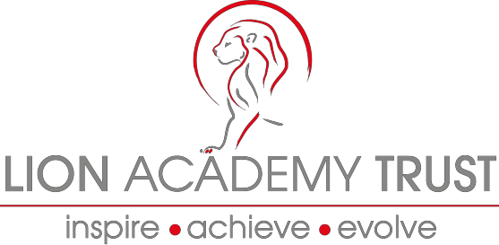

Lion Academy Trust
Information and Application Pack or the position of:
Class Teachers:
Main Payscale M1 – M6 (£24,018 - £34,934) + Recruitment & Retention - £2,500
Location: Basildon, Essex
(Not suitable for NQT’s)

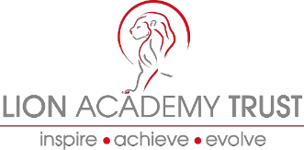
Dear Candidate

Thank you for the interest you have shown in the post of Class Teacher.

Lion Academy Trust is looking to recruit outstanding, enthusiastic, innovative and committed class teachers in January 2018 in our schools located in Essex, Maple Grove Primary and Leigh Beck Junior. If you are excited by innovation and challenge, and if you are energised by opportunities to develop and share your practise, whilst learning with your colleagues and from the children you work with, then we look forward to hearing from you.

They serve the community in Basildon and Canvey Island and our schools are on a journey to become truly outstanding schools.

Maple Grove is currently seeking KS1/2 Teachers.

We can offer you:
- Rapid and structured career progression - our growth and your growth are linked;
- Competitive salaries and performance related incentives;
- Access to vibrant schools situated in a culturally diverse area across the country with exposure to a wide range of settings and rewards;
- Lively, friendly and aspirational children who are determined to make the most of their schooling
- Innovative CPD which is of the highest quality.
- A supportive and forward thinking Trust Board and Senior Executive; and
- An employer who is constantly seeking to moderate and reduce the workload on all staff through innovation and use of related technologies.

The following pages provide further information about the Lion Academy Trust. A detailed job description and person specification are enclosed which explain the attributes you will need to succeed in this role.

We are seeking Class Teachers to commence from as soon as possible or in the next relevant term. I trust the information provided is helpful. For informal discussions, or to arrange a site visit, or if you do have any questions please contact:

Dan Lough, Head Teacher on 01268553547 or Karen Egleton on 01268 683037

Yours sincerely
Gemma Jackson
Regional Director

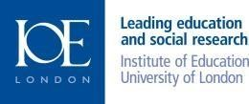
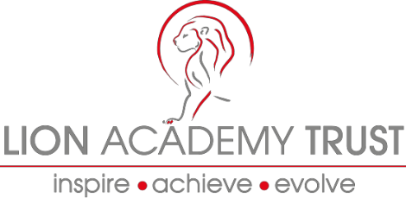
The Lion Academy Trust is a non-profit making educational charity with over twenty years of experience in running schools in and around London and is growing to meet the demand of schools in need of support nationally, through our two new hubs.

The Lion Academy Trust is a sponsor of schools in need of a structural and education change to how they operate for the benefit of their pupils and local communities. Successful candidates need to share our no excuses and have an inherent belief that all children, irrespective of context or background have the right to an outstanding education and can succeed.

If you are looking to become a Teacher in an organisation that has a proven track record of promoting staff with the right skills, attitude and disposition into senior leadership posts, we offer support to enable you to improve your teaching and learning practice by being reflective practitioners, taking part in professional development and practice opportunities and taking ownership of your professional development in order to aspire and achieve outstanding outcomes for all pupils.

The successful candidate will also work closely with colleagues, subject leaders in the planning development and delivery of an effective curriculum, ensuring that our pupils have the best possible education and school experience.

We support a range of school improvement services including brokering support from our Specialist Leaders of Education to assist other schools.

We run a series of internal networks including NQTs, subject leaders, EYFS leaders, SEN and Inclusion leaders. Alongside our internal programmes we also facilitate and host licensed national programmes such as National Professional Qualification for Senior Leaders, Middle Leaders and Head teachers.

Lion Academy Trust have high expectations, ambitious and hardworking staff and above all happy and enthusiastic children with a thirst for learning.

We are seeking committed, positive and ambitious candidates who are:

- Innovative, creative and consistently maintain a high standards of teaching;
- Able to lead, motivate, and inspire pupils.
- Able to demonstrate an ability to teach and model the highest possible standards of learning and teaching;
- Friendly and approachable with excellent communication skills and a passion for teaching.

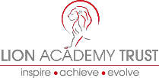

Our Schools

At Barclay Primary School, Sybourn Primary School, Brook House Primary School, Maple Grove Primary School, Leigh Beck Junior School, Thomas Gamuel Primary School and Wellingborough Primary School, we believe that all children and students have a right to have an excellent education in order to give them the best life chances irrespective of race, colour, creed or circumstance. We have high aspirations for our children, staff and communities. At the heart of our schools, are dedicated staff teams who are committed to being part of schools that enable all staff and students to make outstanding progress.

We believe that obstacles and barriers both real and perceived can be overcome by clear, strategic and targeted support that creates culture change based on sharing good and outstanding practice, collegiality, and a relentless pursuit of excellence. This underpins our high expectations and action and drives all the staff to provide opportunities for our children in order for them to reach the highest possible levels of attainment and achieve exceptionally well in all walks of life.

We believe that outstanding teaching and learning must be central to every decision made and every development introduced.

We are inclusive, caring schools where every child matters, we recognise that all children have talents and abilities to celebrate, and part of our role is to help children to discover these. We challenge and develop our children to become curious, autonomous learners who are inspired and stimulated through a rich and varied curriculum that is appropriate to individual needs. We develop children’s learning skills and by setting high expectations and exacting standards, we prepare our children to flourish, have high self-esteem and self-belief.

We believe that teacher learning and continued professional development is central to our success. Teachers will be given opportunity and challenged to continuously improve practice.

Teachers will be supported to:
- Adapt to changing demographics and environments
- Facilitate and lead outstanding learning opportunities and experiences for children
- Become outstanding teachers and learning must be central to every decision made and every development introduced.

As a Trust, we are committed to ensuring that we train, develop and recruit outstanding professionals so that we provide only the best for all our pupils. Through our links with quality tertiary providers we have access to the most up to date research and training that is at the forefront of educational development and transformation. Through effective use of this professional and leadership development we are able to provide learning journeys for aspiring professionals at all levels to develop into outstanding practitioners and leaders within our school.

We are on the journey towards being schools that continually develop and provide high quality education to our local communities and become a group of strong self-sustainable and self-sufficient institutions working and contributing within the Lion Academy Trust.

The Lion Academy Trust believes that access to outstanding education is a right for all our children and young people.

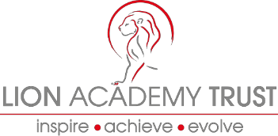
We aim to work closely with our parents, other schools and organisations, building partnerships, which benefit, not only our children, but others in the wider community, both on a local, national and global level.

How to apply
To apply please forward:

- A completed Application Form
- Application monitoring form

Candidates who are invited to interview will have a further opportunity to explore the content and context of these responses.

Please send your completed application by email to: recruitment@lionacademytrust.net

Recruitment process
The recruitment process:

We will treat all enquiries, formal and informal in confidence. Potential applicants are welcome to visit the Schools within the trust. The closing date for applications is 31st January 2018 at 12 noon.
A selection of candidates will be invited for interview on 7th February 2018.

Candidates will have the opportunity to spend time with key people involved in the school.

Alternatively, find out more information and download an application pack from
the Lion Academy Trust Website www.lionacademytrust.net

