

DIRECTOR OF MUSIC

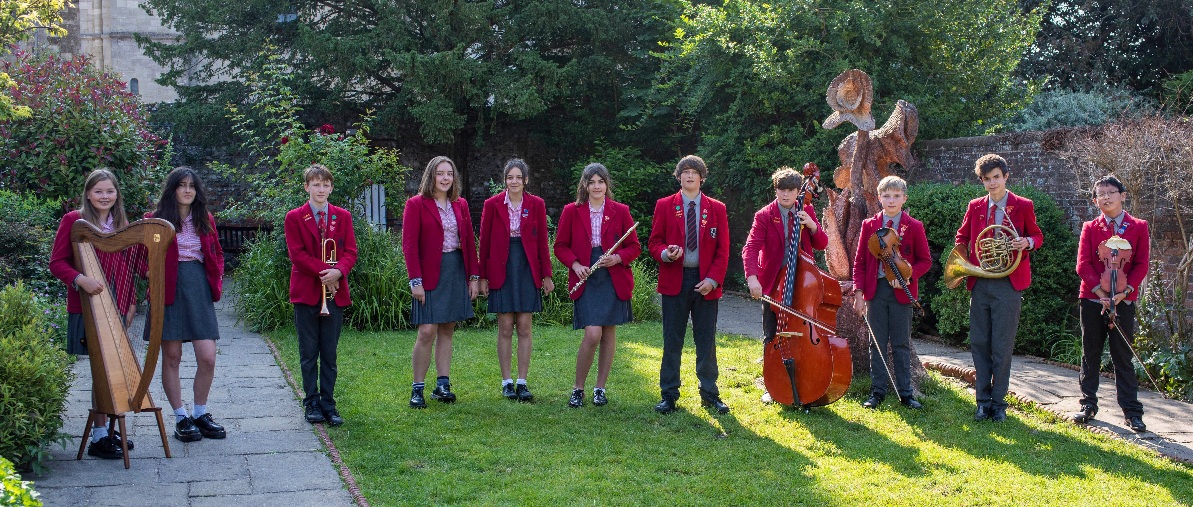

The Prebendal School

We are one of the region’s leading boarding and day schools, educating children aged 3-13.

The Head of the Prebendal School seeks to appoint, for January or as soon as possible thereafter, a talented and creative Director of Music. A high level of keyboard competence, including sight-reading, is essential.

This is a Full Time role. Accommodation is available for a candidate who wishes to assist in the Boarding house.

The Prebendal School is the oldest school in Sussex and probably dates back to the foundation of Chichester Cathedral in the eleventh century when it would have been a ‘song school’ responsible for teaching the choristers. It was re-founded as a grammar school in 1497 by the then Bishop of Chichester, Edward Storey, who attached it to the Prebend of Highleigh, after whom the school was named. The school is now a coeducational day and boarding preparatory school educating children between the ages of 3 and 13 years. Like many other Cathedral Choir Schools, the school occupies a range of buildings in and around the Cathedral Close dating from the original, fourteenth century song school to the modern Highleigh Building built and opened in 2000.

Prebendal is a boarding school with full, weekly and flexi boarders and day pupils. It is expected that the Director of Music will be a visible presence in the department from morning time onwards.

**The Department**

The Music Department has its own purpose-built range of teaching and practice rooms and an office for the Director of Music. It also possesses a good range of instruments available for trial lessons and hire and a full range of percussion. There are several pianos of a very good standard including a Yamaha grand piano in the Richmond Hall.

The Prebendal school has an excellent reputation for its high musical standards. Currently, over 95% of pupils have individual lessons on a wide range of instruments. Many of the pupils learn two or three instruments and some reach grade 8 standard before leaving at the age of 13. Typically, 30-40% of leavers gain music scholarships to the public schools of their choice.

Music is taught as a class subject throughout the school. The scheme of work broadly covers the National Curriculum but there is a much greater emphasis on theory and performance. In addition to the three prestigious cathedral concerts each year, there are regular informal concerts, at which pupils of all abilities are encouraged to perform.

Currently there is a wide variety of weekly ensembles, including 1st orchestra, concert band, junior band, string orchestra and wind, brass, and percussion groups. All pupils sing in a choir, and the optional ‘Chamber Choir’ for pupils in Years 7 and 8 is well represented by boys and girls. The Director of Music is assisted by a number of members of the music staff who run some of these groups.

**Worship**

Tuesday and Thursday mornings assemblies are held in the Cathedral and begin with an instrumental piece played by a pupil or small ensemble. The Orchestra plays the hymn on a Monday and a school choir will often provide an anthem.

The choral tradition is an extremely important element of school life. The 18 cathedral choristers under the direction of the Cathedral Organist sing seven services a week. It is intended that the new Director of Music will develop the school Chamber Choir with a view to singing one or two evensong services each term.

**The Appointment**

We are looking to appoint an exceptional musician with a strong ability to communicate their enthusiasm to children. The successful candidate will show the excellent administrative skills needed to run a department including approximately 20 visiting teachers. The Director of Music will need to be in complete sympathy with the traditions, workings and ethos of a cathedral choir school which has a reputation for musical excellence.

**The Post**

|  |  |
| --- | --- |
| **Job Description** | |
| The Prebendal School is committed to safeguarding and promoting the welfare of children and young people and expects all staff and volunteers to share this commitment. | |
| **Summary of the role** | Director of Music  The Prebendal School  Full Time  School’s own salary scale |
| **Main duties and responsibilities** | **Your Professional Duties**  You are expected to act in accordance with the aims, policies and administrative procedures of the School.  The following duties shall be deemed to be included in the professional duties which you will be required to perform:  **Specific Duties and Responsibilities**  The following duties shall be deemed to be included in the professional duties which you will be required to perform:   1. **Teaching**   • Uphold the School’s high standards of preparation, teaching and discipline  • Support the work of the School to ensure the highest possible levels of achievement  • Plan lessons in accordance with School’s schemes of work  • Contribute to the development, evaluation and monitoring of the policies, syllabuses and schemes of work of the School  • Liaise with relevant colleagues on the planning of work for collaborative delivery  • Monitor and be aware of pupils’ prior levels of attainment and maintaining records  • Set and mark examinations and other forms of assessment  • Use ICT within the curriculum  • Establish high and appropriate expectations for learning, motivation and presentation of work   1. **Assessment, Recording and Reporting**   • Maintain plans of lessons undertaken and records of pupils’ work  • Set and mark homework  • Provide constructive oral and written feedback, with clear goals for future learning  • Reporting on pupil progress in line with School policy and as specified in the published calendar  • Regularly keep parents informed of pupils’ progress at parents’ evenings, and at other times whenever necessary   1. **Pastoral Care**   • Be fully conversant with, and applying, the School’s child protection policy and all related issues  • Promote good attendance and monitor it in accordance with School policy  • Promote the general progress and well-being of pupils in your care  • Support each pupil to achieve their potential   1. **Professional Standards**   • Support the aims and ethos of the School  • Treat all members of the School community with respect and consideration  • Treat all pupils fairly, consistently and without prejudice  • Set a good example to pupils in terms of appropriate dress, punctuality and attendance  • Participate in the School’s extracurricular programme  • Take responsibility for personal professional development within the School’s CPD programme  • Attend all departmental and staff meetings  • Attend Parents’ Evenings and ensure that all deadlines are met as published in the School calendar  • Take responsibility for matters relating to health and safety  • Undertake duties that may be reasonably assigned by the Head (directly or indirectly)  Responsibilities may be direct, joint or through devolved structures, but always in accordance with whole school policies. These details may be amended at any time by agreement, but in any case will be reviewed through the appraisal process. |

|  |  |  |  |
| --- | --- | --- | --- |
| **PERSON SPECIFICATION** | | | |
| The Prebendal School is committed to Safeguarding and Promoting the welfare of children and young people and expects all staff and volunteers to share this commitment. | | | |
|  | | **Essential** | **Desirable** |
| **Qualifications** | | Honours Degree from a recognised University/Conservatoire | PGCE/QTS |
| **Experience** | | Exceptional track record as a music educator. |  |
| **Skills** | | Ability to inspire and motivate students  Excellent communicator, orally and in writing, with pupils, parents and staff  Ability to show initiative within the framework of a strong and supportive team  A willingness to utilise and develop departmental teaching resources  Strong interpersonal skills | Ability to use ICT appropriately to support learning |
| **Knowledge** | | Good understanding of differing teaching methods appropriate for the 3-13 age group.  Ability to utilise teaching strategies to allow learners to make good progress compared to their previous attainment | Ability to use teaching strategies to allow learners to make good progress compared to similar learners nationally |
| **Personal competencies and qualities** | | A creative learner and teacher  Pragmatism and a ‘can do’ approach  Ability to prioritise and remain calm under pressure  Flexible, resilient and organised  Desire to be fully involved in a busy prep school | Ability to advise pupils, parents and staff insightfully. To have a flexible approach to teaching and a willingness to learn.  Commitment to continuing professional development  Ability to work independently using a wide range of resources |
|  |

All Prebendal staff are expected to:

1. Participate in the continuous personal development, participating in appropriate training to maintain up-to-date professional expertise.

2. To undertake other duties appropriate to the general purpose of the post that may from time to time be reasonably assigned by the Head.

3. To make a full and active contribution to the extra-curricular life of the school.

4. To be pro-active on behalf of the school in external matters, particularly in relation to those concerning IAPS and local partnerships with schools

5. To be aware of any signs of stress, emotional imbalance or learning difficulties and keep appropriate people informed over these concerns

6. Ensure that each child is working to the best of his/her ability is well disciplined, well mannered, considerate and happy!

Please apply by emailing an application form (available on the [school website](https://www.prebendalschool.org.uk/265/vacancies)) with a supporting letter to [head@prebendalschool.org.uk](mailto:head@prebendalschool.org.uk)

The closing date for applications is Wednesday 6th October 2021.

The Prebendal School is an equal opportunities employer with a robust Child Protection Policy in force. Further details about the school can be found on our website at [www.prebendalschool.org.uk](http://www.prebendalschool.org.uk)

*A Disclosure from the Disclosure and Barring Service will be requested in the event of a successful application. The Prebendal School follows the Code of Practice issued by the DBS, a copy of which is available on request. A criminal record will not necessarily be a bar to obtaining a position. The Prebendal School is committed to safeguarding and promoting the welfare of children and young people and expects all staff and volunteers to share this commitment.*

