Head of Academic Music September 2019
  - Information for Candidates about the role and the School: A Guide to Nottingham High School
Table of Contents
Nottingham High School 1
Music at Nottingham High School 2
Job Description and details 4
SPECIFIC RESPONSIBILITIES 4
Benefits of Service 6
Safeguarding and Child Protection at Nottingham High School 7
Selection Process 8

Nottingham High School
The High School is an independent day school (HMC), founded in 1513, which relocated to the Arboretum in 1867 and which became co-educational in 2015. A Junior School was established in 1905, moved into new accommodation in 1978 and admitted infants in September 2008.
The Infant and Junior School (ages 4-11) has over 250 students. The Senior School selects for entry at age 11+ and 16+. There are roughly 800 students in the Senior School and a vibrant Sixth Form of over 200. The school’s move to co-education has been a great success with 280 girls in School during the fourth year of co-education and with further significant growth planned in future years.
The High School is a school of national reputation, the Headmaster having membership of HMC; the Infant and Junior Head membership of IAPS. Staff from cluster groups of local independent schools and national large day schools meet annually.
The High School has a very strong academic reputation and achieved the best examination results in the region last summer and has recently been awarded east Midlands Independent School of the Year.
The School has an extensive pupil catchment and is first choice for much of Nottinghamshire, Derbyshire, Lincolnshire and Leicestershire. The School operates a number of coaches to transport students.
Students come from a wide range of backgrounds and the School is committed to maintaining a representative entry, supporting this with generous bursary and scholarship funds. Together, these mean that about a fifth of students receive some form of financial assistance.
Entry is by competitive assessment in the Spring Term.
The Future
The person appointed will be joining a dynamic innovative school. Staff are keen to embrace new methods and technology. The website www.nottinghamhigh.co.uk contains links to Twitter accounts for various parts of the school.
Each of the parts of Nottingham High School has a comprehensive development plan for the future focusing on teaching and learning, pastoral care and co-curricular activities, as well as building developments. A first class Sixth Form Centre and a modern dining facility was completed in 2009 adding to new and refurbished facilities across all parts of the School. A major extension to the Junior School was complete April 2018.

Music at Nottingham High School
Nottingham High School’s Music Department is a busy hub at the heart of the cultural life of the school. Housed in the Lady Carol Djanogly Music School at the front of the site, we are fortunate in having excellent facilities which include a Recital Hall, three academic classrooms, a recording studio and a large number of individual music practice rooms. We have a department of three full-time music teachers, two part-time academic music teachers, a Music Administrator and over twenty Visiting Music Teachers.
Music is taught to all students in Years 7 and 8, becoming optional from Year 9 upwards. Our curriculum aims to challenge students of all ability levels, encourage them to participate in and widen their appreciation of music styles and genres, develop their own musical skills and provide a thorough, intellectually rigorous musical education for those wishing to continue their studies through school and beyond.
We offer the full range of academic qualifications including GCSE and A Level Music as well as Music Technology and we enter more than 150 students for ABRSM Music Examinations each year as well as other students taking examinations for Rock School, Trinity College of Music and the London College of Music. Many of our students go on to study Music and Music Technology at University and Conservatoire and in recent years we have seen students going off to read Music at Oxford, Cambridge, Durham, Newcastle, Leeds, Kings College London and Sheffield Universities as well as specialist performance courses at the The Royal College of Music and Birmingham Conservatoire. Our Music Technology students have gone on to study on the Tonnmeister course at Surrey University as well as study Creative Music Technology at Surrey and Huddersfield Universities and the Academy of Contemporary Music.
The department runs a masterclass programme to help its gifted and talented musicians, inviting many of Europe’s leading musicians and ensembles to give free lunchtime recitals and work with our students. Recent visitors have included the clarinettist, Michael Collins, trumpeter, Crispian Steele-Perkins, conductor, Dominic Ellis-Peckham, the Galliard Wind Ensemble and Julian Lloyd-Webber. In addition, we have a partnership with the internationally renowned Villiers String Quartet, who are the School’s Quartet in Residence. As part of their residency they offer chamber coaching, masterclasses in solo performing, give recitals and work with our composers and students of all ages from the Infant School through to the Sixth Form.
The Department runs more than 30 weekly activities covering the full range of ability levels and musical genres and involving more than a quarter of the school. They encompass the large scale ensembles such as Lower School Boys’ and Girls’ Choirs, Orchestra, Concert Band and Big Band through to barbershop choirs, chamber ensembles and jazz groups. We host more than 40 events a year including the annual Autumn and Summer Concerts, which involve more than a quarter of the school, through to smaller scale events such as our informal series of teatime concerts and lunchtime recitals.
The department regularly performs in prestigious venues across the UK and overseas. Recent tours have included a Concert Band tour to the Rhineland, a Big Band and Barbershop tour to Chicago and two Lower School Music Tours to Paris. The Music Department participates in major music competitions such as the National Concert Band Festival, Music for Youth Festival and Pro Corda Chamber Music Festival and have achieved top awards in all these competitions. In recent years both the Saxophone Quartet and Trombone Quartet have been named as Pro Corda Chamber Champions performing at the Wigmore Hall and Leeds International Festival.
Almost a third of our students have individual music lessons on an instrument or in singing in the school and a large number of students also learn privately. The department is proud of its excellent team of Visiting Music Teachers who offer tuition in the full range of instruments. They are also involved in running ensembles and enriching the co-curricular programme.
For our most talented students we offer up to four Music Scholarships each year as well as a series of one-year Music Exhibitions. Nottingham High School is proud of its musical alumni who include the internationally renowned conductors, the late Christopher Hogwood, Nicholas McGegan and Andrew Massey as well as cellist Richard May and Jazz saxophonist, Julian Siegel.

Job Description and details

SPECIFIC RESPONSIBILITIES

THE ROLE
The Head of Academic Music is a new post and will have a crucial role in supporting the Director of Music. The post holder will be responsible for all academic matters in the Music Department. The Head of Academic Music will champion the academic study of music, inspiring colleagues and students alike and promoting the best possible musical pedagogy. The Head of Academic Music will also be expected to take an active lead in non-academic matters within the department. We seek a talented musician who can communicate to young people a passionate enthusiasm for the subject, extending well beyond the classroom. The post would particularly suit a musician with an excellent track record in the classroom who is also a proficient pianist/organist and who aspires to be a Director of Music. A knowledge of Music Technology A Level would be an advantage but not a prerequisite.

KEY DUTIES AND RESPONSIBILITIES:

Management responsibilities
- oversee and manage the delivery of the curriculum music lessons for KS 3 to 5
- provide inspirational teaching and leadership within the academic music department, not only to consolidate the important place of Music within the school, but also to foster excellence in all that the department does
- attend Departmental Meetings and chair the meeting if the Director of Music cannot attend.
- assist the Director of Music in the provision and administration of a rich and varied programme of co-curricular music
- deputise for the Director of Music, when necessary, during his absence or at the request of the Director of Music should he be unavailable
- attend regular Head of Department meetings
- complete the academic sections of the annual departmental report and development plan.
- oversee the development of and updating of the academic sections of the departmental handbook
- undertake other such roles and responsibilities as the Director of Music might reasonably request.
- Line manage staff in the department in relation to the academic curriculum

Teaching & Learning
- take a lead role within the Music Department to promote academic excellence, ensuring that Schemes of Work are up-to-date, stimulating, challenging and rigorous
- promote the study of academic music and be a role model for colleagues as an outstanding practitioner
- be responsible for the administration of all music coursework in close liaison with the Examinations Officer and the Deputy Head [Academic], ensuring that all exam entries for GCSE and A Level Music and Music Technology are correct, and to organise where necessary standardisation and moderation sessions within the department; also to ensure that all clerical aspects of coursework submission are completed accurately
- liaise with the Director of Music and Deputy Head [Academic] in monitoring of students’ progress in Music
- champion the effective use of baseline data such as MidYIS, YELLIS and ALIS within the department and provide support to colleagues to do this
- oversee the provision of internal academic examinations (such as mocks and end-of-year assessments) as required
- ensure that classroom resources are in place and well-maintained
- act as a mentor to NQTs in the department and PGCE students when necessary.
- keep abreast of, and disseminate, national developments in the evolution of specifications, the curriculum and pedagogy
- maintain, develop and implement online teaching tools and resources and encourage and support the full integration of use of ICT within the Music Department
- co-ordinate curriculum related offsite visits and visiting musicians in School
- contribute to super-selective university preparation when required.
- accompany examinations and recitals and play for assemblies when required.

Additional:
- work closely with the Director of Music and Head of Instrumental Studies in order to maintain the smooth running of all elements of the department’s activities
- run at least one major ensemble/choir and one smaller ensemble/choir as part of the co-curricular commitment
- play a full role in department co-curricular programme of activities, particularly the major school musical events
- assist with departmental outreach projects to cultivate links with local prep and feeder schools
- organise the departmental rooming once the timetable has been produced (alongside the Director of Music)
- review the needs of the academic programme and produce the academic budget accordingly

Benefits of Service

Professional Opportunities and Career Development
The High School believes in, supports and resources an extensive system of continuing professional development and all teachers and non-teaching staff participate in it throughout their careers. The School has developed an Appraisal Scheme for teaching staff. Each member of staff has a Line Manager with whom they have Professional Review or appraisal meetings for their individual personal development. In this case, the Head of Department is the Line Manager.
Working Environment
This is an enjoyable and stimulating place to work. Staff Rooms and Staff Common Room areas are provided where complimentary tea and coffee is provided during the day. Members of the Staff Common Room organise a series of social events during the year for teaching and support staff including an annual Christmas event. Many of the facilities of the School are open to staff and their families, including the Gym and swimming pool.
The School is on the Nottingham Tram system with its own ‘High School’ tram stop. Employees who have children in the School currently benefit from some remission of fees in accordance with School policy, at the discretion of the Governors and are subject to amendment or withdrawal at a calendar year’s notice.
Living in Nottinghamshire
Good quality housing in Nottinghamshire and the surrounding counties is affordable and as a result many of our teaching staff have a good choice of areas to live in and experience a good quality of life. Most live within a twenty-minute commute of school. There are many attractive villages surrounding the city in which staff choose to live as well as a good stock of suburban housing in the city. In the centre of the city there has been considerable development of high quality apartments.
As well as the facilities which would be expected of a city with two universities, Nottingham boasts the Royal Concert Hall and two theatres.
Conditions of Service
This is a full-time post. The successful candidate will be expected to contribute to the full programme of co-curricular activities at the School.

Safeguarding and Child Protection at
Nottingham High School
Nottingham High School is totally committed to doing all it can to ensure the safety and wellbeing of all its students.
A comprehensive policy document, ‘Safeguarding and Child Protection at Nottingham High School’ is published on the school website via the following link:
http://www.nottinghamhigh.co.uk/about-us/school-policies
All adults who work at the School must recognise that there is an absolute duty to respond to any issues that are brought to their notice and as such, this post is subject to an enhanced DBS check. The post holder’s responsibility for promoting and safeguarding the welfare of children for whom s/he is responsible, or with whom s/he comes into contact will be to adhere to and ensure compliance with the School’s Child Protection and Safeguarding Policy at all times. Any safeguarding concerns must be reported to the School’s Designated Senior Lead.
Training in safeguarding children is given to new members of staff and covers essential issues such as:
- Definition of Child Abuse.
- Typical Indicators of child abuse.
- Details of what an adult must do if a child wishes to make a disclosure of abuse.
- The procedure for recording a disclosure.
- The need to discuss any Child Protection concerns with the appropriate Designated Senior Lead (DSL) without delay.
- The requirement to lodge any ‘Record of Child Protection Concern’ with the (DSL) immediately.
- An outline of how the work of the DSL relates to the City and County Safeguarding Children Boards.
The DSL for the Senior School is the Deputy Head (Pastoral), Miss Lisa Gritti.
Phone: Direct 0115 845 2206 or internal 206
Email: gritti.l@nottinghamhigh.co.uk
The DSL for the Infant and Junior School is the Head, Mrs Clare Bruce.
Phone: Direct 0115 8452211/2283 or internal 211/283
Email: bruce.ca@nottinghamhigh.co.uk

Selection Process
Equal Opportunities
The High School seeks to recruit individuals of the highest calibre. We welcome applications from all sections of the community. The High School recognises its responsibility to treat equally each person who comes into contact with the School.
All members of the School are equally valued so that they can develop a sense of self-esteem. No-one is discriminated against because of actual or imagined differences.
This policy applies to both staff and students, and it is the responsibility of all staff to promote practices which overcome prejudice in our society.
The Application Process
Candidates should complete their application form electronically and email it to teach@nottinghamhigh.co.uk addressed to Kevin Fear, Headmaster. There is no need to submit a CV.
Application Form
- Applications will only be accepted from candidates completing the enclosed Application Form in full. CVs will not be accepted in substitution for such forms.
- Candidates should be aware that all posts in the School involve some degree of responsibility for safeguarding children, although the extent of that responsibility will vary according to the nature of the post. Accordingly, this post is exempt from the Rehabilitation of Offenders Act 1974 and therefore all convictions, cautions and bind-overs, including those regarded as ‘spent’ must be declared.
- The successful applicant will be required to complete a Disclosure from the Disclosure and Barring Services at the appropriate level for the post.
- We will seek references on shortlisted candidates and may approach previous employers for information to verify particular experience or qualifications, before interview.
- If you are currently working with children, your current employer will be asked about disciplinary offences, including disciplinary offences relating to children or young persons (whether the disciplinary sanction is current or time expired), and whether you have been the subject of any child protection allegations or concerns and, if so, the outcome of any enquiry or disciplinary procedure. If you are not working with children but have done so in the past, that previous employer will be asked about those issues. Where neither your current nor previous employment has involved working with children, your current employer will still be asked about your suitability to work with children, although a current employer may, where appropriate, answer not applicable if your duties have not brought you into contact with children or young persons.
- You should be aware that provision of false information is an offence and could result in the application being rejected or summary dismissal if the applicant has been selected and possible referral to the police and/or DfE Children’s Safeguarding Operation Unit.
Invitation to Interview
If you are invited to interview this will be conducted in person and the areas which it will explore will include suitability to work with children.
- The interview process for this role may include the requirement to teach a lesson and to undertake relevant activities.
- All candidates invited to interview must bring documents confirming any education and professional qualifications that are necessary or relevant for the post (e.g. the original or certified copy of certificates, diplomas etc.) Where originals or certified copies are not available for the successful candidate, written confirmation of the relevant qualifications must be obtained from the awarding body.
- We will provide full information about the documents to confirm identity required for those invited to interview. Please note that originals of these documents will be required. Photocopies or certified copies will not be sufficient.
Conditional Offer of Appointment: Pre-Appointment Checks
Any offer to a successful candidate will be conditional upon:
- receipt of satisfactory references (if these have not already been received)
- verification of identify and qualifications
- evidence of the right to work in the UK
- a Barred Check List
- a satisfactory Enhanced DBS disclosure (original certificate must be shown to school staff) and Staff Suitability Self-declaration
- verification of professional status such as QTS Status (where required)
- (for teaching posts), verification of successful completion of statutory induction period (applies to those who obtained QTS after 7 May 1999)
- a check of the list of teachers prohibited from the profession
- where the successful candidate has worked or been resident overseas in the previous five years, such checks and confirmations as the School may require in accordance with statutory guidance
- verification of medical fitness in accordance with DfE Circular 4/99 Physical and Mental Fitness to Teach of Teachers and Entrants to Initial Teacher Training
- satisfactory completion of the probationary period
Warning
Where a candidate is:
- found to be on DfE list 99 or the Barring List, or the DBS disclosure shows s/he has been disqualified from working with children by a Court: or
- found to have provided false information in, or in support of, his application or
- the subject of serious expressions of concern as to his/her suitability to work with children the facts will be reported to the Police and/or the DfE Children’s Safeguarding Operation Unit.
Applications should sent electronically to teach@nottinghamhigh.co.uk no later than Midday on Monday 18th March 2019, with interviews tbc.
Applications (by email) to:
teach@nottinghamhigh.co.uk
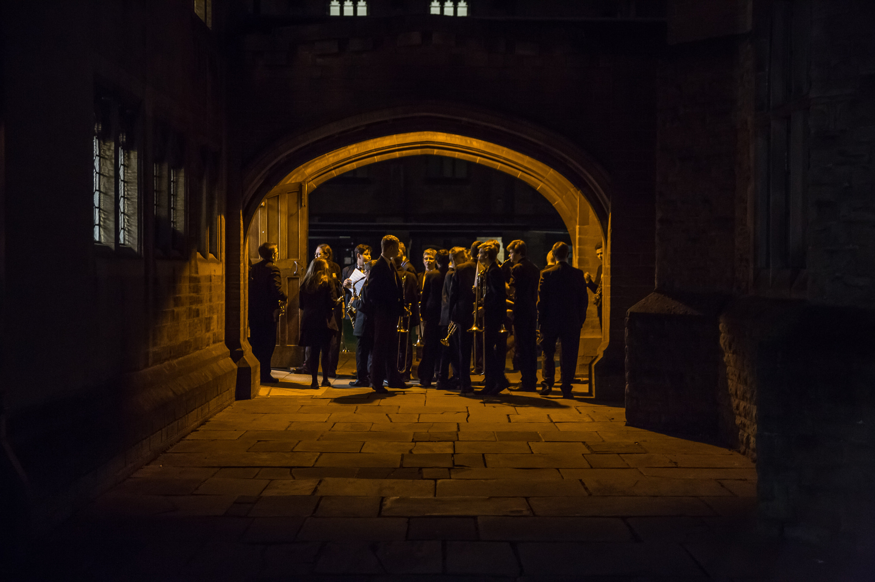
Nottingham High School  Waverley Mount  Nottingham NG7 4ED |  | 0115 978 6056 |  | info@nottinghamhigh.co.uk  www.nottinghamhigh.co.uk

