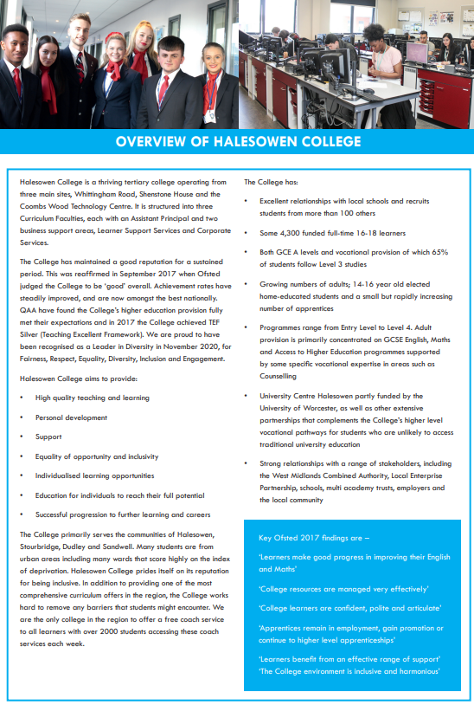

# cid:image004.png@01D42A59.305379E0

# Personnel Administrator

**Job Description**

|  |  |
| --- | --- |
| **Responsible to:** | Personnel Team Leader |
| **Line Manager:** | Personnel Team Leader |
| **Contacts:** | College Staff, General Public, College Stakeholders, Government Agencies |
| **Job Purpose:** | Working as a member of a small team providing exceptional administration skills to support the personnel function. You will adhere to Safeguarding’s Safer Recruitment standards to ensure all pre-employment checks are complete, compliant and systems are accurate for Halesowen College and its subsidiary company, Halesowen College Enterprises ltd. |
| **Hours:** | 30 hours per week (0.8 FTE) Occasional extra hours and weekend work may be required, for which time off in lieu is given. Staff are expected to support College events outside of core business hours. |
| **Salary:** | £19,974 - £21,141 per annum (Grade D) – pro rata for part time staff |
| **Annual Leave:** | The leave year runs from 1 September to 31 August  21 days and after 5 years 26 days  8 days Bank Holiday and 5 days for College Closure |
| **Pension:** | West Midlands Pension Fund and our employer contribution is 16.8%  Employee contributions depend on your annual salary see:  <https://www.wmpfonline.com/members> |
| **Benefits:** | <https://jobs.halesowen.ac.uk/index.cfm?action=content&content=1> |

**Duties and Responsibilities**

* Conducting and co-ordinating administration of the pre-employment compliance process in accordance with Keeping Children Safe in Education, following the rigorous Safer Recruitment processes and adhering to the Recruitment and Selection Policy.
* Ensuring all pre-employment checks are carried out and in place prior to new employees commencing, this involves DBS clearance, occupational health clearance, satisfactory appropriate references, qualifications, right to work approval and any other verification checks such as cross-checking of information supplied on application with the pre-employment checks made (e.g. dates of employment with references, qualifications have certificates supplied).
* To be responsible for the accurate production and distribution of contracts of employment and supporting documentation for new starters and ensuring signed documents are returned to HR.
* Issuing of new starter packs to the successful candidate and ensuring information within the pack is up to date.
* Liaising with line managers to ensure smooth commencement of employment in a timely manner, following completion of pre-employment checks.
* Inputting of data onto personnel record system to an exceptional standard, this also includes the scanning of documentation and other relevant paperwork.
* To process staff contractual changes and relevant supporting paperwork.
* Advising new starters on Disclosure and Barring Service checks and to verify supporting documents and ID via the online Disclosure and Baring Service (DBS) portal. Keep up to date with the DBS rules and regulations.
* Ensuring resignations, retirements and dismissals are processed accurately and timely and providing a good leaving experience.
* Liaising with the payroll team to ensure starter, leavers and contractual changes processed as appropriate.
* Involvement with HR data audit and cleansing.
* Providing generalist administration support to the HR team following through day-to-day changes and updates.
* Acting as a point of contact for staff queries, by email, phone and in-person.
* Providing basic advice on employment terms and conditions, policies and procedures.
* Any other duties commensurate with the level of the post that may be required from time to time.

**Under DBS legislation and guidelines this is a regulated activity.**

Any other duties, which may from time to time, be required and which are commensurate with the skills experience and grade of the post holder.

**Data Protection**

You are required to meet the specifications of the College’s Data Protection Policy as part of your conditions of employment. This will include information relating to past and prospective employees and students, suppliers and customers.

**Harassment and Discrimination**

You have a duty not to discriminate against or harass colleagues, contractors, students, parents, guardians or potential students or other College visitors, by reason of their age, sex, sexual orientation, gender re-assignment, marriage and civil partnership, pregnancy or maternity, race, disability or religion and belief.

**Safeguarding and Staff Code of Conduct**

You have a duty to abide by the Staff Code of Conduct and Safeguarding Policy.

**Health and Safety**

The College and its employees have legal obligations in respect of the health, safety and welfare of persons at work and the protection of others against risks to health and safety in connection with their activities. Specific health and safety responsibilities are detailed in the College Health and Safety Policy.

Other information for job holders/applicants:

**Disclosure and Barring Service Check**

This post, due to its nature, duties and responsibilities, will be subject to a check by the DBS. The level of check which will apply shall be an “Enhanced” level check.  Information about this disclosure can be found at [www.gov.uk](http://www.gov.uk).

To prevent abuse and implement good practice Halesowen College ensures that recruitment practices are robust and rigorous and that all staff employed have up to date and acceptable references, a full and complete employment history, an Enhanced DBS check and a check of the DBS barred lists.

**Safeguarding**   
Halesowen College is committed to safeguarding and promoting the welfare of young people and vulnerable adults and expects all staff and volunteers to share this commitment.  
Successful applicants will be subject to an enhanced Disclosure and Barring check.

**Equality and Diversity**

Halesowen College is proud of its work in embedding equality and diversity principles in its activities and welcomes applications from all suitably qualified people, irrespective of age, sex, gender reassignment, marital or civil partnership status, disability, race, ethnic or national origin, religion or beliefs, sexual orientation, unrelated criminal convictions or family responsibilities.

We welcome all sections of the community and value the contributions to the achievement of the College’s mission that are made by members of the College from a wide range of backgrounds and experiences. All staff must demonstrate an awareness of equality and diversity principles, as set out in College policies that includes **F**airness, **R**espect, **E**quality, **D**iversity, **I**nclusion and **E**ngagement. It is expected that all members of staff on appointment are committed to and include these principles in their work.

More information on our Equality and Diversity policy can be found at <https://www.halesowen.ac.uk/about/equality-diversity/>

**Childcare Facilities**

There is a day Nursery on the Whittingham Road campus for babies from 12 weeks and children aged 2 to 5 years. It is open 8.00 am to 5.30 pm Monday to Thursday and 8.30 am to 5.00 pm Friday. Further details are available from the Nursery staff on 0121 602 7677.

It is registered at present for 29 children in the early year’s age range. The baby room caters for 9 babies.

**Information Technology**

The College has approximately 2,600 computers across its sites including PCs, laptops, netbooks and Macs running a range of industry standard software. Equipment is available for long and short term loans, and guest access to our wireless network is provided for personal devices. We also run a PC booking system to ensure you can get access to a computer when you need it. A wide range of classroom technologies are in place such as the Moodle Virtual Learning Environment, cameras, voting devices and interactive whiteboards/data projectors.

All staff and students are given a personal computer account with access to email and storage which is available on and off site.

**Smoking**

Halesowen College is a designated smoke-free environment within the perimeter of all College property by order of the College Governors. This rule applies equally to staff and students, and to all categories of visitor. Acceptance of this rule is a condition of employment for staff, and a condition of being a student for students.

**Campus**

The College has three sites, Whittingham Road, Shenstone House and Coombs Wood. Staff can be asked to be based at and/or work across all campuses.

**Note: This job description is current at the time of issue. It should be recognised that, in keeping with organisational changes and developments, it may be necessary to review the duties listed from time to time and change them to meet organisational objectives.**

